**THE CINEMA CORNER**

How can I save water?

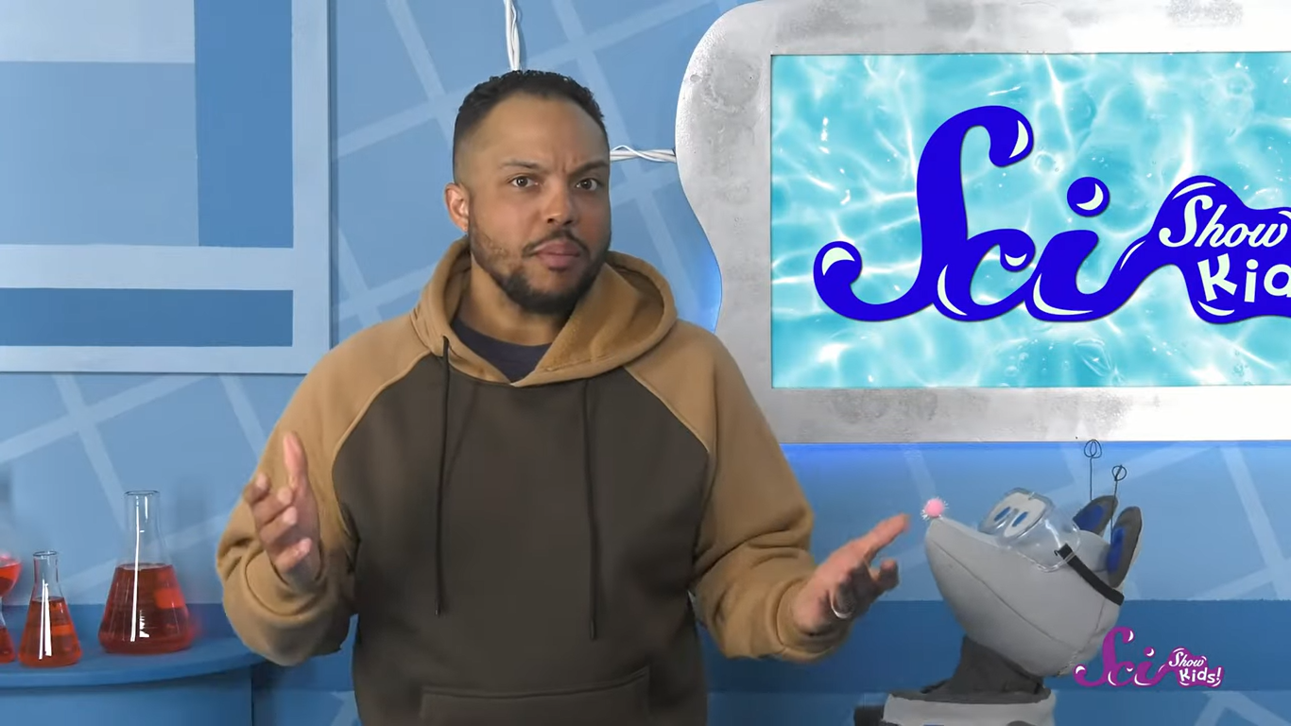

[How can I save water? video](https://www.youtube.com/watch?v=6yCAPAqXodc)

Water Pollution

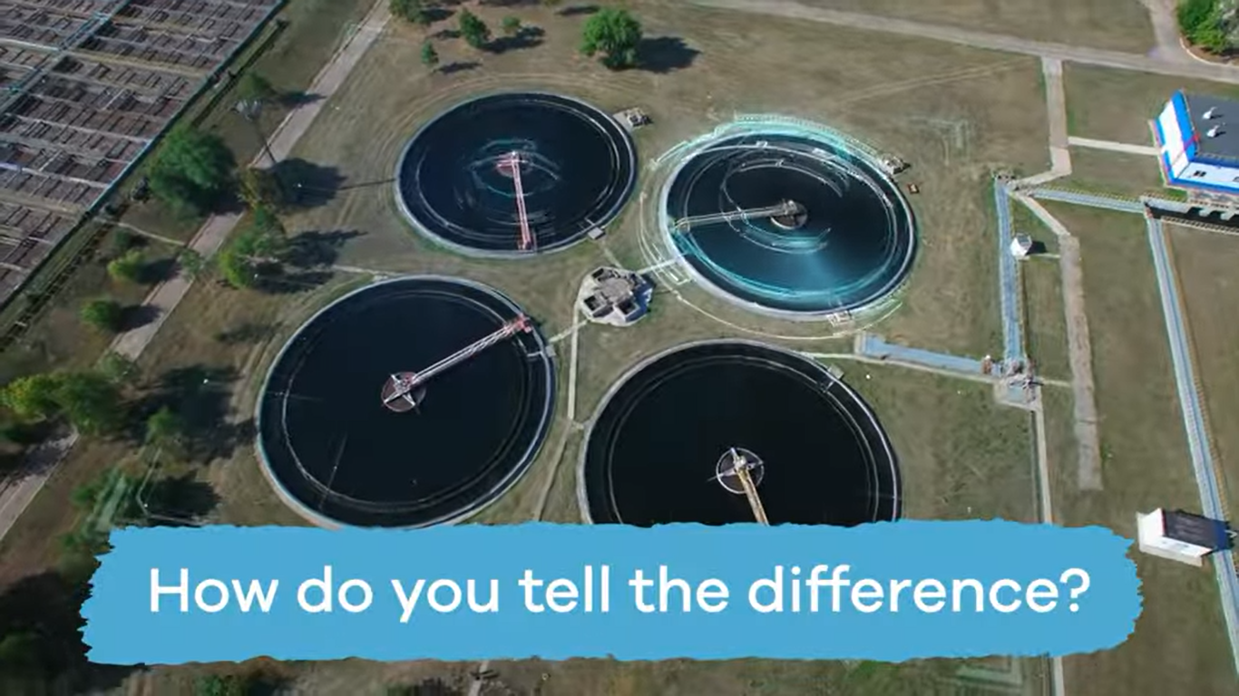

[Water Pollution video](https://www.youtube.com/watch?v=A3rLfrIUzY4&t=348s)

Save Water to Help the Earth

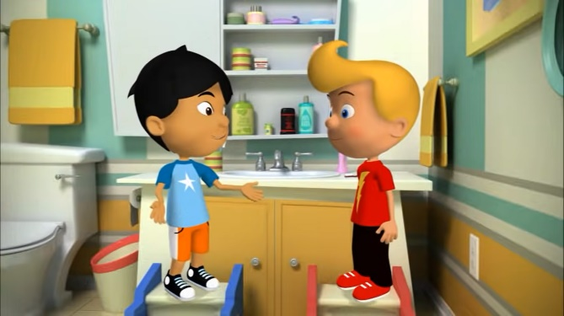

[Save Water to Help the Earth video](https://www.youtube.com/watch?v=rl0YiZjTqpw)

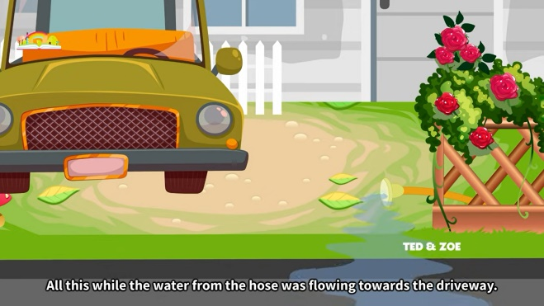Save water

[Save water video](https://www.youtube.com/watch?v=K8iaHwZ_4dQ)