**THE MUSIC CORNER**

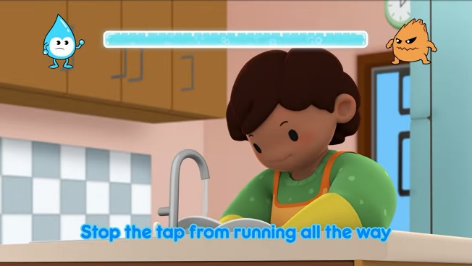Let’s go save water

[Let’s go save water song](https://www.youtube.com/watch?v=ZcCAkWT7df4)

Turn Off The Tap!

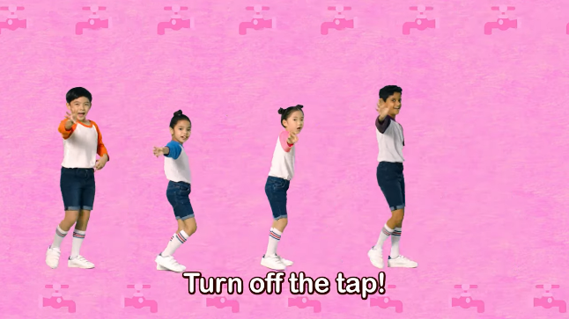

[Turn off the tap song](https://www.youtube.com/watch?v=3eh7NpjiQU0)

Saving Water

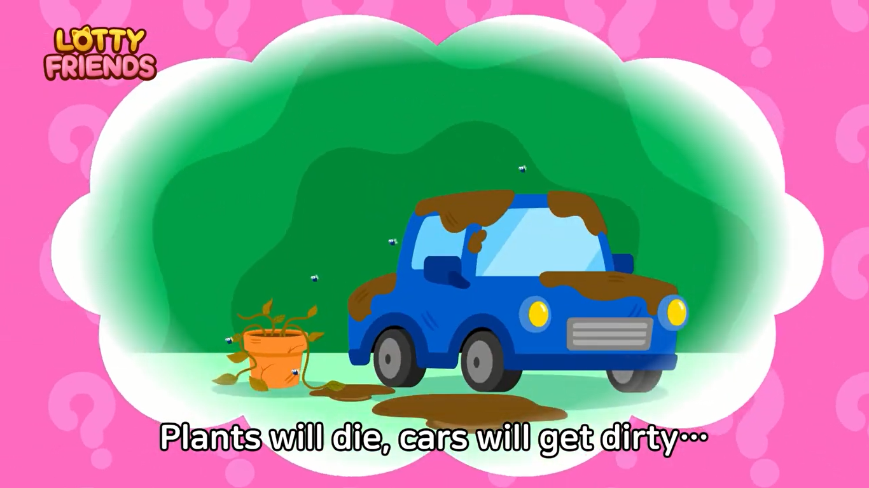

[Saving water song](https://www.youtube.com/watch?v=gwQ7PSrwGuI)

Save water

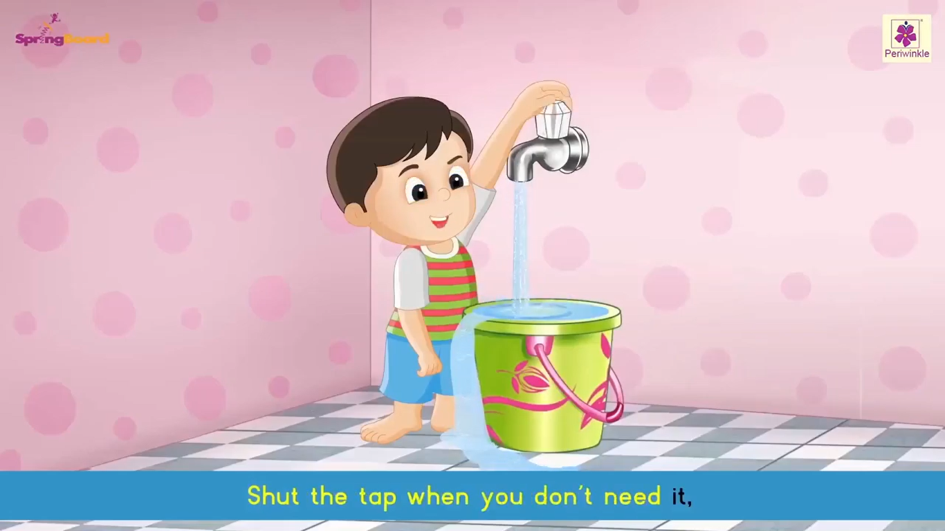

[Save water song](https://www.youtube.com/watch?v=4ydweprvtGM)