**Nama : Muhammad Syifa Albana**

**NIM : 21195003**

**Jurusan : Teknik Informatika**

**Kelas : Reguler Sore**

**Semester : 5**

**MK : Mobile programing**

1. **Halaman Token Push**

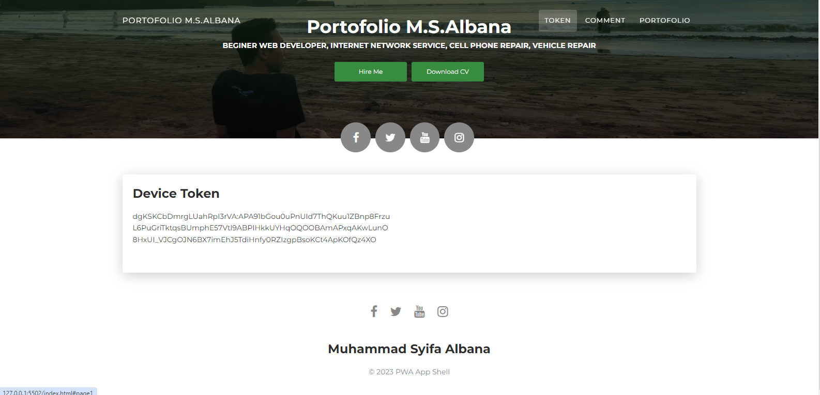

1. **Halaman Indeks DB**

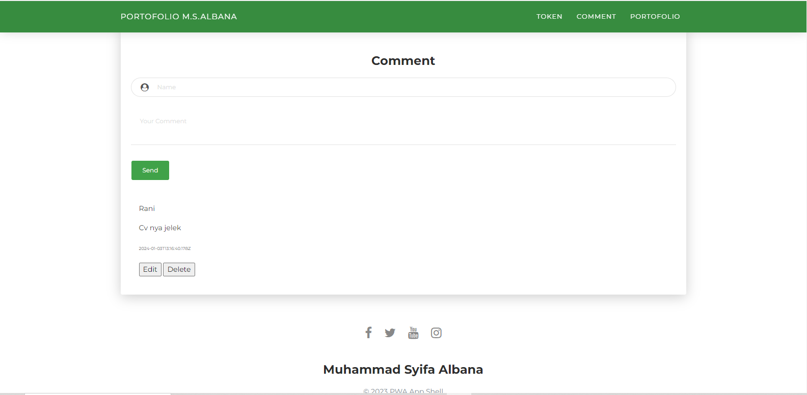

1. **Halaman CV**

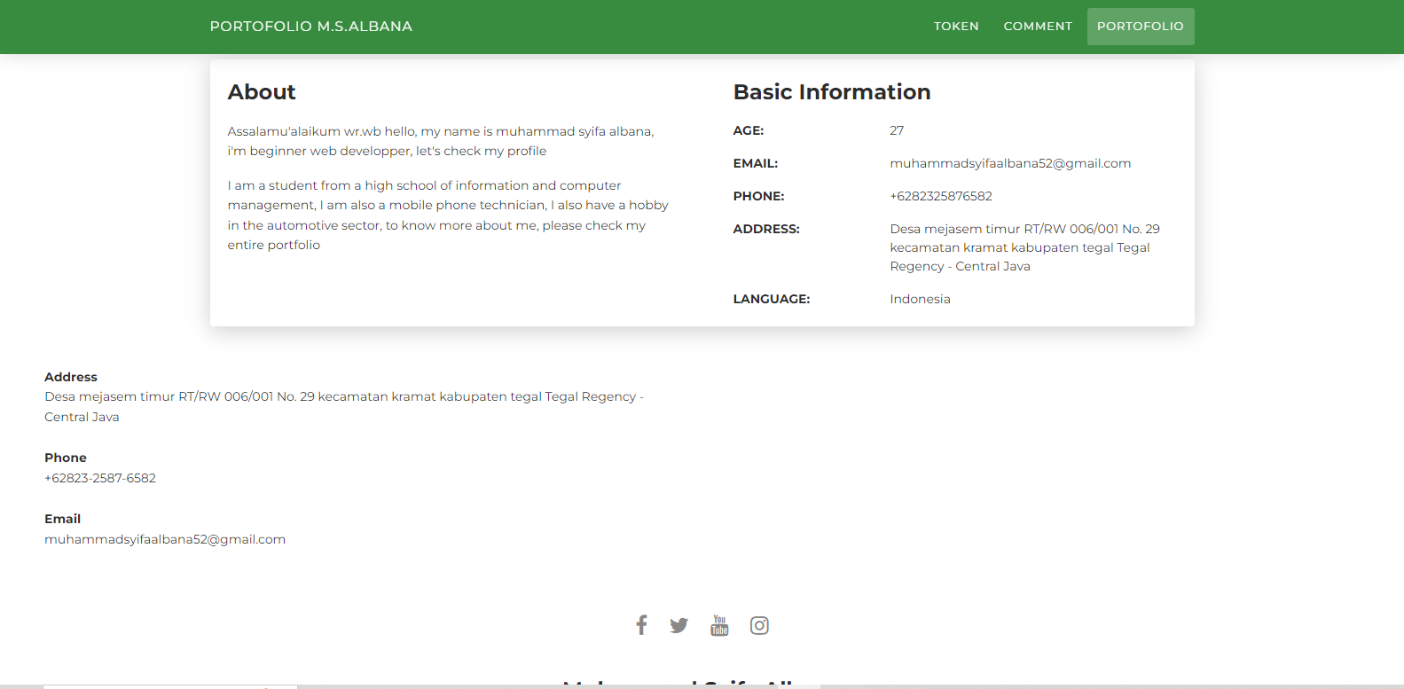

1. **Push Massage**

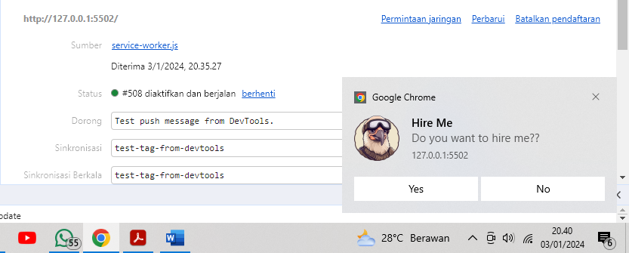

1. **Lighthouse**

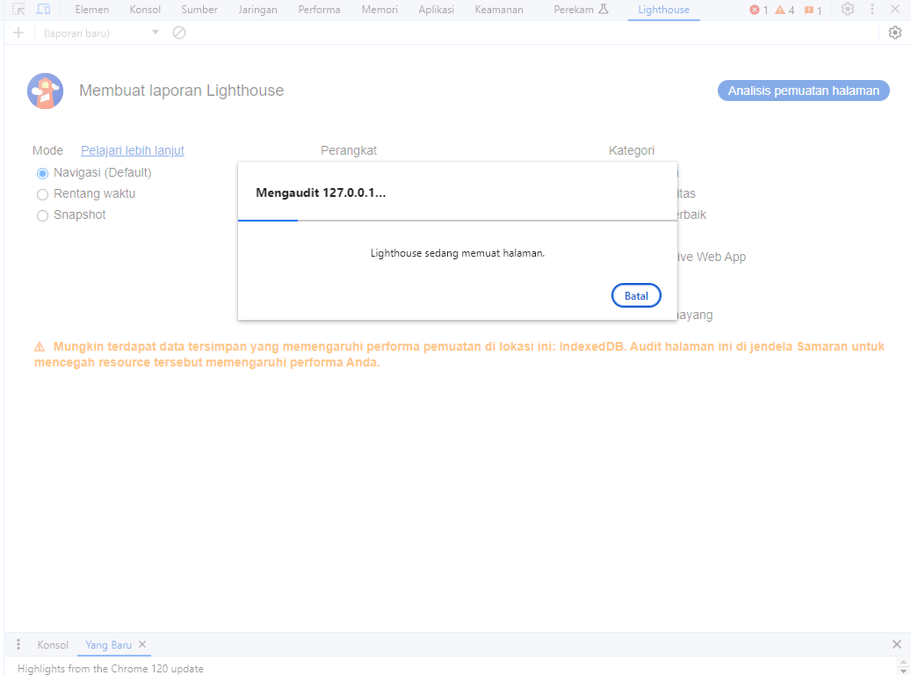

1. **Rincian lighthouse**

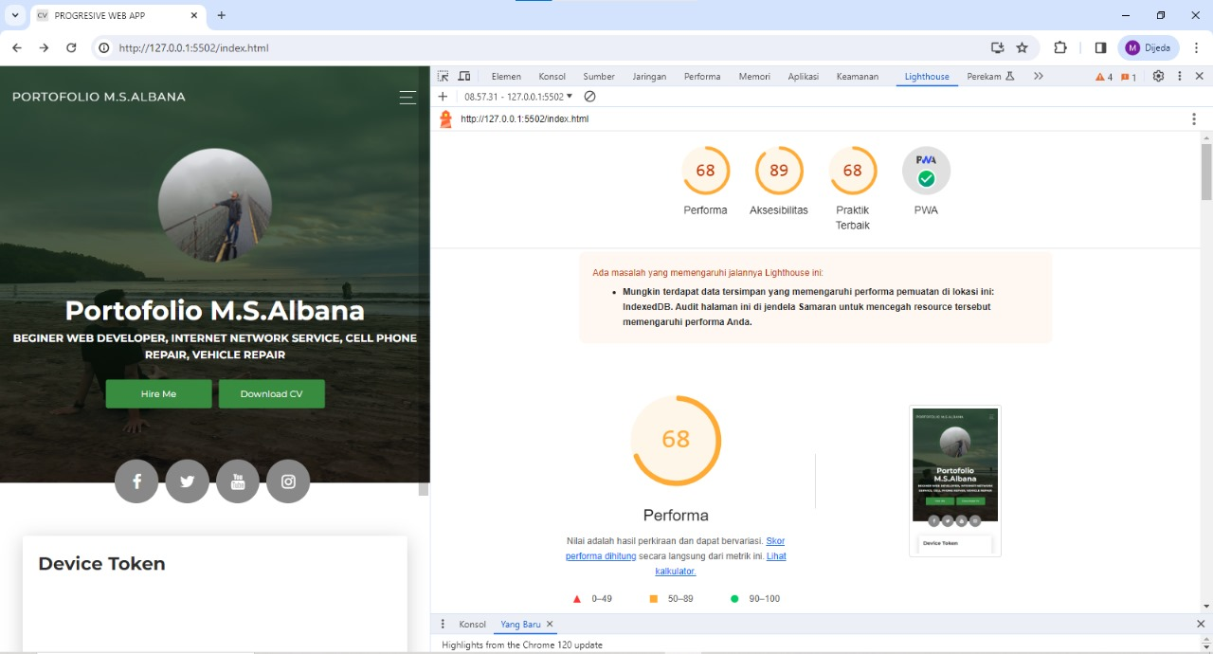

1. **Bukti Jalannya IndeexDB**

