**Turtlebot**

**User Manual**

1. Description of the robot :

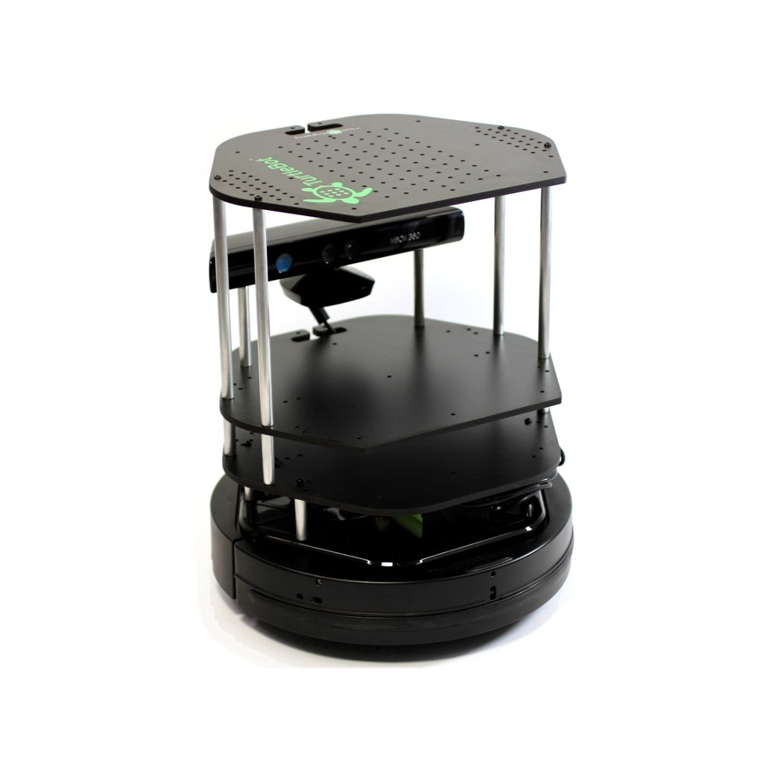

1. Flow Chart :

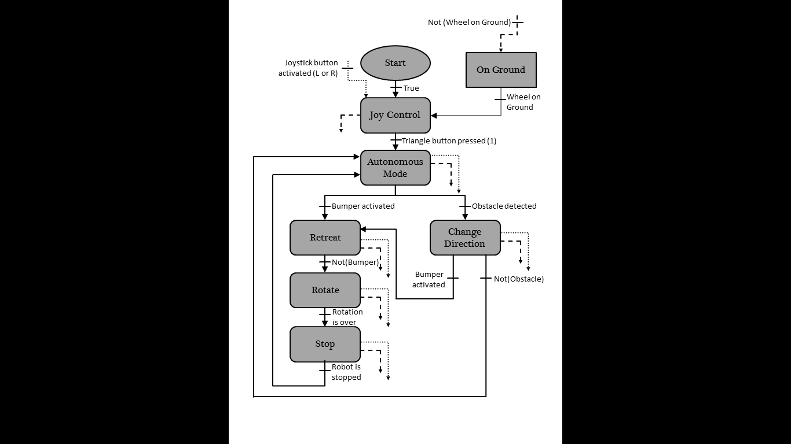

1. Description of actions / How it works:

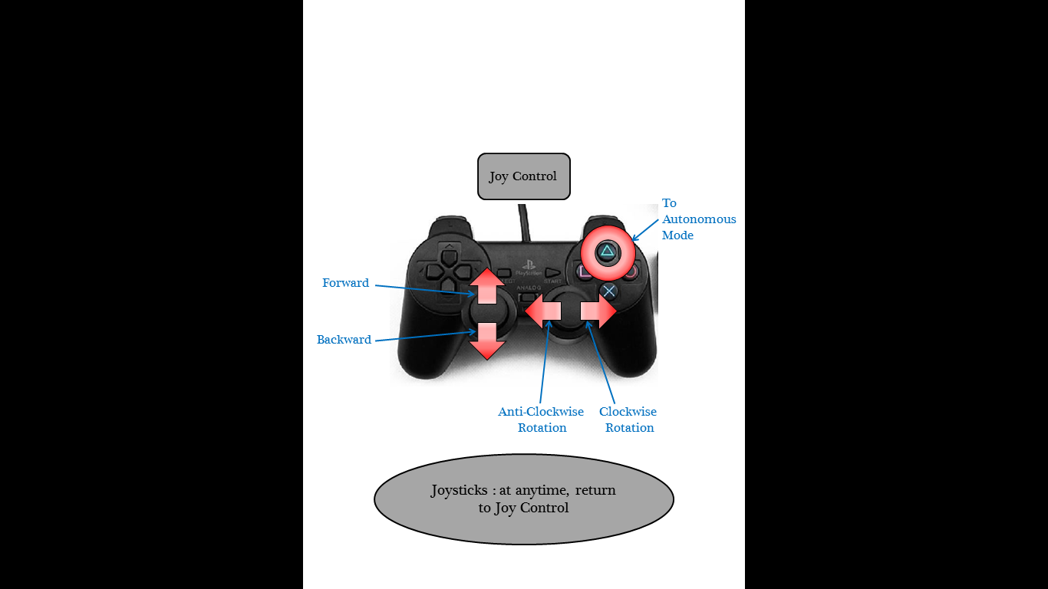 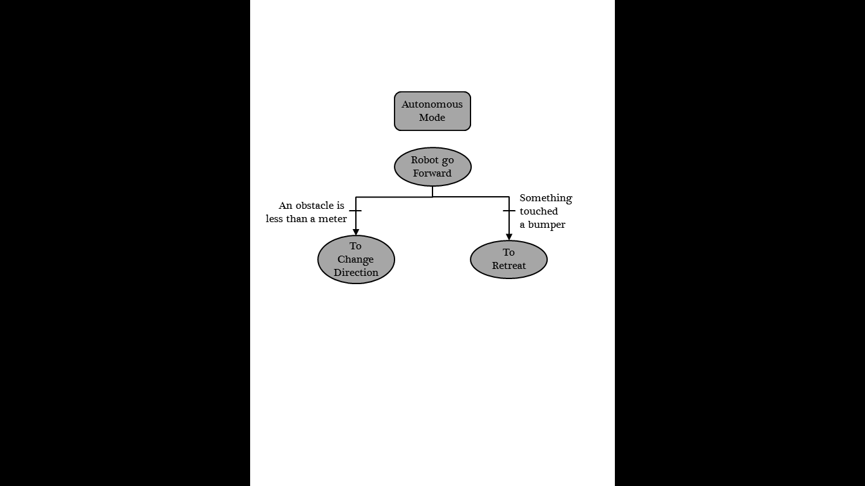

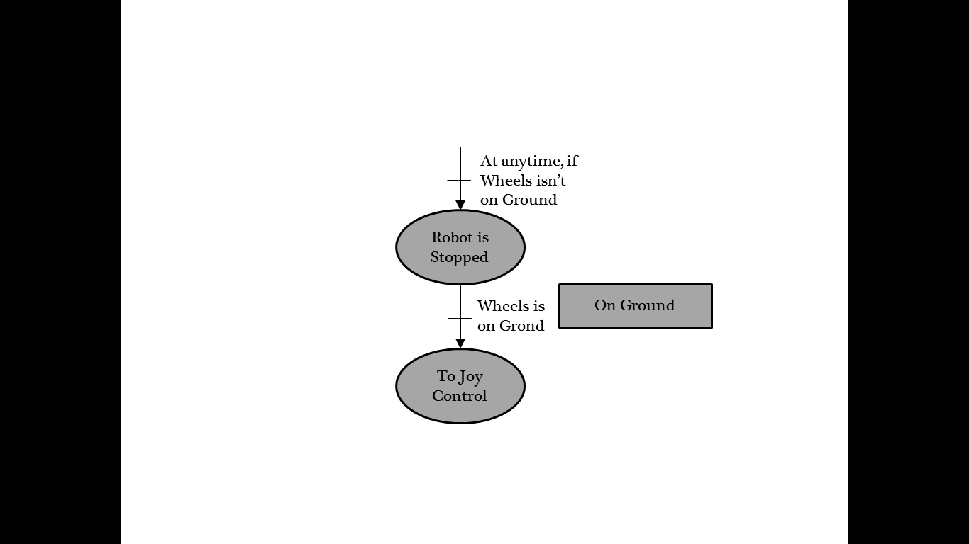 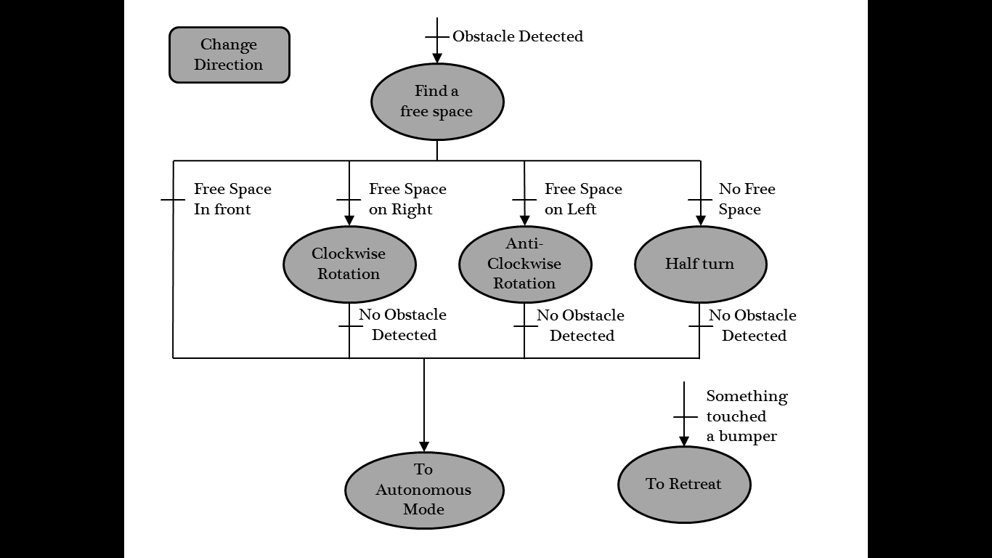

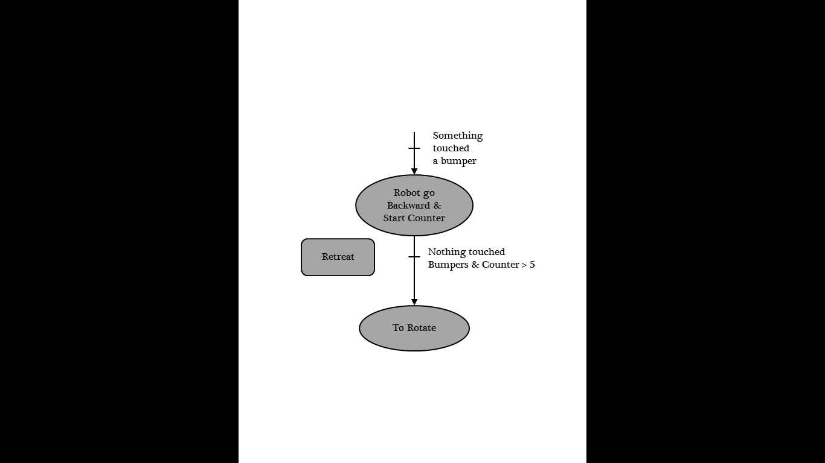 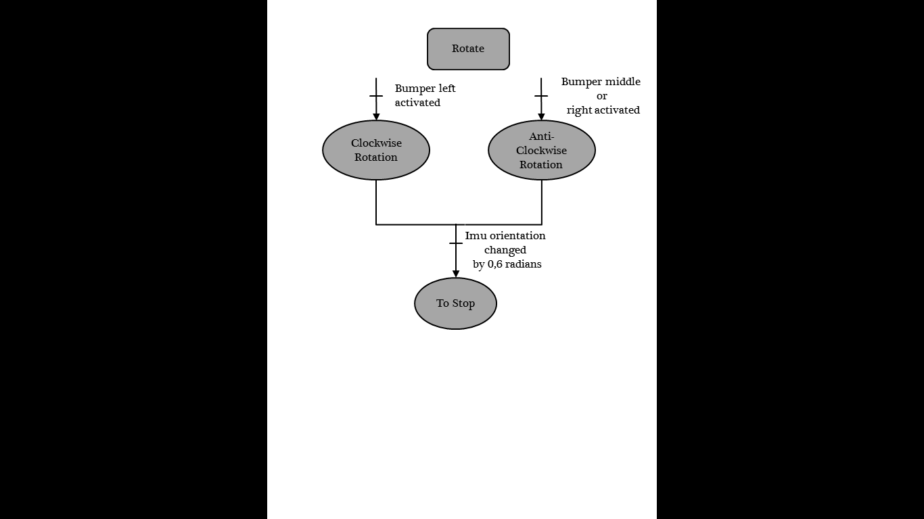

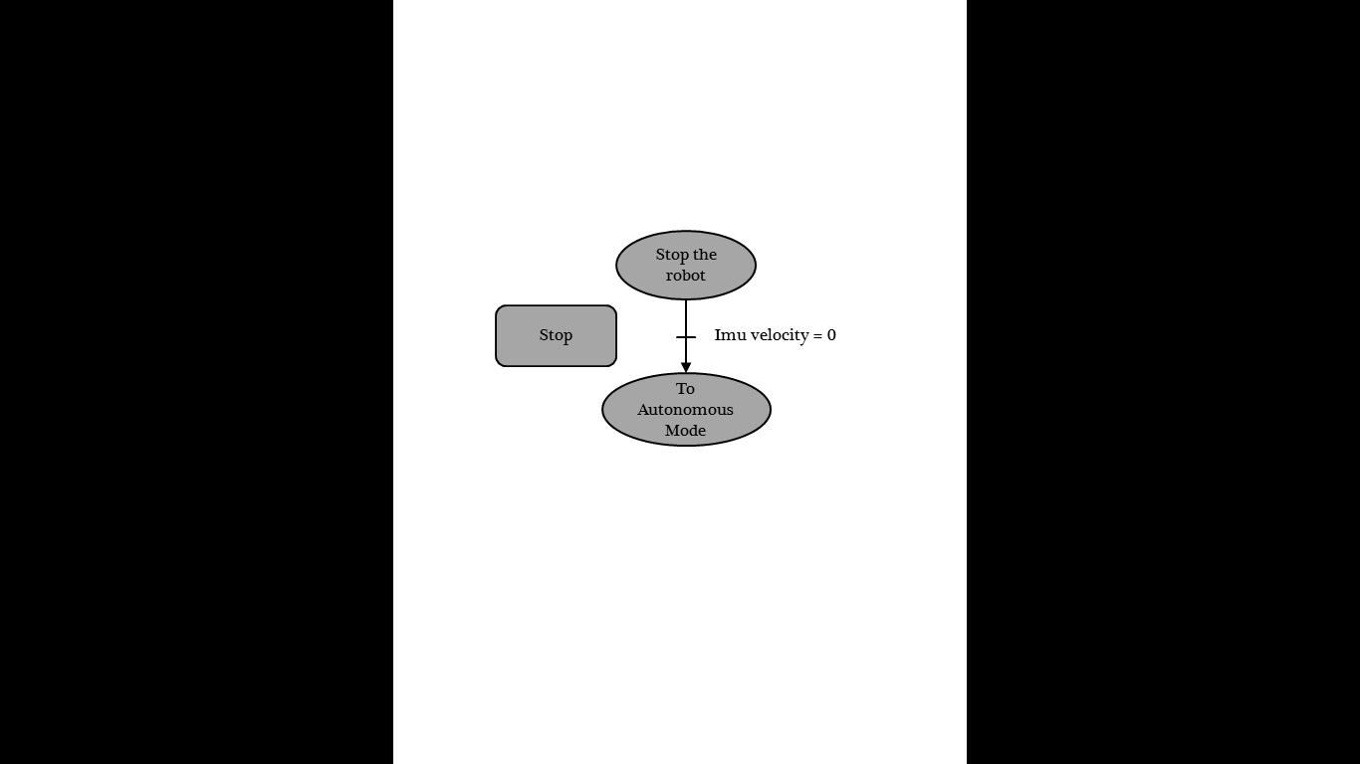

1. How to install :
2. Use a PC with Ubuntu 16.04 or 15.10
3. Install Ros Kinetic:

Follow the instructions in part **V** or on *wiki.ros.org/kinetic/Installation/Ubuntu*

1. Add the files “gazebo_obstacle.launch” and “turtlebot_obstacle.launch” in ~/catkin_ws/src/joy4ctrl/launch
2. Add the file “sm_obstacle.py” in ~/catkin_ws/src/joy4ctrl/script
3. Install Ros Kinetic:
   * *sudo sh -c 'echo "deb http://packages.ros.org/ros/ubuntu $(lsb_release -sc) main" > /etc/apt/sources.list.d/ros-latest.list'*
   * *sudo apt-key adv --keyserver hkp://ha.pool.sks-keyservers.net:80 --recv-key 421C365BD9FF1F717815A3895523BAEEB01FA116*
   * *sudo apt-get update*
   * *sudo apt-get install ros-kinetic-desktop-full*
   * *sudo rosdep init*
   * *rosdep update*
   * *echo "source /opt/ros/kinetic/setup.bash" >> ~/.bashrc*
   * *source ~/.bashrc*
   * *sudo apt-get install python-rosinstall python-rosinstall-generator python-wstool build-essential*
   * *sudo apt-get install -y python-rosinstall python-wstool python-catkin-tools build-essential python-catkin-lint libopencv-dev ros-kinetic-turtlebot-gazebo ros-kinetic-turtlebot3-gazebo*
   * *mkdir -p ~/catkin_ws/src*
   * *cd ~/catkin_ws/*
   * *catkin init*
   * *catkin build*
   * IN *gedit ~/.bashrc* ADD*source /opt/ros/kinetic/setup.sh*

*source ~/catkin_ws/devel/setup.bash*

*export TURTLEBOT3_MODEL=waffle*

* + *echo $ROS_PACKAGE_PATH ~/catkin_ws/src : /opt/ros/kinetic/share*
  + *cd ~/catkin_ws/src*
  + *catkin_create_pkg joy4ctrl*
  + copy the contents of the provided folder ‘joy4ctrl’ into this new folder
  + *cd ~/catkin_ws/*
  + *catkin build*

1. How to launch the gazebo simulation:

* IN *gedit ~/.bashrc* ADD or UNCOMMENT :

*export ROS_MASTER_URI = http:localhost:11311*

*export ROS_PI=127.0.0.1*

Close all consoles or use *bash* to update the changes

Check with *echo $ROS_MASTER_URI*

* Connect the joystick to the computer
* *roslaunch joy4ctrl gazebo_obstacle.launch*

1. How to launch the simulation with the real robot:

* Turn on the turtlebot: the interrupter on the mobile base and the turtlebot’s computer
* Check that your and the turtlebot’s computer are connect to the Wi-Fi HostportROS
* Connect the joystick to the computer
* IN *gedit ~/.bashrc* ADD or UNCOMMENT :

*export ROS_MASTER_URI = http:****turtlebot_ip****:11311*

*export ROS_PI=****my_ip***

(if you don’t know **turtlebot_ip** or **my_ip** follow the instruction on **XX.1**)

Close all consoles or use *bash* to update the changes

Check with *echo $ROS_MASTER_URI*

* Connect to the turtlebot’s console: *ssh turtle@****turtlebot_ip***  password = turtle

And activated sensors: *roslaunch turtlebot_bringup* ***obstacle_launch.launch***

* *roslaunch joy4ctrl turtlebot_obstacle.launch*
* In *ssh* console: you can close the connection with CTRL + C and turn off the turtlebot’s computer with *sudo shutdown –h 0*

(don’t forget to turn off the mobile base)

1. Help
2. How to know IP:
3. Turtlebot IP:

It’s write on the turtlebot (10.0.1.101 or 10.0.1.102)

1. My IP:

When your connect to the right connection: *hostname –I*

You can also click on the *wifi logo > Edit connections .S*elect *HostportROS* > *Edit* and in *IPv4 parameters* change the address.

1. The joystick doesn’t work:

If right joystick doesn’t work: check that the analog led is on

Check in *rostopic echo joy*

if there aren’t 10 buttons edit the launch that you want (in ~*/catkin_ws/src/joy4ctrl/launch*) and replace*/dev/input/js1* to*/dev/input/js0*