# 1. Package Diagram Overview

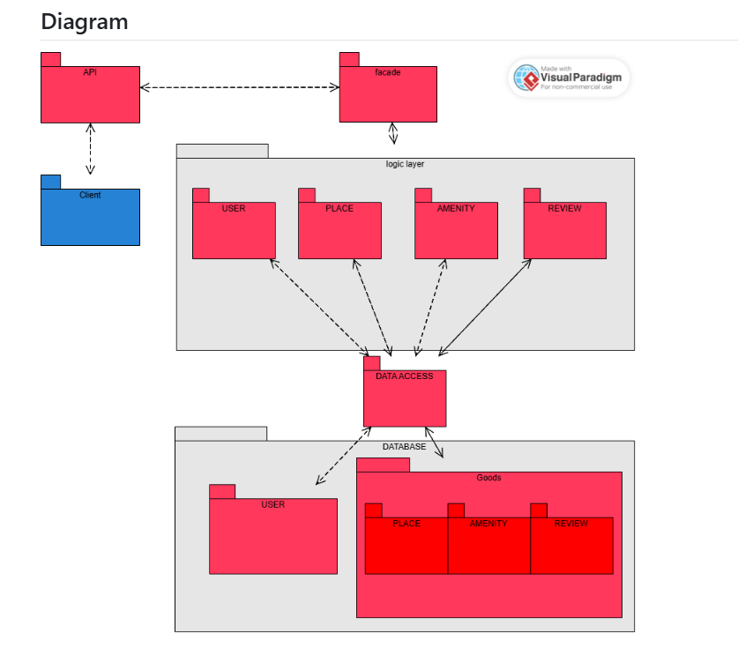

## 1.1 Description

The Package Diagram illustrates the architectural organization of the HBnB system, breaking it into key packages that manage different functionalities.

## 1.2 Main Packages and Their Responsibilities

* Client Package: The front-end interface used by users to interact with the system.
* API Package: Handles communication between the client and the business logic layer.
* Business Logic Package: Contains core functionalities for processing requests and enforcing business rules.
* Data Access Package: Manages interactions with the database to retrieve and store information.
* Database Package: Stores all application data, including users, places, reviews, and amenities.

## 1.3 Design Rationale

* The layered architecture ensures separation of concerns, making it easy to scale and maintain.
* The Façade pattern is implemented in the API package to simplify external interactions with the system.

# 2. Detailed Explanation of Packages

## 2.1 Client Package

* The user-facing interface that allows users to interact with HBnB.
* Communicates with the API to send requests and display data.

## 2.2 API Package

* Acts as an intermediary between the client and the business logic.
* Processes incoming HTTP requests and routes them to the appropriate business logic functions.

## 2.3 Business Logic Package

* Implements the core application logic, such as user authentication, place creation, and review management.
* Ensures data consistency and enforces business rules.

## 2.4 Data Access Package

* Handles interactions with the database.
* Converts business logic requests into database queries and returns structured data.

## 2.5 Database Package

* Stores persistent data, including user accounts, places, amenities, and reviews.
* Ensures efficient retrieval and storage of data for system operations.

# 3. Structure and Design Integrity

* Separation of Concerns: Each package has a well-defined role to ensure modularity.
* Scalability: The system can easily be extended by adding new modules to the business logic or API layers.
* Security: The API package serves as a controlled access point preventing direct interaction with the database.

# 4. Conclusion

This document provides a structured overview of HBnB's Package Diagram, explaining the different modules and their interactions. Understanding this high-level architecture ensures efficient development, maintenance, and scalability of the system.