

**American International University-Bangladesh (AIUB)**

**OBJECT ORIENTED ANALYSIS AND DESIGN**

**F**

**F**

**F**

**gg**

**Project Name: Library Management System**

**USE CASE DIAGRAM**

**- CASE STUDY**

An user first login into his account. He can renew his borrowed books. besides he can search books. A librarian can also do the above works. An user can Return his books. But a librarian can add book, he can also delete some books . Moreover he can edit book tag name.

A librarian can buy books via e commerce sites to add library. He can payment via bkash or Card.

After all activities user and librarian can logout form the portal.

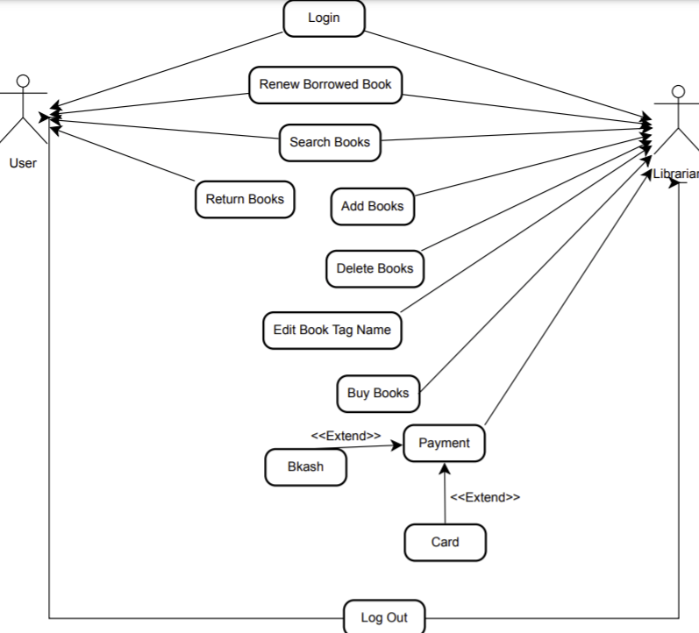

CLASS DIAGRAM

**- CASE STUDY**

A library has many kinds of books. User login into their account and borrow books. User has two part,Staf and students. One user have one account. in the account section users see the history. A library has one or more librarian. A library has a central database. database have add,delete,update features. A librarian has permission to access database. User and librarian both search books.

Books are organized by Tittle and Unique code. User can borrow and refund books. A Librarian verify Users before issue books.

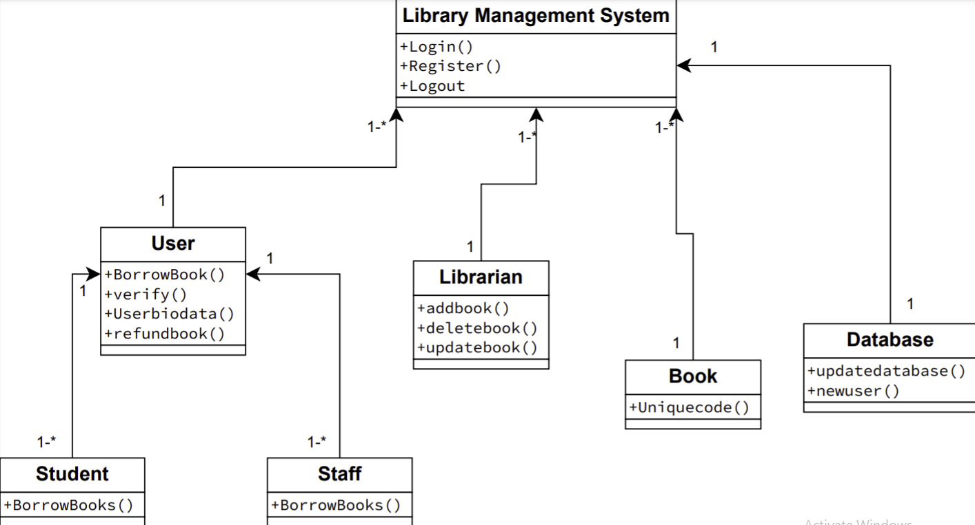

SEQUENCE DIAGRAM

A sequence diagram simply depicts interaction between objects in a sequential order i.e. the order in which these interactions take place. We can also use the terms event diagrams or event scenarios to refer to a sequence diagram. Sequence diagrams describe how and in what order the objects in a system function.

**Sequence Diagram Notations** –

**Actors** – An actor in a UML diagram represents a type of role where it interacts with the system and its objects. It is important to note here that an actor is always outside the scope of the system we aim to model using the UML diagram.  
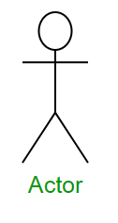

Figure – notation symbol for actor

We use actors to depict various roles including human users and other external subjects. We represent an actor in a UML diagram using a stick person notation. We can have multiple actors in a sequence diagram.  
For example – Here the user in seat reservation system is shown as an actor where it exists outside the system and is not a part of the system.

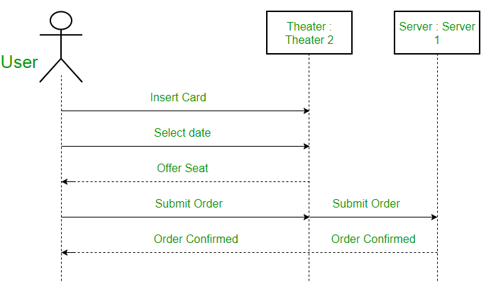

Figure – an actor interacting with a seat reservation system

Lifelines – A lifeline is a named element which depicts an individual participant in a sequence diagram. So basically each instance in a sequence diagram is represented by a lifeline. Lifeline elements are located at the top in a sequence diagram. The standard in UML for naming a lifeline follows the following format – Instance Name : Class Name  
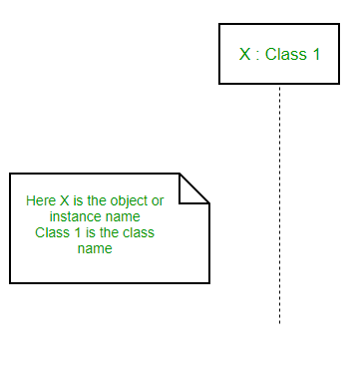

Figure – lifeline

We display a lifeline in a rectangle called head with its name and type. The head is located on top of a vertical dashed line (referred to as the stem) as shown above. If we want to model an unnamed instance, we follow the same pattern except now the portion of lifeline’s name is left blank.

Difference between a lifeline and an actor – A lifeline always portrays an object internal to the system whereas actors are used to depict objects external to the system. The following is an example of a sequence diagram:

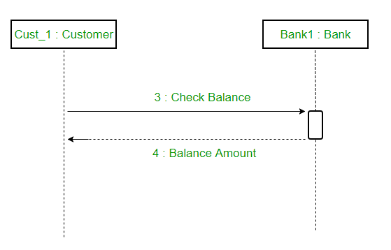

Figure – a sequence diagram

Messages – Communication between objects is depicted using messages. The messages appear in a sequential order on the lifeline. We represent messages using arrows. Lifelines and messages form the core of a sequence diagram.  
Messages can be broadly classified into the following categories :  
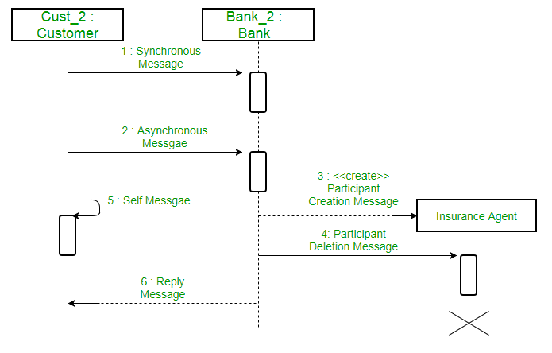

Figure – a sequence diagram with different types of messages

Synchronous messages – A synchronous message waits for a reply before the interaction can move forward. The sender waits until the receiver has completed the processing of the message. The caller continues only when it knows that the receiver has processed the previous message i.e. it receives a reply message. A large number of calls in object oriented programming are synchronous. We use a solid arrow head to represent a synchronous message.  
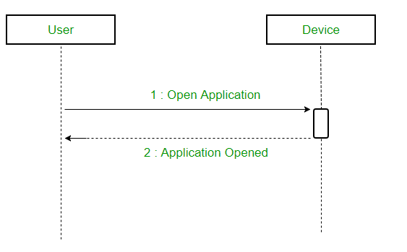

Figure – a sequence diagram using a synchronous message

Asynchronous Messages – An asynchronous message does not wait for a reply from the receiver. The interaction moves forward irrespective of the receiver processing the previous message or not. We use a lined arrow head to represent an asynchronous message.

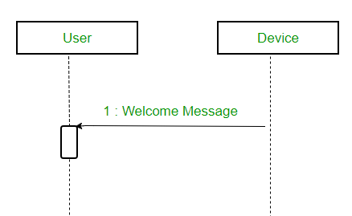

Create message – We use a Create message to instantiate a new object in the sequence diagram. There are situations when a particular message call requires the creation of an object. It is represented with a dotted arrow and create word labelled on it to specify that it is the create Message symbol.  
For example – The creation of a new order on a e-commerce website would require a new object of Order class to be created.  
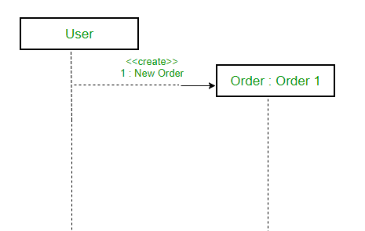

Figure – a situation where create message is used

Delete Message – We use a Delete Message to delete an object. When an object is deallocated memory or is destroyed within the system we use the Delete Message symbol. It destroys the occurrence of the object in the system.It is represented by an arrow terminating with a x.  
For example – In the scenario below when the order is received by the user, the object of order class can be destroyed.  
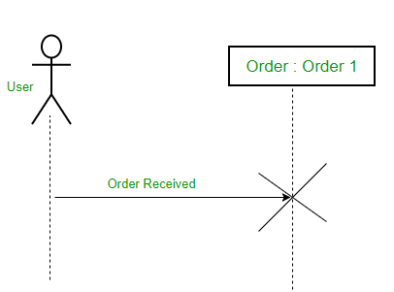

Figure – a scenario where delete message is used

Self Message – Certain scenarios might arise where the object needs to send a message to itself. Such messages are called Self Messages and are represented with a U shaped arrow.  
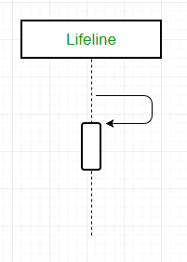

Figure – self message

For example – Consider a scenario where the device wants to access its webcam. Such a scenario is represented using a self message.  
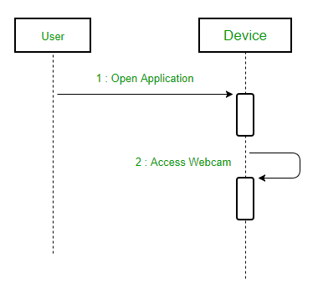

Figure – a scenario where a self message is used

Reply Message – Reply messages are used to show the message being sent from the receiver to the sender. We represent a return/reply message using an open arrowhead with a dotted line. The interaction moves forward only when a reply message is sent by the receiver.

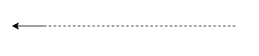

Figure – reply message

For example – Consider the scenario where the device requests a photo from the user. Here the message which shows the photo being sent is a reply message.

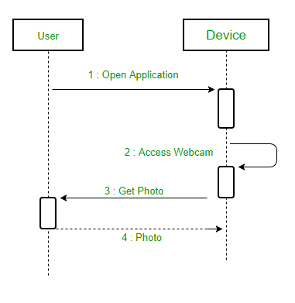

Figure – a scenario where a reply message is used

Found Message – A Found message is used to represent a scenario where an unknown source sends the message. It is represented using an arrow directed towards a lifeline from an end point. For example: Consider the scenario of a hardware failure.

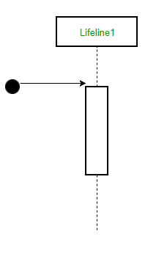

Figure – found message

It can be due to multiple reasons and we are not certain as to what caused the hardware failure.  
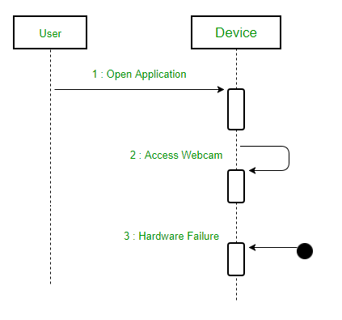

Figure – a scenario where found message is used

Lost Message – A Lost message is used to represent a scenario where the recipient is not known to the system. It is represented using an arrow directed towards an end point from a lifeline. For example: Consider a scenario where a warning is generated.

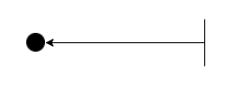

Figure – lost message

The warning might be generated for the user or other software/object that the lifeline is interracting with. Since the destination is not known before hand, we use the Lost Message symbol.

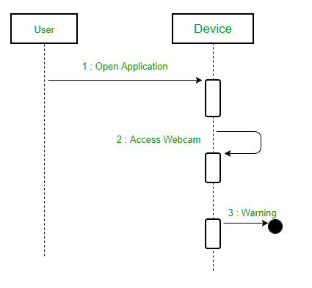

Figure – a scenario where lost message is used

Guards – To model conditions we use guards in UML. They are used when we need to restrict the flow of messages on the pretext of a condition being met. Guards play an important role in letting software developers know the constraints attached to a system or a particular process.

For example: In order to be able to withdraw cash, having a balance greater than zero is a condition that must be met as shown below.  
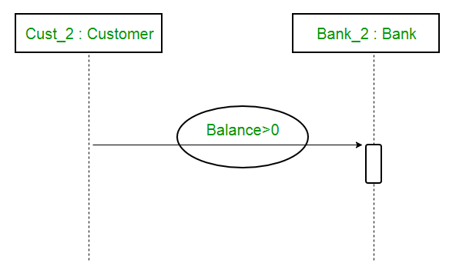

Figure – sequence diagram using a guard

A sequence diagram for an emotion based music player –  
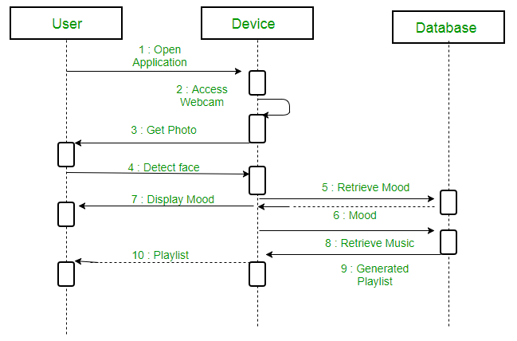

Figure – a sequence diagram for an emotion based music player

The above sequence diagram depicts the sequence diagram for an emotion based music player:

Firstly the application is opened by the user.

The device then gets access to the web cam.

The webcam captures the image of the user.

The device uses algorithms to detect the face and predict the mood.

It then requests database for dictionary of possible moods.

The mood is retrieved from the database.

The mood is displayed to the user.

The music is requested from the database.

The playlist is generated and finally shown to the user.

Uses of sequence diagrams –

Used to model and visualise the logic behind a sophisticated function, operation or procedure.

They are also used to show details of UML use case diagrams.

Used to understand the detailed functionality of current or future systems.

Visualise how messages and tasks move between objects or components in a system.

**-CASE STUDY**

In a management system of a university a member can place a request to book a journal to the librarian. Before the librarian can complete the booking that member has to be verified of his status whether he is allowed to borrow journals or not. The journal then has to be located whether it is in the campus where the request was made or it is in a different campus. If the journal is in a different campus the librarian makes a request for the journal to be sent at the requested campus. The librarian then informs the member about the time required for the journal to reach and completes the booking.

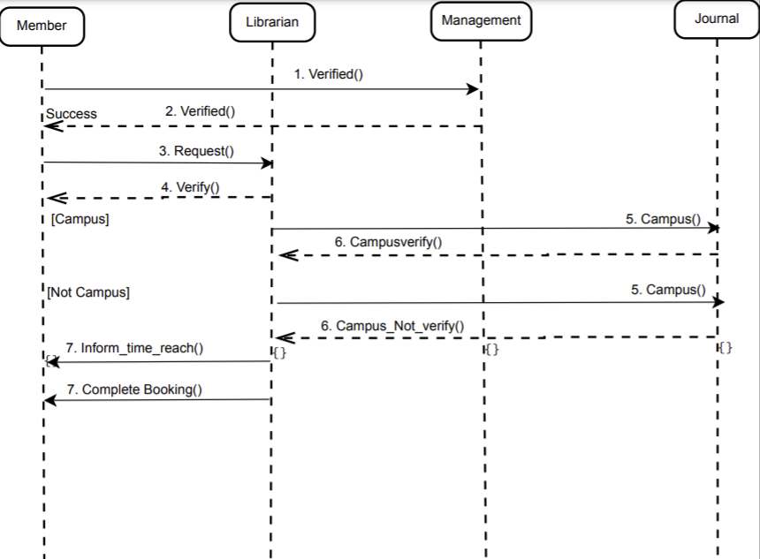

STATECHART DIAGRAM

**- CASE STUDY**

To use the library system at first, reader have to login with his pin. After entering, it will be verified by matching with system records. If it’s verified, if the reader previously borrowed books, he can return it and then he can check book or only can check books. If the reader find his searched book then can borrow the book. He also gain membership by paying 3 Dollars. Then he will be a regular member of a library.

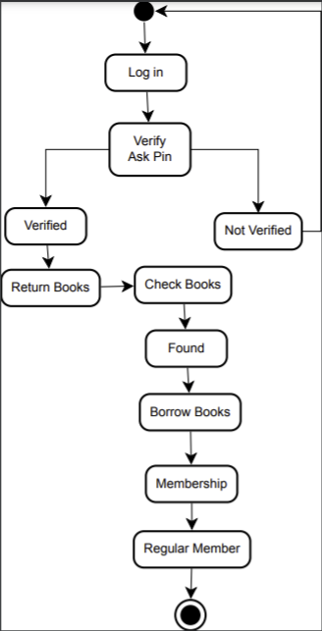

ACTIVITY DIAGRAM

**- CASE STUDY**

User first log in his account. System can verify his id card . User request to check borrowed history. Then system shows borrowed history. Then user return previous borrowed books. Then check books. Besides System show books. He can borrow 1 or more books. Then he will logout from this system.

