Industrial Furnace Control

Description of the Project:

Consider the Proteus schematics seen in fig.1. Temperature of an industrial furnace (oven) will be kept at a given temperature value (set point). If the temperature is above the set point, oven should be cooled by a fan, if the temperature is below than the set point it should be heated. The set point value and the temperature of the oven should be displayed on graphic LCD and if desired on VT (and/or on the Arduino IDE Serial Plotter via COMPIM).

Material List:

* Arduino Mega 2560 Board,
* LM35 Temperature sensor
* Oven
* Graphic LCD
* VT Terminal,
* COMPIM port

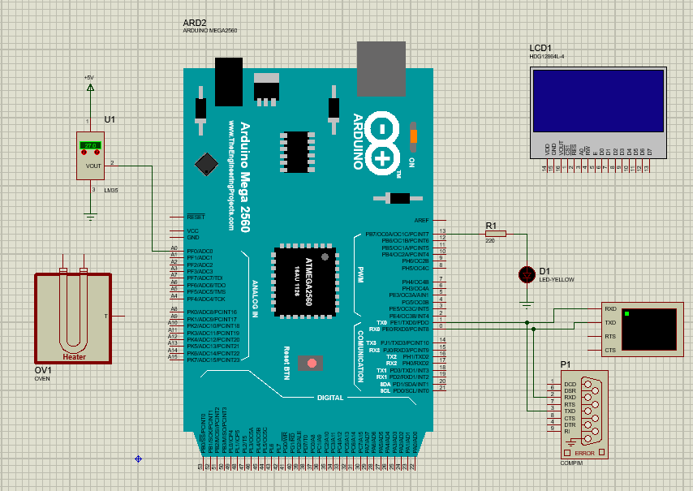

Fig. 1

Links: <https://www.youtube.com/watch?v=XGXOsOvgD6o>