Untitled

Albert Bertran

2023-05-25

install.packages("LaplacesDemon")

adult_train <- read.csv("D:/adult_train.csv")  
library(LaplacesDemon)

## Warning: package 'LaplacesDemon' was built under R version 4.2.3

adult <- adult_train[c('age')]

laplace_mechanism1 <- function(x, epsilon) {  
 sensitivity <- 125  
 scale <- sensitivity / epsilon  
 noise <- rlaplace(n = 1, loc = 0, scale = scale)  
 return(x + noise)  
}  
  
dp_naive <- function(adult, epsilon) {  
 n <- nrow(adult)  
 d <- ncol(adult)  
 dp_data <- matrix(0, nrow = n, ncol = d)  
 for (i in 1:n) {  
 dp_data[i] <- laplace_mechanism1(adult[i,], epsilon)  
 }  
 return(as.data.frame(dp_data))  
}  
  
epsilon <- 0.01  
errors = c()  
meanAfterDp = c()  
for (i in 1:10) {  
 histogramE = c()  
 histogramM = c()  
 for (j in 1:25) {  
 dp_data <- dp_naive(adult, epsilon)  
 mdp <- mean(dp_data$V1)  
 morig <- mean(adult$age)  
 histogramE[j] <- abs(mdp - morig)  
 histogramM[j] <- mdp  
 }  
 e <- mean(histogramE)  
 errors[i] <- e  
 m <- mean(histogramM)  
 meanAfterDp[i] <- m  
 epsilon <- epsilon + 0.299  
}  
errors

## [1] 80.3474908 2.5884278 1.2637386 0.8817059 0.6774335 0.5414435  
## [7] 0.4115679 0.3811028 0.3883267 0.3035289

dp_histogram_mean <- function(adult, epsilon, num_bins) {  
 n <- length(adult$age)  
   
 # Calculate histogram properties  
 min_age <- min(adult$age)  
 max_age <- max(adult$age)  
 bin_width <- (max_age - min_age) / num_bins  
   
 # Calculate global sensitivity of the histogram query  
 max_count <- 0  
 histogram_counts <- rep(0, num_bins)  
   
 for (i in 1:n) {  
 individual_age <- adult$age[i]  
 bin_index <- pmin(pmax(floor((individual_age - min_age) / bin_width) + 1, 1), num_bins)  
 histogram_counts[bin_index] <- histogram_counts[bin_index] + 1  
 max_count <- max(max_count, histogram_counts[bin_index])  
 }  
   
 # Apply Laplace noise to protect the histogram counts  
 noisy_counts <- histogram_counts + rlaplace(num_bins, scale = max_count / epsilon)  
   
 # Compute the differentially private mean from the protected histogram  
 sum_age <- 0  
 total_count <- sum(noisy_counts)  
   
 for (i in 1:num_bins) {  
 bin_age <- min_age + (i - 0.5) * bin_width  
 sum_age <- sum_age + noisy_counts[i] * bin_age  
 }  
   
 dp_mean <- sum_age / total_count  
   
 return(dp_mean)  
}  
  
# Main code  
epsilon_values <- seq(0.01, 3, by = 0.299)  
num_bins_list <- c(10, 25, 50, 100)  
num_iterations <- 25  
  
mean_values <- matrix(0, nrow = length(epsilon_values), ncol = length(num_bins_list))  
error_values <- matrix(0, nrow = length(epsilon_values), ncol = length(num_bins_list))  
  
for (i in 1:length(epsilon_values)) {  
 epsilon <- epsilon_values[i]  
   
 for (j in 1:length(num_bins_list)) {  
 num_bins <- num_bins_list[j]  
   
 histogram_errors <- matrix(0, nrow = num_iterations, ncol = 1)  
 mean_after_dp_list <- matrix(0, nrow = num_iterations, ncol = 1)  
   
 for (iter in 1:num_iterations) {  
 dp_mean <- dp_histogram_mean(adult, epsilon, num_bins)  
 mean_after_dp_list[iter] <- dp_mean  
 orig_mean <- mean(adult$age)  
 histogram_errors[iter] <- abs(dp_mean - orig_mean)  
 }  
   
 error_values[i, j] <- mean(histogram_errors)  
 mean_values[i, j] <- mean(mean_after_dp_list)  
 }  
}  
  
# Plot the results  
plot_labels <- paste("Bins:", num_bins_list)  
  
matplot(epsilon_values, error_values, type = "b", pch = 16, xlab = "Epsilon", ylab = "Error",  
 main = "Error vs. Epsilon for Different Numbers of Bins", col = 1:length(num_bins_list))  
legend("topright", legend = plot_labels, col = 1:length(num_bins_list), pch = 16, inset = 0.02)

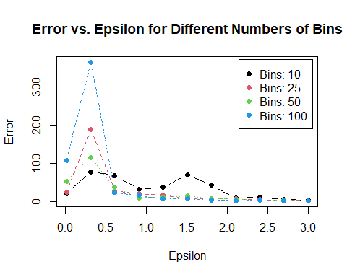

print(mean(adult$age))

## [1] 38.58165

# Laplace mechanism for differentially private summation query  
dp_summation <- function(data, epsilon) {  
 sensitivity <- max(data) - min(data)  
 scale <- sensitivity / epsilon  
 noise <- rlaplace(n = 1, loc = 0, scale = scale)  
 return(sum(data) + noise)  
}  
  
# Laplace mechanism for differentially private counting query  
dp_counting <- function(data, epsilon) {  
 sensitivity <- 125  
 scale <- sensitivity / epsilon  
 noise <- rlaplace(n = 1, loc = 0, scale = scale)  
 return(length(data) + noise)  
}  
  
# Initialize vectors to store error and mean values  
epsilon_values <- seq(0.01, 3, by = 0.299)  
error_values <- rep(0, length(epsilon_values))  
mean_values <- rep(0, length(epsilon_values))  
  
# Iterate over epsilon values  
for (i in 1:length(epsilon_values)) {  
 epsilon <- epsilon_values[i]  
 mean_results <- numeric(25)  
 error_results <- numeric(25)  
   
 # Compute mean and error 25 times  
 for (j in 1:25) {  
 dp_sum <- dp_summation(adult$age, epsilon)  
 dp_count <- dp_counting(adult$age, epsilon)  
 orig_mean <- mean(adult$age)  
   
 dp_mean <- dp_sum / dp_count  
 mean_results[j] <- dp_mean  
 error_results[j] <- abs(dp_mean - orig_mean)  
 }  
   
 # Store mean and error values  
 mean_values[i] <- mean(mean_results)  
 error_values[i] <- mean(error_results)  
}  
  
# Plot the results  
plot(epsilon_values, error_values, type = "b", pch = 16, xlab = "Epsilon", ylab = "Error", main = "Error vs. Epsilon")

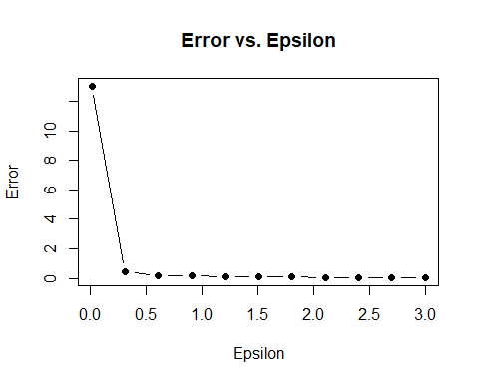

plot(epsilon_values, mean_values, type = "b", pch = 16, xlab = "Epsilon", ylab = "Mean", main = "Mean vs. Epsilon")

