3X03
Assignment 3
11/21, 2025
Johnson Ji
400499564

Problem 1-3:
Finished in Julia file.
Problem 4:
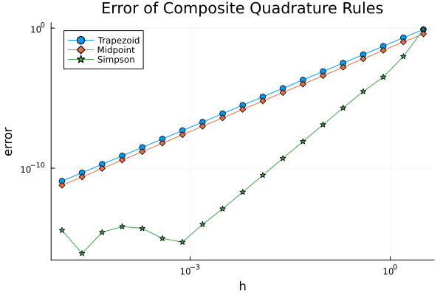
(a)
Remember for the errors of composite methods are:
- for trapezoidal $error=-\frac{f^{''}\left(μ\right)}{12}h^{2}(b-a), μ∈(a,b)$
- for midpoint $error=\frac{f^{''}\left(μ\right)}{24}h^{2}(b-a)$
- for Simpson’s rule $error=\frac{f^{''}\left(μ\right)}{180}h^{4}(b-a)$
so, for trapezoidal and midpoint rule, we can find that they share the same slope, which is because they are proportional to h², while the Simpson’s rule is proportional to h⁴, that also explains why the error curve of Simpson’s rule is steeper than the others.
(b)
Compare these 2 parallel lines, we find the trapezoidal rule is higher than midpoint, since this plot is comparing the magnitude of the error, so the coefficient depends on the “height” of each point in the curve, since for trapezoidal is 1/12 and midpoint is 1/24, so the trapezoidal will higher than midpoint.
(c)
Notice that for Simpson’s rule, the error curve is divided into 2 parts; the right part is the linear part, which is when the h is high and the error behavior is stable (i.e. the h⁴ is higher than the machine epsilon of the computer); when the h is small, we can find that the error line is fluctuating since h⁴ leads the error term be very small and close or less to the machine epsilon, then since the error that we measure is truncation error, so the small h makes the error that we plot is basically be round off error of the computer, that leads the “piecewise linear” behavior.

