1. Please describe the architecture of the current chatbot system. Identify the components and check where are they running now.

1)**Natural Language Processing (NLP)** which enables the chatbot to transfer user input(txt, voice etc.) to structured data that machine can understand. Many Ai chatbot have this component for example ChatGPT can understand user’s intention.

2)**Knowledge base** is a repository for chatbot to get data and information used to respond to users. For example, some chatbots running on shopping website have data base with information about products, price, and functions.

3)**Data storage** can be used to store the conversations, NLP models, and many other data that important for a chatbot running. For example, SQL server can be used as data base for data storage.

4)**Natural Language Generation** which can be used for generating human-readable text. For example, After filtering the data in the knowledge base to select what to include in the response, chatbot constructs the answer and performs sentence aggregation and grammar checking, and then put the data into a language template to ensure that the answer is given as naturally as it would be in a human conversation.

5)**User interface** is the front-end for chatbot to give the physical representation in conversations with users. For example, we can use telegram chat as a front-end for our own chatbots.

2. Explain how do your chatbot handle the special command. You need to trace the code and explain that.

Assuming that we have completed the creation on the telegram chatbot,

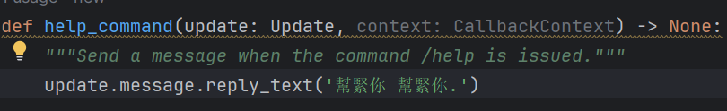

The code above is to define a function when a chatbot receive a special command, the chatbot will reply “幫緊你 幫緊你”

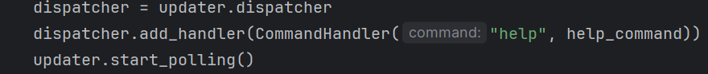

In main function, The updater object has a dispatcher that is used to add handlers to the bot, we can register handlers for handling messages and commands, then “updater.start_polling()” to start the chatbot.

3. Update your code so that when user type /hello Kevin , it will reply Good day, Kevin! . Write down the change you have made. ‘

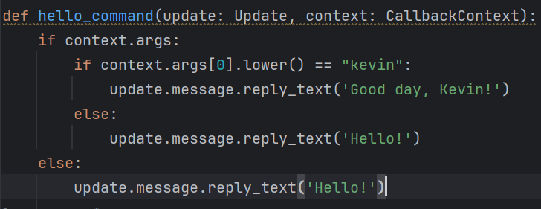



Define a new function called hello and make it can handle args with command /hello and check the args whether is “Kevin”, then add a dispatcher.

4. Make a few screen caps to prove that you have applied your own Redis account, used it in your chatbot, and push the code on GitHub (at least 2 commits - lab3/lab4).

