**Table of contents**

1 Objective and purpose 2

2 How to add a new message in DBC 2

2.1 CAN spec 2

2.2 Update flow 3

2.3 Adding a new value table 4

2.4 Adding a new signal 6

2.5 Adding a new message 7

2.6 Mapping Transmitter ECUs 10

2.7 Mapping Receiver ECUs 11

3 FAQ 13

3.1 Cannot update Init Value of a signal 13

Revision History 15

# Objective and purpose

This document provides the actual practices of adding a new message in CAN communication database (DBC format). It helps new team members to quickly manipulate DBC file, and also could be a reference for old team members if they found issue with DBC update.

# How to add a new message in DBC

## CAN spec

The input for DBC update is CAN spec. For each message – In Suzuki project - you can find 2 tables:

* The first table give information about DLC, message cycle, the transmitter and receiver.

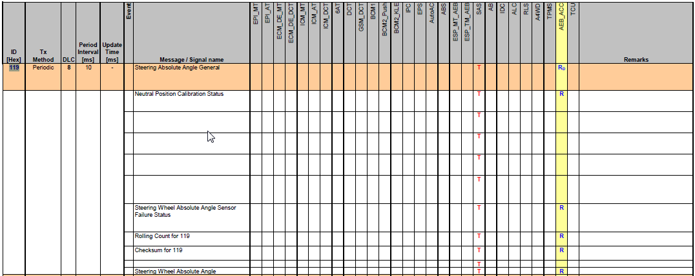

* The second table give details of signals.

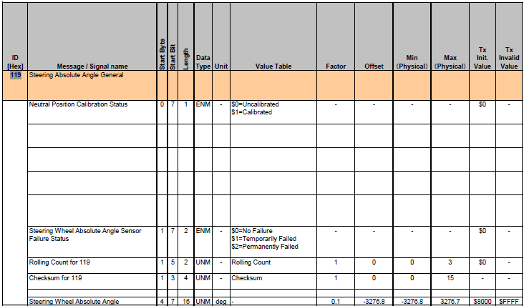

## Update flow

The below diagram show the flow to add 1 new message in DBC file

Add new value tables

(if required)

Add new signals

Add new message

Map the transmitter, receiver

## Adding a new value table

View 🡪 Value Tables or click on the “Value table” button

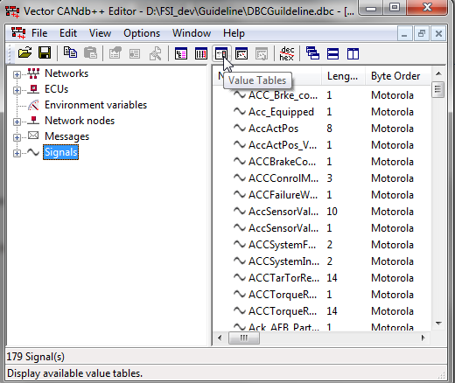

Edit 🡪 New

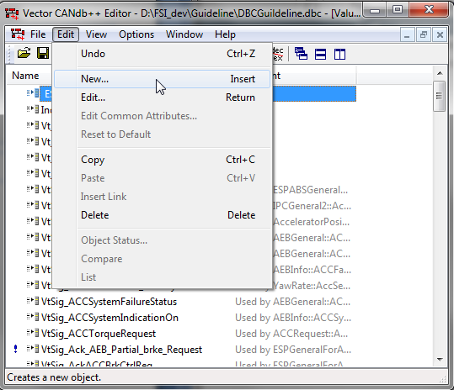

In the Value Table window, provide the Value table Name in tab “Definition”,

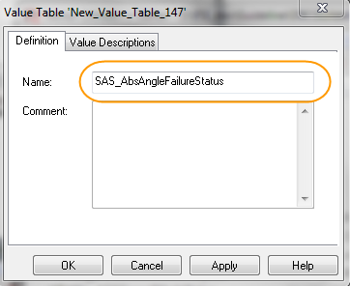

In tab “Value Descriptions”, click “Add” and provide Description for each value (follow the CAN spec)

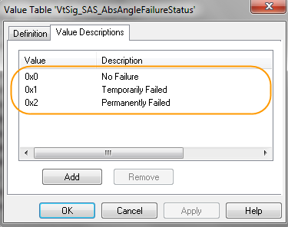

Then click Apply 🡪 OK

If you want to go back to the default View, click View 🡪 Overview or the “Overview” button

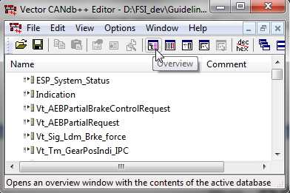

## Adding a new signal

Right click on Signals 🡪 New ...

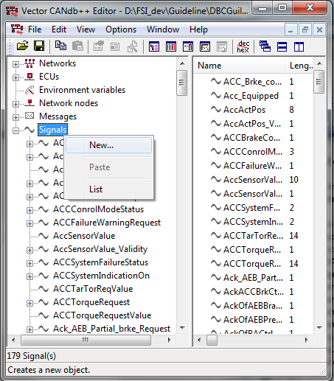

In tab “Definition”, refer the CAN spec to provide all information. For “Value Table”, you can choose the created value table in the list.

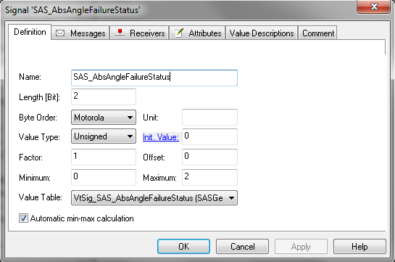

If Value Table is linked correctly, you can see the information in tab “Value Descriptions”

## Adding a new message

Right click on Messages 🡪 New ...

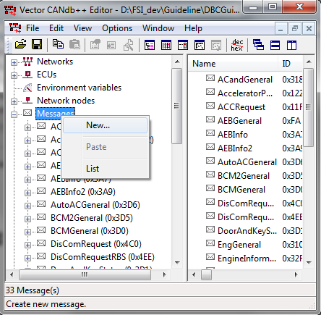

In tab “Definition”, provide the Message Name, Message Type, Message ID and DLC ( all these things are from CAN spec)

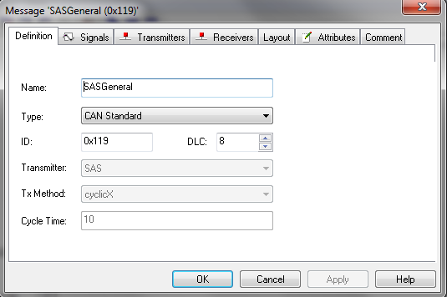

In tab “Attributes”, update the message cycle to GenMsgCycleTime. After clicking “OK”, the message cycle will appear in tab “Cycle Time” of tab “Definition”

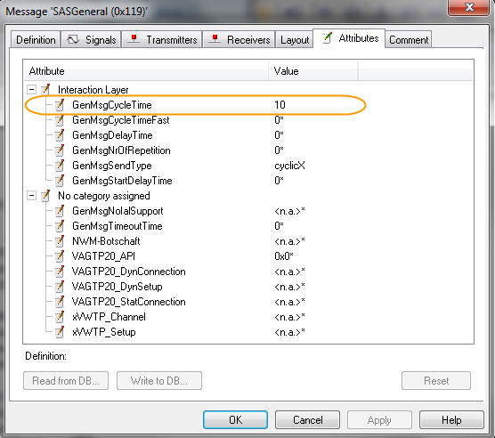

In tab Signals, click “Add” and choose all relevant signals of this message

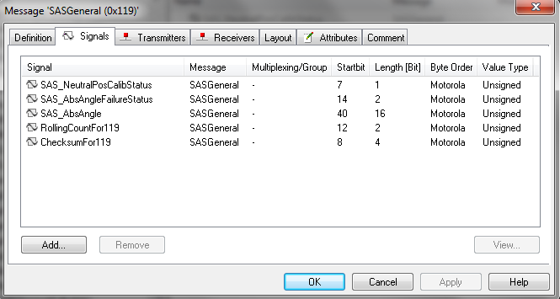

In tab Layout, drag the signals to form the correct message layout.

Please note that for SUZUKI project, start bit is MSB in CAN spec, while it’s LSB in DBC. Then you only need to drag the MSB of the signal to the start bit mentioned in CAN spec, regardless how it displays in DBC file.

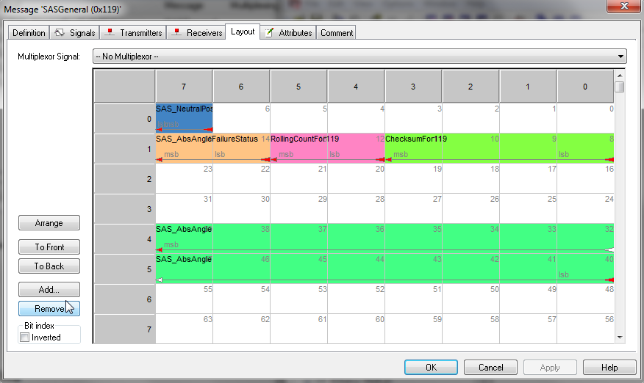

## Mapping Transmitter ECUs

In tab “Transmitters” of Message windows, click “Add”

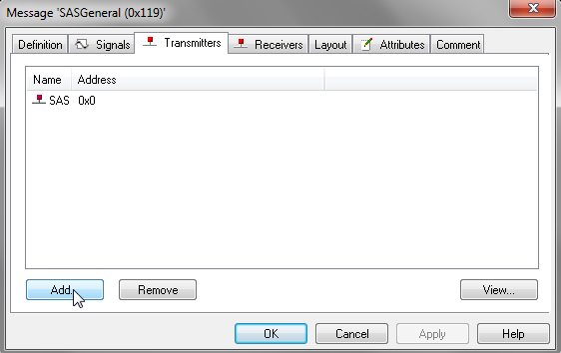

Refer the CAN spec to choose the transmitter ECUs from the list. Then click OK.

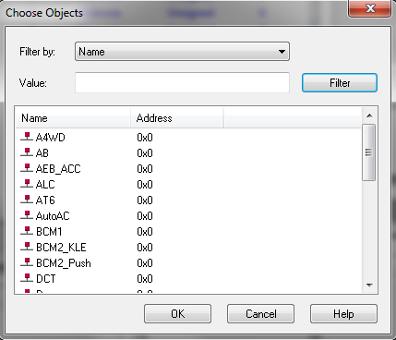

## Mapping Receiver ECUs

You cannot map message and receiver ECU directly because an ECU may only care about some signals in a message. Then you have to map the signals to the receiver ECUs

To map signals to a receiver ECU, first choose the correct ECU in the “Network nodes”. Then Right click 🡪 Edit Node...

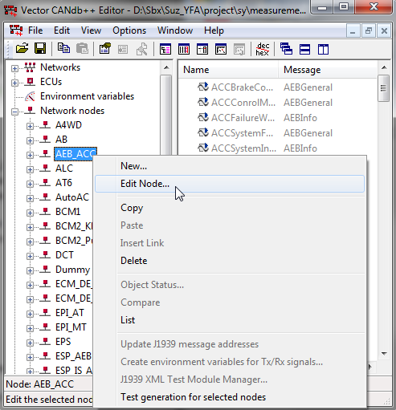

In tab “Mapped Rx Sig”, click “Add”

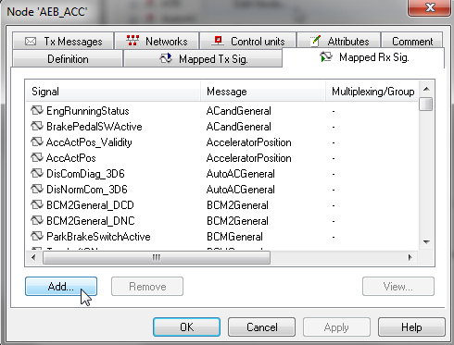

Refer the CAN spec to choose the signals from the list. Then click OK.

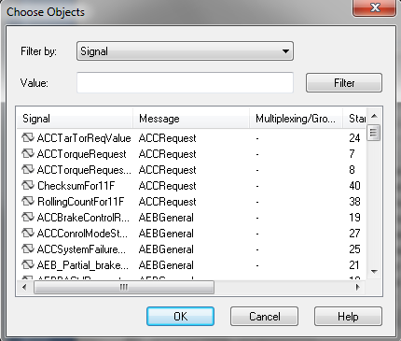

# FAQ

## Cannot update Init Value of a signal

You can face problem when trying to update the Init Value because <GenSigStartValue> attribute is not configured.

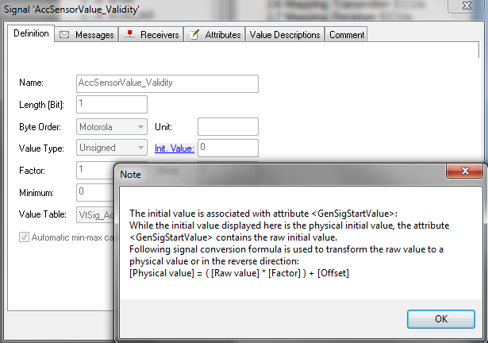

To solve this issue, first switch to the Attribute Definition View by click View 🡪 Attribute Definition

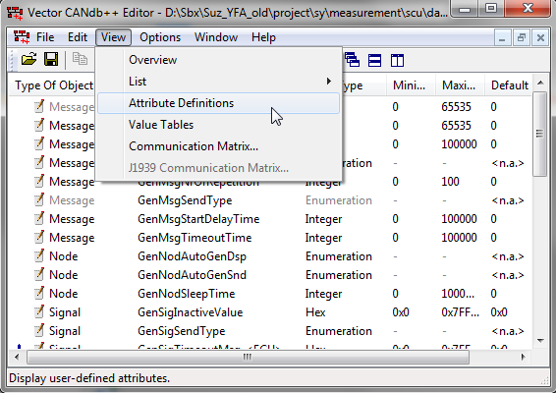

Click Edit 🡪 New

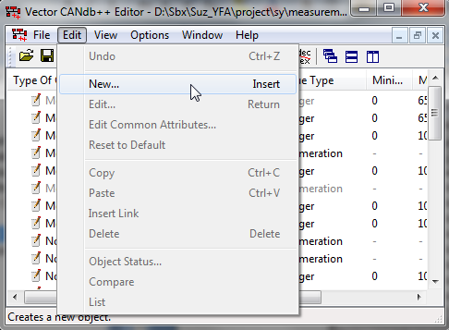

Provide the Attribute Name “GenSigStartValue”, then click OK

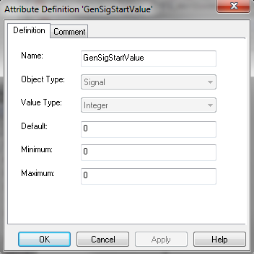

Revision History

|  |  |  |  |
| --- | --- | --- | --- |
| **Issue** | **Date** | **Editor** | **Description of amendment** |
| 1.0 | 1-Dec-2014 | Huynh Mai Phuoc Loc | Initial version |
|  |  |  |  |
|  |  |  |  |