1. **I added different kinds of ants, workers and soilders. Worker ants seek food and carry it back to the nest. Soilder ants wil wander around the nest.**

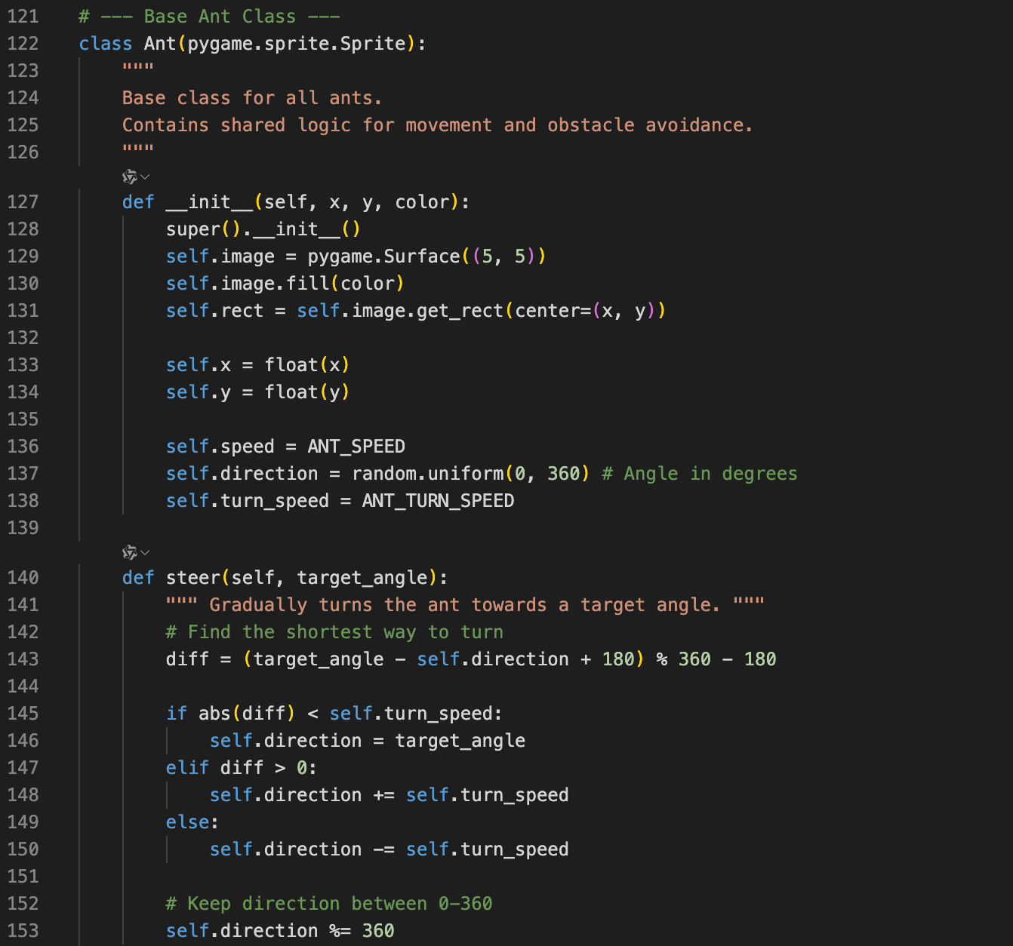

Figure 1. Base ant class(ants behaviors)

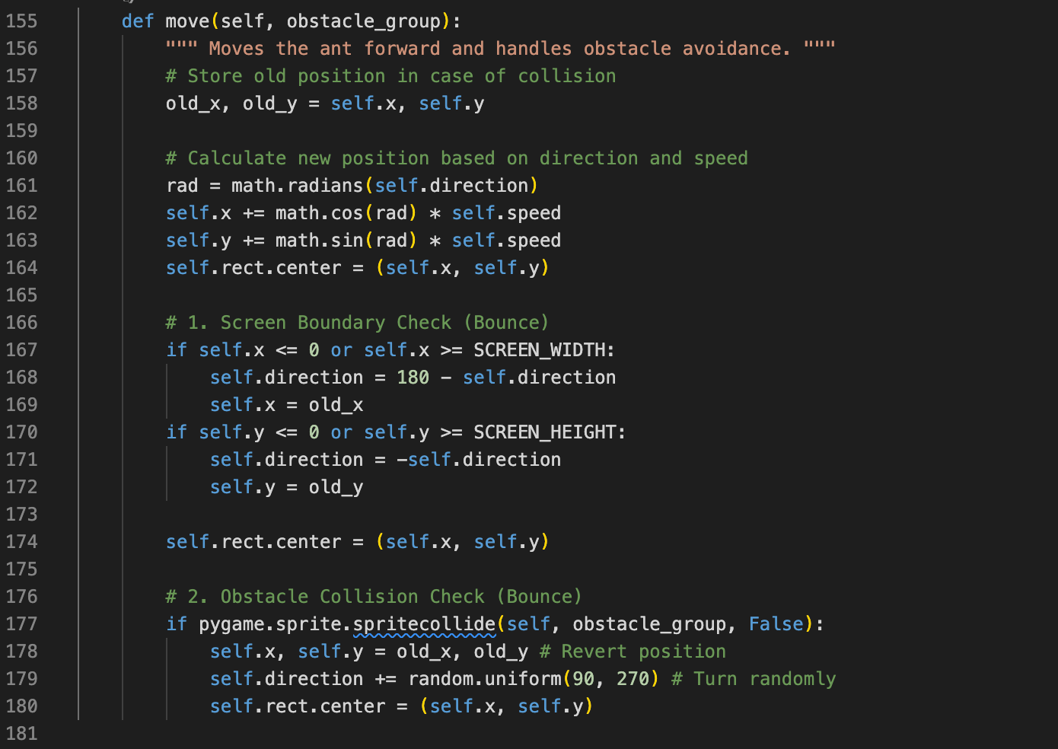

Figure 2. Base ant class(ants behaviors)

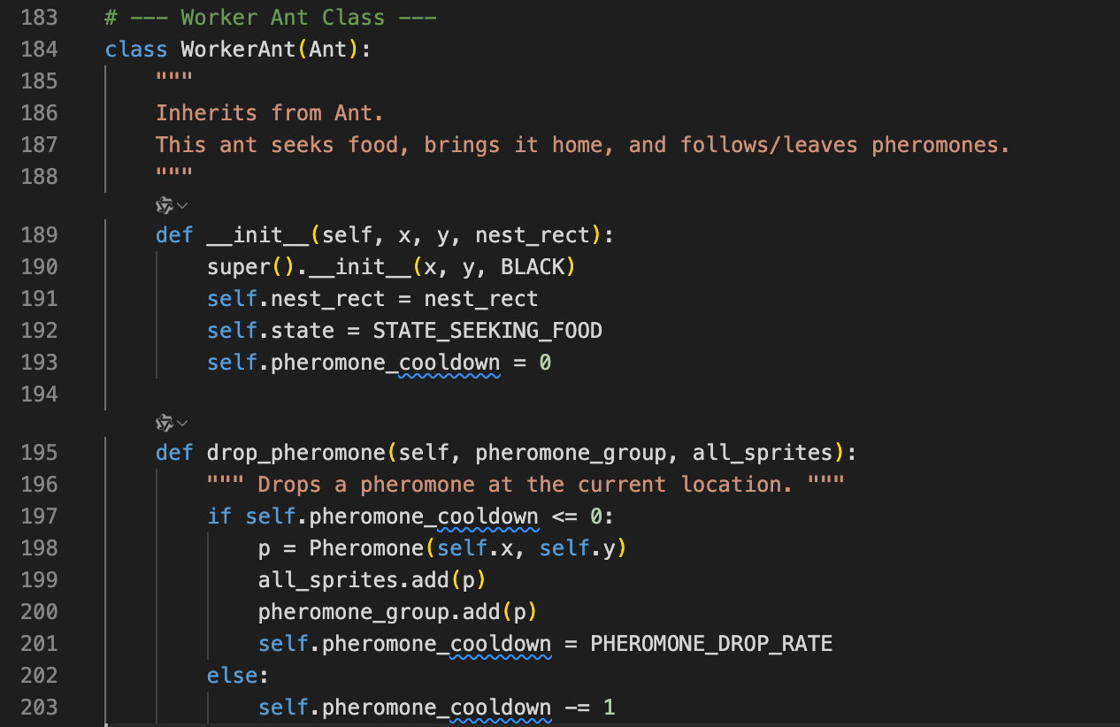

Figure 3. Work ants class

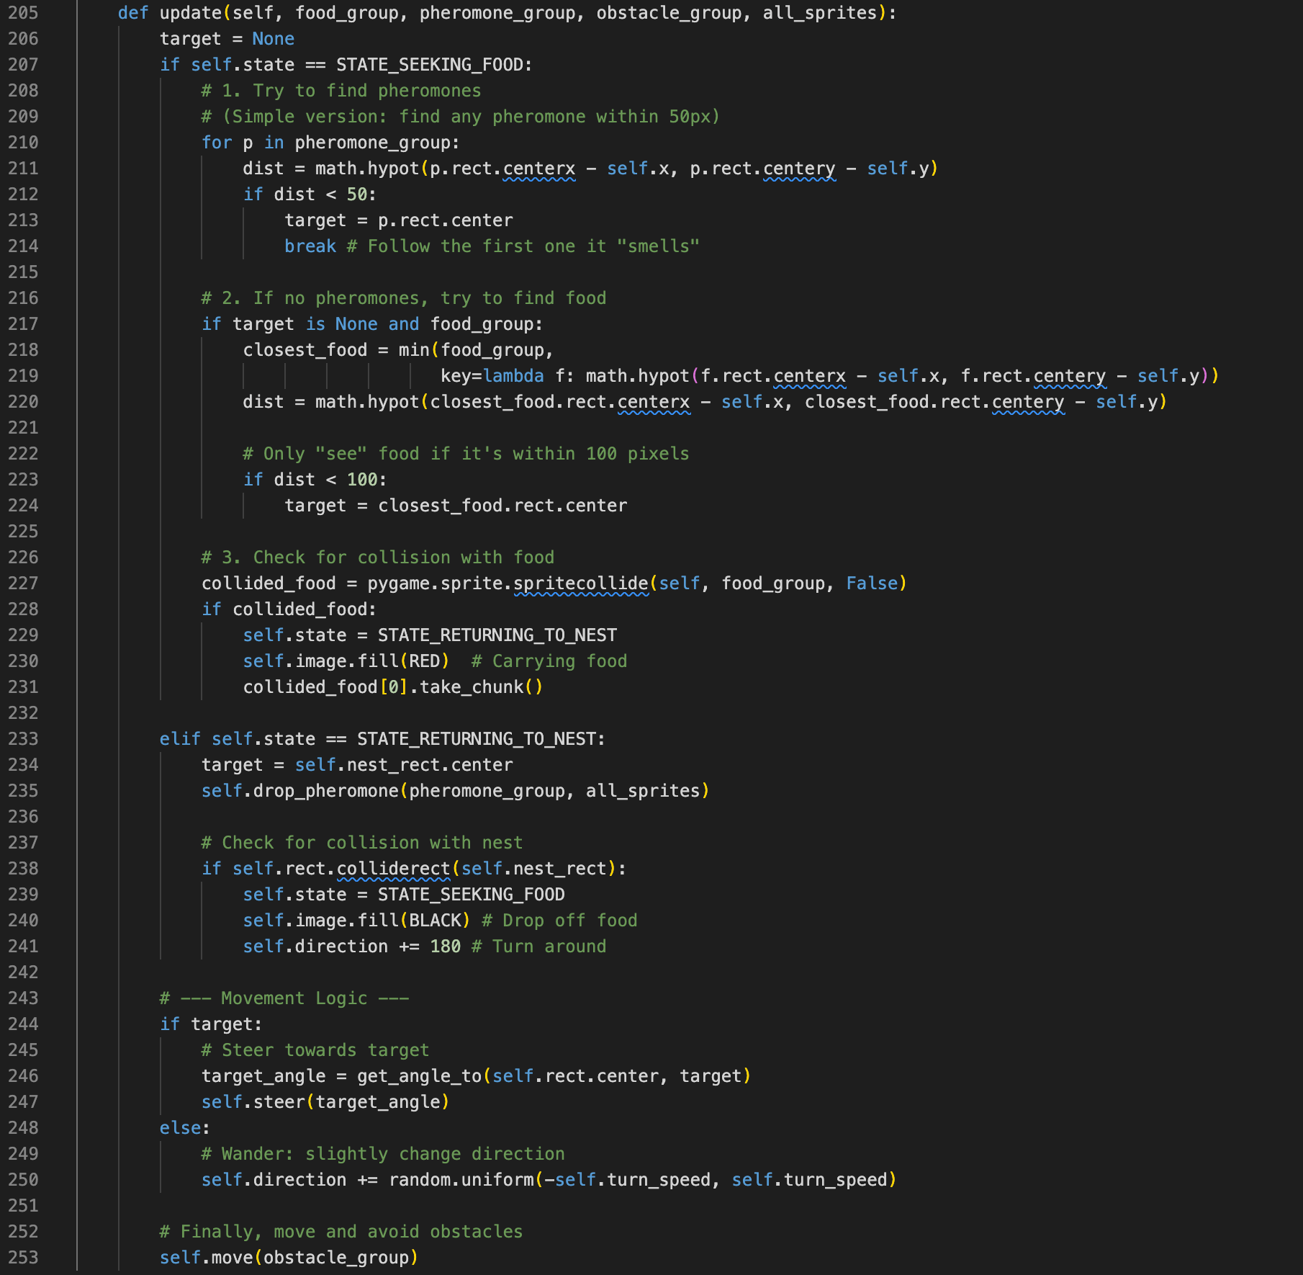

Figure 4. Work ants class

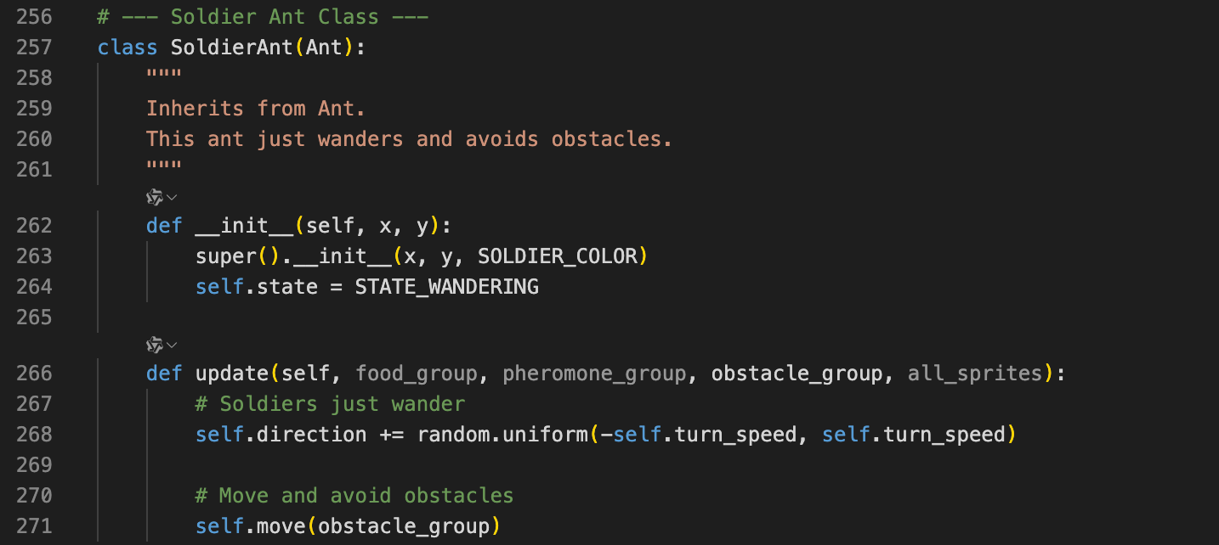

Figure 5. Soilder ants class

1. **I added some food sources which worker ants can seek and carry.**

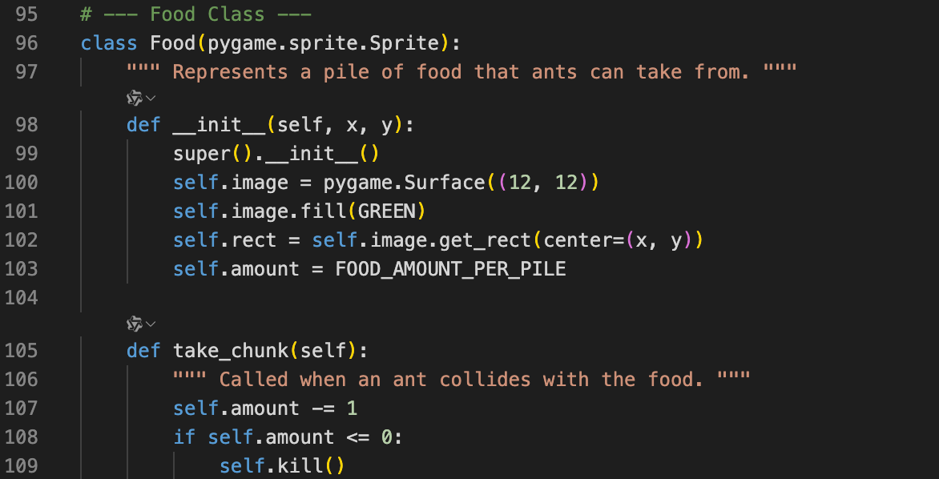

Figure 6. Food class

1. **I create pheromones. When worker ants find food, they leave pheromone trail on their way back to the nest. If other worker ants find this trail, they will follow it to the food. Additionally, the pheromones fade over time and eventually disappear.**

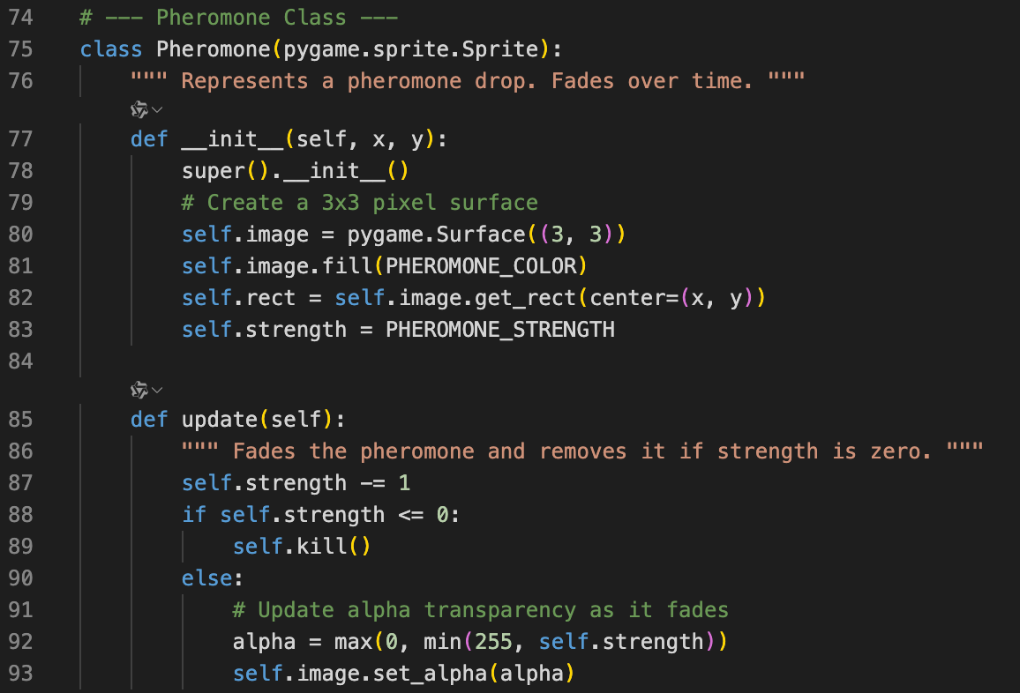

Figure 7. Pheromone class

1. **I also craete some obstacles that ants cannot pass through.**

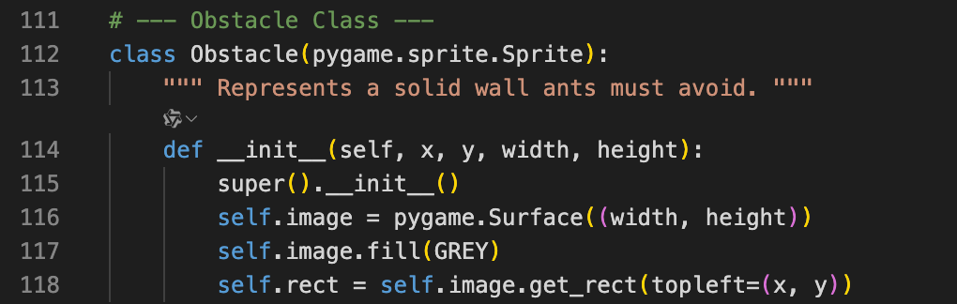

Figure 8. Obstacles class

1. **The final presentation:**

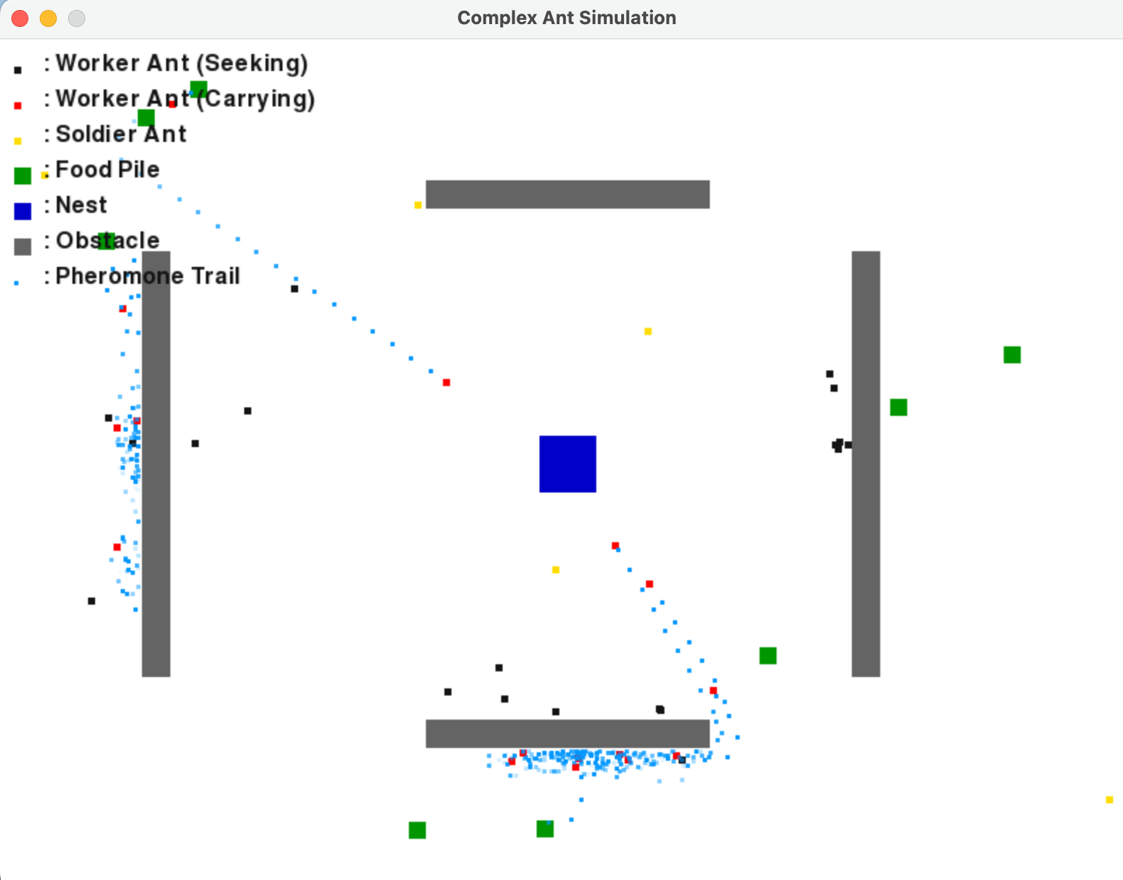

Figure 9. Final presentation