This work involves the recognition of hand signs through the use of a single hand to identify the alphabet. Every letter from A to Z (except J and Z) can be recognized by utilizing the illustration in Figure 2, which shows the landmark positions, and the numbered coordinates provided in Figure 1. The aim of this project is to develop an algorithm capable of recognizing the positions of hand landmarks and accurately identifying the corresponding hand sign.
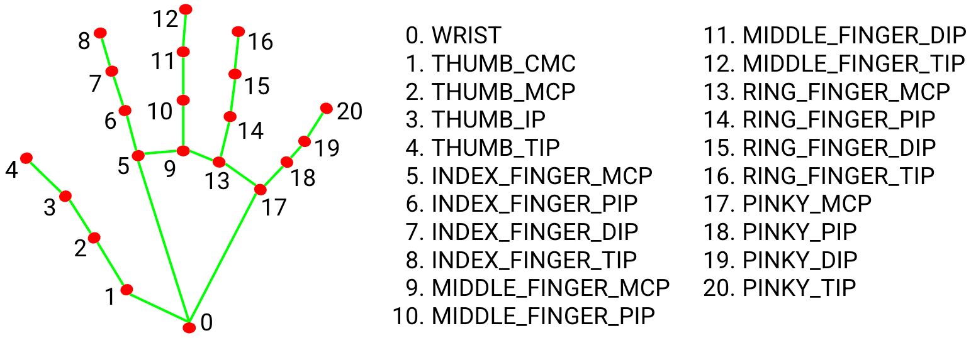

Figure [1]-Landmarks

The Hand Sign Gestures to represent letters is given by the following Figure:

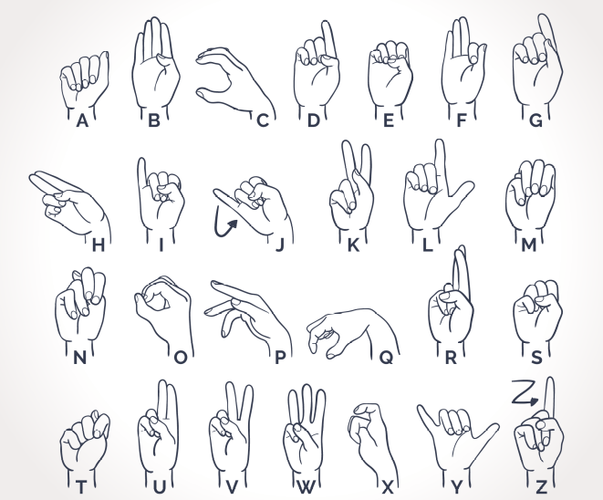
Figure [2]-Hand sign gestures

Representation of the letters from [2] given landmarks of [1], for handsign recognition through the software:

A)
Height: Width:
7>8 4>8
11>12 3>7
15>16 2>6
19>20 2>5
4>3 4>8
2>1 8>12
4>6 12>16
4>10 16>20
4>14
4>18
10>11
14>15
18>19
6>7

B)
Height: Width:
8>7 5>3
12>11 1>4
16>15 3>4
20>19 2>4
12>16
16>8
8>20
7>10
7>14
7>18
4>3
2>1

C)
Height: Width:
4>3 1>2
5>4 2>3
12>8 3>4
11>7 0>1
7>8
6>7
5>6
10>11
0>5
0>9
4>6
4>5
4>14

D)
Height: Width:
11>12 3>4
15>16 5>9
19>20 9>13
8>7 13>17
7>6 8>4
6>4 4>16
11>4 3>4
15>4 2>1
3>2
2>1
1>0
5>4
14>15
10>11
7>6
E)
Height: Width:
7>8 8>4
11>12 4>20
15>16
19>20
8>4
12>4
16>4
20>4

F)
Height: Width:
12>16 4>7
16>20 3>8
18>8 8>9
4>3 12>16
3>2 16>20
2>1 8>12
4>8
4>5
11>7
7>8
12>11
16>15
20>19

G)
Height: Width
11>12 3>12
15>16 12>16
19>20 16>20
8>7 4>12
7>11
4>11
4>15
4>20
6>5
7>6
10>4
4>5

H)
Height: Width:

8>12
7>11 0>5
10>6 0>9
16>20 0>13
4>16 0>17
5>9 16>4
16>20 5>4
12>11 20>10
11>10 16>10
8>7
7>6
6>5

I)

Height: Width:
20>19 8>12
15>16 12>16
11>12 16>20
3>8 8>4
4>8 4>16
4>12 5>4
4>16 4>0
12>0

K)

Height: Width:
12>8 8>4
14>18 7>4
15>16 6>4
19>20 4>14
15>16 4>12
19>20
4>14
4>5
5>15
5>19
8>7
7>6
6>5
12>11
11>10

L)
Height: Width
8>7 1>5
6>5 9>13
4>3 13>17
2>1 5>9
1>0 4>3
11>12 3>2
15>16 2>1
19>20 2>5
5>4
14>4
7>6
3>2
10>11
14>15
18>19

M)
Height: Width:
14>4 16>4
14>18 8>4
6>7 14>4
7>8 8>12
10>4 12>16
14>4 16>20
6>4 6>10
11>12 10>14
14>15 14>18
15>16
18>19
19>20
18>20
8>20
12>20
4>18
16>20

N)
Height Width
4>14 12>4
14>18 8>4
10>6 10>4
6>7 4>14
7>8 8>12
10>11 12>16
11>12 16>20
14>15 6>10
15>16 10>14
18>19 14>18
19>20
12>8
8>16
4>10

O)
Height: Width:
7>8 5>6
7>4 6>7
6>7 7>8
5>0 8>4
1>0 0>1
4>3
3>2
1>0

P)
Height: Width:
8>7 5>4
7>6 4>6
6>5 4>10
6>10 4>16
10>14 0>5
15>16 0>9
5>9 0>13
9>13 0>17
13>17
4>14

Q)

Height: Width:
6>7 1>2
7>8 2>3
5>6 3>4
3>4 5>6
2>3 9>10
1>2 13>14
0>17 17>18
5>1 0>1
10>6

R)

Height: Width:
12>8 12>8
8>7 12>4
12>11 8>4
14>4 4>20
4>16
4>20
6>4
10>4
19>20
15>16

S)
Height: Width:
4>11 4>14
4>15 10>14
4>18 14>18
14>18 4>0
10>6 6>4
6>14
4>1
18>19
14>15
10>11
7>8
6>7

T)
Height: Width:
4>3 6>4
2>1 4>10
4>6 10>14
4>10 14>18
4>14
4>18
10>11
14>15
18>19
6>7

U)
Height: Width
12>11 9>4
11>10 16>4
10>9 2>8
15>16 8>12
19>20 9>14
8>7 14>18
4>15 5>8
4>19
6>5
7>6

V)
Height: Width
12>11 9>4
11>10 16>4
10>9 9>12
15>16 8>12
19>20 9>14
8>7 14>18
4>15 8>5
4>19
6>5
7>6

W)
Height: Width
12>11 9>4
11>10 4>16
10>9 8>2
16>15 8>12
19>20 9>14
8>7 14>18
14>13
4>19
6>5
7>6

X)
Height: Width:
8>7 0>1
6>5 1>2
10>2 2>3
5>9 6>7
9>13 7>8
13>17 10>11
17>12 5>9
8>12 9>13
12>16 13>17
12>20
8>10

Y)
Height: Width:
6>4 4>3
4>3 3>2
3>2 2>1
2>1 1>8
20>19 8>12
19>18 12>16
18>17 16>20
7>8 0>20
11>12
15>16
5>8
13>15
9>11

Symbols

Additionally we implemented two hand operation recogtion to represent certain symbols with both hands or indications

In this example we used 2 Hands to represent a symbol(Heart):


Figure 3-hearth representation

Symbol <3:

Right Hand
Height: Width:
7>8 4>3
6>7 3>2
6>5 2>1
11>2 1>0
10>9 5>1
15>16 9>1
14>15 13>1
14>13 17>1
19>20
18>19
18>17
0>4

Left Hand
Height: Width:
7>8 3>4
6>7 2>3
6>5 1>2
11>2 0>1
10>9 1>5
15>16 1>9
14>15 1>13
14>13 1>17
19>20
18>19
18>17
0>4

References:

[1]https://github.com/google-ai-edge/mediapipe/blob/master/docs/solutions/hands.md

[2] https://www.freepik.es/vector-gratis/alfabeto-lenguaje-signos-dibujado-mano_2611759.htm#query=lengua%20signos%20manos&position=1&from_view=keyword&track=ais_user&uuid=2baad9c3-a9d3-4358-9319-bbc4d44e12af
https://www.printablee.com/post_sign-language-numbers-1-100-chart-printables_313728/

[3]https://www.google.com/url?sa=i&url=https%3A%2F%2Femojiterra.com%2Fes%2Fmanos-formando-un-corazon-tono-de-piel-claro%2F&psig=AOvVaw2209vOE0c--p3iJO5s7Mnh&ust=1718437563007000&source=images&cd=vfe&opi=89978449&ved=0CBEQjRxqFwoTCMDLttbT2oYDFQAAAAAdAAAAABAp

