WEEK 13 SUBMISSION DOCUMENTATION

Community Service
Hours Tracker
Advanced Automation and Scripting
Student Name | Mark Albert A. Blanco
Course / Section | BSIT 3B

1. Project Overview
The Community Service Hours Tracker is a web application for managing community-service activities, student reservations, and submitted service hours. Students can view activities, reserve an available activity, and submit completed hours. Administrators can manage activities and review submitted service hours.
Technologies: Flutter Web, Dart, Laravel, PHP, MySQL/MariaDB, and Laravel Sanctum authentication.
Week 13 focus: A bounded reservation automation workflow with retry handling, recovery, and structured logs.

2. Automation Workflow Boundary and Trigger
Trigger: a signed-in student selects an available activity and presses the Reserve button. The automation covers validation, sending the reservation request, limited retry of temporary failures, and recording the final outcome. It does not automatically approve service hours or create activities.
Step | Action
1. Trigger | Student presses Reserve Activity.
2. Validate | Check authentication, activity ID, request key, duplicate reservation, activity status, and capacity.
3. Send request | Flutter sends the reservation request to the Laravel API with one UUID request key.
4. Retry decision | Retry temporary network/server failures only, up to three attempts. Reuse the same UUID.
5. Finish | Record success, recovered retry, or a permanent failure; show the corresponding result in the UI.

Retry boundary: maximum 3 attempts. Temporary statuses considered by the Flutter client: 429, 502, 503, and 504, plus timeout and connection exceptions. Validation, authorization, and business-rule errors should stop without retry.

3. Flutter Web Screen Flow and UI States
Screen / State | Expected behavior
Login | User enters credentials; invalid credentials show an error.
Dashboard / Activity List | Show activities; show an empty state when there are no activities.
Reservation Loading | Show progress while the reservation request is being processed.
Reservation Success | Show confirmation and the reservation details.
Validation / Authorization Error | Explain invalid input or that the user is not allowed to reserve.
Network / Server Error | Show a safe error message; temporary failures may retry within the limit.
Service Hours | Student submits hours; administrator reviews and approves or rejects them.

4. Bounded Automation and Structured Logs
The reservation client limits retries to three attempts and reuses the same request UUID to reduce the risk of duplicate reservations. The Laravel API validates the request, checks the activity capacity inside a database transaction, and records automation events in the automation_logs table.
Log outcome | Meaning
success | Reservation completed on the first attempt.
recovered | A retry or safe replay reached an existing/successful reservation.
failed | A temporary failure occurred and another attempt is allowed.
permanent_failure | The request must stop, such as after the retry limit or a non-retryable error.

Test evidence status: The backend PHP syntax check and Laravel cache-clear command were shown as successful. A normal reservation success is present in the database log screenshot. The required recovered transient-failure and routed permanent-failure scenarios still need their actual test run and log screenshots before they can be marked complete.

5. Test Results Record
Test | Expected result | Actual result / status
Normal reservation | Reservation is created; success log is recorded. | Success was shown in the existing automation log screenshot.
Temporary failure and recovery | First attempt fails temporarily; a later attempt succeeds and is logged as recovered. | Pending verification.
Permanent failure | Retry stops after the defined limit; permanent failure is logged. | Pending verification.
Flutter Web run and UI states | Browser run and applicable loading, success, empty, validation, authorization, network, and server-error states are checked. | Record test screenshots and actual results.

6. Week 13 Evidence Index
Use descriptive filenames. Add the actual screenshot, log export, repository link, or test record in the location column. Do not mark an item complete until the evidence is captured and checked.
Evidence item | Suggested filename / location | Status
Current repository and commit | GitHub repository URL; commit hash or tag | To add
Flutter Web browser run | W13_01_flutter_web_run.png | Login and administrator dashboard screenshots included in Appendix A (Figures 1–2).
Successful reservation | W13_02_reservation_success.png | Student reservation screenshot included in Appendix A (Figure 3); existing success log shown in Figure 6.
Recovered transient failure | W13_03_retry_recovery.png and matching log output | Pending. None of the supplied screenshots shows a temporary failure followed by successful recovery.
Permanent failure routing | W13_04_permanent_failure.png and matching log output | Pending. None of the supplied screenshots shows three failed attempts and permanent-failure routing.
Structured automation logs | W13_05_automation_logs.txt or screenshot | Partial. Database schema and existing first-attempt success entries are shown in Appendix A (Figures 5–6). Retry/failure log evidence remains pending.
Screen flow and workflow | This document, Sections 2–3 | Included
Individual contribution | Section 7 below | Complete after filling details

7. Individual Contribution Note
I contributed to the Community Service Hours Tracker by working on the Flutter Web frontend and Laravel backend integration. My work included connecting the application to the API, supporting the student reservation workflow, and implementing bounded retry handling and structured reservation logging. I also helped prepare the Week 13 workflow, screen-flow, and testing evidence. I will identify the exact files and tasks I personally completed in the final contribution record.

8. Final Submission Checks
• Flutter Web runs in the supported browser using documented commands. | • The required workflow reaches the Laravel backend API.
• Client and server validation behave consistently. | • Applicable loading, success, empty, validation, authorization, network, and server-error states are checked.
• At least one adverse case and the required recovery or safe failure are demonstrated. | • The submitted Git commit or tag matches the evidence.
• Evidence files have descriptive names; expected and actual results are recorded. | • Logs, requests, and screenshots identify the tested build and environment.
• Limitations are stated; the project is not described as production-ready without proof. | • No live credentials, secrets, tokens, private keys, or unapproved personal data are included.
• Every group member can explain the work listed in their contribution record. | • No test result, log, citation, or screenshot is fabricated or misleadingly changed.
• After upload, reopen the submission, verify the files and repository access, and preserve the confirmation.

Appendix A. Screenshot Evidence
Six representative screenshots are selected from the 46 screenshots shared during development. They document the application screens, reservation/service-hour workflow, database structure, and backend checks. Repeated setup/code captures and temporary blank/error screens are not used as proof of successful tests.
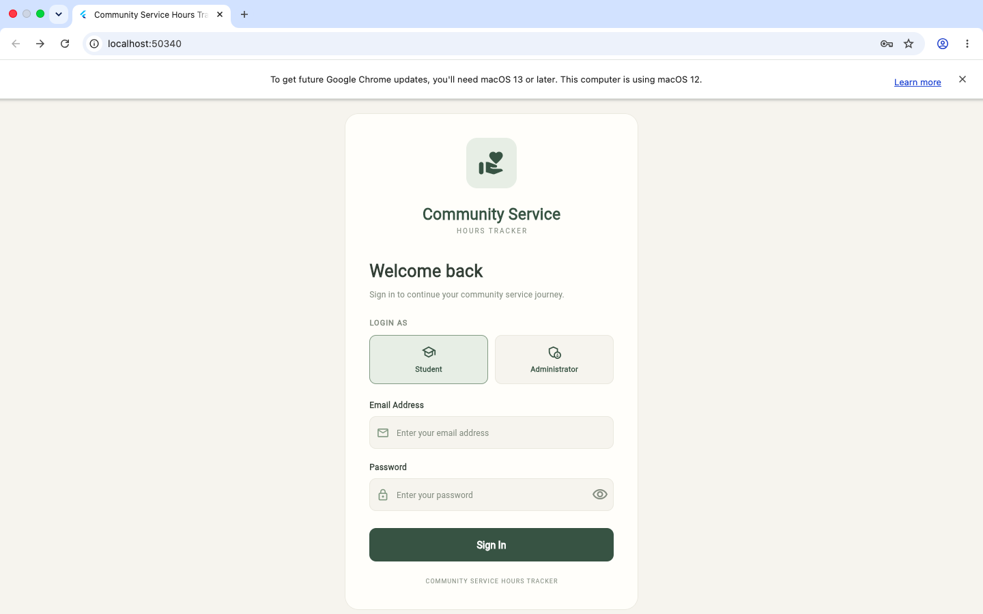
Figure 1. Flutter Web login screen with Student and Administrator role selection.
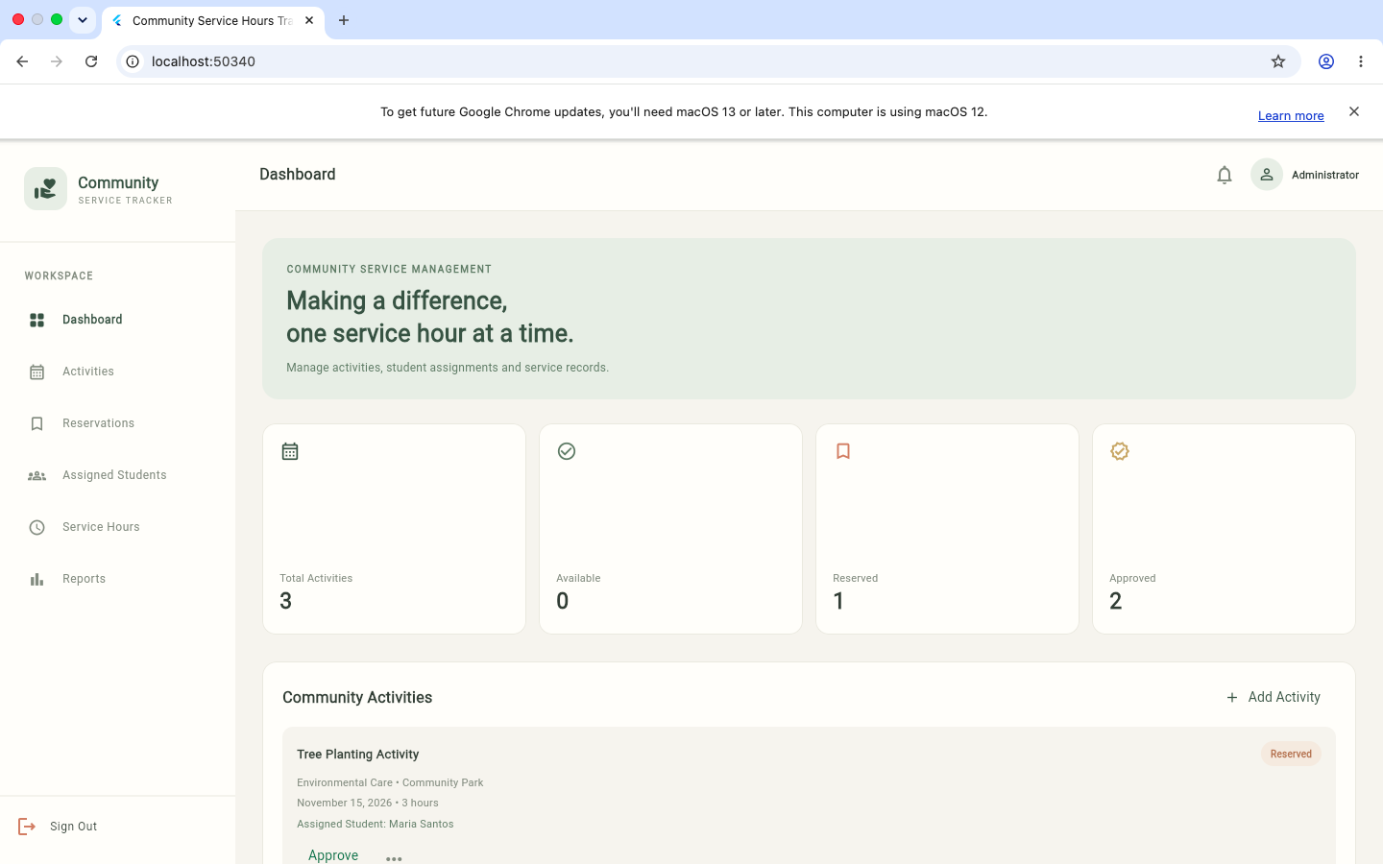
Figure 2. Administrator dashboard showing activity-management navigation and activity summary.

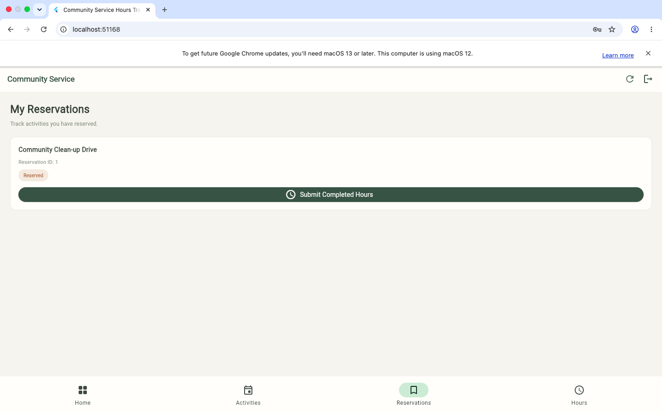
Figure 3. Student My Reservations screen showing Community Clean-up Drive with Reserved status.
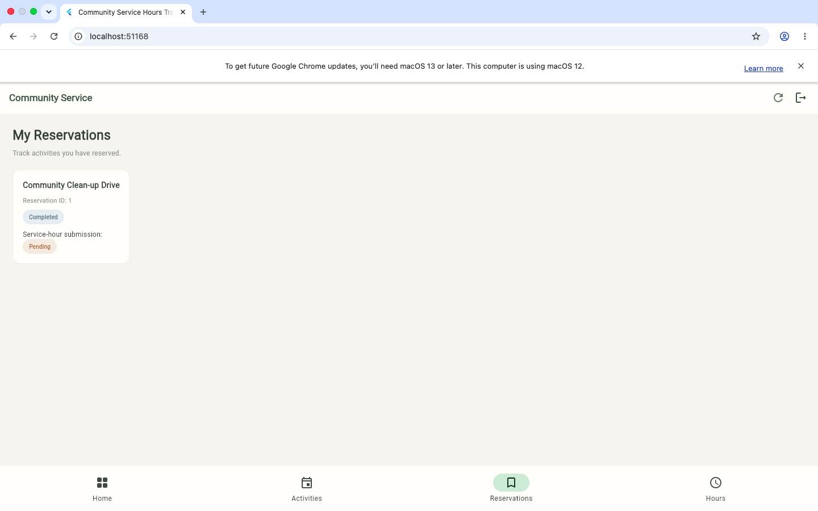
Figure 4. Student reservation after service-hour submission: reservation Completed and service-hour review Pending.

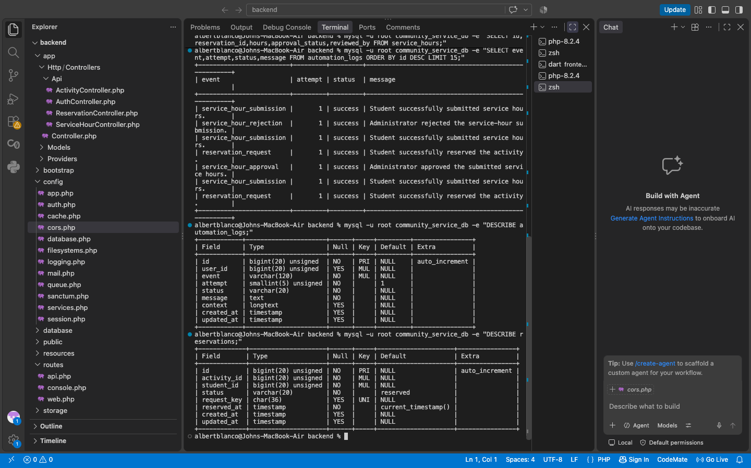
Figure 5. MySQL table structure for automation_logs and reservations, including the unique UUID request_key.
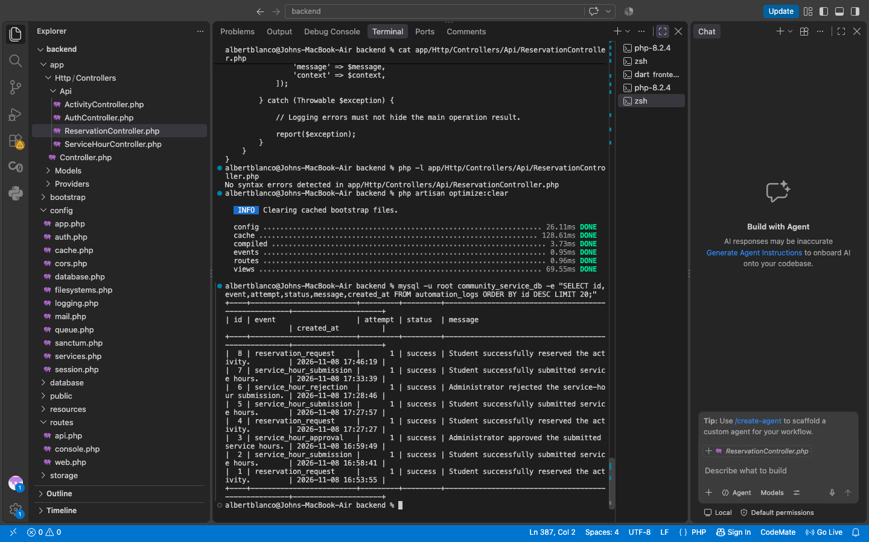
Figure 6. Backend verification: PHP syntax check, Laravel cache clear, and existing automation log entries showing first-attempt successes.

