**Look & Feel 8th future generation**

**General Look 8th**

The 8th generation differs from the previous generation thanks to cleaner and more real 3d graphics. We now have a more realistic and immersive world also thanks to the new VR and AR technologies.

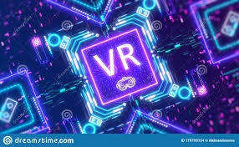  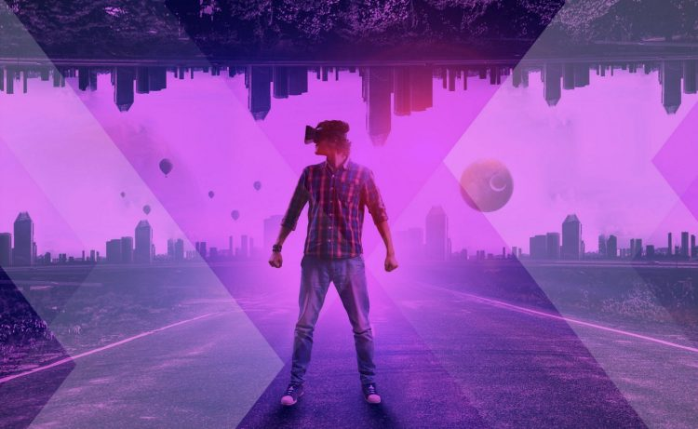

The images and the feel is more smooth and clean. The colors should be bright.

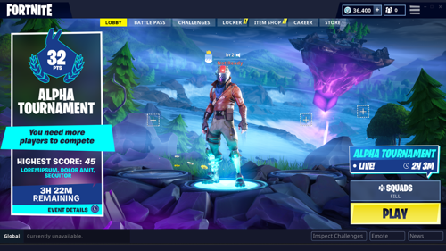 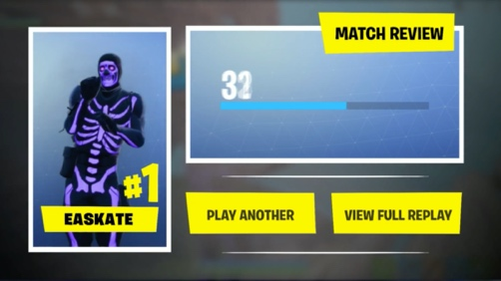

**Font: Futura**

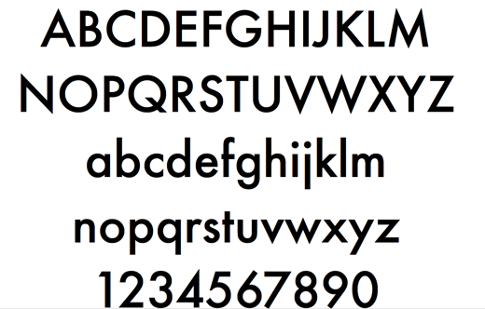

**General Look Future**

The future generation is going to be innovative and powerful creating more realistic world. We can think about it as a futuristic technology.

 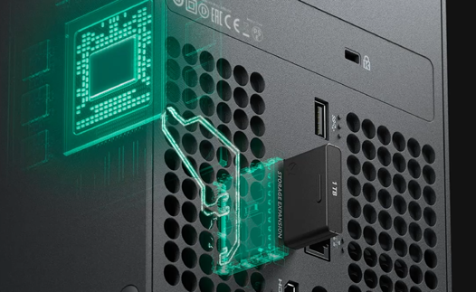

I suggest the use of “neon” color (they remind the upcoming Cyberpunk 2077)

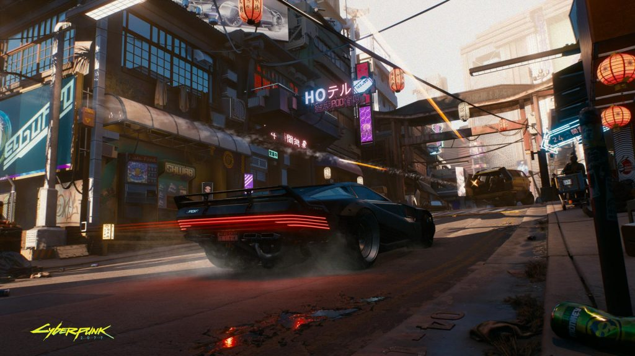 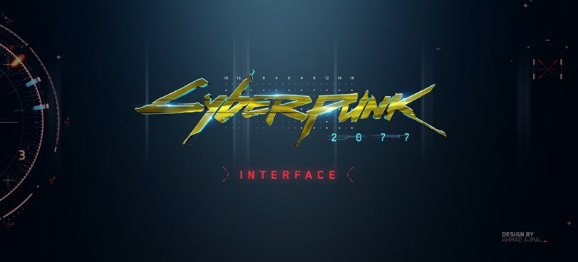

**Font: Good Times (**https://www.1001fonts.com/good-times-font.html**)**

