Jmol 11.1 Perspective/Navigation Model (rev.06.12.21)

Bob Hanson, hansonr@stolaf.edu
12/21/2006

Jmol 11.1 introduces the possibility of scripted navigation through a model. In order to achieve this effect, changes were necessary to the underlying perspective model of Jmol 10.2/11.0. For backward compatibility, the default perspective model in Jmol 11.1 is still that of 10.2, but issuing of either of the following commands initiates use of the more flexible 11.1 model. “Jmol” in discussions below refer to Jmol 11.1 specifically. The 10.2 model was written by Miguel Howard; the 11.1 model was written by Bob Hanson.

set navigationMode
set perspectiveStyle 11

Jmol Coordinate Transformation

Jmol applies perspective as the final step in the transformation of 3D molecular coordinates (xyz) to 2D screen coordinates (XY) and an associated standard z-buffer value (Z, with 1 being nearest the observer and infinity being far away from the observer). All coordinates in Jmol are Java float values, but there are times when integers are used instead. In discussions below, (m) or (xyz) indicates molecular coordinates; (s) or (XYZ) refers to screen coordinates (0,0 in upper left corner, Z increasing away from the user); and (p) refers to vertical plane number, which is linearly related to Z as described below.
The overall transformation is carried out in two steps, one involving a matrix, matrixTransform, and one involving a function, getPerspectiveFactor() according to the following steps:

1a) translate the fixed rotation center to (0,0,0) (m)
1b) apply the current molecular rotation (m)
1c) apply zoom-based scaling, scalePixelsPerAngstrom (s)
1d) add a Z-translation, modelCenterOffset (s)

2a) if a Z value is undefined or less than 1, set it equal to 1
2b) translate the center of perspective to (0,0) (s)
2c) apply a perspective factor to X and Y based on the value of Z. For low to moderate Z
values, this is just:

X *= perspectiveScale / Z;
Y *= perspectiveScale / Z;

(For extraordinarily high zoom levels, there may be some additional scaling.)
2d) move the center of perspective to the appropriate XY screen position.

The perspectiveScale parameter is constant. Thus, the perspective “function” is contained in the value of Z. Its calculation is the subject of this summary.
Zoom is taken into account as a factor in scalePixelsPerAngstrom. (In Jmol 10.2 this quantity was also dependent upon the “camera depth”, but that association has been removed in Jmol 11.1.)
Because Jmol must scale properly for different screen sizes, it is convenient to define measurements in multiples of screenPixelCounts. The Jmol model defines the screenPixelCount as two less than either the height or the width of the screen in pixels, determined as follows: If the default set zoomLarge is in effect, then the larger dimension of height and width is used; if the user/developer has issued set zoomLarge FALSE, then the smaller of the two is used. Thus, for a 400-wide by 300-high applet, by default screenPixelCount = 398. The designation (p) for units in the following discussion implies that the quantity is measured by taking screen pixels and dividing by screenPixelCount, thus making it general to any screen size.

The Jmol Perspective Model

The Jmol perspective model is most easily described in terms of a perspective diagram (Figure 1) in which the vertical axis represents 1/f, where f is the perspective factor applied to a given point (perspectiveScale / Z), and the horizontal axis is an X or Y screen coordinate. The horizontal center of the diagram is 0, the center of perspective.
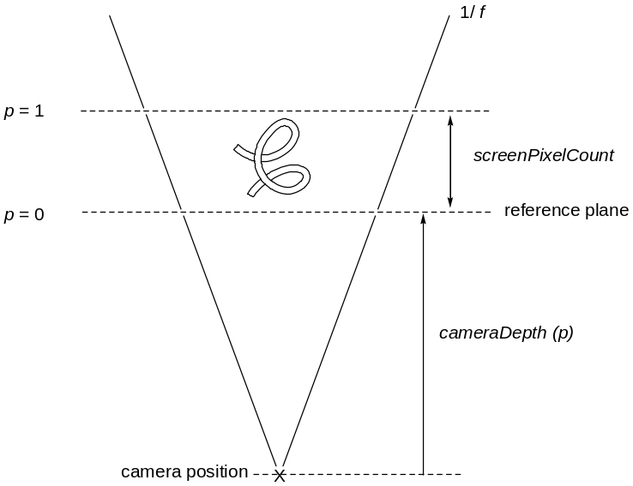

Figure 1. Jmol linear perspective model. 1/f increases
with distance from the user.
The easiest way to think about it is that you are omnisciently looking DOWN from the top of the model. The horizontal distance between the diagonal lines in all cases represents the actual screen width – items near the rear will be compressed to fit this number of pixels; items near the front will be stretched. This produces the illusion of depth.

In Jmol, the function f is given by:

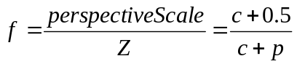

where c is the “cameraDepth” (p), and p is the Z-position of the point relative to a reference plane situated just in front of the model when the default zoom of 100% is applied. Note that by this definition, 1 / f is linearly related to p, increasing with increasing distance from the user; thus the linear V-shaped diagram. Note that the quantity “c + 0.5” is a measure of the distance from the camera to the center of the model, where p is 0.5. The perspective factor at this position is 1; a flat model will appear the same in Jmol with or without perspective set (using set perspectiveDepth TRUE/FALSE). The default value for cameraDepth in Jmol is 3.0, but much smaller camera depths, around 0.5, may be useful. This value can be set using set cameraDepth x.x, where x.x is the desired depth in multiples of screenPixelCount.
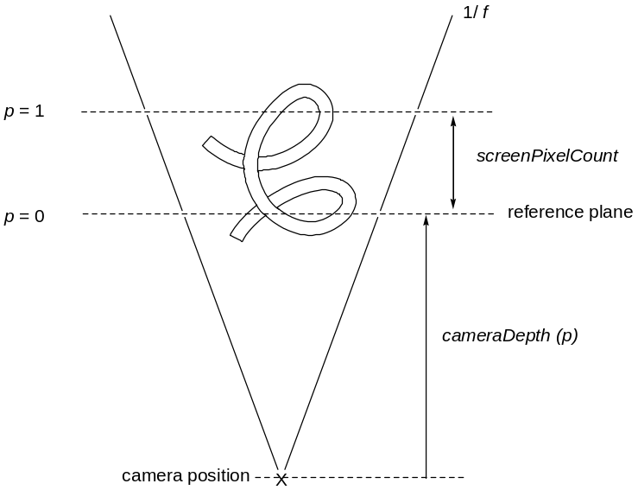

Figure 2. With zoomPercent = 200, the model has
the same center but is twice as large in all dimensions.
Zoom

Zoom in Jmol is simply applied by keeping the center of the model in place and making the model larger (Figure 2). The default 100% zoom setting determines the default scale based on the nominal rotationRadius (m) of the model. This is the smallest radius in molecular coordinates that perfectly contains the entire model. The idea is simply that for any given model, “zoom 100” should display the model in such a way that it is as big as it can be without overflowing the screen no matter how the user rotates it. Thus we have in general:

scalePixelsPerAngstrom
= zoom * screenPixelCount /
(2 * rotationRadius)

Navigation

The above simple model handles most needs for perspective. Late in 2006 Charles Xie, working on a project with the Concord Consortium, suggested that Jmol be extended in such a way as to allow more dramatic “fly-throughs” of molecular systems. One might, for example, navigate through a nanotube, zip through the core of an alpha helix, or ride the wave of a beta-pleated sheet. The result of that collaboration is given below. It involves the addition of several additional components to the model (Figure 3), namely:

visualRange (m) A parameter defining the minimum distance across the screen, in Angstroms, for objects in a given Z-plane to be displayed. The idea is that the difference between navigating through a molecule and looking at it through a telescope is that when navigating you are in front of part of the model, while with a telescope there would be problems with atoms very “near” the user eclipsing others further away. We need navigation, not telescoping. This parameter defines a specific plane with position observerOffset (s).

navigationCenter (m) and navigationOffset (s) The position in molecular (xyz) and equivalent screen (XYZ) coordinates for the point in space corresponding to the user. While X and Y screen coordinates may be set by the user, the Z coordinate of this point is always set to be at observerOffset (s). Thus, the navigationOffset point is in the plane defined by visualRange.
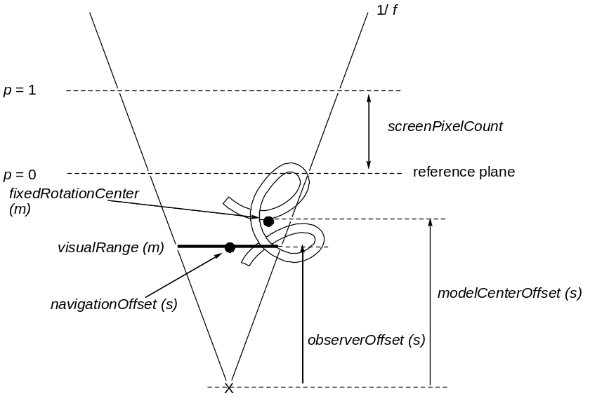

Figure 3. The Jmol navigation model includes a clipping
plane defined by visualRange (m), an observer-based
navigationCenter (m), and an adjustable modelCenterOffset (s).
modelCenterOffset (s) In order to give the appearance of the model rotating around the observer even though it is really being transformed in relation to the fixedRotationCenter (m), the key to navigation is that the Z-position of the fixedRotationOffset (s) is adjustable. This is accomplished in Jmol by allowing the modelCenterOffset to be changed in response to navigation. If the user scans to the right, the model in response rotates counter-clockwise (as seen from the top), and translations are applied to keep the navigationCenter at its current navigationOffset position. In addition, the user can control the XY coordinates of the navigationOffset by pressing SHIFT while using the arrow keys.
In typical navigation through the model, the only actual change is in the position, orientation, and scale of the model itself. On this diagram, the position of the visualRange plane and the navigationOffset do not change. To accomplish this, as navigation or any other operation occurs (such as user manipulation of the structure using the mouse), the underlying molecular coordinates of the navigationCenter are continually adjusted.

Zoom and Clipping In Relation to Navigation

Two potential problems with this navigation model arise. The first is that the model will be prematurely clipped as it is moved forward. This is particularly possible when a very small cameraDepth is used, for example 0.5. To avoid this situation, user action intended to “move in” must be managed so as to sometimes effect zooming (when the model is far away from the user) and sometimes effect adjustment of modelCenterOffset (when the model is close.) This operation is not apparent to the user.
A second problem is illustrated in Figure 4. When modelCenterOffset is zero, and the fixedRotationCenter coincides with the camera position, then zoom has no effect. Essentially, the rearward movement of objects due to zooming perfectly compensates for the additional arc size, and the same scene is rendered. And when the model center is beyond the camera position, then attempted zooming only results in the model appearing smaller. (It is interesting that the Jmol 10 perspective model sometimes required enormous amounts of zooming – up to 200000 percent – primarily because in that model there was no option to bring the object center closer to the camera. With the Jmol 11 navigation model, only very modest amounts of zooming on the order of 200-1000 percent are required, depending upon the camera position).
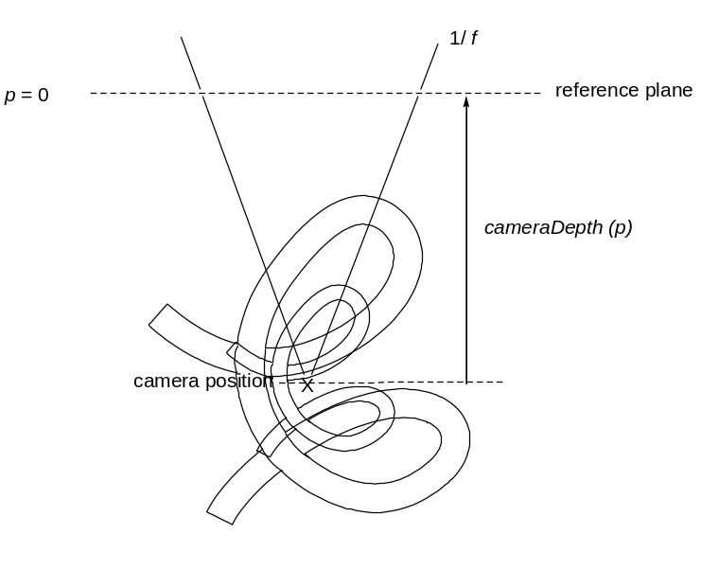

Figure 4. When the center of the model is at the
camera position, standard zoom has no effect.

Scripted Navigation

Navigation can be scripted. Commands include:

set cameraDepth x.xx
set hideNavigationPoint
set navigationMode TRUE/FALSE
set perspectiveStyle 11/10 # (10 disallows navigation)
set picking navigation
set rotationRadius x.xx
set showNavigationPointAlways
set visualRange x.xx

navigation nSec center {x y z}
navigation nSec center $object
navigation nSec center (atom selection)
navigation nSec depth p # a depth value, like slab, in percent (0 rear, 100 front)
navigation nSec path $object indexStart indexEnd
navigation nSec path (atom expr) {x y z} (atomexpr) (atomexpr) {x y z} etc...
navigation nSec path {x y z theta} {x y z theta}{x y z theta}{x y z theta}...
navigation nSec rotate X degrees
navigation nSec rotate Y degrees
navigation nSec rotate Z degrees
navigation nSec translate x.xx y.yy # percentages; 0 0 center
navigation nSec translate X x.xx # relative percent
navigation nSec translate Y y.yy # relative percent
navigation nSec translate {x y z}
navigation nSec translate $object # could be a draw object
navigation nSec translate (atom selection) #average of values

The nSec parameter is optional and defaults to 2 seconds. Commands can be stacked together for convenience only using “/”:

navigation depth 50 / rotate X 30 / depth 20 / translate X 10

Note that “depth 20” after the rotation is different from “depth 50” before – it is along a different axis. Also note that concurrent spinning of the model, though possible, is not recommended during navigation. Many of these commands depend upon the current model orientation. If that is changed by the user or by spinning during navigation, the end result is not guaranteed. In principal one could safeguard against this, but we are not there yet.

In addition, an extension to the moveTo command allows simultaneous reorienting and navigation:

moveTo [timeSec] {x y z w} zoom [xTrans yTrans]
({center}) [rotationRadius] ({navCenter}) [navX navY navDepth]

The center and navCenter parameters can be any one of (a) a draw object preceded by $, (b) an atom expression in parentheses, or (c) a (possibly fractional) coordinate in braces.

Commands that can be used to help develop pages using navigation include:

show/save/restore state
show/save/restore orientation
show set # displays all settings

