3. The Integrated S-BPM Process Model

3.1 To Go

|  |  |
| --- | --- |
| Now I have gotten the message from the last two chapters that language plays a prominent role for the documentation and modeling of business processes. I also understood that subjects have to be at the center of processes, since acting requires actors. However, the introduction of processes could also be performed here along the usual BPM procedure—analysis, modeling, and implementation: Why do we need a specific process model to implement S-BPM? | Tuete_Schleife - Kopie |
| Becher_Krawatte - Kopie | The concept of S-BPM could actually be implemented along the traditional way of introducing or improving business processes. Nevertheless, the procedure to follow in S-BPM is subject-oriented in itself. The creation of a process is also a process driven by a stakeholder—a process cannot be created by itself. When implementing S-BPM consequently, we leave behind our traditional BPM hierarchical arrangement of organizational roles and identify four categories of actors that drive S-BPM, regardless of their positions in organizations. These categories are aligned in accordance with S-BPM process requirements, and their activities are already well known. We call them activity bundles, as they bundle actions that are selected according to requirements and work processes at hand. In this way, we are able to demonstrate how S-BPM meets the requirements of an integrated method. |

Subject-oriented Business Process Management does not only include the opportunity to transfer information expressed in natural language with minimal effort into a model. It also allows a continuous change of business processes in a structured way. The S-BPM method itself is subject-oriented, with actors (subjects) at the focus. In the following, we explain the coordinated S-BPM activity bundles (predicates) that are executed by the respective actors. The object in S-BPM is the process itself. In this way, the S-BPM process model can be fully specified by its inherent elements and logic of description. This self-referentiality reflects the consistency of the approach.

First, we introduce the process understanding required for S-BPM. We then address the importance of S-BPM for organizations and introduce the various S-BPM stakeholders and activity bundles. Thereafter, the methodological framework of S-BPM is detailed. And finally, we show the multiple integrated nature of S-BPM.

3.2 Concept of Processes in S-BPM

The concept of processes for S-BPM is consistent with the concept commonly used to define business processes in traditional BPM (cf. [Becker et al. 2008, p. 6], [Schmelzer et al. 2010, p. 61 ff]), and [Fischermann, 2006]).

We therefore understand a business process as a set of interrelated activities (tasks) which are handled by active entities (persons or systems performing work tasks) in a logical (with respect to business) and chronological sequence, and which use resources (material, information) to work on a business object for the purpose of satisfying a customer need (to thus contribute an added value), and which have a defined start and input, as well as a defined end state and result.

Business objects as such are those objects which are economically relevant for shaping the business and which include the communication relationships in the course of task accomplishment. In S-BPM therefore, those objects are considered which are relevant during the exchange of messages between subjects, and which are also relevant for the individual activities of the subjects.

3.3 S-BPM Stakeholders

S-BPM is driven by several active roles. Governors (persons caring for, taking responsibility for, or driving processes) create the conditions under which Actors operate. These Actors manage work tasks, and in so doing, cooperate with specialists (Experts) when needed. Governors are also responsible for organizational development. The respective stages of development are supported by Facilitators, who again involve Experts where needed. S-BPM does not require a hierarchical structuring of these actors, and in turn does not require explicit management structures. It rather dissolves the classic distinction between business and IT people. Representatives from both areas can be found in all of the roles relevant for S-BPM.

3.3.1 Governors (Persons caring for, taking responsibility for, or driving processes)

Governors are subjects who have responsibility for environmental factors and who take influence on the respective work and development processes. Governors should bridge the gap in the organizational development between executive officers and the operational business. They are not responsible for the technical control of work processes. They rather ensure that processes meet certain quality standards. Consequently, each process needs to be considered in the context of its organizational embodiment. In order for a process to become productive, requirements of corporate governance have to be provided. They need to be implemented under the responsibility of the Governor (business and IT compliance).

In the context of modeling, the organizational design or development department is in the role of the Governor. It implements the rules of how models shall be generated (in terms of modeling methods, types of models, tools, etc.). This department also takes care of accompanying process workers (Actors when modeling processes) by methods specialists (Experts) of its unit.

A Governor may need to handle several influencing factors simultaneously in a responsible way. In addition, different players may take differential influence on the organizational development, leading to additional or changing constraints. Typical examples are:

* Management: Definition of business-/domain strategy
* Middle Management: Definition of functional strategies (tactics)
* IT Management: Definition of the IT strategy
* Organizational Design Department: Specification of methods, tools and conventions
* Process Owner: Definition of process metrics and target values

Accordingly, the task profile of Governors is diverse. Their profile is detailed later on when introducing the S-BPM activity bundles.

Helplessness of managers does not protect organizations from harm—alternatives to existing behavior patterns need to be brought up in such situations. This is what the Governor is for—he helps to trigger creative and reflective processes. And he needs to take responsibility for them.

3.3.2 Actors (Active participants in a process)

Actors run work processes. They are empowered through S-BPM to participate actively in (re-) developing their organization of work. They correspond to subjects and become part of subject-oriented process models when their behavior needs to be represented.

In accordance with the objectives of S-BPM, Actors are active elements and simultaneously the points of reference, primarily in the analysis, modeling, optimization, and implementation of business process models. Actors are supported by Experts and Facilitators.

For instance, Actors can identify weaknesses in their work process and, where appropriate, in consultation with the responsible Governor and supported by Facilitators and Experts, eliminate by themselves deficiencies in the organization of work in a responsible way.

Without time, money, and individually invested energy, there can be no S-BPM—working actors (Actors) need time, skills, confidence, and distance, in order to engage in change processes with the required intensity.

3.3.3 Experts (Specialists in a specific field)

Once expertise in a certain domain or situation is required, experts are needed. They are activated either by the Actors, the Governor, or the Facilitator. They are expected to deliver solutions to recognized problems. Typical examples of experts are:

* Internal and external process consultants
* Organizational developers
* IT architects
* Domain experts, such as software developers or database specialists

Options for organizing work can neither be prescribed nor re-invented by a single person—domain experts and managers shape work processes together with those accomplishing tasks.

3.3.4 Facilitators (Persons accompanying organizational development)

Facilitators support Actors when initiating organizational development steps, when taking action within a bundle of activities or development step, and during transition from one step (activity) or bundle to another step or bundle. They accompany the introduction or adaptation of a business process towards stakeholder needs. They influence organizational development processes through specific recommendations. For instance, once a particular part of a process has been modeled successfully, the Facilitator advises the involved Actors to validate the current model before proceeding with modeling.

Structural persistence is usually characterized by a lack of communication. In this case, the Facilitators explore opportunities for stakeholder communication. They create the necessary interaction pathways and support stakeholders in the context of design and reflection processes. The Facilitators also control and support the communication of Actors and Experts. For instance, they recognize when another Actor or Expert needs to be involved.

Thus, we regard the Facilitators as a catalyst when developing an organization. They should succeed in qualifying Actors professionally and personally. Typical examples of Facilitators, performing different support services, are:

* Members of middle management
* Project managers
* Organizational developers
* Coaches
* Service desk staff

It is the inner commitment that leads to changes. If an organization does not recognize that conditions of operation are changing and how they are changing, then it cannot accomplish its mission and is “doomed to die” sooner or later. It requires a team including Governor, Facilitator, Actor, and Expert to empower people to commonly develop and share inner commitment on the organizational level.

3.4 S-BPM Activity Bundles

The different activity bundles (cf. [Schmidt et al. 2009, p. 52 f.]) are the topic of main chapters following later. They are therefore just briefly described here:

* Analysis: The first step in S-BPM is usually the analysis. In this phase, a process is examined while being decomposed into parts. In addition, its operational context and rationale is made transparent. The object of concern is on the one hand derived from the organization's strategy to structure work and its S-BPM strategy. On the other hand, analysis activities can also be triggered by feedback stemming from another bundle of activity, especially monitoring, for instance to identify causes of deviations from desired process performance.
* Modeling: Modeling in Business Administration means reducing the complexity of the reality through mapping observations to a specific medium [Meyer 1990, p. 16]. Before doing so, a self-contained set of characteristic items and relationships needs to be identified and abstracted from the observed reality. Modeling of business processes is essentially a matter of representing which subjects (humans, machines as actors) perform which activities (tasks, functions) on which objects (as a rule, information which is bound to specific carriers) using which tools (e.g., IT systems), and how they interact to achieve the desired process goals and outcomes. Initially, an abstract process model is created. This model is still independent of the specific actors. These are then added in the course of the organizational and IT implementation of business process models.
* Validation: Validation in the context of S-BPM means checking whether a process is effective, i.e., whether it yields the expected output in the form of a product or service. The subject of validation is the observed business process itself or its model. Through validation, a process model can be evaluated to see whether it corresponds to the intended representation.
* Optimization: While the goal of validation is to ensure the effectiveness of business processes, the target of optimization is the efficiency of the same processes. Process efficiency can be expressed in terms of process attributes concerning the consumption of resources, such as duration, costs, and frequency of use. Optimization means to adjust a process and its sub-processes with respect to specific (resource) parameters (in the sense of achieving an organizational goal by meeting corresponding parameter values, such as cost limits).
* Organization-specific implementation: When embodying processes, validated and optimized processes are embedded into an existing or novel organizational environment according to its specific settings.
* IT implementation: The IT implementation of a process means the technical introduction of a business process into an organization, namely as an IT-based workflow including the integration of a suitable user interface, business logic, and the required IT systems.
* Monitoring: Once optimized and implemented, processes become productive (go live) in an organization. They are executed within the work structure of the organization and its IT environment in daily operations. In the course of monitoring process execution, data are collected and recorded. They are calculated to provide accurate actual values to be compared with previously defined performance targets. The results are processed through reporting according to the need of target groups and made available to the intended recipients. The evaluation of the results, when comparing actual performance data to plan data, may lead back to the analysis of causes in case of undesirable deviations, and depending on the nature of the perceived need for action, to the iteration of a downstream S-BPM activity bundle.

3.5 The Open Control Cycle of S-BPM Activity Bundles

The modeling of business processes is an essential part of business process management. In its basic features, it represents a traditional management process. When accomplishing its tasks, the management deals with business processes. Management activities are carried out along a feedback control cycle composed of the phases: analysis, modeling, validation, optimization, organization-specific implementation, IT implementation, operation, and monitoring. The phases follow the logic of BPM, whereby information about business processes and their design is accumulated progressively during cycle time.

The S-BPM activity bundles correspond to a great extent to these management activities of traditional BPM approaches. However, in contrast to traditional BPM approaches, as a rule they are not necessarily performed sequentially. We therefore speak of an *open* feedback control cycle, driven by people in the S-BPM roles that we have identified in section 3.3 (see Figure 3.1). The S-BPM activity bundles can be performed in the logic of S-BPM along a complete organizational development step as described is section 3.4. However, the sequence of execution may also differ from this linear procedure. A non-linear sequence is triggered by events in the individual activity bundles requiring such different paths, as detailed in the respective sub-chapters.

The control loop of cybernetics teaches us to think in terms of feedback systems. S-BPM reflects the diversity of organizational interventions. Despite the central position of modeling activities, organizational development can be started in a continuous process from controlling (e.g., optimization), implementation (e.g., IT implementation), or analysis (e.g., validation).

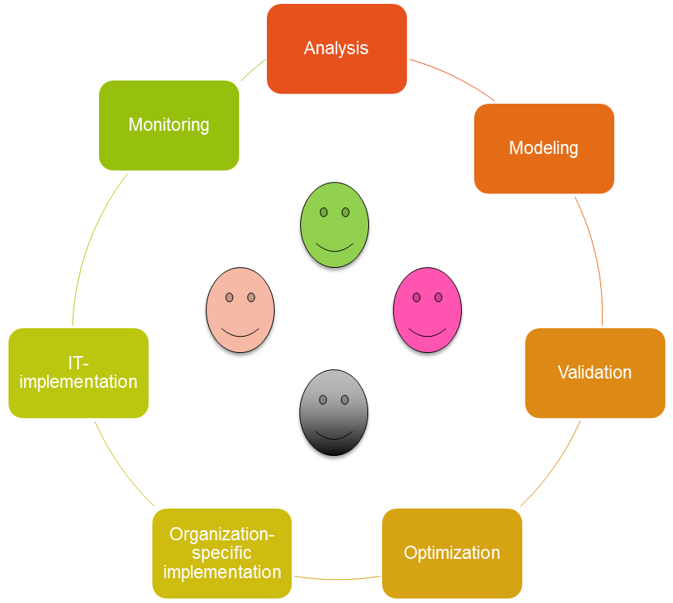

Figure 3.1: Activity bundle for the design of a process

In BPM practice, the activities of the bundles, or even bundles out of the cycle, often cannot be clearly distinguished from each other. Quite often, organizations move back and forth between them without disruption. For instance, in case stakeholders identify ambiguities during the modeling of the process, they could switch to an upstream process step and consult the stakeholder involved in that process step for analysis. Once the issue is settled, they continue modeling their process. During the validation, the involved stakeholders can recognize obvious potential for optimization, embody it in their current model, and validate it again.

In this way, activity bundles are iterated and the process is enriched successively with information, until the process specification is complete and sufficiently detailed to meet the project target. Stepping back to a previous activity always leads to an analysis state, and, depending on the results of this analysis, back to another downstream activity bundle. This applies in particular to the feedback from monitoring activities. When modifications of the model follow, each downstream activity bundle after modeling has to be completely performed subsequently. Otherwise, it is possible to skip steps. For instance, when process owners recognize during monitoring a negative deviation from a target value, they initiate a causal chain analysis. In case this analysis results in recognizing a lack of work force handling the particular case, this deficiency can be removed through another organizational implementation of the process (simply by providing additional work force), without having to change the process model itself. There are no further steps required. If the process owner concludes from the analysis that extensive throughput times are caused by lacking possible parallel execution of process steps, the model needs to be modified and re-validated. In this case, the implementation of the process into the organization and the IT infrastructure (organization-specific implementation) needs to be reviewed according to the modified model, and adapted where required.

Which bundles of activities are executed iteratively depends on the purpose of each project. In case only the process documentation is concerned, e.g., for certification within quality management, modeling and description of the current processes are sufficient.

Before detailing the various S-BPM bundles of activities in distinct chapters, let us clarify the conditions under which the activities are performed, and also how these activities are affected by those conditions.

3.6 S-BPM Framework

Business process management based on the described bundles of activities is not independent of its environment in an organization. It is embedded in organizational frameworks that are designed primarily by Governors. Figure 3.2 provides an overview of various framework conditions, the Governors typically responsible for these conditions, and the affected activity bundles (see Figure 3.2). Then, we detail the main framework conditions of S-BPM.

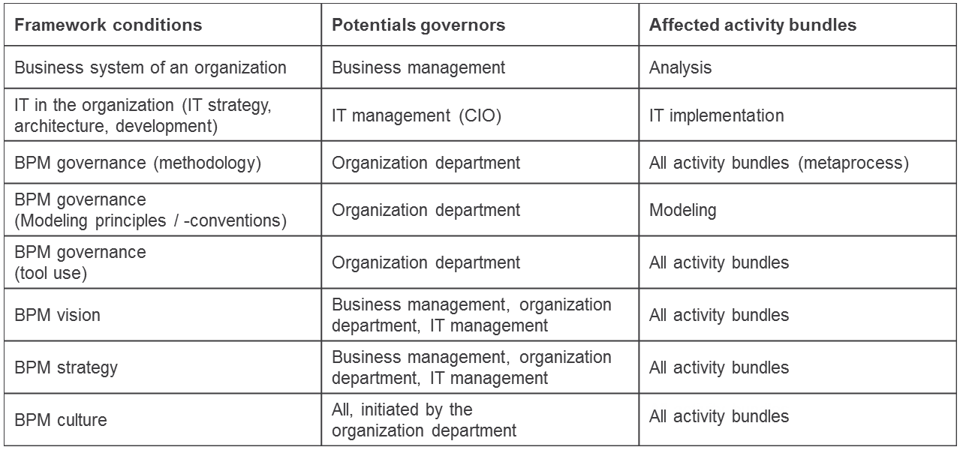

Figure 3.2: Design of framework conditions through Governors

3.6.1 Business System of an Organization

The vision of an organization frames the formulation of its objectives. The strategy defines ways to achieve these objectives, such as the product-market combination for competitive positioning or the influencing of cost structures.

For implementing the strategy, i.e., the actual operation of a business, the design and execution of business processes, including their support by appropriate IT systems, are required. In this triad of strategy, processes, and information systems (cf. [Oesterle et al. 2003, p. 3 ff.] and [Schmidt, 2010a, p. 37 ff.]), Business Process Management is positioned according to its integrative meaning (see Section 3.7). As a management concept, it has close, usually complementary relationships with other management tools, such as Balanced Scorecard (BSC), Six Sigma, Total Quality Management (TQM), or the Model of the European Foundation for Quality Management (EFQM) (cf. [Schmelzer et al. 2010, p. 14 ff.] and [Fischer et al. 2006, p. 21 ff.]).

The entire business operation is subjected to Corporate Governance, a management system for corporate control and monitoring which is oriented towards long-term value creation, while following both legal frameworks and ethical principles (cf. [RDCGK 2010, Preamble] and [Schmidt 2010b, p. 355]). The foundation for this is based on (inter-)national regulations, such as the German Corporate Governance Code, the Law on Control and Transparency (KonTraG), and the Accounting Law Modernization Act (BilMoG) (cf. [Klotz et al. 2008, p. 6]).

The issues raised in this context are usually in the responsibility of management as Governor and are relevant primarily for the S-BPM analysis.

3.6.2 IT of an Organization

In the sense of IT/Business Alignment, IT vision and IT strategy have to be derived from their counterparts at the organizational level (company level), as detailed in the previous section (cf. [Schmidt 2010a, p. 75 ff]). The IT, for its part, provides impulses for business operation, e.g., by enabling new business models.

IT governance, when derived from the Corporate Governance, should ensure with appropriate leadership and corresponding organizational structures and processes that IT supports the achievement of business goals (and contributes an added value). Hereby, resources should be responsibly used and risks properly monitored (cf. [ITGI 2003, p. 11 ff], [Schmidt 2010b, p. 355 ff], and [Johannsen et al. 2007, p. 21 f.]).

IT delivers its value proposition from a strategic perspective by enabling competitive advantages and from an operational perspective by optimally supporting the business processes required to implement the business strategy. In the latter context, the technical dimension of S-BPM comes into play (see Section 3.7).

The vision, strategy, architecture, and governance of IT are essential conditions for the IT implementation of business processes. The role of Governor for the definition of these is usually taken by the head of IT (CIO) in an organization.

3.6.3 Business Process Management in an Organization

The business system and the IT of an organization lay the framework for Business Process Management. BPM in turn should create an environment in which the BPM process model is embedded. Essentially, it is about developing a vision and strategy which are connected to the corporate culture and from which governance for business process management can be derived. These conditions usually have a long term perspective, but need to be modified to reflect feedback from the activity bundles or changing environmental conditions (e.g., a change in corporate strategy). Particularly in the case of S-BPM, impulses may come from the operational work force. They influence vision and strategy in the long term.

3.6.3.1 Development of an S-BPM Vision

A vision is an attractive representation, which a person can identify with, of future reality [Wittmann et al. 2004, p. 16]. The vision does not anticipate this future situation by specifically describing it. Rather, it should lead to a creative tension between the present state (as-is state) and a desired target (to-be state), and in this way serve as a management and motivational tool. Visions are usually formulated at the corporate level (see Section 3.6.3), and decomposed to organizational units (e.g., IT) and projects. The key elements of an S-BPM vision for introducing and operating business process management are summarized in Figure 3.3.

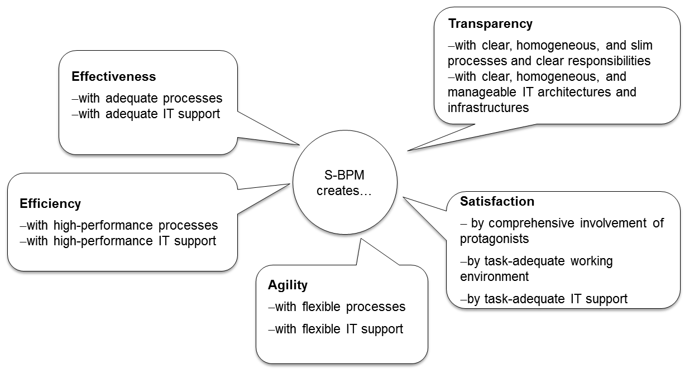

Figure 3.3: Possible S-BPM Vision [Schmidt, 2009, p. 7]

With its focus on processes for implementing a strategy and associated IT support, the S-BPM vision is closely related to the overall corporate vision and IT vision. As a result, the management, the organization department, and the IT management can be derived in the role of Governor.

An S-BPM vision needs to be communicated throughout an organization, in order to achieve stakeholder-oriented participation in organizational development processes.

No S-BPM vision, no strategy development—it highlights the different roles required for organizational development in a concerted fashion. Consequently, diversity and complexity can be handled in a constructive way.

3.6.3.2 Development of an S-BPM Strategy

The first step of a strategic controlling process is the development of an S-BPM strategy (strategic process planning)—see Section 11.1. In the course of initially formulating the S-BPM strategy, first of all, specific organizational objectives are determined for action fields on the basis of the S-BPM vision (cf. [Schmelzer et al. 2010, p. 231 ff.]). Besides the vision, both impulses from the competitive environment (stimuli from outside), as well as, once S-BPM is implemented, feedback from executing the S-BPM process model (internal impulses) can be incorporated in the sense of a continuous improvement process. The next task is to identify the processes that need to be considered (cf. [Becker et al. 2008, p. 123 ff]). This starts with the representation of the existing and the envisioned value chain. Afterwards, existing processes are classified based on a first process map. In this way, processes can be grouped and evaluated with regard to actual and target values.

Under the participation of stakeholders, process groups are ranked and those groups with the highest potential are first selected for further evaluating cost effectiveness. Hereby, special attention is given to the existing and potential IT support and process automation. The results of this analysis lay the ground for prioritizing the processes that ultimately form the subject-matter of BPM. This allows process owners of the so identified processes to proceed with detailed planning in regards to project realization. Based on this prioritization, an economically sound standing roadmap for implementing an S-BPM strategy is created. Just like the vision, strategy and roadmap need to be communicated throughout the organization by all responsible stakeholders, in order to ensure transparency and acceptance [Schmidt 2009, p. 8].

The presented strategic planning process includes use of instruments, such as the Balanced Scorecard (BSC) and Strategy Maps, and completes the first step to strategic process controlling. Once the BSC is transformed into scorecards with key performance indicators concerning business processes of an organization or its units, the implementation of the S-BPM strategy can be reviewed within the strategic process monitoring and control.

An analysis checking the discrepancy of target values (to-be values) of performance parameters to those actual values (as-is values) collected periodically (e.g. quarterly) from the current operation allows the identification of strategic gaps and needs for further action (cf. [Schmelzer et al. 2010, p. 231 ff.]). In addition, the assessment of the maturity of processes using respective models can give indications for the further development of the S-BPM strategy (see Section 11.1.1).

Of particular interest is the learning perspective, as it reveals development potential with respect to organizational change, customer structure, and finances. In S-BPM, executives and staff are enabled to generate business processes from their individual perspective. The resulting models can be reflected and further developed as part of a collective learning process. The latter ultimately lead to a modified process map of an organization.

The value chain and the associated derived process classes are mainly influenced by the corporate strategy. Therefore, the outlined approach ensures to a large extent the consistency of the S-BPM vision and strategy with the corporate vision and strategy. Thus, it is likely that in the case of a cost leadership strategy, the process groups moving to the focus of interest differ from those in the case of a differentiation strategy. With the recognition of the importance of IT support and automation in S-BPM, the reference to the IT strategy is also established. S-BPM strategy and vision thus form a connecting link between corporate vision and strategy and IT vision and strategy, and therefore significantly contribute to IT/Business Alignment (see Section 3.6.2).

The Governor's role to establish the S-BPM strategy as a framework is taken by corporate management, the organization department, and IT management (cf. S-BPM vision).

3.6.3.3 Development and Promotion of an S-BPM Culture

S-BPM vision and strategy contribute to the development of an S-BPM culture and to its establishment in a sustainable way in an organization. Such a culture is also a result of the S-BPM process model, as well as its critical success factor [Schmidt 2009, p. 9].

For achieving an S-BPM culture, it is indispensable that senior management is committed to process orientation in general, and the massive support of S-BPM projects exists in particular. Without this backing, there is the risk that the sustainable establishment of S-BPM is hindered by more or less strong resistance to change of the organization.

For successful S-BPM, it is necessary to promote the acceptance of managers and employees for S-BPM projects at all levels, and, ideally, to motivate them to participate actively. Appropriate Facilitators are the early, regular, and reflected:

* Increasing awareness of the importance of S-BPM
* Communication of S-BPM vision and strategy
* Information about specific S-BPM projects
* Involvement of affected persons and institutions ("making concerned parties to engaged ones")
* Qualification of participants (situational)
* Communication of working results of S-BPM activities ("success stories")

In this way, organizations can develop a culture that provides orientation for staff members and reduces uncertainty and fears of change. An ambience focusing on learning facilitates engaging promoters and especially opponents of S-BPM in a constructive discourse.

Incentives, such as a reward system aligned with results of process execution (e.g., a bonus for the achievement of targets for key performance indicators, such as the average processing time) and a proposal scheme for rewarding suggestions for process-related improvements can bring about a willingness to change.

3.6.3.4 Development of an S-BPM Governance

S-BPM governance should be interpreted in this context largely in analogy to IT governance, namely as leadership behavior, organizational structures, and rules. These factors ensure that S-BPM supports the corporate strategy and organizational objectives in an optimal way while carefully considering the risks involved. Leadership behavior and organizational structures are primarily represented by the anchoring of S-BPM in the organization. Rules become evident, e.g., by the definition of S-BPM standards.

For instance, before implementing S-BPM projects, a variety of general regulations should be set up and documented in an obligatory standard guide for modeling. This also needs to be communicated as such to become effective [Schmidt 2009, p. 10]. Such a standard or style guide should contain:

* Process model: Prescription of a uniform approach (BPM process), e.g., according to the S-BPM-model.
* Modeling principles: Specification of constraints when modeling, such as the Principles of Proper Modeling (PoPM) given in Figure 3.4 (cf. GoM in [Becker et al 2008, p. 47 ff.]).
* Modeling conventions: Specification of concrete rules to be followed when modeling, e.g., how to use methods and model types, descriptions, layout, etc.
* Specification of a previously carefully selected tool environment for modeling, and other S-BPM activity bundles when needed.

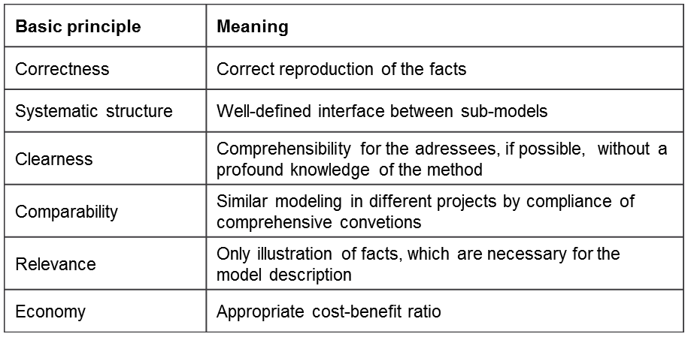

Figure 3.4: Principles of Proper Modeling (PoPM)

In practice, convention manuals often include 100 and more pages. Consequently, they may not be accepted by modelers, as they regulate too much or in a far too pedantic way. As we will show later, for subject-oriented modeling only a few conventions are required, since the method can be used by mastering just a few symbols.

The outlined standards need to be periodically reviewed and adjusted if required according to practical experiences. They are handled by organizational departments, which take the Governor role here.

For S-BPM governance, the principle of systems thinking and acting is essential. In addition to classical economic parameters, organization-specific factors (information infrastructure, task profiles, communication structures, etc.) and their interdependencies have to be taken into account.

3.6.4 Governance, Risk, Compliance Triad (GRC-Triad)

A comprehensive condition for Business Process Management is the so-called Governance, Risk, Compliance Triad. The term expresses the close interdependence of the three aspects and their increasing relevance for running businesses [Klotz et al. 2008, p. 7].

In the previous sections, we have detailed governance at the corporate, IT, and S-BPM levels. It has thereby been shown that governance encompasses as a major component the handling of risks and the associated conflict potential, which implies the establishment of a sound standing risk management in organizations. A significant part of business risks stem from the increasing amount of regulations organizations need to follow.

Here, compliance comes into play, aiming to prevent risks from violation of external and internal regulations by ensuring their implementation at the operational level (cf. [Klotz et al. 2008, p. 5 et seq.]). Compliance is not about the apparent obedience to existing laws, but about identifying possible violations of regulations as risks subject to the regime of risk management which need to be encountered with appropriate organizational, technical, and personnel measures (cf. [Klotz et al. 2008, p. 7]). Examples of such measures are the design and implementation of respective processes (such as workflows for approval), the careful nurturing of awareness, the informing and qualifying of staff, and the regular monitoring, control, and documentation of compliance to regulations, including sanctions in case of violation.

As with governance, we can consider IT compliance as a subset of corporate compliance. With such a comprehensive understanding, they both refer not only to compliance with legal regulations, such as the Federal Data Protection Act (BDSG), the Digital Signature Act (SigG), or the Principles of Access to Data and Verifiability of Digital Documents (GDPdU), but also to meet other external regulations, such as contracts and service level agreements or frameworks like the IT Infrastructure Library (ITIL), as well as internal corporate compliance requirements, e.g., self-imposed rule sets such as an IT security policy. The binding effect (commitment) and the risks of non-compliance are higher for external regulations and decrease accordingly when dealing with internal standards (cf. [Klotz et al. 2008, pp. 8]).

The co-operation of corporate compliance and IT compliance can be interpreted as compliance for Business Process Management (BPM compliance). In the context of corporate compliance, i.e., on the business level, it is important to identify compliance-related processes and to formulate respective compliance requirements. S-BPM facilitates meeting these requirements through an appropriate process design, e.g., incorporation of control steps (cf. [Schmelzer et al. 2010, p. 40]). The IT compliance then covers the abidance to IT-related regulations through the technology support of business processes. In the development and maintenance of processes, especially the responsible Governor ensures that the requirements are incorporated into the respective processes.

1. Governance–2. Risk–3. Compliance—not vice versa. A livable holistic organizational model cannot emerge from standardization efforts.

3.7 S-BPM for the Integrated Development of an Organization

S-BPM is a methodology that enables integration in multiple ways in an organization. In order to demonstrate this capability, we first consider the business and technical aspect of S-BPM—two dimensions which traditionally allow the term Business Process Management to be grasped (BPM) (cf. [Bucher et al. 2009, p. 6], [Becker et al. 2009, p. 3], and [Schmelzer et al. 2010, p. 5]). The original exclusive economic point of view refers to an integrated management approach for documentation, design, optimization, implementation, control, and further development of management, core, and support processes in organizations. It is intended to meet the needs of stakeholders, especially to satisfy customers, and to achieve business objectives.

Moreover, the term BPM in science and industry is also often associated with its technical dimension of IT support of business processes. This ranges from tools for documenting and modeling of processes, to workflow engines for the execution of process instances while using functionalities of application software (such as services of an ERP system), to business intelligence applications to evaluate the performance of processes. Solutions with a high degree of coverage of these aspects are referred to as Business Process Management Systems (BPMS) or, preferably by software vendors as business process management suites. An example of such is the Metasonic Suite, which already covers the modeling and validation of process specifications based on executable models.

S-BPM integrates the business and technical point of view by focusing on business processes from the perspective of all stakeholders. It provides them with a tool which enables them to express their respective views of these processes effectively and efficiently. S-BPM is a role-centric and communication-centric tool for the development of organizations. Unlike other BPM approaches, it does not put the development of functional processes in the foreground, but rather the parties involved, i.e., the subjects and their interactions. Thus, development is equally enabled on both the organizational and personal level.

The organizational aspect of work does not only come to bear from the technological operational perspective, but rather already when dealing with the respective work profiles, in the context of which stakeholders in the operational business ultimately need to be supported by information technology. In S-BPM, subjects determine the roles of Actors that are relevant to the achievement of organizational objectives. Subsequently, their respective behavior is defined, and synchronized through the exchange of messages when performing tasks.

Unlike many BPM approaches, a model developed with S-BPM is directly executable. This means that in each step of development models can be processed without further transformation. Thus, for the first time, a coherent development process based on subject-oriented modeling can be established (seamless round-trip engineering). With this approach, modeling and implementation can be directly interconnected.

In addition, the S-BPM process model comprises a procedure that allows the dynamic integration of activity bundles with each other. Going beyond classical life cycle approaches, parallel and branched activities can be triggered—depending on what is currently required according to the business process. Feedback between the activity bundles can occur, which leads to successive transitions, not only forwards and backwards between business logic states, but also skipping intermediate states.

Finally, S-BPM itself can be described in a subject-oriented way using the available tools. The item to be represented in a model, i.e., the process, can be grasped by using subject-predicate-object descriptors (i.e., modeling), just as the process of developing a process model itself can be described by using subject-predicate-object sequences (see Figure 3.1). The core is the modeling process, which is embedded in an organization-specific development process based on modeling.

S-BPM is coherent: It is the stakeholders who are involved in S-BPM specific interaction, either as Governor, Actor, Expert, or Facilitator. They are the subjects that act (predicate), which leads to changes in organizational processes (objects). Consequently: Always think in complete sentences for S-BPM projects!

3.8 References

[Becker et al. 2009]

Becker, J., Mathas, C., Winkelmann, Geschäftsprozessmanagement, Berlin 2009.

[Becker et al. 2008]

Becker, J., Kugeler, M., Rosemann, M. (Hrsg.): Prozessmanagement, 6. Auflage, Berlin 2008.

[Bucher et al. 2009]

Bucher, T., Winter, R., Geschäftsprozessmanagement – Einsatz, Weiterentwicklung und Anpassungsmöglichkeiten aus Methodiksicht, HMD 266, S. 5-15.

[Fischer et al. 2006]

Fischer, H., Fleischmann, A. und Obermeier, S., Geschäftsprozesse realisieren, Wiesbaden 2006.

[Fischermann 2006]

Fischermann G., Praxishandbuch Prozessmanagement, ibo Schriftenreihe Band 9, Gießen 2006.

[ITGI 2003]

IT Governance Institute, IT Governance für Geschäftsführer und Vorstände, 2. Ausgabe 2003, http://www.itgi.org/Template \_ITGI. cfm?Section=Recent\_Publications&CONTENTID=14529&TEMPLATE=/Con¬tentManagement/ContentDisplay.cfm, Download am 19.01.2007.

[Johannsen et al. 2007]

Johannsen, W., Goeken, M., Referenzmodelle für IT-Governance, Heidelberg, 2007.

[Klotz et al. 2008]

Klotz, M., Dorn, D., IT-Compliance – Begriff, Umfang und relevante Regelwerke, in: HMD - Praxis der Wirtschaftsinformatik, Heft 263, 2008, S. 5-14.

[Meyer 1990]

Operations Research – Systemforschung, 3. Auflage, Stuttgart 1990.

[Österle et al. 2003]

Österle, H. und Winter, R., Business Engineering, in: Österle, H. und Winter, R. (Hrsg.), Business Engineering, 2. Auflage, Berlin 2003, S. 3-20.

[RDCGK 2010]

Regierungskommission Deutscher Corporate Governance Kodex, Deutscher Corporate Governance Kodex in der Fassung vom 26. Mai 2010, http://www.corporate-governance-code. de/ger/download/kodex\_2010/D\_CorGov\_Endfassung\_Mai\_2010.pdf, Download am 15.02.2011.

[Schmelzer et al. 2010]

Schmelzer, H., Sesselmann, W.: Geschäftsprozessmanagement in der Praxis, 7. Auflage, München 2010.

[Schmidt 2010a]

Schmidt, W., IT-Strategie, in: Hofmann, J. und Schmidt, W. (Hrsg.), Masterkurs IT-Management, Wiesbaden 2010, S. 11-92.

[Schmidt 2010b]

Schmidt, W., IT-Governance, in: Hofmann, J. und Schmidt, W. (Hrsg.), Masterkurs IT-Management, Wiesbaden 2010, S. 355-403.

[Schmidt et al. 2009a]

Schmidt, W., Fleischmann, A. und Gilbert, O., Subjektorientiertes Geschäftsprozessmanagement, HMD – Praxis der Wirtschaftsinformatik, Heft 266, S. 52-62, 2009.

[Schmidt 2009b]

Schmidt, W., Integrierter Business-Process-Management-Zyklus, Arbeitsberichte (Working Papers) der Hochschule Ingolstadt, Heft Nr. 16, 2009

[Wittmann et al. 2004]

Wittmann, R., Littwin, A., R., Reuter, M. u. Sammer, G., Unternehmensstrategie und Businessplan, Frankfurt 2004.