Portfolio for Data Science COM618
  - Student ID - Q15995259 Name - Albert Gomes

Introduction

Diabetes is a long-term health condition that impacts millions of people around the world and requires proper management to avoid serious complications. As the prevalence of diabetes continues to rise, data analytics has emerged as a valuable tool for predicting, managing, and treating the disease. Predictive modelling can analyse patient information to estimate the risk of developing diabetes, facilitating early intervention and more efficient resource distribution.

Research indicates that data analytics can be instrumental in pinpointing high-risk patients by utilising a combination of demographic, lifestyle, and clinical data, such as blood glucose levels, body mass index (BMI), and insulin sensitivity (American Diabetes Association 2022). Predictive analytics has the potential to revolutionize diabetes management not only by detecting the disease's onset but also by forecasting trends that can assist in public health planning (World Health Organization 2021).

The integration of data analytics for predicting diabetes comes with its own set of challenges. It is common to encounter missing or incorrect data within healthcare datasets, which can greatly affect the accuracy of predictive models. Moreover, the presence of outliers in medical data can distort results and result in unreliable forecasts. Furthermore, the absence of standardized procedures for data preprocessing and model evaluation complicates the comparison of results across different studies (Fregoso-Aparicio et al. 2021).

Predicting diabetes using open datasets requires dealing with noisy data, managing missing values, and creating resilient models that are both interpretable and precise. This coursework emphasizes tackling these challenges to build dependable predictive models.

This project aims to:
- Explore and clean open-source diabetes datasets.
- Identify significant patterns and trends in the data using visualisation techniques.
- Develop predictive models to forecast diabetes outcomes and evaluate their performance.
- Highlight the importance of data preprocessing and feature engineering for accurate predictions.

Methods
Dataset

The dataset contains 9 columns, including clinical and demographic features, along with a binary outcome column that specifies whether the patient is diagnosed with diabetes (1) or not (0). The table below provides a detailed description of the dataset:

Variable Name | Description | Type | Data Type | Values/ Range | Potential Role
Id | Unique identifier for each patient | Categorical | Integer | N/A | Excluded from modeling
Pregnancies | Number of times the patient has been pregnant | Discrete Numeric | Integer | 0 to 17 | Independent Variable
Glucose | Plasma glucose concentration during a 2-hour oral glucose tolerance test | Continuous Numeric | Float | 0 to 199 | Independent Variable
Blood Pressure | Diastolic blood pressure (mm Hg) | Continuous Numeric | Float | 0 to 122 | Independent Variable
Skin Thickness | Triceps skinfold thickness (mm) | Continuous Numeric | Float | 0 to 99 | Independent Variable
Insulin | 2-hour serum insulin (mu U/ml) | Continuous Numeric | Float | 0 to 846 | Independent Variable
BMI | Body mass index, calculated as weight in kg divided by height in m² | Continuous Numeric | Float | 0 to 67.1 | Independent Variable
Diabetes Pedigree Function | A function that scores the likelihood of diabetes based on family history | Continuous Numeric | Float | 0.078 to 2.42 | Independent Variable
Age | Age of the patient | Discrete Numeric | Discrete Numeric | 21 to 81 | Independent Variable
Outcome | Binary outcome indicating whether the patient is diabetic (1) or non-diabetic (0) | Categorical Nominal | Categorical Nominal | 0:500 (65%)/ 1:268 (35%) | Dependent Variable

Analysis Of Unique Values:
Column | Number of Unique Values | Key Insights
Pregnancies | 17 | Includes a wide range, from patients with no pregnancies to high numbers of 17.
Glucose | 136 | Continuous variable with missing/ invalid zero values replaced by the median.
Blood Pressure | 48 | Shows variability, with zero values replaced during preprocessing.
Skin Thickness | 51 | Skewed data with many zeros replaced by median values.
Insulin | 186 | Highly variable with outliers, many zeros replaced by the median.
BMI | 248 | A broad range of missing zeros was addressed during cleaning.
Diabetes Pedigree Function | 517 | Captures unique family history probabilities, no missing values observed.
Age | 52 | Skewed distribution with higher representation in older age groups.
Outcome | 2 | Balanced, though slightly skewed towards non-diabetic cases.

This Dataset is designed specifically for predicting diabetes, which aligns perfectly with the project’s goal of demonstrating how data analysis can help in healthcare. The dataset includes important features like glucose levels, BMI, and age, all of which are common measurements used to diagnose diabetes. This means the findings can be applied in actual healthcare situations. Furthermore, since it is an open-source dataset available on Kaggle, it encourages transparency and allows others to reproduce the research easily, making it even more valuable for this project (Khare 2022).
Many research studies have used machine learning methods to assess datasets such as this one for predicting diabetes. In a study conducted by Ting et al. (2020), logistic regression and random forests were applied to comparable datasets, resulting in high accuracy in distinguishing between diabetic and non-diabetic individuals. The American Diabetes Association (2022) emphasizes the growing adoption of predictive analytics for early detection and monitoring of diabetes in patients.
Before proceeding with the analysis, the dataset underwent comprehensive preprocessing to enhance its quality and ensure accurate predictions. First, missing values were addressed by replacing zero values in columns like "Glucose," "Blood Pressure," and "BMI" with the median values of their respective columns, as zero is not a valid measurement in these cases. Next, outliers were identified through Interquartile Range (IQR) analysis and were removed to minimize their influence on the performance of the machine learning model (Ghazali 2018). Finally, numerical columns were normalised to maintain consistent scaling, which aids in the performance of algorithms that are sensitive to variations in feature magnitudes.

Analysis and Results
Dataset Preparation
Preparing the dataset is essential for ensuring high quality and usability in analysis. The diabetes dataset was thoroughly assessed for missing values, outliers, and appropriate data types. Tools such as `.info()` (Fig.1) and `.isna().sum()` (Fig.2) were utilised to identify any null values, and checks were made for invalid or placeholder values, particularly zeros in critical columns like Glucose, Blood Pressure, and BMI, which are not clinically valid (W3School c; W3School d).
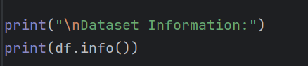
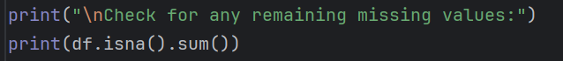
Fig.1 Code Fig.2 Code
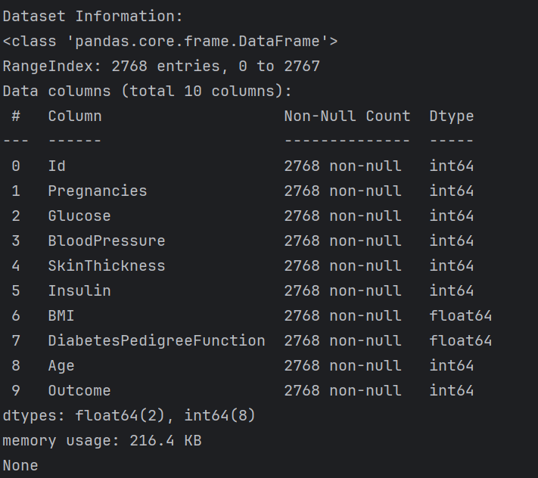
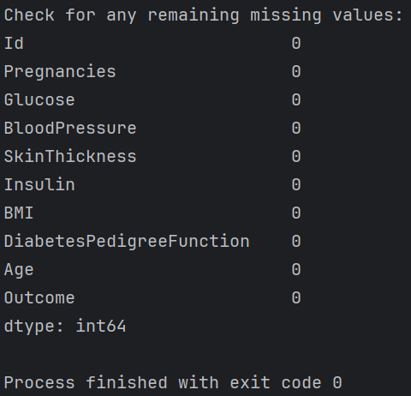
Fig.1 Result Fig.2 Result
To clean the data, invalid placeholder values were replaced with the median of their respective columns using Python's SimpleImputer (Fig.3) from the sklearn library, as median imputation helps mitigate the influence of outliers compared to mean imputation (Solent Online Learning | Data Science | Computing). Additionally, outliers were detected and removed using the Interquartile Range (IQR) (Fig.4) method to avoid bias in the analysis. The dataset consists of numeric data (both continuous and discrete) and a categorical column (Outcome) used for classification, with numeric columns such as Glucose, BMI, and Age appropriately typed for analysis purposes. With 768 entries, the dataset is optimally sized, negating the need for subsetting and ensuring effective analysis without performance issues. Finally, cleaning the data was critical, as addressing null values and outliers helps ensure that the analysis and predictive modelling yield reliable and consistent results.
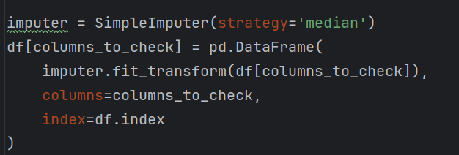
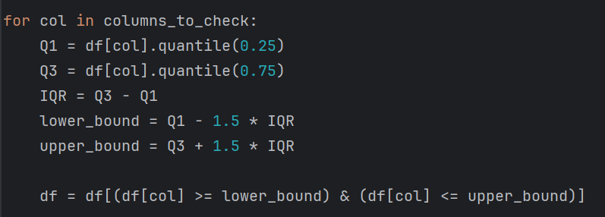
Fig. 3 Code Fig.4 Code
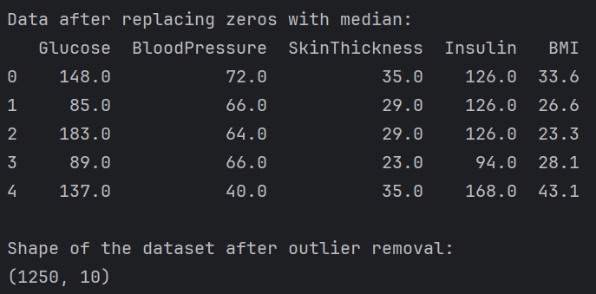
Result

Below is a snapshot of the dataset after cleaning, with null values addressed and outliers removed:
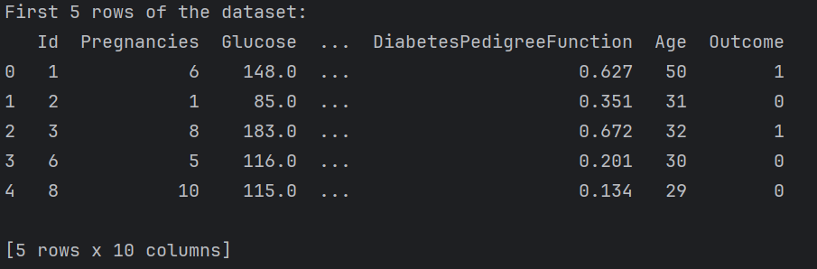

Exploratory Data Analysis
Exploratory Data Analysis (EDA) was performed to uncover patterns, relationships, and distributions within the dataset. A key step involved examining the distribution of various variables. Histograms were plotted for critical attributes such as Glucose, BMI, and Age to analyze their distributions. The findings revealed that both Glucose (Fig. 5) and BMI (Fig.6) exhibited near-normal distributions, whereas the distributions for Pregnancies (Fig.7) and Age (Fig.8) showed some skewness, reflecting variability among the patients.
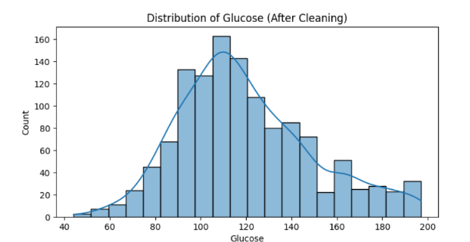
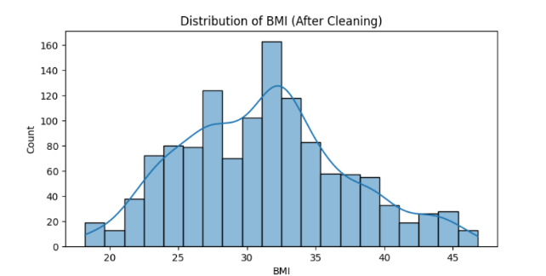
Fig.5 Glucose Fig.6 BMI
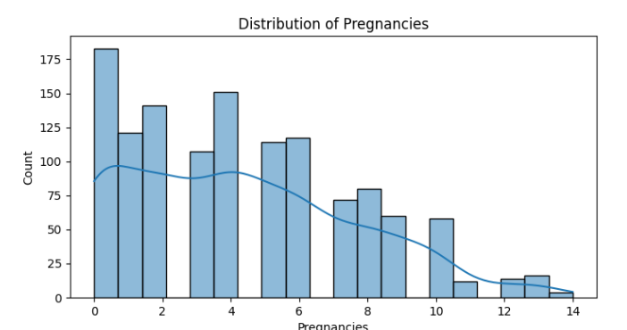
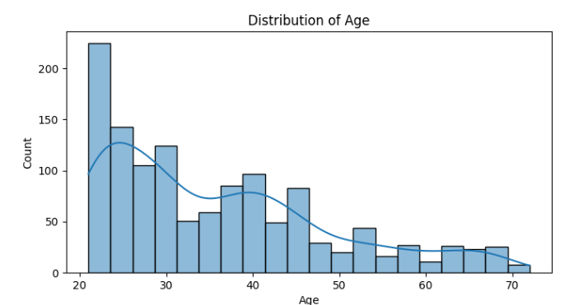
Fig. 7 Pregnancies Fig.8 Age
Correlation analysis was another important aspect of the EDA process. A heatmap was created using Seaborn to visualize the relationships between different variables (Seaborn) . The results indicated that Glucose has a strong positive correlation with the Outcome variable, highlighting its significance in predicting diabetes. Additionally, BMI and Age were found to have moderate correlations with the outcome, further informing potential predictive factors (Fig.9).
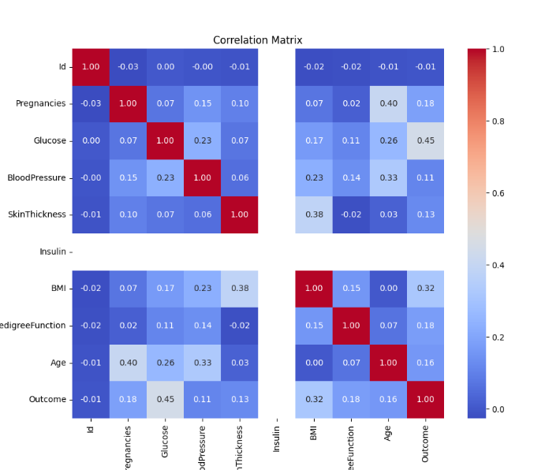
Fig.9 Correlation Analysis

Outlier detection was addressed through the use of boxplots, which facilitated the visualization of outliers in continuous variables like Insulin (Fig.10) and BMI (Fig.11). This analysis helped identify and remove outliers, leading to an overall improvement in data quality.
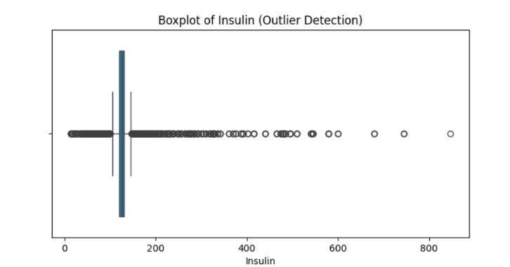
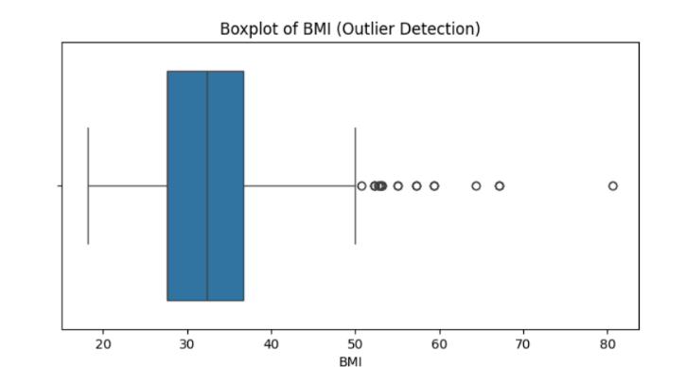
Fig.10 Insulin Fig.11 BMI

Furthermore, an exploration of class balance in the Outcome variable was conducted by plotting a bar chart (Fig.12). This revealed a slightly imbalanced dataset, where a higher number of patients were categorized as non-diabetic (Outcome = 0). This insight can be crucial for modelling and addressing potential biases in predictions.
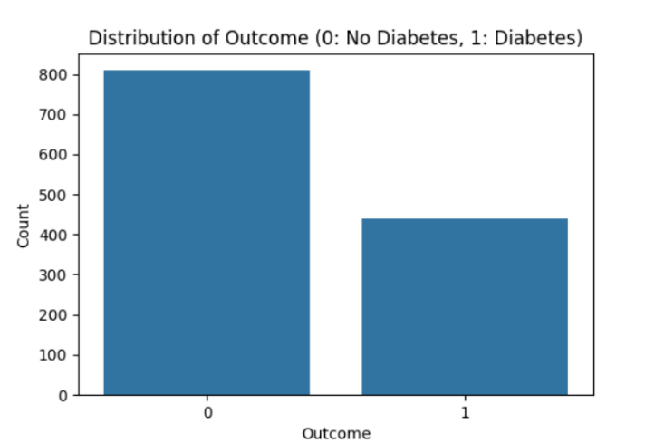
Fig.12 Bar Chart
Data Modelling and Visualization
In the analysis of diabetes prediction, several independent variables were identified, including pregnancies, glucose levels, blood pressure, skin thickness, insulin, BMI, diabetes pedigree function, and age, with the dependent variable being the outcome.
Two primary techniques were employed to build predictive models: Logistic Regression and Random Forest Classifier. Logistic Regression served as a baseline model due to its simplicity and interpretability, making it suitable for binary classification tasks. On the other hand, the Random Forest Classifier, an ensemble learning technique, was applied to enhance prediction accuracy and address potential overfitting concerns (Fig.13) (Solent Online Learning | Data Science | Computing).
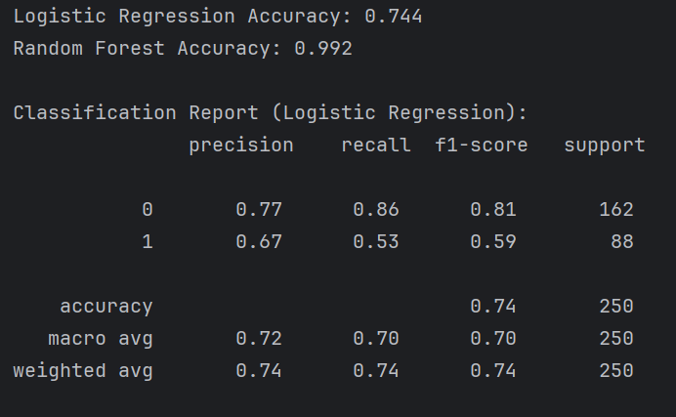
Fig.13
To evaluate the performance of these models, a confusion matrix (Fig.14) was utilized and presented as a heatmap to compare actual versus predicted outcomes. Additionally, the Receiver Operating Characteristic (ROC) curve (Fig.15) was generated for the Logistic Regression model to assess its ability to distinguish between classes, with the Area Under the Curve (AUC) serving as a key performance metric. This approach allowed for a thorough documentation of the predictive modelling steps and evaluation techniques, emphasizing accuracy and interpretability to aid in informed decision-making regarding diabetes prediction.
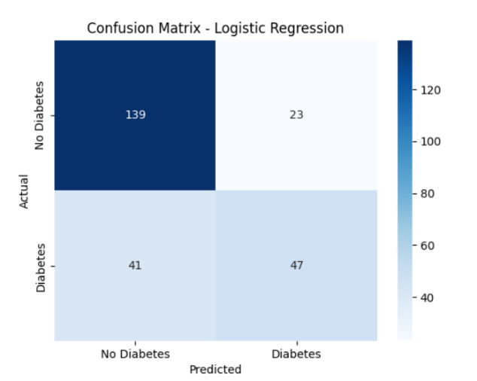
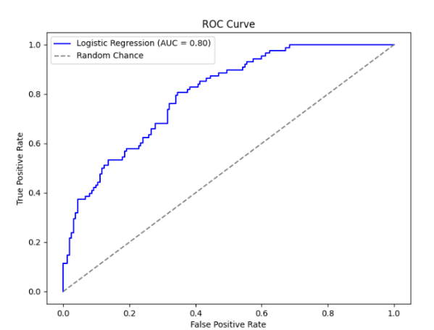
Fig.14 Confusion Matrix Fig.15 ROC Curve

Evaluation
Upon applying Logistic Regression and Random Forest Classifier models, various insights emerged regarding the dataset and the interactions among its variables. The Logistic Regression model exhibited a moderate level of predictive accuracy, emphasising the direct connections between specific features such as Glucose and BMI and the probability of diabetes. In contrast, the Random Forest model showed enhanced accuracy and resilience, particularly in managing feature interactions and identifying non-linear relationships among the variables.

Limitations and Challenges
Similar studies highlighted in American Diabetes Association (2022b) underscore the significance of Glucose and BMI as key predictors of diabetes. These insights resonate with our analysis, where feature importance identified by the Random Forest model similarly emphasised these variables. In addition, other research has utilised Logistic Regression for its interpretability as a baseline model, while also employing advanced ensemble methods like Gradient Boosted Trees to achieve enhanced accuracy.The strengths of our approach lie in its simplicity and interpretability, particularly with Logistic Regression. The use of Random Forest also aided in enhancing accuracy and facilitating a robust feature importance analysis. Additionally, we conducted a comprehensive evaluation using confusion matrices and ROC curves.

On the other hand, I encountered several challenges and limitations during my study. One primary concern was data quality, as the dataset contained missing or invalid values, particularly zeros in medical measurements like Blood Pressure or Insulin. Although we employed median imputation to address this, more advanced methods such as K-Nearest Neighbors imputation or Multiple Imputation by Chained Equations (MICE) could yield better results. We also identified and removed outliers in features like BMI and Glucose; however, this action may have inadvertently discarded valid extremes, making the balance between data cleaning and maintaining variability quite challenging.

In terms of model complexity, while we leveraged Logistic Regression and Random Forest, the consideration of more sophisticated models, like XGBoost or SVM, could potentially enhance performance metrics. Yet, due to constrained computational resources and a preference for interpretability, these alternatives were not utilized. Additionally, while the dataset size was adequate, we noticed a slight imbalance in the binary outcome (diabetes versus non-diabetes), which could impact model performance.

A significant limitation of our study was the absence of external validation. Although we split the dataset into training and test sets, we didn’t use external datasets to assess the model's generalizability. Future efforts could remedy this by incorporating diverse datasets for external testing. Furthermore, we did not derive any new features from the existing dataset, potentially restricting the model's capacity to capture complex relationships. Employing techniques like interaction terms or domain-specific transformations could improve predictive performance. Lastly, while our study was data-driven, integrating more domain knowledge, such as establishing thresholds for specific medical metrics, could sharpen feature selection and enhance model interpretability.

Conclusion

This project offered valuable insights into the analysis and prediction of diabetes through machine learning models. Each phase, from data cleaning to feature exploration, and from model implementation to evaluation, was a valuable learning opportunity in overcoming real-world data challenges.
A significant takeaway was the crucial role of data quality and preprocessing, as issues like missing values and outliers greatly affected the models' reliability. Techniques such as imputation and outlier removal highlighted the necessity for meticulous preparation before training the models. Furthermore, exploring feature relationships using visualisation and statistical methods enriched the analysis and facilitated the interpretation of the results.
The implementation of Logistic Regression and Random Forest models revealed a balance between simplicity and performance. While Logistic Regression provided clarity and interpretability, Random Forest proved effective at capturing complex relationships.
Reflecting on this experience, I developed a deeper understanding of the iterative process in data science—navigating through exploration, testing, refinement, and interpretation to uncover meaningful insights. This project has enhanced my ability to systematically address data-driven problems and laid a solid foundation for tackling more complex datasets and employing advanced techniques in the future.
In summary, this work not only reinforced my theoretical understanding but also improved my practical skills, setting the groundwork for ongoing learning and development in data science and healthcare analytics.

Reference List (Harvard Style) Or Bibliography (Harvard Style)

AMERICAN DIABETES ASSOCIATION, 2022. Standards of Medical Care in Diabetes—2022 Abridged for Primary Care Providers. Clinical Diabetes, 40(1), 10–38

CHEN, T., et al., 2020. A Simple Framework for Contrastive Learning of Visual Representations [viewed Dec 20 2024]. Available from: http://arxiv.org/abs/2002.05709

FREGOSO-APARICIO, L. et al., 2021. Machine learning and deep learning predictive models for type 2 diabetes: a systematic review. Diabetology & Metabolic Syndrome, 13(1), 148

GHAZALI, I.A., 2018. How to Remove outlier from DataFrame using IQR? In: Stack Overflow. -05-22 [viewed Dec 18, 2024]. Available from: https://stackoverflow.com/q/50461349

SEABORN, seaborn.heatmap — seaborn 0.13.2 documentation.

SimpleImputer [viewed Dec 18 2024]. Available from: https://scikit-learn/stable/modules/generated/sklearn.impute.SimpleImputer.html

SOLENT ONLINE LEARNING | DATA SCIENCE | COMPUTING, Tab: Week 10 | Data Science (COM618) | Solent Online Learning [viewed Dec 19 2024]. Available from: https://learn.solent.ac.uk/course/view.php?id=58828&section=15

KHARE, A.D., 2022. Diabetes Dataset Available from: https://www.kaggle.com/datasets/akshaydattatraykhare/diabetes-dataset

WORLD HEALTH ORGANIZATION, 2021. Using big data to inform health care: opportunities, challenges and considerations Available from: https://www.who.int/europe/news-room/26-05-2021-using-big-data-to-inform-health-care-opportunities-challenges-and-considerations

W3SCHOOL, a. Pandas - Analyzing DataFrames [viewed Dec 18 2024]. Available from: https://www.w3schools.com/python/pandas/pandas_analyzing.asp

W3SCHOOL, b. Pandas DataFrame describe() Method [viewed Dec 18 2024]. Available from: https://www.w3schools.com/python/pandas/ref_df_describe.asp

W3SCHOOL, c. Pandas DataFrame info() Method [viewed Dec 18 2024]. Available from: https://www.w3schools.com/python/pandas/ref_df_info.asp

W3SCHOOL, d. Pandas DataFrame isna() Method [viewed Dec 18 2024]. Available from: https://www.w3schools.com/python/pandas/ref_df_isna.asp

W3SCHOOL, e. Seaborn [viewed Dec 18 2024]. Available from: https://www.w3schools.com/python/numpy/numpy_random_seaborn.asp

Appendix
