retrauci-plots
2026-06-22
##
## Adjuntando el paquete: 'dplyr'
## The following objects are masked from 'package:stats':
##
## filter, lag
## The following objects are masked from 'package:base':
##
## intersect, setdiff, setequal, union
## Warning: package 'ggplot2' was built under R version 4.5.3
#SUMMARY
- 1 GENERAL DATA
- MORTALITY
#GENERAL DATA
Year | Number of admissions | Deaths | Mortality (%)
2015 | 1273 | 146 | 11.5
2016 | 2128 | 282 | 13.3
2017 | 2179 | 205 | 9.4
2018 | 1952 | 235 | 12.0
2019 | 1880 | 218 | 11.6
2020 | 1294 | 144 | 11.1
2021 | 1337 | 120 | 9.0
2022 | 1390 | 162 | 11.7
2023 | 2073 | 218 | 10.5
2024 | 1795 | 186 | 10.4
2025 | 1734 | 208 | 12.0

Year | N | Mean time trauma-hospital (min) | SD | Median (min) | IQR (min)
2015 | 861 | 151.2 | 206.0 | 76 | 97.0
2016 | 1290 | 141.0 | 194.8 | 75 | 89.0
2017 | 1276 | 152.7 | 223.1 | 75 | 87.2
2018 | 1353 | 128.5 | 167.3 | 75 | 74.0
2019 | 1275 | 137.8 | 193.2 | 75 | 70.0
2020 | 850 | 119.6 | 152.6 | 74 | 68.0
2021 | 801 | 124.4 | 162.3 | 75 | 70.0
2022 | 824 | 137.1 | 200.2 | 75 | 70.0
2023 | 1192 | 122.1 | 166.7 | 75 | 66.5
2024 | 1103 | 114.0 | 150.1 | 74 | 62.0
2025 | 1226 | 112.3 | 154.4 | 71 | 56.0
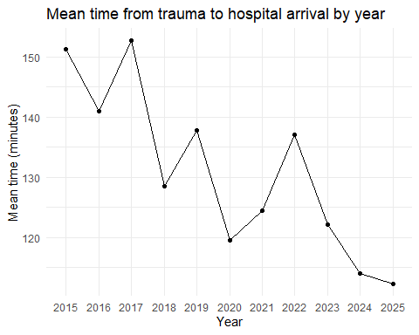
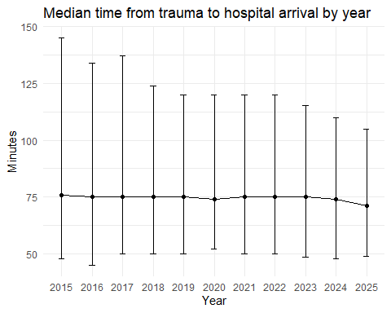
year | MAIS1 | MAIS1>=3 | MAIS2 | MAIS2>=3 | MAIS3 | MAIS3>=3 | MAIS4 | MAIS4>=3 | MAIS5 | MAIS5>=3 | MAIS6 | MAIS6>=3
2015 | 61.7 | 47.2 | 21.1 | 3.5 | 53.1 | 41.6 | 28.2 | 12.7 | 44.9 | 20.0 | 5.8 | 1.3
2016 | 60.9 | 45.9 | 20.9 | 3.0 | 53.1 | 40.2 | 27.8 | 14.5 | 45.2 | 18.9 | 3.5 | 1.0
2017 | 62.3 | 46.2 | 22.1 | 3.0 | 52.5 | 39.6 | 29.5 | 15.4 | 46.5 | 20.2 | 4.0 | 1.0
2018 | 63.7 | 49.1 | 22.5 | 2.7 | 49.0 | 37.2 | 27.0 | 14.1 | 42.7 | 18.7 | 3.7 | 1.2
2019 | 57.3 | 44.0 | 19.7 | 3.0 | 53.1 | 39.1 | 29.3 | 14.8 | 44.9 | 19.9 | 3.7 | 0.9
2020 | 54.7 | 38.4 | 20.6 | 2.9 | 53.8 | 40.8 | 31.0 | 15.8 | 50.5 | 23.8 | 5.0 | 1.5
2021 | 55.9 | 40.2 | 23.9 | 3.9 | 53.9 | 41.5 | 28.9 | 16.1 | 46.1 | 20.9 | 5.8 | 1.2
2022 | 60.9 | 47.7 | 22.4 | 2.9 | 51.3 | 39.0 | 28.1 | 15.2 | 43.0 | 20.1 | 8.2 | 1.9
2023 | 55.3 | 42.0 | 20.3 | 2.5 | 52.3 | 39.7 | 30.8 | 17.1 | 43.9 | 18.0 | 9.1 | 1.3
2024 | 58.4 | 43.2 | 21.2 | 2.8 | 51.2 | 38.7 | 29.2 | 16.3 | 42.5 | 19.6 | 8.7 | 1.6
2025 | 60.9 | 46.5 | 21.5 | 3.2 | 51.2 | 40.3 | 30.4 | 15.9 | 42.7 | 20.1 | 6.7 | 0.9

