

02.10.2024

Dear **Reader,**

This is a short document to **demonstrate that you can fill Word docs using R**. That way, you can dynamically fill the document with the content that you want. That’s why there are so many **STUPID** styles in this document. You know, to prove that you can use anything Word gives you and modify that with R. Or even insert extra stuff. For example, here is a chart about everyone’s favorite penguins:

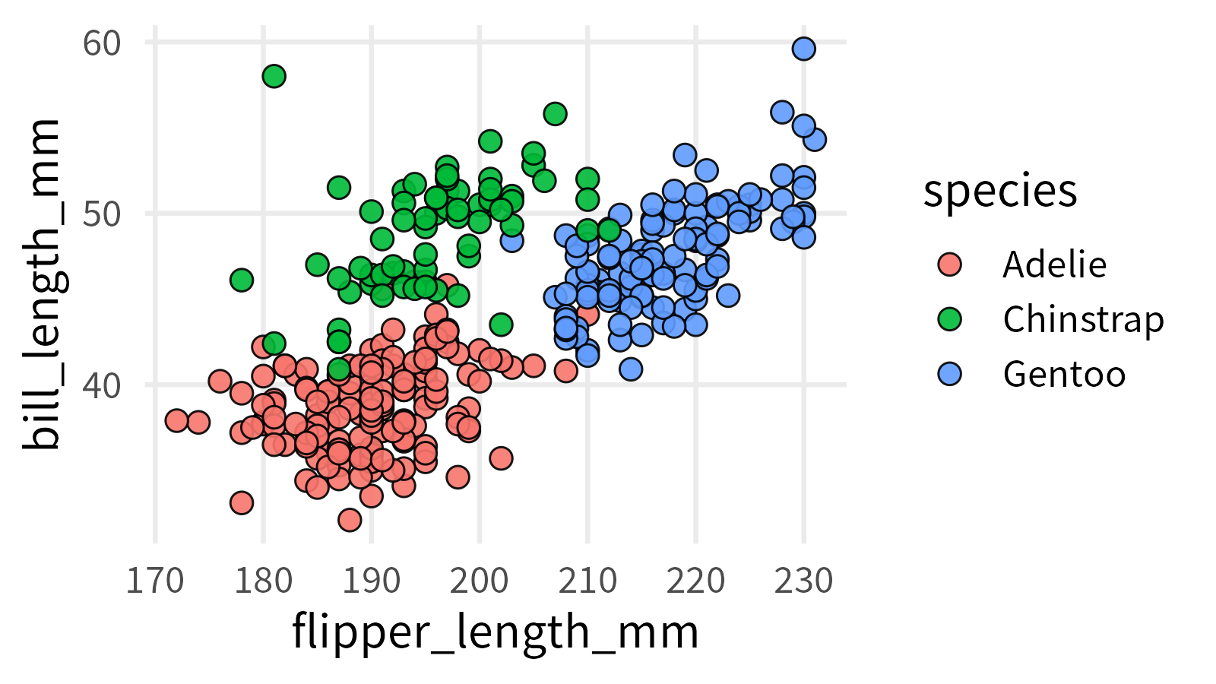

Warm Regards,

Albert  
https://3mw.albert-rapp.de/