Client Use Case Realiations

Add new contact
*User clicks button requesting to add new contact.
*'Add new contact' form is displayed, requesting name of new contact.
*User enters username of contact they wish to add, then clicks 'Ok' button.
*Username is sent to the controller for validation.
*If username is valid, the controller creates a Json packet containing the username and sends it to the websocket
*Websocket sends the Json packet to the server application.
*The server responds with a Json packet indicating whether the contact was added.
*The controller unpacks the Json packet to identify the result.
*If the packet indicates that the request was successful, the controller updates the contact data in the client's database.
*The controller notifies the client view form that the contact was added so that it can display the information to the user.

Logout
*User clicks the 'logout' button.
*View form tells the controller to send logout request.
*Controller creates Json packet to notify server of logout.
*Controller sends packet to Websocket to send to server.
*Controller clears contact data from client database.
*Controller notifies main client view form to hide and show the login form.

Class Diagram:
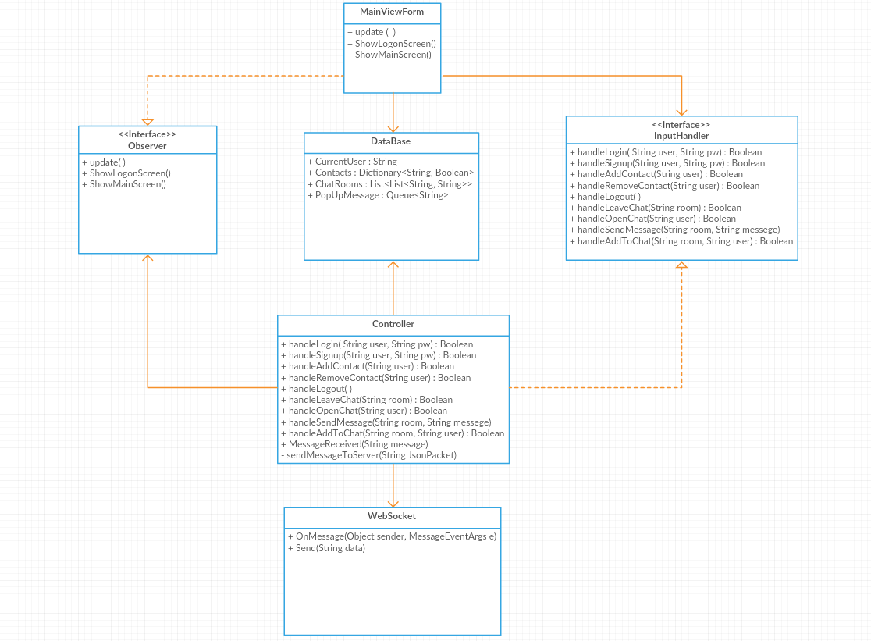

State Diagram:

