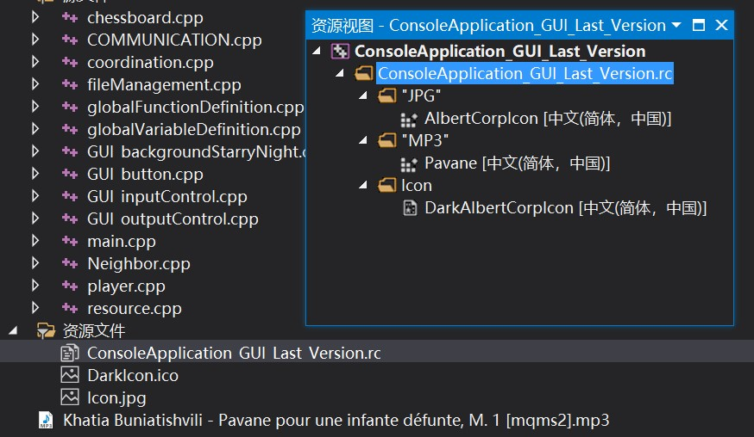

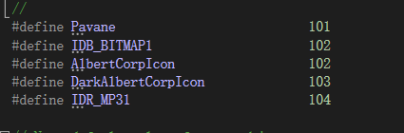

**To build a project using these document, you should make iCONs and music your resource file, and**

**a) embed music into your project.**

**define it as an "MP3" file.**

**b) drag icon onto your desktop, especially when VS tells you "file not found".**

**rewrite the codes in resoure.h or another resource management file**