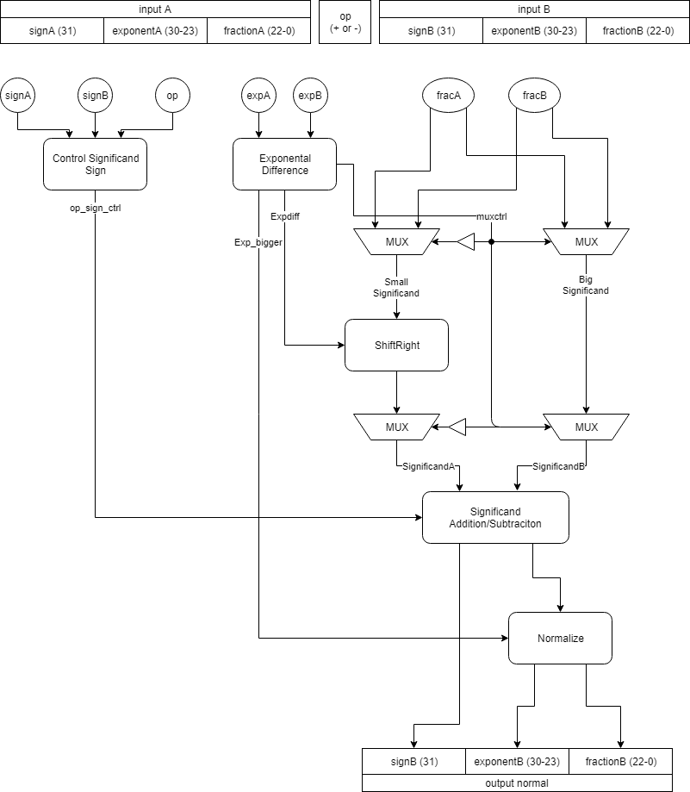

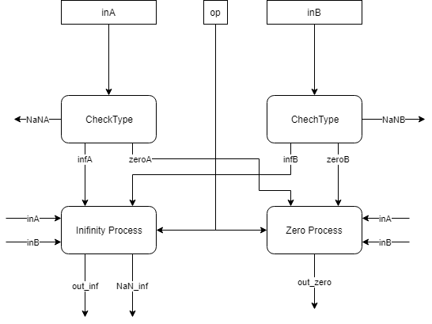

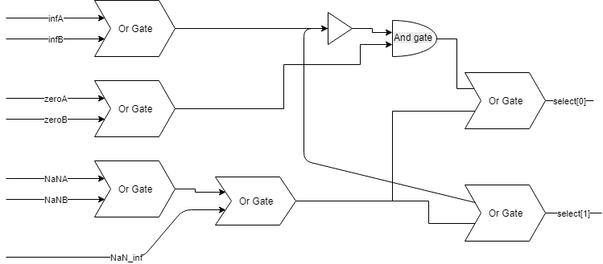
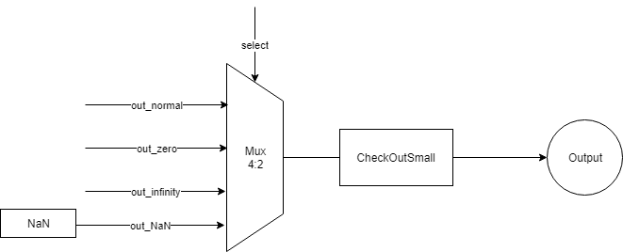
- Khối control significand sign:

Dựa vào dấu của các input và operation (+ hay -) để quyết định đảo bit các significand.

signA | signB | Op | Opsign[1] | Opsign[0]
+ | + | + | 0 | 0
+ | + | - | 1 | 0
+ | - | + | 1 | 0
+ | - | - | 0 | 0
- | + | + | 0 | 1
- | + | - | 1 | 1
- | - | + | 1 | 1
- | - | - | 0 | 1

Opsign[1] quyết định signficand B. Opsign[0] quyết định significand A. Opsign[1] hay [0] nếu bằng 1 thì đảo bit significand tương ứng.
- Khối Exponental Difference
Dùng tìm ra số mũ lớn hơn và chênh lệch về số mũ để dùng trong dịch significand và chuẩn hóa (normalize).
Trừ 2 số mũ để tìm chênh lệch, dùng dấu của kết quả trừ để biết số mũ nào lớn hơn.
Sau cùng là lấy bù 2 kết quả trừ nếu kết quả trừ trên bị âm.
- Chuẩn bị cho các significand
Significand của số có phần số mũ nhỏ hơn sẽ được lựa chọn thông qua các MUX để lái vào bộ dịch phải. Lượng bit dịch phải chính là chênh lệch về số mũ. Sau đó, các significand được trả về vị trí cũ cũng qua các MUX
- Khối Significand
Khối này dùng để cộng 2 phần significand lại với nhau.
Significand sẽ được đảo bit tùy thuộc vào opsign ở phần trước.
Các significand có 24 bit, kết quả trả về là 25 bit. Vì vậy trước khi cộng ta sign-extend các significand lên 26 bit, với bit thứ 26 dùng để xác định dấu ngõ ra.
Nếu bit dấu nói trên bằng 1(kết quả âm) , thực hiện lấy bù 2 để ra kết quả dương.
Các quá trình cộng sử dụng CSA.
- Khối normalize (chuẩn hóa)
Dùng để tìm số mũ và phần fraction phù hợp cho ngõ ra.
Các công đoạn:
- Tìm bit 1 đầu tiên tính từ MSB đến LSB
- Dựa vào vị trí bit 1 để lấy phần fraction và tính phần số mũ cần trừ xuống
- Làm tròn phần fraction
- Tìm số mũ ngõ ra.
Sau khối này ta có ngõ ra của bộ cộng trừ trong trường hợp ngõ vào là số bình thường( kah1c 0, inf hay NaN)”
- Phần dấu có từ khối Significand
- Phần mũ và fraction có từ khối Normalize.
- Xử lí với các trường hợp đặc biệt.
Các trường hợp đặc biệt:
- Zero (0). Phần mũ và fraction bằng 0
- Infinity: Phần mũ bằng 11111111, phần fraction bằng 0
- NaN(not a number): Phần mũ bằng 11111111, phần fraction khác 0.

Khối CheckType có tác dụng kiểm tra ngõ vào A và B
Khối InifinityProcess dùng để tìm ngõ ra phù hợp trong trường hợp có ít nhất 1 ngõ vào là vô cùng:
- Kết quả trả về là vô cùng nếu chỉ có 1 ngõ vào là vô cùng.
- Nếu 2 ngõ vào đều là vô cùng, các phép tính toán cho kết quả inf – inf (vô định) sẽ được chuyển về NaN, ngược lại trả về vô cùng. Ngõ ra NaN_inf là nhằm mục đích trên.
Khối ZeroProcess dùng để tìm ngõ ra phù hợp trong trường hợp có ít nhất 1 ngõ vào là 0:
- Ngõ ra có thể là 0, inA hoặc inB và sẽ được lựa chọn thông qua bộ MUX.

Sau cùng: các ngõ ra gồm: out_normal, out_inf, out_zero và outNaN (được gán thẳng bằng NaN) sẽ được đưa qua MUX 4-1, với tín hiệu lựa chọn là select.
Inf=infA+infB | Zero=zeroA+zeroB | NaN=NaNA+NaNB+NaN_inf | Chọn
0 | 0 | 0 | Out_normal
0 | 0 | 1 | Out_NaN
0 | 1 | 0 | Out_zero
0 | 1 | 1 | Out_NaN
1 | 0 | 0 | Out_inf
1 | 0 | 1 | Out_NaN
1 | 1 | 0 | Out_inf
1 | 1 | 1 | Out_NaN

Select[0] = select zero + select NaN = Zero./(inf) + NaN
Select[1] = select inf + select NaN = NaN + inf

//Stage 1
HalfAdder H10(a[2],b[0],al2,ah2);
HalfAdder H11(a[3],b[1],al3,ah3);
FullAdder F10(a[4],b[2],c[0],al4,ah4);
FullAdder F11(a[5],b[3],c[1],al5,ah5);
FullAdder F12(a[6],b[4],c[2],al6,ah6);
FullAdder F13(a[7],b[5],c[3],al7,ah7);
FullAdder F14(a[8],b[6],c[4],al8,ah8);
FullAdder F15(a[9],b[7],c[5],al9,ah9);
FullAdder F16(a[10],b[8],c[6],al10,ah10);
FullAdder F17(a[11],b[9],c[7],al11,ah11);
FullAdder F18(a[12],b[10],c[8],al12,ah12);
FullAdder F19(a[13],b[11],c[9],al13,ah13);
FullAdder F110(a[14],b[12],c[10],al14,ah14);
FullAdder F111(a[15],b[13],c[11],al15,ah15);
FullAdder F112(a[16],b[14],c[12],al16,ah16);
FullAdder F113(a[17],b[15],c[13],al17,ah17);
FullAdder F114(a[18],b[16],c[14],al18,ah18);
FullAdder F115(a[19],b[17],c[15],al19,ah19);
FullAdder F116(a[20],b[18],c[16],al20,ah20);
FullAdder F117(a[21],b[19],c[17],al21,ah21);
FullAdder F118(a[22],b[20],c[18],al22,ah22);
FullAdder F119(a[23],b[21],c[19],al23,ah23);
FullAdder F120(a[24],b[22],c[20],al24,ah24);
FullAdder F121(a[25],b[23],c[21],al25,ah25);

HalfAdder H12(d[2],e[0],dl2,dh2);
HalfAdder H13(d[3],e[1],dl3,dh3);
FullAdder F122(d[4],e[2],f[0],dl4,dh4);
FullAdder F123(d[5],e[3],f[1],dl5,dh5);
FullAdder F124(d[6],e[4],f[2],dl6,dh6);
FullAdder F125(d[7],e[5],f[3],dl7,dh7);
FullAdder F126(d[8],e[6],f[4],dl8,dh8);
FullAdder F127(d[9],e[7],f[5],dl9,dh9);
FullAdder F128(d[10],e[8],f[6],dl10,dh10);
FullAdder F129(d[11],e[9],f[7],dl11,dh11);
FullAdder F130(d[12],e[10],f[8],dl12,dh12);
FullAdder F131(d[13],e[11],f[9],dl13,dh13);
FullAdder F132(d[14],e[12],f[10],dl14,dh14);
FullAdder F133(d[15],e[13],f[11],dl15,dh15);
FullAdder F134(d[16],e[14],f[12],dl16,dh16);
FullAdder F135(d[17],e[15],f[13],dl17,dh17);
FullAdder F136(d[18],e[16],f[14],dl18,dh18);
FullAdder F137(d[19],e[17],f[15],dl19,dh19);
FullAdder F138(d[20],e[18],f[16],dl20,dh20);
FullAdder F139(d[21],e[19],f[17],dl21,dh21);
FullAdder F140(d[22],e[20],f[18],dl22,dh22);
FullAdder F141(d[23],e[21],f[19],dl23,dh23);
FullAdder F142(d[24],e[22],f[20],dl24,dh24);
FullAdder F143(d[25],e[23],f[21],dl25,dh25);

HalfAdder H14(g[2],h[0],gl2,gh2);
HalfAdder H15(g[3],h[1],gl3,gh3);
FullAdder F144(g[4],h[2],i[0],gl4,gh4);
FullAdder F145(g[5],h[3],i[1],gl5,gh5);
FullAdder F146(g[6],h[4],i[2],gl6,gh6);
FullAdder F147(g[7],h[5],i[3],gl7,gh7);
FullAdder F148(g[8],h[6],i[4],gl8,gh8);
FullAdder F149(g[9],h[7],i[5],gl9,gh9);
FullAdder F150(g[10],h[8],i[6],gl10,gh10);
FullAdder F151(g[11],h[9],i[7],gl11,gh11);
FullAdder F152(g[12],h[10],i[8],gl12,gh12);
FullAdder F153(g[13],h[11],i[9],gl13,gh13);
FullAdder F154(g[14],h[12],i[10],gl14,gh14);
FullAdder F155(g[15],h[13],i[11],gl15,gh15);
FullAdder F156(g[16],h[14],i[12],gl16,gh16);
FullAdder F157(g[17],h[15],i[13],gl17,gh17);
FullAdder F158(g[18],h[16],i[14],gl18,gh18);
FullAdder F159(g[19],h[17],i[15],gl19,gh19);
FullAdder F160(g[20],h[18],i[16],gl20,gh20);
FullAdder F161(g[21],h[19],i[17],gl21,gh21);
FullAdder F162(g[22],h[20],i[18],gl22,gh22);
FullAdder F163(g[23],h[21],i[19],gl23,gh23);
FullAdder F164(g[24],h[22],i[20],gl24,gh24);
FullAdder F165(g[25],h[23],i[21],gl25,gh25);

HalfAdder H16(j[2],k[0],jl2,jh2);
HalfAdder H17(j[3],k[1],jl3,jh3);
FullAdder F166(j[4],k[2],l[0],jl4,jh4);
FullAdder F167(j[5],k[3],l[1],jl5,jh5);
FullAdder F168(j[6],k[4],l[2],jl6,jh6);
FullAdder F169(j[7],k[5],l[3],jl7,jh7);
FullAdder F170(j[8],k[6],l[4],jl8,jh8);
FullAdder F171(j[9],k[7],l[5],jl9,jh9);
FullAdder F172(j[10],k[8],l[6],jl10,jh10);
FullAdder F173(j[11],k[9],l[7],jl11,jh11);
FullAdder F174(j[12],k[10],l[8],jl12,jh12);
FullAdder F175(j[13],k[11],l[9],jl13,jh13);
FullAdder F176(j[14],k[12],l[10],jl14,jh14);
FullAdder F177(j[15],k[13],l[11],jl15,jh15);
FullAdder F178(j[16],k[14],l[12],jl16,jh16);
FullAdder F179(j[17],k[15],l[13],jl17,jh17);
FullAdder F180(j[18],k[16],l[14],jl18,jh18);
FullAdder F181(j[19],k[17],l[15],jl19,jh19);
FullAdder F182(j[20],k[18],l[16],jl20,jh20);
FullAdder F183(j[21],k[19],l[17],jl21,jh21);
FullAdder F184(j[22],k[20],l[18],jl22,jh22);
FullAdder F185(j[23],k[21],l[19],jl23,jh23);
FullAdder F186(j[24],k[22],l[20],jl24,jh24);
FullAdder F187(j[25],k[23],l[21],jl25,jh25);

FullAdder F188(b[24],c[22],m[2],bl24,bh24);
FullAdder F189(b[25],c[23],m[3],bl25,bh25);
HalfAdder H18(c[24],m[4],cl24,ch24);
HalfAdder H19(c[25],m[5],cl25,ch25);
FullAdder F190(e[24],f[22],m[8],el24,eh24);
FullAdder F191(e[25],f[23],m[9],el25,eh25);
HalfAdder H110(f[24],m[10],fl24,fh24);
HalfAdder H111(f[25],m[11],fl25,fh25);
FullAdder F192(h[24],i[22],m[14],hl24,hh24);
FullAdder F193(h[25],i[23],m[15],hl25,hh25);
HalfAdder H112(i[24],m[16],il24,ih24);
HalfAdder H113(i[25],m[17],il25,ih25);
FullAdder F194(k[24],l[22],m[20],kl24,kh24);
FullAdder F195(k[25],l[23],m[21],kl25,kh25);
HalfAdder H114(l[24],m[22],ll24,lh24);
HalfAdder H115(l[25],m[23],ll25,lh25);

//Stage 2
HalfAdder H20(ah2,al3,ahl2,ahh2);
HalfAdder H21(ah3,al4,ahl3,ahh3);
HalfAdder H22(ah4,al5,ahl4,ahh4);
FullAdder F20(ah5,al6,d[0],ahl5,ahh5);
FullAdder F21(ah6,al7,d[1],ahl6,ahh6);
FullAdder F22(ah7,al8,dl2,ahl7,ahh7);
FullAdder F23(ah8,dh2,al9,ahl8,ahh8);
FullAdder F24(ah9,dh3,al10,ahl9,ahh9);
FullAdder F25(ah10,dh4,al11,ahl10,ahh10);
FullAdder F26(ah11,dh5,al12,ahl11,ahh11);
FullAdder F27(ah12,dh6,al13,ahl12,ahh12);
FullAdder F28(ah13,dh7,al14,ahl13,ahh13);
FullAdder F29(ah14,dh8,gh2,ahl14,ahh14);
FullAdder F210(ah15,dh9,gh3,ahl15,ahh15);
FullAdder F211(ah16,dh10,gh4,ahl16,ahh16);
FullAdder F212(ah17,dh11,gh5,ahl17,ahh17);
FullAdder F213(ah18,dh12,gh6,ahl18,ahh18);
FullAdder F214(ah19,dh13,gh7,ahl19,ahh19);
FullAdder F215(ah20,dh14,gh8,ahl20,ahh20);
FullAdder F216(ah21,dh15,gh9,ahl21,ahh21);
FullAdder F217(ah22,dh16,gh10,ahl22,ahh22);
FullAdder F218(ah23,dh17,gh11,ahl23,ahh23);
FullAdder F219(ah24,dh18,gh12,ahl24,ahh24);
FullAdder F220(ah25,dh19,gh13,ahl25,ahh25);
FullAdder F221(bh24,dh20,gh14,bhl24,bhh24);
FullAdder F222(bh25,dh21,gh15,bhl25,bhh25);
FullAdder F223(ch24,dh22,gh16,chl24,chh24);
FullAdder F224(ch25,dh23,gh17,chl25,chh25);
FullAdder F225(dh24,gh18,jh12,dhl24,dhh24);
FullAdder F226(dh25,gh19,jh13,dhl25,dhh25);
FullAdder F227(eh24,gh20,jh14,ehl24,ehh24);
FullAdder F228(eh25,gh21,jh15,ehl25,ehh25);
FullAdder F229(fh24,gh22,jh16,fhl24,fhh24);
FullAdder F230(fh25,gh23,jh17,fhl25,fhh25);
FullAdder F231(gh24,jh18,gl25,ghl24,ghh24);
FullAdder F232(gh25,jh19,hl24,ghl25,ghh25);
FullAdder F233(hh24,jh20,hl25,hhl24,hhh24);
FullAdder F234(hh25,jh21,il24,hhl25,hhh25);
FullAdder F235(ih24,jh22,il25,ihl24,ihh24);
FullAdder F236(ih25,jh23,jl24,ihl25,ihh25);
FullAdder F237(jh24,jl25,m[19],jhl24,jhh24);
HalfAdder H23(jh25,kl24,jhl25,jhh25);
HalfAdder H24(kh24,kl25,khl24,khh24);
HalfAdder H25(kh25,ll24,khl25,khh25);
HalfAdder H26(lh24,ll25,lhl24,lhh24);
HalfAdder H27(lh25,m[24],lhl25,lhh25);

HalfAdder H28(dl6,g[0],dll6,dlh6);
HalfAdder H29(dl7,g[1],dll7,dlh7);
HalfAdder H210(dl8,gl2,dll8,dlh8);
FullAdder F238(al15,dl9,gl3,all15,alh15);
FullAdder F239(al16,dl10,gl4,all16,alh16);
FullAdder F240(al17,dl11,gl5,all17,alh17);
FullAdder F241(al18,dl12,gl6,all18,alh18);
FullAdder F242(al19,dl13,gl7,all19,alh19);
FullAdder F243(al20,dl14,gl8,all20,alh20);
FullAdder F244(jh2,al21,dl15,jhl2,jhh2);
FullAdder F245(jh3,al22,dl16,jhl3,jhh3);
FullAdder F246(jh4,al23,dl17,jhl4,jhh4);
FullAdder F247(jh5,al24,dl18,jhl5,jhh5);
FullAdder F248(jh6,al25,dl19,jhl6,jhh6);
FullAdder F249(jh7,bl24,dl20,jhl7,jhh7);
FullAdder F250(jh8,bl25,dl21,jhl8,jhh8);
FullAdder F251(jh9,cl24,dl22,jhl9,jhh9);
FullAdder F252(jh10,cl25,dl23,jhl10,jhh10);
FullAdder F253(jh11,dl24,gl18,jhl11,jhh11);
FullAdder F254(dl25,gl19,jl13,dll25,dlh25);
FullAdder F255(el24,gl20,jl14,ell24,elh24);
FullAdder F256(el25,gl21,jl15,ell25,elh25);
FullAdder F257(fl24,gl22,jl16,fll24,flh24);
FullAdder F258(fl25,gl23,jl17,fll25,flh25);
FullAdder F259(gl24,jl18,m[12],gll24,glh24);
HalfAdder H211(jl19,m[13],jll19,jlh19);
HalfAdder H212(gl9,jl3,gll9,glh9);
HalfAdder H213(gl10,jl4,gll10,glh10);
HalfAdder H214(gl11,jl5,gll11,glh11);
FullAdder F260(gl12,jl6,m[0],gll12,glh12);
FullAdder F261(gl13,jl7,m[1],gll13,glh13);
HalfAdder H215(gl14,jl8,gll14,glh14);
HalfAdder H216(gl15,jl9,gll15,glh15);
HalfAdder H217(gl16,jl10,gll16,glh16);
HalfAdder H218(gl17,jl11,gll17,glh17);
HalfAdder H219(jl12,m[6],jll12,jlh12);

//Stage 3
HalfAdder H30(ahh2,ahl3,ahhl2,ahhh2);
HalfAdder H31(ahh3,ahl4,ahhl3,ahhh3);
HalfAdder H32(ahh4,ahl5,ahhl4,ahhh4);
HalfAdder H33(ahh5,ahl6,ahhl5,ahhh5);
HalfAdder H34(ahh6,ahl7,ahhl6,ahhh6);
FullAdder F30(ahh7,ahl8,dl3,ahhl7,ahhh7);
FullAdder F31(ahh8,ahl9,dl4,ahhl8,ahhh8);
FullAdder F32(ahh9,ahl10,dl5,ahhl9,ahhh9);
FullAdder F33(ahh10,ahl11,dll6,ahhl10,ahhh10);
FullAdder F34(ahh11,dlh6,ahl12,ahhl11,ahhh11);
FullAdder F35(ahh12,dlh7,ahl13,ahhl12,ahhh12);
FullAdder F36(ahh13,dlh8,ahl14,ahhl13,ahhh13);
FullAdder F37(ahh14,alh15,ahl15,ahhl14,ahhh14);
FullAdder F38(ahh15,alh16,ahl16,ahhl15,ahhh15);
FullAdder F39(ahh16,alh17,ahl17,ahhl16,ahhh16);
FullAdder F310(ahh17,alh18,ahl18,ahhl17,ahhh17);
FullAdder F311(ahh18,alh19,ahl19,ahhl18,ahhh18);
FullAdder F312(ahh19,alh20,ahl20,ahhl19,ahhh19);
FullAdder F313(ahh20,jhh2,glh9,ahhl20,ahhh20);
FullAdder F314(ahh21,jhh3,glh10,ahhl21,ahhh21);
FullAdder F315(ahh22,jhh4,glh11,ahhl22,ahhh22);
FullAdder F316(ahh23,jhh5,glh12,ahhl23,ahhh23);
FullAdder F317(ahh24,jhh6,glh13,ahhl24,ahhh24);
FullAdder F318(ahh25,jhh7,glh14,ahhl25,ahhh25);
FullAdder F319(bhh24,jhh8,glh15,bhhl24,bhhh24);
FullAdder F320(bhh25,jhh9,glh16,bhhl25,bhhh25);
FullAdder F321(chh24,jhh10,glh17,chhl24,chhh24);
FullAdder F322(chh25,jhh11,jlh12,chhl25,chhh25);
FullAdder F323(dhh24,dlh25,dhl25,dhhl24,dhhh24);
FullAdder F324(dhh25,elh24,ehl24,dhhl25,dhhh25);
FullAdder F325(ehh24,elh25,ehl25,ehhl24,ehhh24);
FullAdder F326(ehh25,flh24,fhl24,ehhl25,ehhh25);
FullAdder F327(fhh24,flh25,fhl25,fhhl24,fhhh24);
FullAdder F328(fhh25,glh24,ghl24,fhhl25,fhhh25);
FullAdder F329(ghh24,jlh19,ghl25,ghhl24,ghhh24);
FullAdder F330(ghh25,hhl24,jl21,ghhl25,ghhh25);
FullAdder F331(hhh24,hhl25,jl22,hhhl24,hhhh24);
FullAdder F332(hhh25,ihl24,jl23,hhhl25,hhhh25);
FullAdder F333(ihh24,ihl25,m[18],ihhl24,ihhh24);
HalfAdder H35(ihh25,jhl24,ihhl25,ihhh25);
HalfAdder H36(jhh24,jhl25,jhhl24,jhhh24);
HalfAdder H37(jhh25,khl24,jhhl25,jhhh25);
HalfAdder H38(khh24,khl25,khhl24,khhh24);
HalfAdder H39(khh25,lhl24,khhl25,khhh25);
HalfAdder H310(lhh24,lhl25,lhhl24,lhhh24);
HalfAdder H311(lhh25,m[25],lhhl25,lhhh25);

HalfAdder H312(all18,j[0],alll18,allh18);
HalfAdder H313(all19,j[1],alll19,allh19);
HalfAdder H314(all20,jl2,alll20,allh20);
HalfAdder H315(jhl2,gll9,jhll2,jhlh2);
FullAdder F334(ahl21,jhl3,gll10,ahll21,ahlh21);
FullAdder F335(ahl22,jhl4,gll11,ahll22,ahlh22);
FullAdder F336(ahl23,jhl5,gll12,ahll23,ahlh23);
FullAdder F337(ahl24,jhl6,gll13,ahll24,ahlh24);
FullAdder F338(ahl25,jhl7,gll14,ahll25,ahlh25);
FullAdder F339(bhl24,jhl8,gll15,bhll24,bhlh24);
FullAdder F340(bhl25,jhl9,gll16,bhll25,bhlh25);
FullAdder F341(chl24,jhl10,gll17,chll24,chlh24);
FullAdder F342(chl25,jhl11,jll12,chll25,chlh25);
FullAdder F343(dhl24,dll25,m[7],dhll24,dhlh24);

//Stage 4
HalfAdder H40(ahhh2,ahhl3,ahhhl2,ahhhh2);
HalfAdder H41(ahhh3,ahhl4,ahhhl3,ahhhh3);
HalfAdder H42(ahhh4,ahhl5,ahhhl4,ahhhh4);
HalfAdder H43(ahhh5,ahhl6,ahhhl5,ahhhh5);
HalfAdder H44(ahhh6,ahhl7,ahhhl6,ahhhh6);
HalfAdder H45(ahhh7,ahhl8,ahhhl7,ahhhh7);
HalfAdder H46(ahhh8,ahhl9,ahhhl8,ahhhh8);
HalfAdder H47(ahhh9,ahhl10,ahhhl9,ahhhh9);
FullAdder F40(ahhh10,ahhl11,dll7,ahhhl10,ahhhh10);
FullAdder F41(ahhh11,ahhl12,dll8,ahhhl11,ahhhh11);
FullAdder F42(ahhh12,ahhl13,all15,ahhhl12,ahhhh12);
FullAdder F43(ahhh13,ahhl14,all16,ahhhl13,ahhhh13);
FullAdder F44(ahhh14,ahhl15,all17,ahhhl14,ahhhh14);
FullAdder F45(ahhh15,ahhl16,all18,ahhhl15,ahhhh15);
FullAdder F46(ahhh16,allh18,ahhl17,ahhhl16,ahhhh16);
FullAdder F47(ahhh17,allh19,ahhl18,ahhhl17,ahhhh17);
FullAdder F48(ahhh18,allh20,ahhl19,ahhhl18,ahhhh18);
FullAdder F49(ahhh19,jhlh2,ahhl20,ahhhl19,ahhhh19);
FullAdder F410(ahhh20,ahlh21,ahhl21,ahhhl20,ahhhh20);
FullAdder F411(ahhh21,ahlh22,ahhl22,ahhhl21,ahhhh21);
FullAdder F412(ahhh22,ahlh23,ahhl23,ahhhl22,ahhhh22);
FullAdder F413(ahhh23,ahlh24,ahhl24,ahhhl23,ahhhh23);
FullAdder F414(ahhh24,ahlh25,ahhl25,ahhhl24,ahhhh24);
FullAdder F415(ahhh25,bhlh24,bhhl24,ahhhl25,ahhhh25);
FullAdder F416(bhhh24,bhlh25,bhhl25,bhhhl24,bhhhh24);
FullAdder F417(bhhh25,chlh24,chhl24,bhhhl25,bhhhh25);
FullAdder F418(chhh24,chlh25,chhl25,chhhl24,chhhh24);
FullAdder F419(chhh25,dhlh24,dhhl24,chhhl25,chhhh25);
FullAdder F420(dhhh24,dhhl25,ell25,dhhhl24,dhhhh24);
FullAdder F421(dhhh25,ehhl24,fll24,dhhhl25,dhhhh25);
FullAdder F422(ehhh24,ehhl25,fll25,ehhhl24,ehhhh24);
FullAdder F423(ehhh25,fhhl24,gll24,ehhhl25,ehhhh25);
FullAdder F424(fhhh24,fhhl25,jll19,fhhhl24,fhhhh24);
FullAdder F425(fhhh25,ghhl24,jl20,fhhhl25,fhhhh25);
HalfAdder H48(ghhh24,ghhl25,ghhhl24,ghhhh24);
HalfAdder H49(ghhh25,hhhl24,ghhhl25,ghhhh25);
HalfAdder H410(hhhh24,hhhl25,hhhhl24,hhhhh24);
HalfAdder H411(hhhh25,ihhl24,hhhhl25,hhhhh25);
HalfAdder H412(ihhh24,ihhl25,ihhhl24,ihhhh24);
HalfAdder H413(ihhh25,jhhl24,ihhhl25,ihhhh25);
HalfAdder H414(jhhh24,jhhl25,jhhhl24,jhhhh24);
HalfAdder H415(jhhh25,khhl24,jhhhl25,jhhhh25);
HalfAdder H416(khhh24,khhl25,khhhl24,khhhh24);
HalfAdder H417(khhh25,lhhl24,khhhl25,khhhh25);
HalfAdder H418(lhhh24,lhhl25,lhhhl24,lhhhh24);

//Stage 5
HalfAdder H50(ahhhh2,ahhhl3,aXl2,aXh2);
HalfAdder H51(ahhhh3,ahhhl4,aXl3,aXh3);
HalfAdder H52(ahhhh4,ahhhl5,aXl4,aXh4);
HalfAdder H53(ahhhh5,ahhhl6,aXl5,aXh5);
HalfAdder H54(ahhhh6,ahhhl7,aXl6,aXh6);
HalfAdder H55(ahhhh7,ahhhl8,aXl7,aXh7);
HalfAdder H56(ahhhh8,ahhhl9,aXl8,aXh8);
HalfAdder H57(ahhhh9,ahhhl10,aXl9,aXh9);
HalfAdder H58(ahhhh10,ahhhl11,aXl10,aXh10);
HalfAdder H59(ahhhh11,ahhhl12,aXl11,aXh11);
HalfAdder H510(ahhhh12,ahhhl13,aXl12,aXh12);
HalfAdder H511(ahhhh13,ahhhl14,aXl13,aXh13);
HalfAdder H512(ahhhh14,ahhhl15,aXl14,aXh14);
FullAdder F50(ahhhh15,ahhhl16,alll19,aXl15,aXh15);
FullAdder F51(ahhhh16,ahhhl17,alll20,aXl16,aXh16);
FullAdder F52(ahhhh17,ahhhl18,jhll2,aXl17,aXh17);
FullAdder F53(ahhhh18,ahhhl19,ahll21,aXl18,aXh18);
FullAdder F54(ahhhh19,ahhhl20,ahll22,aXl19,aXh19);
FullAdder F55(ahhhh20,ahhhl21,ahll23,aXl20,aXh20);
FullAdder F56(ahhhh21,ahhhl22,ahll24,aXl21,aXh21);
FullAdder F57(ahhhh22,ahhhl23,ahll25,aXl22,aXh22);
FullAdder F58(ahhhh23,ahhhl24,bhll24,aXl23,aXh23);
FullAdder F59(ahhhh24,ahhhl25,bhll25,aXl24,aXh24);
FullAdder F510(ahhhh25,bhhhl24,chll24,aXl25,aXh25);
FullAdder F511(bhhhh24,bhhhl25,chll25,bXl24,bXh24);
FullAdder F512(bhhhh25,chhhl24,dhll24,bXl25,bXh25);
FullAdder F513(chhhh24,chhhl25,ell24,cXl24,cXh24);
HalfAdder H513(chhhh25,dhhhl24,cXl25,cXh25);
HalfAdder H514(dhhhh24,dhhhl25,dXl24,dXh24);
HalfAdder H515(dhhhh25,ehhhl24,dXl25,dXh25);
HalfAdder H516(ehhhh24,ehhhl25,eXl24,eXh24);
HalfAdder H517(ehhhh25,fhhhl24,eXl25,eXh25);
HalfAdder H518(fhhhh24,fhhhl25,fXl24,fXh24);
HalfAdder H519(fhhhh25,ghhhl24,fXl25,fXh25);
HalfAdder H520(ghhhh24,ghhhl25,gXl24,gXh24);
HalfAdder H521(ghhhh25,hhhhl24,gXl25,gXh25);
HalfAdder H522(hhhhh24,hhhhl25,hXl24,hXh24);
HalfAdder H523(hhhhh25,ihhhl24,hXl25,hXh25);
HalfAdder H524(ihhhh24,ihhhl25,iXl24,iXh24);
HalfAdder H525(ihhhh25,jhhhl24,iXl25,iXh25);
HalfAdder H526(jhhhh24,jhhhl25,jXl24,jXh24);
HalfAdder H527(jhhhh25,khhhl24,jXl25,jXh25);
HalfAdder H528(khhhh24,khhhl25,kXl24,kXh24);
HalfAdder H529(khhhh25,lhhhl24,kXl25,kXh25);

//Final stage
assign out[0]=a[0];
assign out[1]=a[1];
assign out[2]=al2;
assign out[3]=ahl2;
assign out[4]=ahhl2;
assign out[5]=ahhhl2;
assign out[6]=aXl2;
HalfAdder HF0(aXh2,aXl3,out[7],aXX2);
FullAdder FF0(aXh3,aXl4,aXX2,out[8],aXX3);
FullAdder FF1(aXh4,aXl5,aXX3,out[9],aXX4);
FullAdder FF2(aXh5,aXl6,aXX4,out[10],aXX5);
FullAdder FF3(aXh6,aXl7,aXX5,out[11],aXX6);
FullAdder FF4(aXh7,aXl8,aXX6,out[12],aXX7);
FullAdder FF5(aXh8,aXl9,aXX7,out[13],aXX8);
FullAdder FF6(aXh9,aXl10,aXX8,out[14],aXX9);
FullAdder FF7(aXh10,aXl11,aXX9,out[15],aXX10);
FullAdder FF8(aXh11,aXl12,aXX10,out[16],aXX11);
FullAdder FF9(aXh12,aXl13,aXX11,out[17],aXX12);
FullAdder FF10(aXh13,aXl14,aXX12,out[18],aXX13);
FullAdder FF11(aXh14,aXl15,aXX13,out[19],aXX14);
FullAdder FF12(aXh15,aXl16,aXX14,out[20],aXX15);
FullAdder FF13(aXh16,aXl17,aXX15,out[21],aXX16);
FullAdder FF14(aXh17,aXl18,aXX16,out[22],aXX17);
FullAdder FF15(aXh18,aXl19,aXX17,out[23],aXX18);
FullAdder FF16(aXh19,aXl20,aXX18,out[24],aXX19);
FullAdder FF17(aXh20,aXl21,aXX19,out[25],aXX20);
FullAdder FF18(aXh21,aXl22,aXX20,out[26],aXX21);
FullAdder FF19(aXh22,aXl23,aXX21,out[27],aXX22);
FullAdder FF20(aXh23,aXl24,aXX22,out[28],aXX23);
FullAdder FF21(aXh24,aXl25,aXX23,out[29],aXX24);
FullAdder FF22(aXh25,bXl24,aXX24,out[30],aXX25);
FullAdder FF23(bXh24,bXl25,aXX25,out[31],bXX24);
FullAdder FF24(bXh25,cXl24,bXX24,out[32],bXX25);
FullAdder FF25(cXh24,cXl25,bXX25,out[33],cXX24);
FullAdder FF26(cXh25,dXl24,cXX24,out[34],cXX25);
FullAdder FF27(dXh24,dXl25,cXX25,out[35],dXX24);
FullAdder FF28(dXh25,eXl24,dXX24,out[36],dXX25);
FullAdder FF29(eXh24,eXl25,dXX25,out[37],eXX24);
FullAdder FF30(eXh25,fXl24,eXX24,out[38],eXX25);
FullAdder FF31(fXh24,fXl25,eXX25,out[39],fXX24);
FullAdder FF32(fXh25,gXl24,fXX24,out[40],fXX25);
FullAdder FF33(gXh24,gXl25,fXX25,out[41],gXX24);
FullAdder FF34(gXh25,hXl24,gXX24,out[42],gXX25);
FullAdder FF35(hXh24,hXl25,gXX25,out[43],hXX24);
FullAdder FF36(hXh25,iXl24,hXX24,out[44],hXX25);
FullAdder FF37(iXh24,iXl25,hXX25,out[45],iXX24);
FullAdder FF38(iXh25,jXl24,iXX24,out[46],iXX25);
FullAdder FF39(jXh24,jXl25,iXX25,out[47],jXX24);
// FullAdder FF40(jXh25,kXl24,jXX24,out[48],jXX25);
// FullAdder FF41(kXh24,kXl25,jXX25,out[49],kXX24);

