What problems do space communications face, and how does the current CCSDS File Delivery Protocol solve these issues?

CCSDS (Consultative Committee for Space Data Systems) protocols are continuously being redesigned to take into account advancements in technology. The last redesign of the file delivery protocol was in 2007, however continuous standards are being released related to networking in the space environment. With our current technology these problems still exist in deep space networking [1]:

1) Very long propagation delay. The speed of light is our universal speed limit. Until we find a faster way to transmit data, the speed of light will be our network’s bottleneck. For satellites orbiting earth, propagation delay is negligible. However, for deep-space missions propagation delay can rise in the order of minutes, to hours in our local solar system, or 4 hours to the nearest star [3].

2) Data corruption and noise. In space electromagnetic radiation is more abundant than here on Earth. This radiation spans multiple spectrum and can cause interference in deep space communications [4] . Interference results in corrupted packets, these packets are thrown out by the network layer and a re transmission request is sent. A single corrupted packet can lower the transmission time of a file by its propagation delay multiplied by two (two because of sending the request, and then re-transmission).

3) asymmetrical and interrupted communication links. Some deep space missions, do not maintain a direct line of sight to Earth and require relays (other spacecraft) to send files to. Furthermore, orbiting satellites may not have continuous access to ground-station receivers. These satellites require file transfer procedures that can respond to interrupted file transfer windows.

4) The computational power and memory capacity of spacecraft is limited. Radiation requirements and energy requirements of spacecraft limits the types of computers we can put into space. Currently spacecraft only get power from solar panels and reserve power with batteries. This small power source limits the amount of computational hardware that can be efficiently used. Furthermore, radiation is also a problem for hardware, as it can quickly burn out non-radiation hardened processors [Citation required].

5) Varying user needs. Some users need early access to data even regardless of quality. However, getting data regardless of quality, doesn’t mean that quality isn’t important. Ideally we want to get data as fast as we can with the best quality, we want to maximise speed and quality if we can.

The core functionality of the CCSDS file delivery protocol is point to point file transfer. However, advancements in storage technology has allowed engineers to extend the protocol creating store-and-forward and routing features. Perhaps the most useful technological advancement for file transfers in the past decade has been the development of solid state drives (SSD). SSDs can store gigabytes of data and use random access addressing which allows for quick transmissions of lost data. SSDs also benefit from being more shock resistant, consume less power, and create less heat than traditional hard disk drives [2].

Using a store-and-forward and routing techniques allows us to mitigate some of the problems we face in space communication. We can’t do anything about the speed of light, but we can limit how far it has to travel by setting up CCSDS compliant peers as relays that use store-and-forward. Setting up relays allow us to lesson the propagation delay of re-transmission caused by lost or corrupt packets. Furthermore, with many CCSDS compliant peers acting as relays, we increase increase the number of routes CCSDS peers can send communications along lowering the number of asymmetric and interrupted communication links. Lastly, by increasing the amount of communication links, and lowering propagation delay, we should be able to reduce the amount of time we have to wait for high quality data.

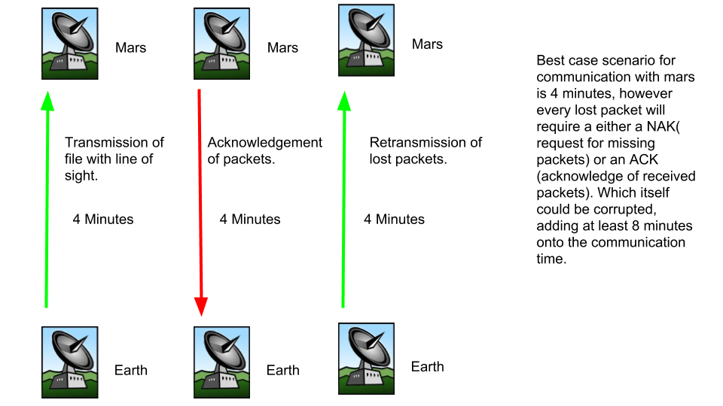

Fig 1.

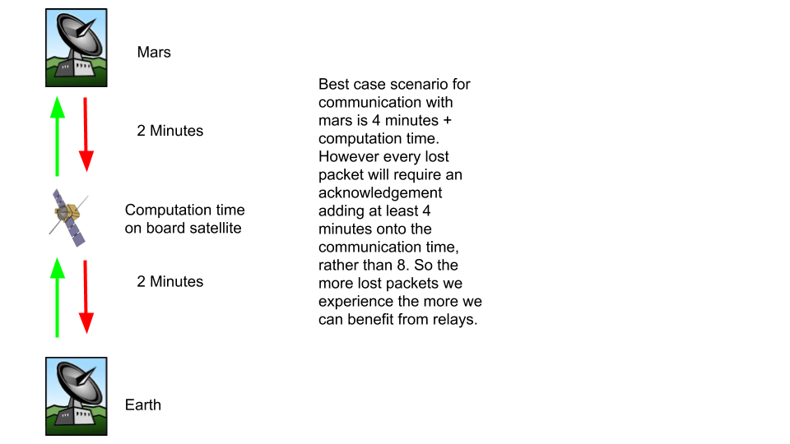
Fig 2.

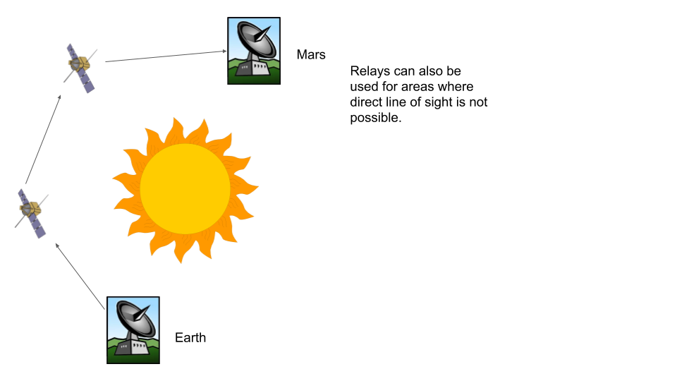
Fig 3.

1 PAGE iii (https://public.ccsds.org/Pubs/727x0b4.pdf)

2 https://www.prosofteng.com/blog/choosing-between-ssd-or-hdd/

3 https://www.spaceacademy.net.au/spacelink/commdly.htm

4 Extraterrestrial Noise as a Factor in Space Communications https://ieeexplore-ieee-org.ezproxy.macewan.ca/document/4066060/references#references

