**DESIGN AND DEVELOPMENT OF ELECTRICITY-BUYING APP WITH PUSH NOTIFICATIONS AND A CHATBOT FEATURE**

BY

CELACY LESLIE DUMEHASIE

GIDEON ADOM BOATENG

**A PROJECT WORK SUBMITTED TO DEPARTMENT OF COMPUTER SCIENCE IN PARTIAL FULFILLMENT OF THE REQUIREMENTS FOR THE DEGREE OF**

**BACHELOR OF SCIENCE IN COMPUTER SCIENCE**

**AUGUST 2023**

**DECLARATION**

We the undersigned solemnly declare that the project documentation dubbed ‘ELECTRICITY-BUYING APP WITH PUSH NOTIFICATION AND A SIMPLE CHATBOT FEATURE’ is based on our work conducted during the study. We assert that the statements made and conclusions drawn are an outcome of our research work. We further certify that:

1. The work in the report is original and has been done by us.
2. The work has not been submitted to any other Institution for any other degree/certificate. in this university or any other university.
3. We have followed the guidelines provided by the university in authoring the documentation.
4. Whenever we have used materials (data, theoretical analysis, and text) from other sources, we have given due credit to them in the report and given their details in the references.

Team Members:

.................................................................. Undergraduate Student

Dumehasie Celacy Leslie

.................................................................. Undergraduate Student

Boateng Gideon Adom

.................................................................. Supervisor

Dr. AS Gaddafi

**DEDICATION**

This project is devoted to God Almighty, our creator, the unwavering foundation, and the wellspring of our motivation, intelligence, wisdom, and comprehension. His support has been the bedrock of our perseverance during this undertaking, and it is solely by relying on His guidance that we have achieved great heights.

**ACKNOWLEDGEMENT**

We express our heartfelt gratitude to Dr. AS Gaddafi, our supervisor, his able teaching assistant, and the entire Computer Science department for granting us the opportunity to embark on this project and for their invaluable guidance during the extensive research phase.

Furthermore, we extend our thanks to our classmates and fellow students for their unwavering support, always lending a helping hand whenever we faced challenges. The experience we shared with them is truly cherished, and it has enriched our knowledge and expertise in this field. We are sincerely thankful to all of them for their contributions to our journey.

**ABSTRACT**

Over the last three years, Ghana has been actively working towards digitalizing all government services. The initial step involved the introduction of the ECG app, enabling citizens to purchase electricity electronically. However, the app's implementation did not fully address every electricity-related issue. Many Ghanaians still lack awareness of their remaining prepaid units until they are depleted, and they face difficulties in making complaints through the app as it often requires an unavailable phone number. In response to this situation, our project aims to develop an ECG buying app called “**PowerPal**”. This app will utilize Firebase notifications to inform users about their current prepaid units before they run out. Additionally, we plan to incorporate a chatbot feature to handle customer-related issues efficiently.

Table of Contents

CHAPTER ONE 8

1.1 Introduction 8

1.2 Problem Statement 8

1.3 Aim of Project 9

1.4 Specific Objectives 9

1.5 Justification of the Project 9

1.6 Motivation 10

1.7 Scope of Project 10

1.8 Project Limitations 10

1.9 Project Benefeciaries 11

1.9a Academic and Practical Relevance of Project 12

1.9b Structure of the Report 13

1.9c Project Deliverables 14

CHAPTER TWO 15

2.1 Review of existing works 15

2.2 Proposed System 18

2.3 Software Features 19

2.4 Development tools and environment 19

2.5 Benefits of implementation of the proposed system 20

CHAPTER THREE 21

3.1 Requirement Specifications 21

3.2 Functional Requirements 23

3.3 Non-functional Requirements 23

3.4 UML Diagrams 24

3.5 Project Methodology 28

3.6 Project Design Consideration 29

CHAPTER FOUR 31

4.1 Mapping logical design onto physical platform 31

4.2 Testing 32

4.3 Results 33

CHAPTER FIVE 34

5.1 Summary 34

5.2 Recommendation by users 34

5.3 Response 34

5.4 Findings 34

5.5 Limitations 35

5.6 Lesson Learnt 35

5.7 Future works 35

5.6 References 36

# CHAPTER ONE

## Introduction

The global energy landscape is undergoing significant transformation, with an increasing focus on renewable energy sources and sustainable practices. As a result, electricity consumers are seeking more convenient and efficient ways to buy and manage their energy consumption. Demand response provides an opportunity for consumers to play a significant role in the operation of the electric grid by reducing or shifting their electricity usage during peak periods in response to time-based rates or other forms of financial incentives. A ChatBot is a computer program that conducts conversation between a user and a computer through auditory or textual methods. It works as a real-world conversational partner. Notifications are an important tool used on the majority of applications, aimed at improving user experience & used to engage users with your application. The Cloud Messaging module provides basic support for displaying and handling notifications. Push notifications help attract user attention and, when implemented properly in tandem with high-quality content, can contribute to major marketing success. The development of a user-friendly electricity buying app with push notifications and a simple chatbot holds the potential to revolutionize how consumers interact with energy providers, enabling them to make informed decisions, monitor usage, and contribute to a greener future.

## Problem Statement

* Customers lack notifications regarding their remaining prepaid units, leading to depletion at inconvenient times and hindering them from purchasing new prepaid units promptly.
* Customers face difficulty in lodging complaints about the app or services, causing discomfort and dissatisfaction.
* Additionally, customers cannot track their consumption rate, resulting in the quick depletion of prepaid units without understanding the cause behind it.

## Aim of the project

This project aims to allow customers to track their consumption rate, lodge complaints about the app or services, and also notify them of their remaining prepaid units.

## Specific Objectives

* To keep users informed about the remaining prepaid units to prevent depletion.
* To enable users to lodge complaints related to their accounts and the service provided.
* To provide users with updates on their consumption rate.

## Justification of the Project

The justification for developing an electricity-buying app with push notifications and a simple chatbot feature can be based on several compelling reasons:

* Convenience and Accessibility: An electricity-buying app would offer consumers a convenient and accessible way to purchase electricity. Users can avoid the hassle of physically visiting payment centers or dealing with paper-based processes. With just a few taps on their smartphones, they can quickly and securely buy electricity from anywhere at any time.
* Real-time Notifications: The push notification feature would provide users with real-time updates about their electricity usage, billing information, and any relevant service alerts. This proactive communication can help users manage their electricity consumption better, avoid unexpected power outages, and stay informed about any changes in electricity rates or policies.
* Enhanced Customer Engagement: By incorporating a simple chatbot feature, the app can engage users in interactive conversations. The chatbot can address common queries, provide personalized assistance, and guide users through various processes, such as how to buy the prepaid. This level of engagement can improve user satisfaction and foster a stronger connection with the service provider.

## Motivation

## 

This project is motivated by the frustration customers encounter when their prepaid units run out unexpectedly, leaving them unable to lodge complaints or seek answers to electricity-related queries promptly. Additionally, I find motivation in the opportunity to not only acquire knowledge in the field of Computer Science through the implementation of this project but also to generate some income for myself.

## Scope of Project

The scope of the project was to develop a mobile app for purchasing electricity, providing features such as electricity usage tracking, push notifications to alert users before their prepaid units are depleted, and a chatbot for handling basic inquiries. Customer data would be managed using a database, and a payment gateway would be integrated for transactions within the app. Notably, the project did not utilize real-time data; instead, all the data used was generated internally.

## Project Limitations

The project has the following limitations:

* The payment gateway integration in the mobile app remains incomplete as the app and business platform are not verified.
* Real-time data couldn't be utilized due to the electricity provider classifying it as confidential, leading to a denial of access.
* The chatbot's functionality is restricted to handling only basic requests since the platform used for creating the chatbot offers advanced features exclusively in premium-level plans.

## 1.9 Project Benefeciaries

The primary beneficiaries of this project are the customers who opt for electronic electricity purchases. By leveraging the newly developed mobile app, these customers gain access to a user-friendly platform that empowers them to conveniently and efficiently buy electricity without the need for physical transactions. The electronic purchasing system allows them to top up their prepaid electricity units seamlessly and monitor their usage, all from the comfort of their smartphones or devices. This innovative solution eliminates the hassle of visiting physical outlets or handling cash for electricity purchases, making the whole process more convenient and accessible for the end-users. As a result, customers can enjoy greater control over their electricity consumption, better manage their energy usage, and ensure they have a continuous and reliable power supply as per their needs. With the app's features, such as push notifications for low prepaid units and an interactive chatbot for simple inquiries, the customers experience enhanced convenience and support throughout their electricity consumption journey. This transformative project aims to elevate the overall electricity buying experience for the beneficiaries, making their lives more comfortable and enabling them to stay connected to the power grid with ease.

## 1.9a Academic and Practical Relevance of the Project

Academic Relevance

* Technology Integration: This project involves integrating multiple cutting-edge technologies, including mobile app development, push notifications, chatbot implementation, database management, and payment gateways. It can serve as an excellent educational opportunity for students to gain hands-on experience in these technologies and understand how they work together in a real-world application.
* Problem-Solving Skills: Developing an electricity-buying app with additional features requires problem-solving skills. Students can learn to address various challenges, such as user authentication, data privacy, security, and seamless payment processing.
* User Experience (UX) Design: Designing an intuitive and user-friendly interface for the app is essential to ensure a positive user experience. This project can help students explore UX design principles and conduct user testing to optimize the app's usability.

Practical Relevance:

* Addressing Consumer Needs: An electricity-buying app with push notifications and a chatbot can meet the practical needs of consumers who prefer digital transactions and real-time updates. It provides a more convenient way for customers to purchase electricity and stay informed about their usage.
* Enhancing Customer Engagement: With push notifications, customers can receive timely alerts about their prepaid units, helping them avoid sudden power interruptions. The chatbot offers quick and simple support, addressing customer inquiries and improving overall satisfaction.

## 1.9b Structure of the report

The report has five chapters and follows this structure:

* **Chapter 1**: This chapter provides an introduction to the project, including the problem statement, project aim, and specific objectives. It also justifies and motivates the project, outlines its scope and limitations, identifies the beneficiaries, and discusses the academic and practical relevance. The chapter further presents the project plan, deliverables, and the overall structure of the report.
* **Chapter 2**: This chapter conducts a comprehensive review of related systems, comparing them with the proposed system and presenting the conceptual design. It outlines the development tools and environment utilized in the project, discusses the software features, and highlights the benefits of implementing the proposed system.
* **Chapter 3**: Here, the report delves into requirement specifications, detailing the process of gathering both functional and non-functional requirements. It includes UML diagrams relevant to the project and describes the project methodology employed during development. Additionally, the chapter covers the UI design and the development tools used in the project.
* **Chapter 4**: This chapter is dedicated to the implementation and results of the project. It provides a detailed account of how the project was executed, the challenges faced, and the outcomes achieved. The results obtained from implementing the proposed system are thoroughly analyzed and presented.
* **Chapter 5**: The final chapter encompasses the findings derived from the project, discussing any notable discoveries made during its course. It acknowledges the challenges encountered and the valuable lessons learned during the development process. Furthermore, the chapter presents recommendations for future improvements and enhancements. The report concludes with a list of references used throughout the project.

## 1.9c Project Deliverables

Upon project completion, a compact disc containing the mobile app’s installation files will be provided, along with comprehensive project documentation.

# CHAPTER TWO

## 2.1 Review of existing works

Various instances of systems related to this project will be presented, along with their positive and negative attributes. These systems encompass:

* **ECG PowerApp**

ECG Mobile APP is meant for conveniently paying prepaid and postpaid bills, viewing power usage, and getting notified on any ECG activity(*How To Use The ECG Mobile App (ECG Power) And Shortcode On Your Phone: Download App, Buy Credit, Pay Bills July 2023*, n.d.). Below are some pros and cons of the ECG PowerApp:

Pros:

* + - Convenience: Users can conveniently compare electricity plans and purchase them from various providers within the app, eliminating the need for extensive research and phone calls.
    - Real-Time Information: It offers real-time data on electricity prices and consumption, helping users make informed decisions to reduce costs.

Cons:

* + - Complexity: It has a complex interface and requires a learning curve, which could be challenging for some users, particularly those who are less tech-savvy.
    - Energy Saving: It does not provide energy-saving tips and insights, enabling users to monitor their electricity usage.
    - Customer Service: It does not allow customers to lodge complaints and receive responses promptly by the use of a chatbot.
    - Notifications: It does not notify customers of their remaining prepaid units before they deplete.
* **OhmConnect**

OhmConnect is part of a power-saving initiative aimed at asking people to reduce their energy usage when and anyone across the United States can sign up. The company will let you know when a so-called “Dirty” power plant in your area is gearing up to turn on and will ask to you to conserve electricity to prevent excess energy usage. (How Much Can You Earn with OhmConnect? - The Salty Mamas, n.d.). Below are some pros and cons:

Pros:

* + - Energy Savings: OhmConnect encourages users to reduce their electricity consumption during peak periods, leading to overall energy savings and potentially lower electricity bills.
    - Environmental Impact: By reducing energy usage during peak times, users can contribute to reducing greenhouse gas emissions and promoting sustainable energy practices.
    - Financial Rewards: OhmConnect offers financial incentives and rewards, such as cash payments or credits, to users who actively participate in energy-saving actions.
    - Easy Integration: The app integrates with various smart home devices and platforms, making it easy for users to automate energy-saving actions and participate effortlessly.

Cons:

* + - Complexity: It has a complex interface and requires a learning curve, which could be challenging for some users, particularly those who are less tech-savvy.
    - Customer Service: It does not allow customers to lodge complaints and receive responses promptly by the use of a chatbot.
    - Notifications: It does not notify customers of their remaining prepaid units before they deplete.
* **WattTime**

WattTime is an environmental tech nonprofit that empowers all people, companies, policymakers, and countries to slash emissions and choose cleaner energy. (Wartime – The Power to Choose Clean Energy, n.d.). Below are some pros and cons of WattTime:

Pros:

* + - Environmental Impact: By scheduling electricity usage during cleaner energy periods, users can significantly reduce their carbon emissions and contribute to a more sustainable environment.
    - Flexibility: WattTime's technology allows users to adapt their energy usage based on real-time data, providing more flexibility in choosing when to consume electricity.
    - Easy Integration: The technology can be integrated into various smart home devices, appliances, and electricity-buying apps, making it accessible to a wide range of users.

Cons:

* + - Complexity: It has a complex interface and requires a learning curve, which could be challenging for some users, particularly those who are less tech-savvy.
    - Customer Service: It does not allow customers to lodge complaints and receive responses promptly by the use of a chatbot.
    - Notifications: It does not notify customers of their remaining prepaid units before they deplete.

## 2.2 Proposed System

The system under consideration is envisaged as a sophisticated mobile application, equipped with essential functionalities like a seamless payment gateway, interactive push notification system, intelligent chatbot feature, and a visually captivating and user-friendly interface. The central focus of this proposed system revolves around integrating a payment gateway, ensuring secure and efficient monetary transactions for users. With this feature, users can easily complete transactions and payments within the app, fostering a hassle-free and trustworthy environment for financial interactions. Moreover, the system is designed to implement an interactive push notification system, which will proactively inform users about relevant information. By leveraging push notifications strategically, the mobile app aims to keep users engaged, informed, encouraging consistent usage and fostering a sense of inclusiveness. Furthermore, the inclusion of an intelligent chatbot feature adds an extra layer of user assistance and convenience. The chatbot will be capable of providing prompt and accurate responses to user inquiries, thereby enhancing user satisfaction and significantly reducing response time for addressing queries or concerns. In terms of aesthetics and usability, great emphasis has been placed on designing an aesthetically appealing and user-friendly interface. The User Interface (UI) of the app will be thoughtfully crafted, employing intuitive design principles and modern aesthetics to ensure a seamless and enjoyable user experience.

## 2.3 Software Features

* User Registration and Authentication: Secure user registration and login functionality using email, phone number, or social media accounts. Password reset and account recovery options for users who forget their credentials.
* Payment Gateway Integration: Integration with a secure payment gateway to facilitate seamless and safe transactions for purchasing electricity plans. Support for multiple payment methods, such as credit/debit card.
* Push Notification System: Push notifications to inform users about important updates related to their electricity plans and billings.
* Intelligent Chatbot: An AI-powered chatbot that can answer user inquiries and provide personalized assistance.
* Billing and Invoicing: Access to billing details, including current and past invoices, payment history, and billing cycle information.
* Energy Usage History: Historical data on energy consumption, allowing users to compare usage patterns over time. Monthly, weekly, and daily breakdowns of energy consumption.

## 2.4 Development tools and environment

For the implementation of this project, the chosen development tools include Flutter, Firebase, and DialogFlow. The project was crafted within the development environment of Visual Studio Code, leveraging its versatile capabilities to facilitate the creation of a robust and efficient application. The synergy between Flutter, Firebase, and DialogFlow enables the seamless integration of functionalities, secure authentication, and an intelligent chatbot feature. Visual Studio Code's user-friendly interface and extensive plugin support fostered a smooth development process, ensuring the app's successful realization.

## 2.5 Benefits of implementation of the proposed system

The implementation of an electricity-buying app with push notifications and a chatbot can offer several benefits to users. Below are some advantages:

* Convenience for Users: With the app, users can easily buy electricity credits from the comfort of their homes or on the go. They no longer have to visit physical stores or stand in long queues to purchase electricity tokens. This convenience can lead to higher customer satisfaction and retention.
* Real-Time Push Notifications: Push notifications can be used to alert users about their electricity consumption, payment reminders, and other important updates. This keeps users informed and reduces the chances of any interruptions in their electricity supply due to insufficient credits.
* Chatbot Assistance: The chatbot integrated into the app can handle customer queries and provide quick responses. It can assist users with issues related to their electricity usage, payment status, troubleshooting, and more. This can significantly reduce the burden on customer support and improve response times.
* Seamless Payments: Integration with Paystack or any other secure payment gateway allows users to make quick and secure payments for electricity credits. This reduces the chances of payment delays and ensures a smooth transaction process.

# CHAPTER THREE

## 3.1 Requirement Specifications

The Stake holders

App Users: These individuals or businesses are actively engaged with the app to purchase electricity, deriving the primary advantages from its offerings.

Gathering process

A survey was conducted using google forms to ask users about their view concerning the ECG PowerApp. The questions that were asked are as follows:

* Is the Interface user friendly?
* Will you like to get notified about meter usage?
* Will you like to have a hands on interaction with a chatbot to answer FAQs?

Below is pie chart of the data collected from the survey:

* 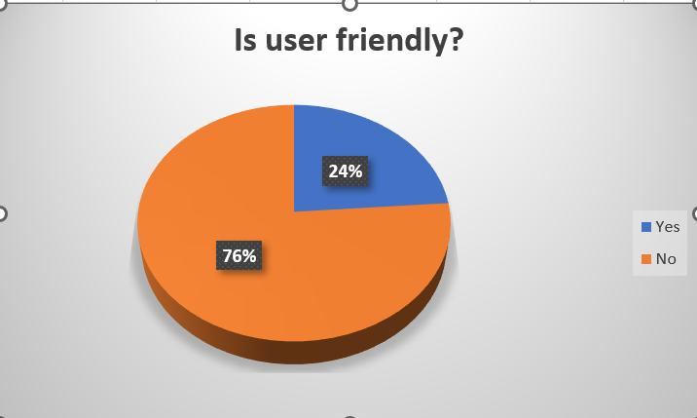Out of 21 participants 24% chose “YES” and 76% chose “NO”
* 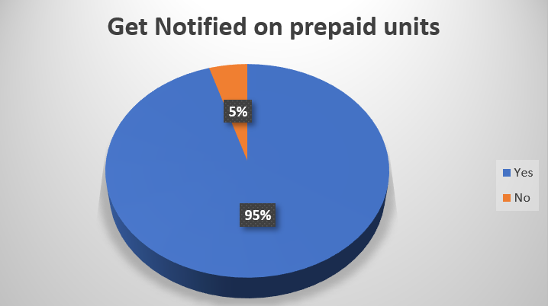Out of 21 participants 5% chose “NO” and 95% chose “YES”
* Out of 21 participants 5% chose “NO” and 95% chose “YES”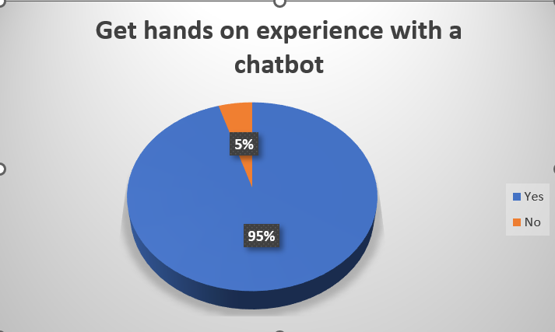

## 3.2 Functional Requirements

Functional requirements for this project include:

* Users should be able to create accounts, log in, and manage their profiles securely.
* The chatbot should offer customer support and offer general assistance. It should be capable of understanding natural language and providing accurate responses.
* Users should receive push notifications for important updates, such as billing reminders, and outage notifications.
* Users should be able to view and manage their billing history, payment methods, and invoices.
* Users should be able to update their account details and preferences.

## 3.3 Non-functional Requirements

Non-functional requirements outline the qualities and attributes that an application must possess beyond its core functionality. For this project, non-functional requirements should include:

* Performance:
* Response Time: The app should provide quick responses to user interactions with the chatbot and notifications, ensuring minimal delays.
* Reliability: The chatbot and notifications should be available and responsive, even during peak usage periods.
* Security:
* Authentication and Authorization: Users should be securely authenticated before accessing sensitive features like purchasing electricity or managing accounts.
* Secure Communication: All interactions between the app, chatbot, and server should be encrypted to prevent unauthorized access.
* Usability and User Experience:
* User-Friendly Interface: The app should offer an intuitive and easy-to-navigate interface, enhancing user engagement and satisfaction.
* Chatbot Conversational Quality: The chatbot should provide accurate, relevant, and context-aware responses to user queries, contributing to a positive user experience.
* Availability and Reliability:
* Uptime and Availability: The app, chatbot, and push notifications should have a high level of availability to ensure users can access them when needed.
* Error Handling: The app should gracefully handle errors, preventing crashes or data loss, and providing clear error messages to users.
* Integration:
* Chatbot Integration: The chatbot should seamlessly integrate with the app's interface and backend systems, providing a cohesive user experience.
* Notification Integration: Push notifications should work reliably across different devices and operating systems.

## 3.4 UML Diagrams

Unified Modelling Language Diagrams are ways of visualizing a software program using a collection of diagrams. There are several diagrams in the UML diagrams. These are class diagrams, activity diagrams, sequence diagrams, object diagrams, package diagrams, and use case diagrams.

Activity diagram

User is Registered

Start

User Login ID & Password

Check Login ID & Password

Invalid Login/Password

Login to the App Successfully

Go to Home Screen

Access the Internal App Functionalities

End

This is an activity diagram for the Home Screen of the app.

Use case diagram

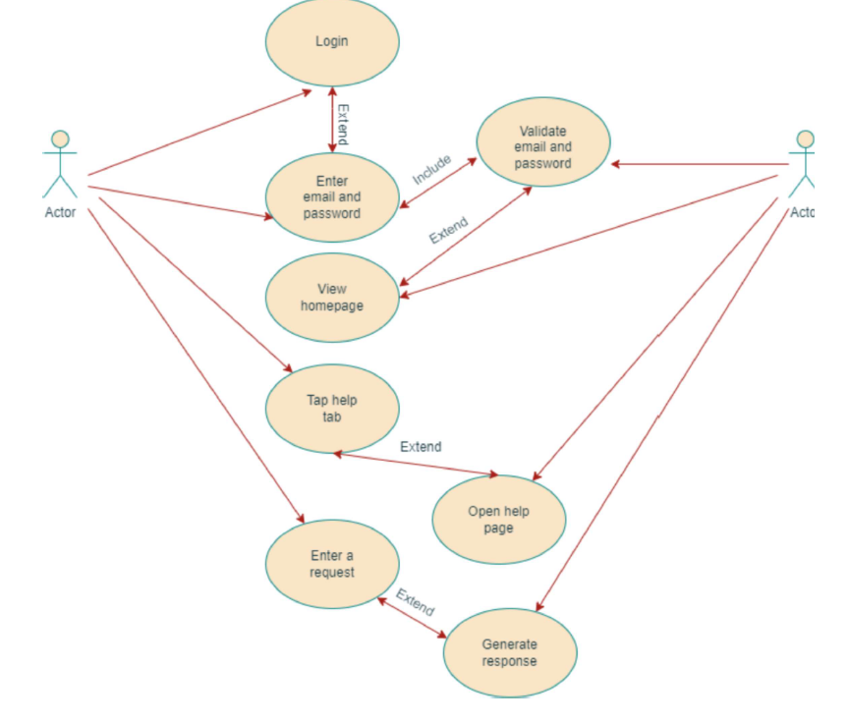

A use case diagram for the help page.

Sequence diagram

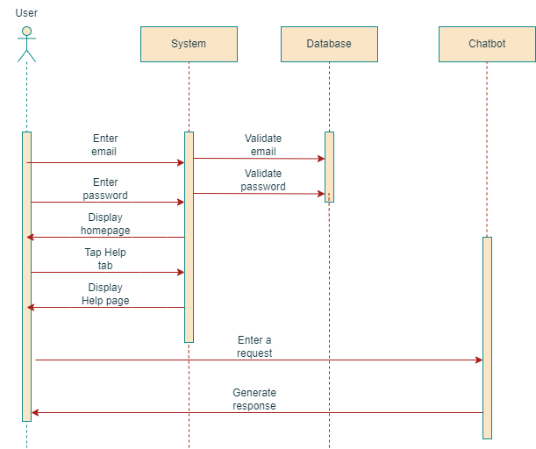

Sequence diagram for the help page interacting with chatbot

## 3.5 Project Methodology

Model adapted and justification

Incremental Methodology:

The project method adopted for this system is the Incremental methodology. This is because the system will be developed initially and new features will be added as time goes on to improve user experience.

The Incremental development method is adopted because the software is needed by the client and the systems will be broken into modules. The user’s requirements will be top priority and developed as increment. Early increments act as a prototype to help elicit requirements for later increments.

Since the highest priority increments will receive the most testing, this is will help reduce bugs and errors in subsequent modules or increments and reduce risk of overall project failure.

DIAGRAM OF INCREMENTAL METHODOLOGY

## 3.6 Project Design Consideration

User Interface Design

Below are the tools, components and libraries used for designing the user interface for this project.

* Flutter Framework: Flutter is a UI toolkit developed by Google for building natively compiled applications for mobile, web, and desktop from a single codebase.
* Dart Programming Language: Flutter uses the Dart language for building applications, so you'll need to be familiar with Dart's syntax and concepts.
* Material Design or Cupertino: Depending on your target platform (Android or iOS), you can choose either the Material Design widgets for Android-style UI or the Cupertino widgets for iOS-style UI.
* Widgets: Utilize various Flutter widgets to create the app's user interface elements, such as buttons, text fields, dropdowns, cards, and more.
* Chatbot Integration: To implement the chatbot feature, you can use a third-party chatbot SDK or library. Dialogflow by Google is a popular choice for creating conversational agents (chatbots). You can use the `flowtter_dialogflow` package to integrate Dialogflow's functionality into your app.
* Push Notifications: For push notifications, you'll need to integrate a push notification service like Firebase Cloud Messaging (FCM) using the `firebase_messaging` package. This will allow you to send push notifications to users' devices.
* Networking: Use Flutter's networking libraries like `http` to make API calls to fetch data from your server or backend services.
* Authentication: If your app requires user authentication, you can use Firebase Authentication or other authentication providers.
* Responsive Design: Ensure that your app's user interface is responsive and adapts well to various screen sizes and orientations.
* UI Design Tools: You might use tools like Adobe XD, Figma, or Sketch to design the app's UI before implementing it in Flutter.

# CHAPTER FOUR

## 4.1 Mapping logical design onto physical platform

Flowchart Diagram

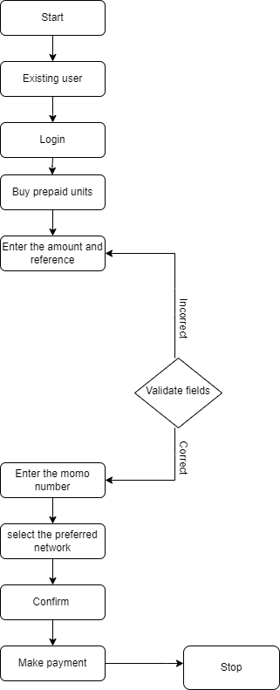

Code Snippets

## 4.2 Testing

Testing objectives

* Functional Testing:
* Chatbot Interaction; Test different user queries and ensure the chatbot provides accurate and relevant responses.
* Push Notifications: Verify that push notifications are triggered accurately based on usage thresholds and transaction events.
* Usability Testing:
* Evaluate the overall user experience of the app, including ease of navigation, clarity of UI, and intuitiveness of the chatbot interaction.
* Performance Testing:
* Measure the app's response times during various scenarios, interact with the chatbot, and receive push notifications.
* Payment Integration Testing:
* Test the integration with payment gateways to ensure successful payment processing, error handling, and proper transaction records.
* Chatbot Testing:
* NLP Testing: Verify that the chatbot can accurately understand and respond to a variety of user queries.
* Fallback Handling: Ensure the chatbot provides appropriate responses when it cannot understand a query.
* Push Notification Testing:
* Verify that push notifications are sent correctly based on defined triggers.
* Test the timing of notifications and ensure they are delivered promptly.

Testing environment

The application underwent thorough testing through the utilization of an Android emulator, specifically designed to simulate the Android 12 operating system environment. This testing process was aimed at comprehensively evaluating the app's functionality, performance, and user experience within an environment that closely emulates the latest Android version.

Testing of Functional requirements

The system has two main system requirements. Tests were conducted for each one of them.

* Allow users to make complaints using the chatbot:To test this requirement, user queries were given to the chatbot and these requests were sorted out. The requests which cannot be understood by the chatbot had fallback handling parameters to handle such queries.
* Allow users to be notified about their prepaid units:To test this requirement, Firebase was used to set up the parameters on which the push notification will be triggered and the Android emulator was used to view the output of the triggered parameter.

Testing to meet user expectations

Users were satisfied with the system, response showed that the system is very easy to use. User requirements were met and the mobile app worked as expected.

## 4.3 Results

Various results from the test showed that the system is very good, meets its functional and non-functional requirement. The system also passed verification and validation testing. Testing showed overall user satisfaction with the entire system.

# CHAPTER FIVE

## 5.1 Summary

We discuss the discoveries that were found during the project's development in this chapter. The limitations the project encountered are emphasized. The lesson learned in the course of the project development are discussed and recommendations are made. Lastly plans for future work are discussed and then references are stated.

## 5.2 Recommendation by users

In this chapter, we talk about the recommendations made by some users of the application. discovered in the course of the project development.

* A user recommended the use of a reliable chatbot service to answer very complex user requests.
* Suggestions / Estimations on how much to purchase on a weekly/monthly basis.

## 5.3 Response

We were pleased with the feedback from the users and continue to improve upon the application.

## 5.4 Findings

After the project, these were the findings made;

* Electricity purchasing apps should have some level of offline functionality, allowing users to view previously loaded data and make decisions even when not connected to the internet.
* If your app is intended for a global audience, provide support for multiple languages and currencies to cater to users from different regions.

## 5.5 Limitations

The limitations of this project were that an electricity purchasing app heavily relies on real-time electricity pricing data. If the data source experiences downtime or inaccuracies, it can impact the user experience and the accuracy of purchasing decisions.

## 5.6 Lesson Learnt

We learnt to use various flutter libraries as well as API integration. We also leant that building the app is just the beginning. Ongoing maintenance, bug fixes, performance optimizations, and updates are necessary to keep the app relevant and functional.

## 5.7 Future works

Future works on this application would be to implement data analytics and visualization features to help users understand their electricity usage patterns and make informed purchasing decisions.

## 5.6 References

*How Much Can You REALLY Earn with OhmConnect? - The Salty Mamas*. (n.d.). Retrieved July 31, 2023, from https://thesaltymamas.com/microhustle-monday-ohmconnect/

*How To Use The ECG Mobile App (ECG Power) And Shortcode On Your Phone: Download App, Buy Credit, Pay Bills July 2023*. (n.d.). Retrieved July 31, 2023, from https://avenuegh.com/how-to-use-the-ecg-mobile-app-ecg-power-and-shortcode-on-your-phone-download-app-buy-credit-pay-bills/

*Watttime – The Power to Choose Clean Energy*. (n.d.). Retrieved July 31, 2023, from https://www.watttime.org/