Stat - Week 2

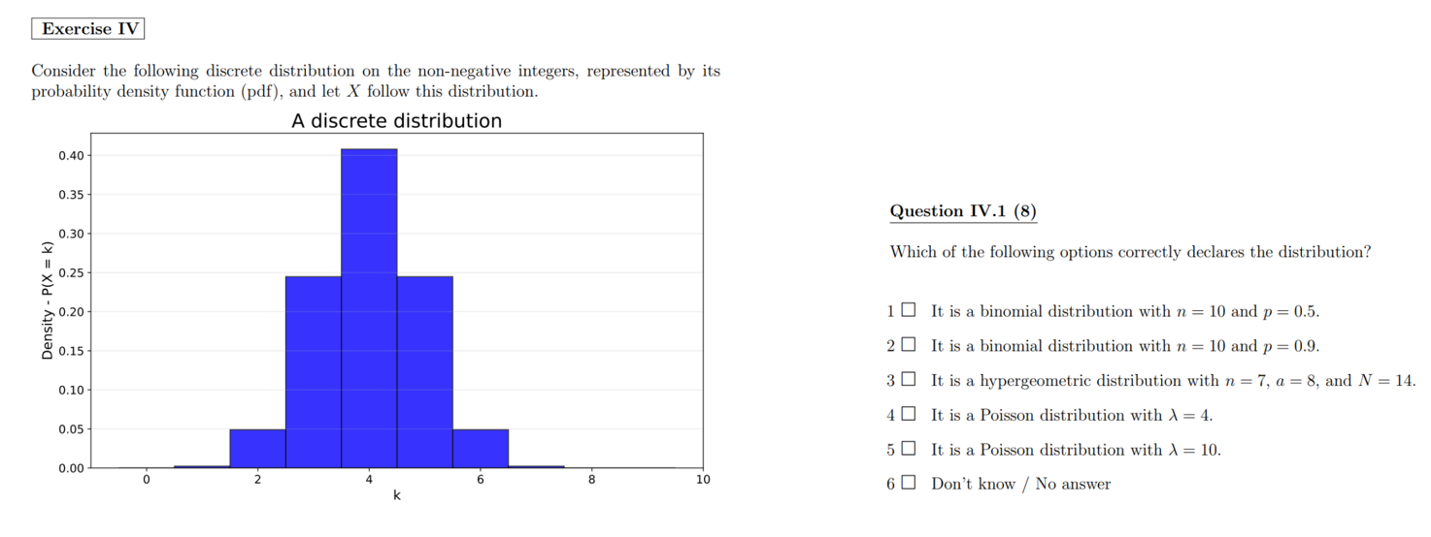

Hint: Use your knowledge of the means for the different distributions:

Binomial distribution: $n·p$
Hypergeometric distribution: $n·\frac{a}{N}$
Poisson distribution: $λ$

Now only options 3 and 4 are left.

A Poisson distribution models the number of events occurring in a fixed interval, and it has no fixed upper limit, so values like 8, 9, 10 etc. are still possible.
But here only 7 items are drawn, so the number of successes cannot exceed 7.

This upper limit fits the hypergeometric distribution, so option 3 is correct.
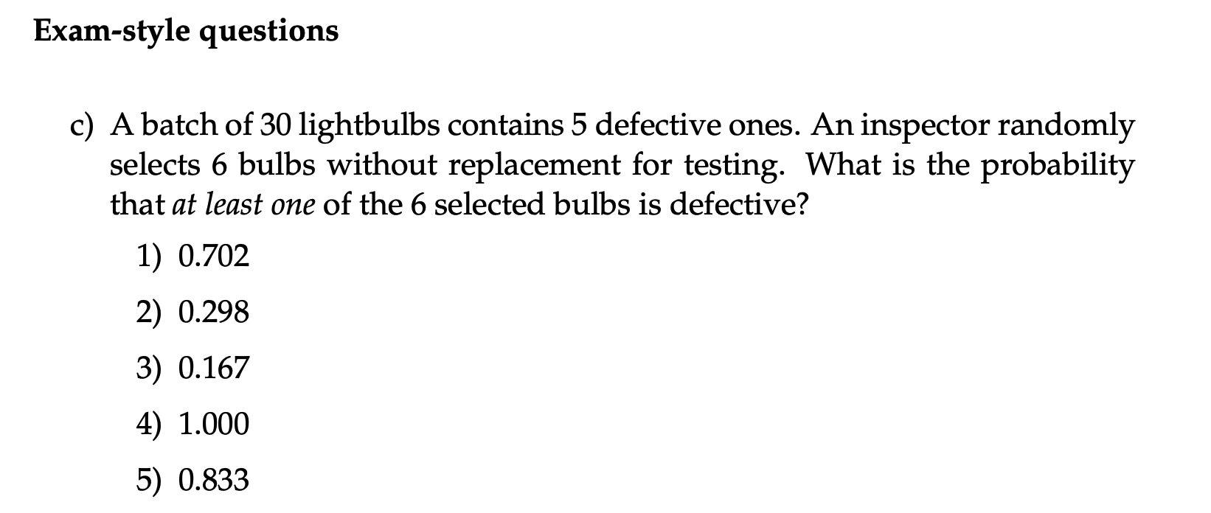

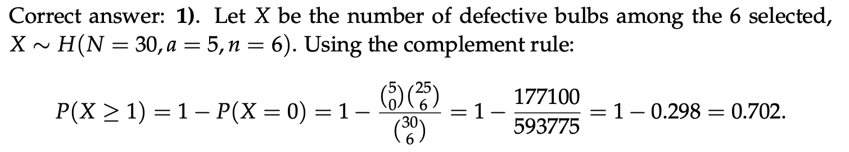

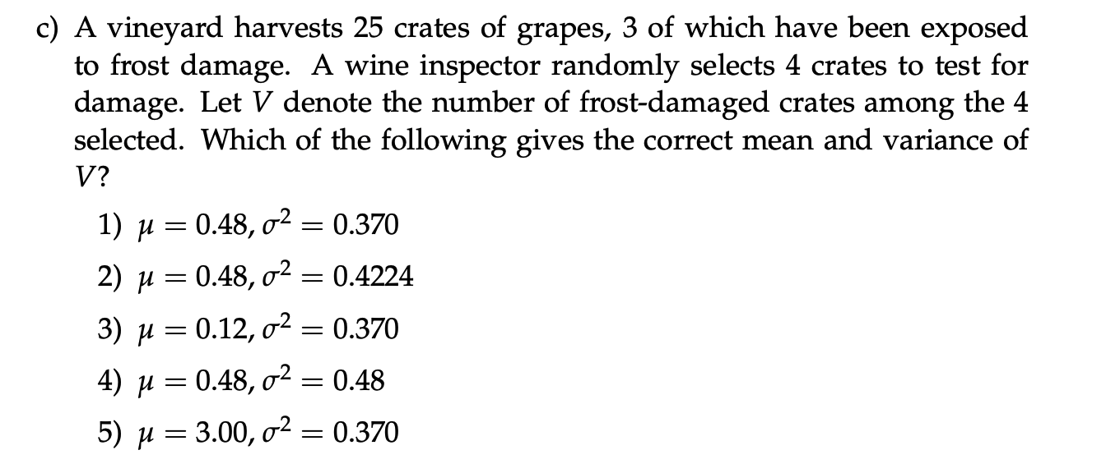

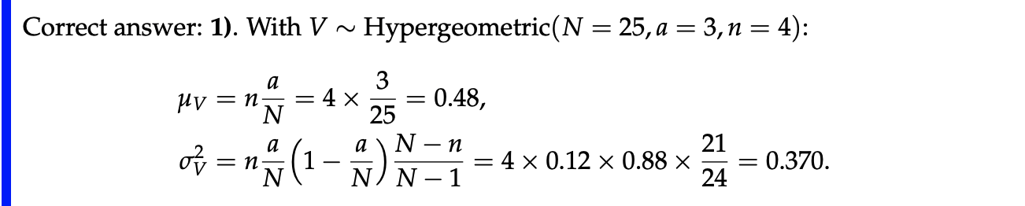

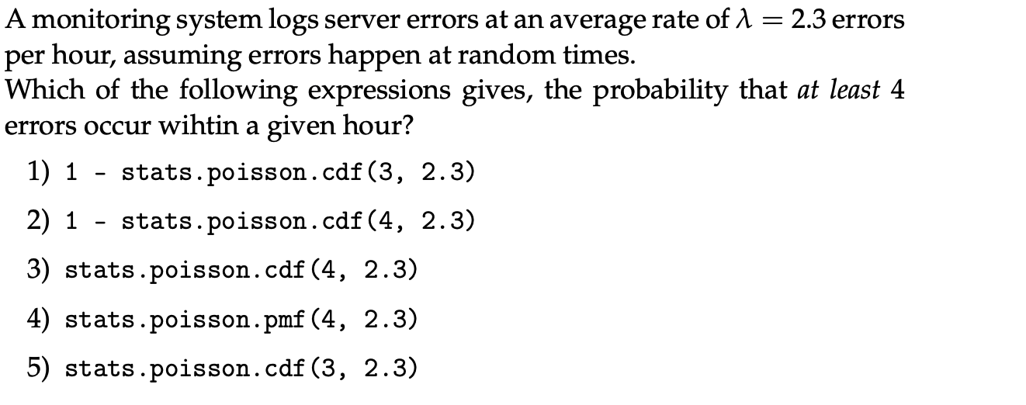

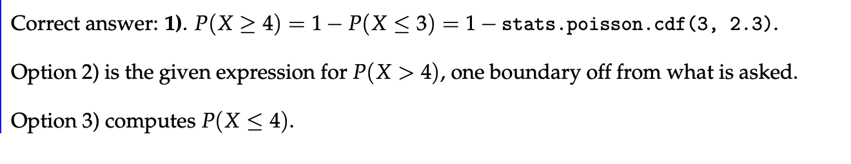
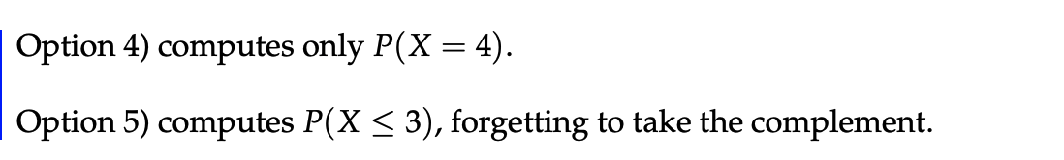

Exercise 2.1 - Discrete random variable

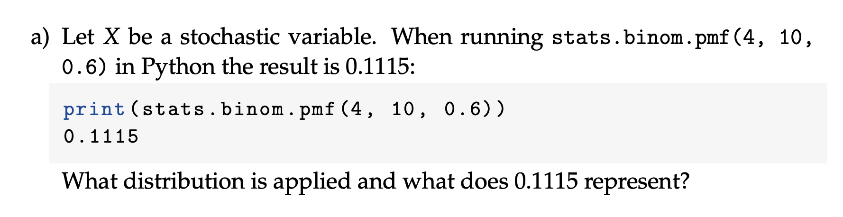
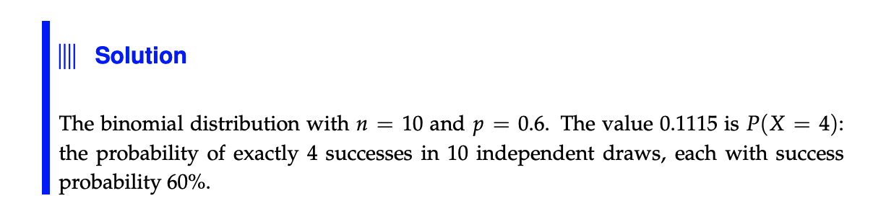

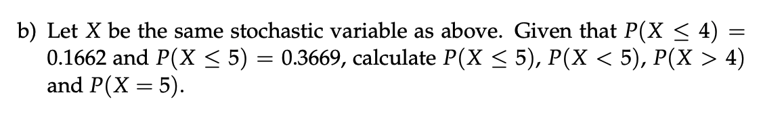
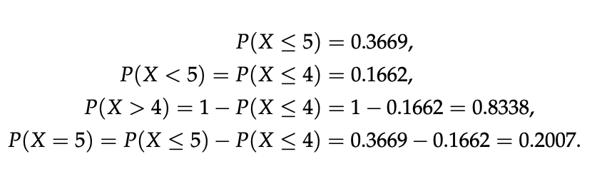
#Use pmf when $P\left(X=a\right),$use cdf when the probability is “greater than (or equal to)” or “less than (or equal to)” e.g. $P(X≤a)$

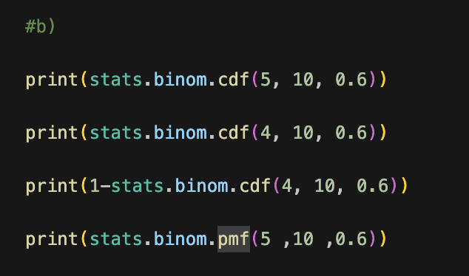
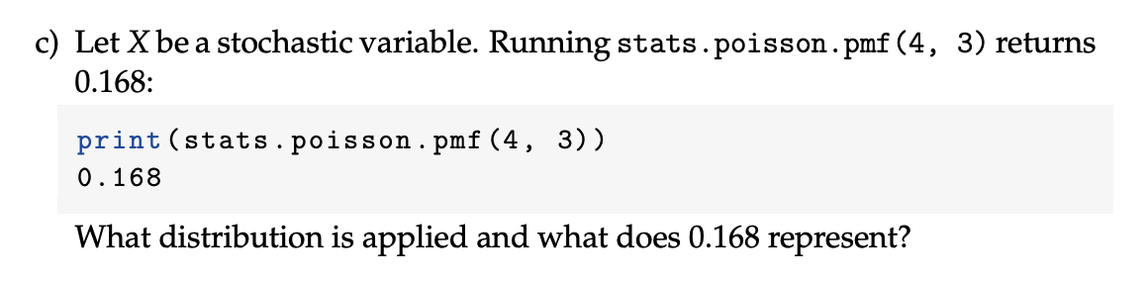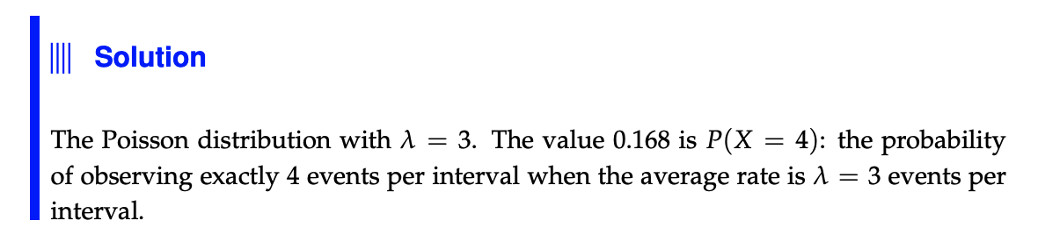

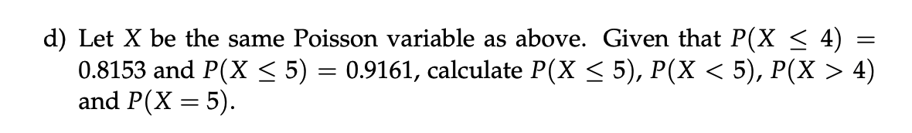
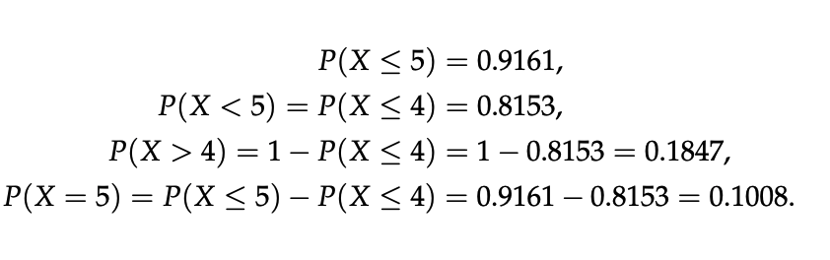

Exercise 2.4 - Consumer survey
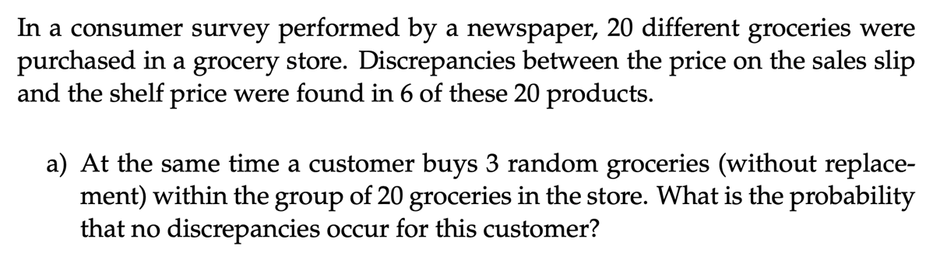
#Look at page 22 in the book. (24 in pdf). Which distribution? Hypergeometric. Why? Because there is no replacement of the products. What is n? 3. What is a? 6, the number of successes in the N elements large population. What is N (number of element in large population)? 20.

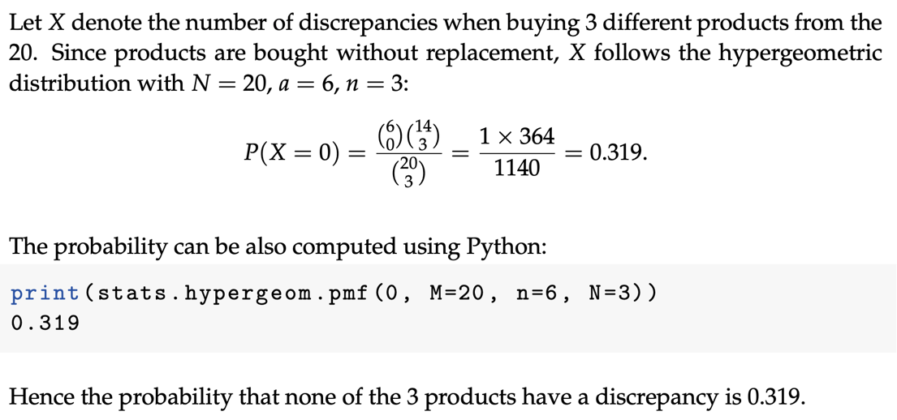

Exercise 2.5 - Hay delivery quality
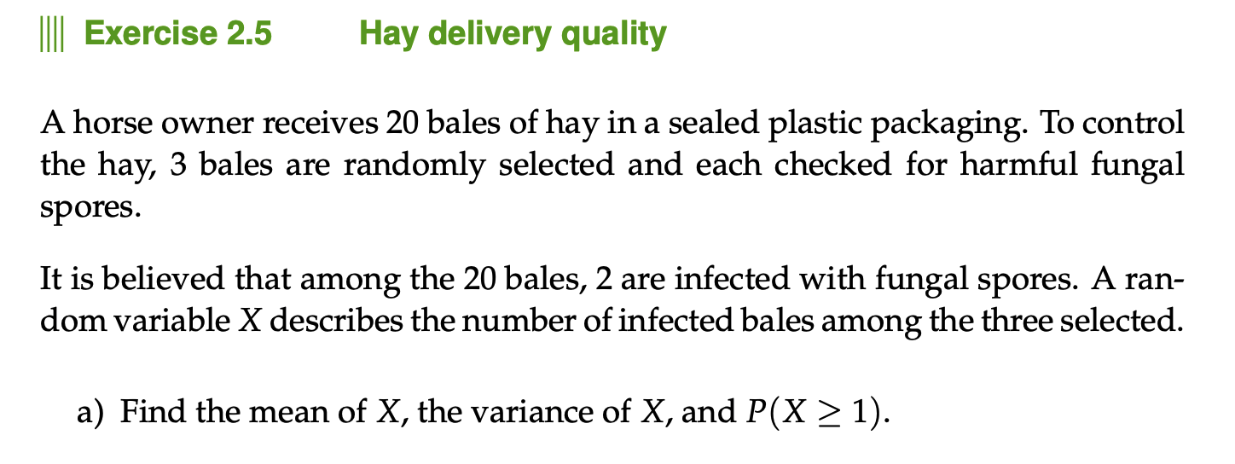
#Page 22 In the book (page 24 in pdf) Which distribution? Hypergeometric. What is n? what is a? what is N? (number of element in large population = 20)

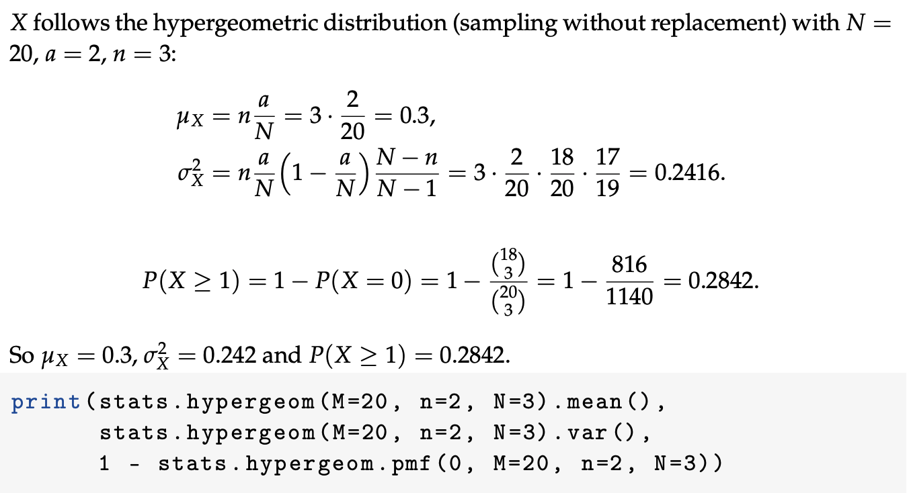

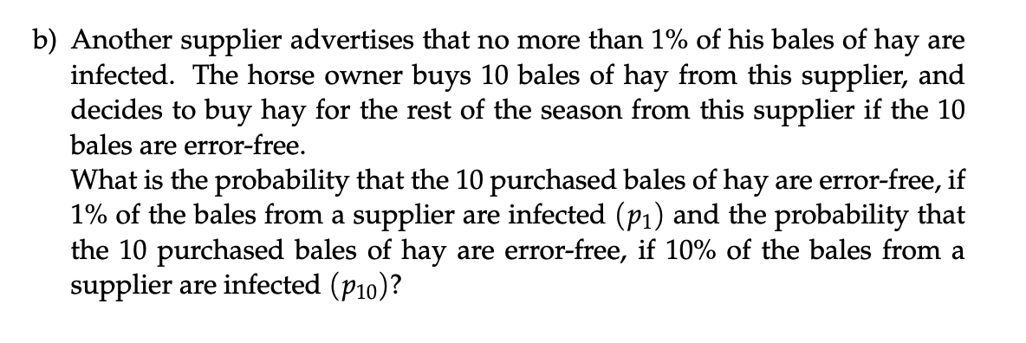
Without replacement → Hypergeometric, unless the population is very large compared with the sample; then Binomial is usually a good approximation, since not actually putting the hay bale back wont statistically affect the larger population. So, in this exercise we choose the binomial distribution.
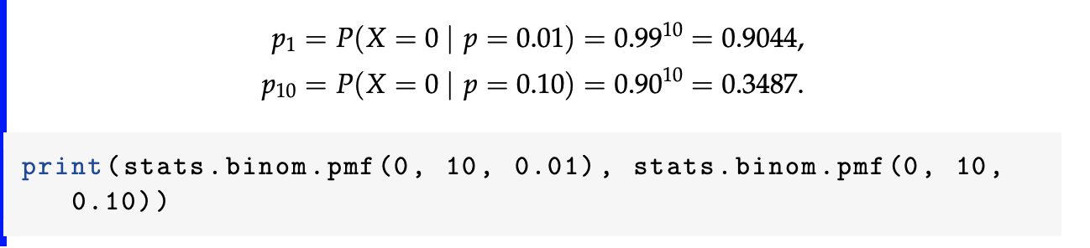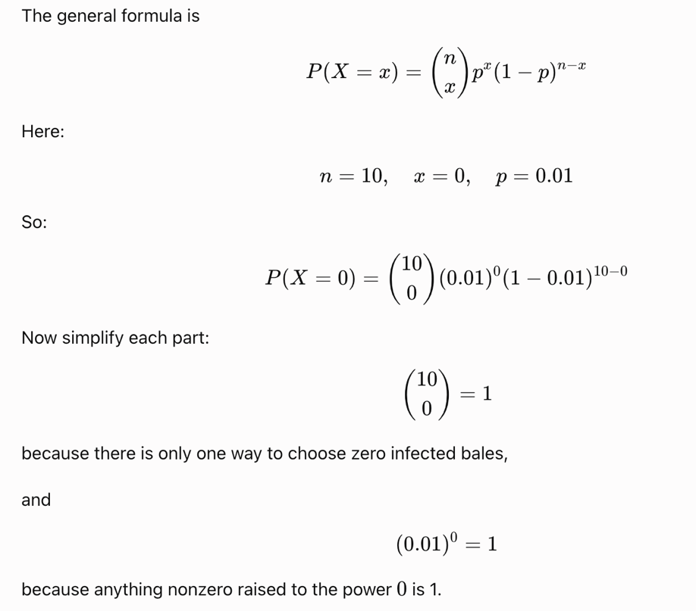
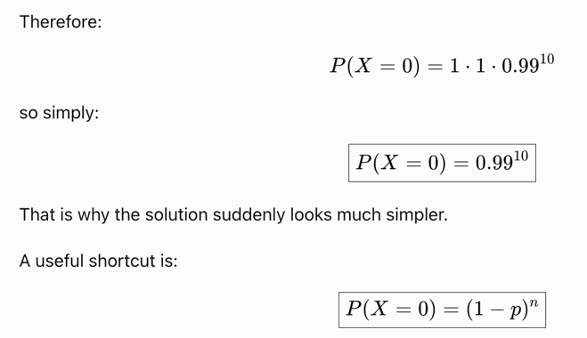

Exercise 2.7 - A fully automated production
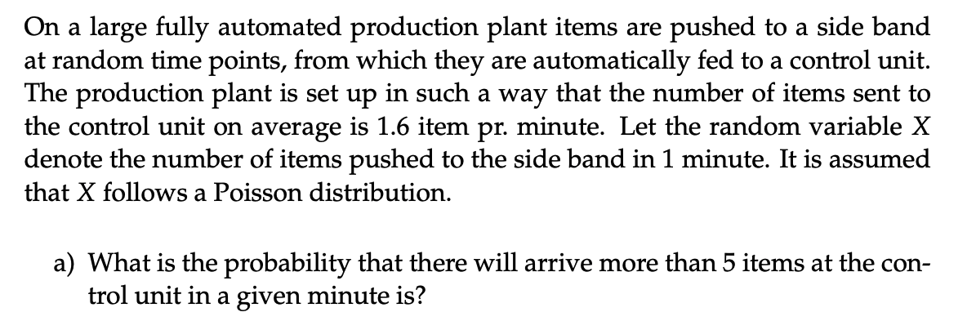
#Page 24 (page 26 in pdf). What distribution?


