Opgave 7.1)
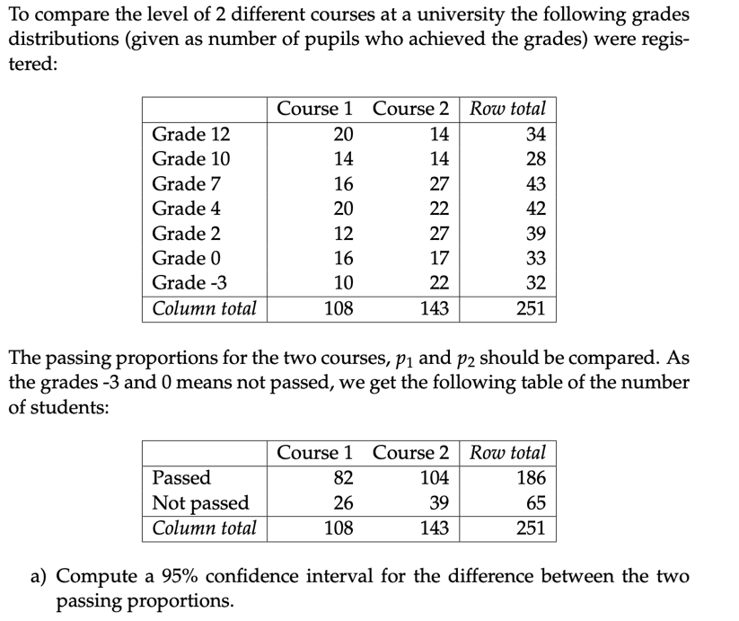
Using Equation (7-2) in Chapter 7, the sample passing proportions are
$${\hat{p}}_{1}=\frac{82}{108}=0,76$$
$${\hat{p}}_{2}=\frac{104}{143}=0,73$$
The estimated difference is ${\hat{p}}_{1}-{\hat{p}}_{2}=0.76-0.73=0,03.$
Assuming independent random samples, we use the normal approximation in Method 7.15. The observed numbers of passes and failures in both courses are all at least 10, which satisfies the large-sample rule of thumb when we use the sample proportions to estimate the expected counts.
Using Equation (7-29), the estimated standard error of the difference is
$${\hat{σ}}_{{\hat{p}}_{1}-{\hat{p}}_{2}}=\sqrt{\frac{0.75926\left(1 - 0.75926\right)}{108}+\frac{0.72727\left(1 - 0.72727\right)}{143}}≈ 0.05549$$
For a 95% confidence interval, the standard normal critical value is 1.96. Using Equation (7-30), we obtain: $0.03 ± 1.96· 0.05549 ≈ [-0.0768, 0.1408]$
Since the interval contains zero, the data provide insufficient evidence at the 5% significance level that the two courses have different passing proportions.

We test $H₀: p₁ = p₂$ at the 1% significance level. The table compares two courses, with each student classified as passed or not passed. According to Method 7.20 in Chapter 7, the chi-square test statistic in Equation (7-46) is compared with a chi-square distribution with $c - 1$ degrees of freedom. Since there are two courses, the degrees of freedom are $2 - 1 = 1.$
We reject H₀ for large values of the test statistic, so the critical value is the 99th percentile of the chi-square distribution with 1 degree of freedom. This leaves 0.01 in the upper tail:
$$from scipy.stats import chi2 \\ chi2.ppf(0.99, df=1)$$
Critical value $≈ 6.635$
We reject $H₀$ at the 1% significance level if the observed chi-square statistic exceeds 6.635.
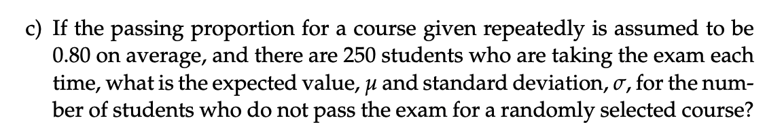
Let X be the number of students who do not pass the exam. The probability that a student does not pass is $p_{fail} = 1 - 0.80 = 0.20.$
Assuming that the students’ results are independent and that each student has the same probability of failing, X follows a binomial distribution with $n = 250 and p_{fail} = 0.20$, as in Equation (7-1). Using Equation (7-3), the expected number of students who do not pass is:
$$μ = np = 250· 0.20 = 50 students.$$
Using Equation (7-4), the variance is:
$$Var\left(X\right)= np\left(1-p\right)= 250· 0.20· 0.80 = 40$$
The standard deviation is the square root of the variance:
$$σ = \sqrt{40} ≈ 6.32 students$$

Opgave 7.2)
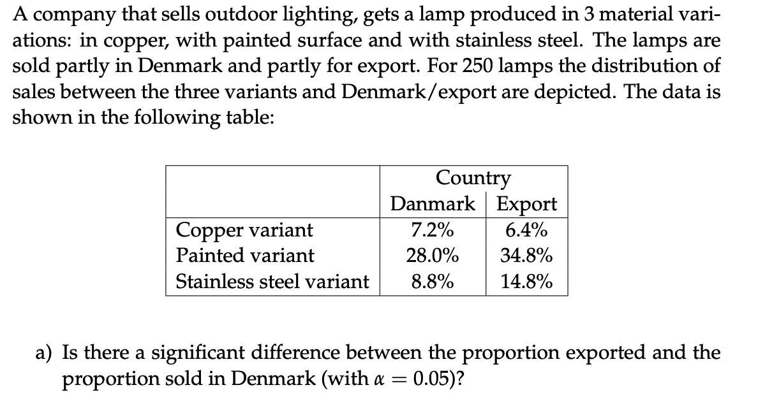
Exported: 6.4% + 34.8% + 14.8% = 56.0% $→ 250· 0.56 = 140 lamps$
Sold in Denmark: 7.2% + 28.0% + 8.8% = 44.0% $→ 250· 0.44 = 110 lamps$

Let $p$ be the true export proportion. The $sold in Denmark$ proportion is $1-p$, so equal proportions imply $p = 0.50$. We use the two-sided one-sample proportion test in Method 7.11.

$$H₀: p = 0.50$$
$$H₁: p ≠ 0.50$$

Under $H₀,$ the expected counts are $250· 0.50 = 125$ in each category. Both exceed 15, so the normal approximation is appropriate (Theorem 7.10).

Test statistic (Equation (7-16)):
$$z =\frac{\left(140 - 250· 0.50\right)}{\sqrt{250· 0.50· 0.50} } ≈ 1.897.$$

Two-sided p-value (Equation (7-21)):

p-value = $2· P\left(Z > 1.897\right)≈ 0.0578,$

$$z = 1.897$$
$$p_{value}= 2·\left(1 - norm.cdf\left(abs\left(z\right)\right)\right)$$

where Z follows a standard normal distribution.

Since 0.0578 > 0.05, we fail to reject $H₀.$ The observed difference of 56.0% − 44.0% = 12.0% is not statistically significant at the 5% level.

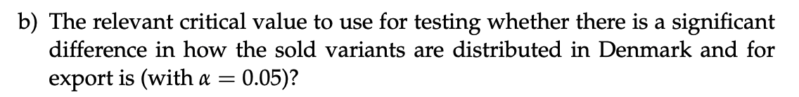

The table has 3 rows for the lamp variants and 2 columns for the sales destinations. Using Method 7.22 in Chapter 7, the degrees of freedom are:

$$df = \left(r-1\right)\left(c-1\right)= \left(3-1\right)·(2-1) = 2$$

By Equation (7-56), the critical value is the 1 − α = 0.95 quantile of the chi-square distribution with 2 degrees of freedom. This leaves 5% in the upper tail.

$$critical_value = chi2.ppf(0.95, df=2)$$

Critical value = 5.991.

We reject the hypothesis that the variant distribution is the same for Denmark and export if the observed chi-square statistic exceeds 5.991.

BONUS/Extra not part of exercise:

Multiply each percentage by 250 to get the observed counts. For example,$250· 0.072 = 18$ copper lamps were sold in Denmark.

Copper: 18 sold in Denmark, 16 exported (34 total).
Painted: 70 sold in Denmark, 87 exported (157 total).
Stainless steel: 22 sold in Denmark, 37 exported (59 total).

Under H₀, the expected count in each cell is calculated using Equation (7-53):
Expected count = row total × column total / grand total

Copper:
Denmark = $34·\frac{110}{250} = 14.96$
Export = $34·\frac{140}{250}$ = 19.04

Painted:
Denmark = $157·\frac{110}{250} = 69.08$
Export = $157·\frac{140}{250} = 87.92$

Stainless steel:
Denmark = $59·\frac{110}{250} = 25.96$
Export = $59·\frac{140}{250} = 33.04$

Using Equation (7-55), we add the six contributions $\frac{{\left(observed-expected\right)}^{2}}{expected}$
$$χ^{2}obs =\frac{{\left(18 - 14.96\right)}^{2}}{14.96} +\frac{{\left(16 - 19.04\right)}^{2}}{19.04}$$
$$+\frac{{\left(70 - 69.08\right)}^{2}}{69.08}+\frac{{\left(87 - 87.92\right)}^{2}}{87.92}$$
$$+\frac{{\left(22 - 25.96\right)}^{2}}{25.96} +\frac{{\left(37 - 33.04\right)}^{2}}{33.04}$$

$$≈ 2.204.$$

Since $2.204 < 5.991$, we fail to reject H₀ by Equation (7-56). The distribution of lamp variants does not differ significantly between Denmark and export at the 5% level.

Opgave 7.3)
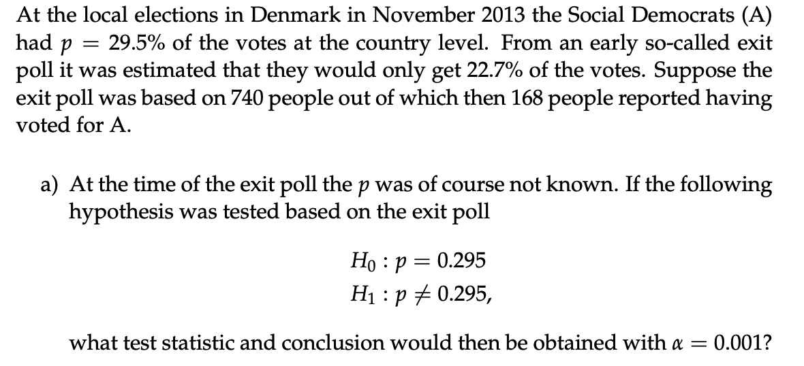

The exit poll had n = 740 respondents, where x = 168 voted for A. Using Method 7.11 in Chapter 7 with $p₀ = 0.295$, we test
$$H₀: p = p₀$$
$$H₁: p ≠ p₀$$

The expected counts under $H₀$ are $740· 0.295 = 218.3$ and $740· 0.705 = 521.7$.
Both exceed 15, so the normal approximation is appropriate (Theorem 7.10).

Using Equation (7-16), the test statistic is

$$z =\frac{\left(x - np_{0}\right)}{\sqrt{np_{0}\left(1 - p_{0}\right)}}=\frac{168 - 740 × 0.295}{\sqrt{740 × 0.295 × 0.705}}≈ -4.055$$

Using Equation (7-21), the two-sided p-value is

$$p_{value} = 2· P(Z > |z|) ≈ 0.0000502.$$

$$n, x, p0 = 740, 168, 0.295$$
$$z = (x - n * p0) / sqrt(n * p0 * (1 - p0))$$
$$p_value = 2 * (1 - norm.cdf(abs(z)))$$

Since $0.0000502 < 0.001$, we reject $H₀$. The exit poll estimate is significantly lower than 29.5% at the 0.1% significance level.

Using Equation (7-8), the sample proportion is $p̂ =\frac{168}{740} ≈ 0.22703$.

Using Equation (7-9) with the 95% critical value 1.96, the confidence interval is

$$\hat{p}± 1.96·\sqrt{\frac{\hat{p}\left(1 - \hat{p}\right)}{n}}= 0.22703 ± 1.96· \sqrt{0.22703·\frac{0.77297}{740}}≈ [0.19684, 0.25721].$$

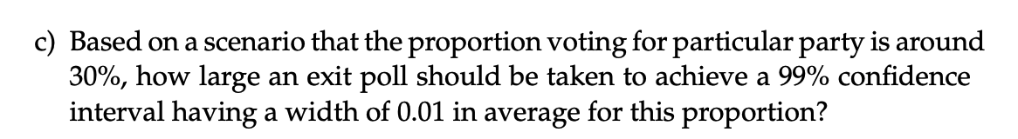

The target width is 0.01, so the margin of error is half the width. $ME =\frac{0.01}{2} = 0.005$

For a 99% confidence interval$, α = 0.01$ and the standard normal critical value is

$$z_{0.995}≈ 2.575829.$$

Using $p = 0.30$in the sample-size formula from Chapter 7, Equation (7-24), we get

$$n = p\left(1 - p\right)· {\left(\frac{z_{0.995}}{ME}\right)}^{2} = 0.30· 0.70· {\left(\frac{2.575829}{0.005}\right)}^{2}≈ 55733,13$$

Rounding up, the exit poll should include 55,734 respondents.

Opgave 7.4)
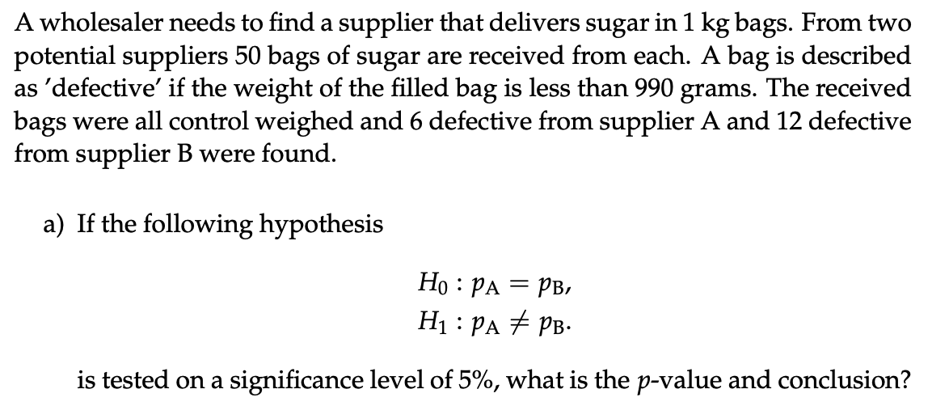

We use the two-sided test in Method 7.18 in Chapter 7.

$$H₀: p_{A} = p_{B}$$
$$H₁: p_{A} ≠ p_{B}$$

The observed defective proportions are$\frac{6}{50} = 0.12$ for A and $\frac{12}{50} = 0.24$ for B. Under $H₀,$ the pooled proportion is calculated using Equation (7-36): $p̂ =\frac{6+12}{50+50} = 0.18$

Using Equation (7-37), the test statistic is

$$z =\frac{\left(0.12 - 0.24\right)}{\sqrt{0.18· 0.82·\left(\frac{1}{50} +\frac{1}{50}\right)}}≈ -1.562$$

Using Equation (7-40), the approximate two-sided p-value is

$$p_{value}= 2· P(Z > |-1.562|) ≈ 0.1183.$$

Since $0.1183 > 0.05$, we fail to reject $H₀.$ The data provide insufficient evidence at the 5% level that the suppliers have different defective proportions.
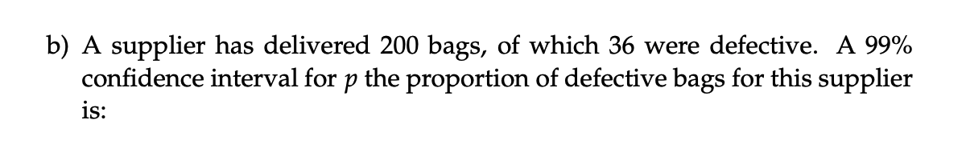
Using Equation (7-8), the sample proportion is$p̂ =\frac{36}{200} = 0.18$. For a 99% confidence interval, the critical value is $z_{0.995} ≈ 2.5758.$

Using Equation (7-9), the interval is

$$\hat{p}± z_{0.995}· \sqrt{\frac{\hat{p}\left(1 - \hat{p}\right)}{n}} = 0.18 ± 2.5758· \sqrt{0.18·\frac{0.82}{200}}≈ [0.1100, 0.2500]$$

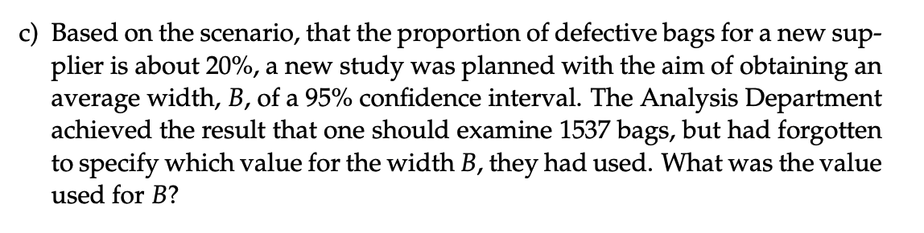
Using Equation (7-23) in Chapter 7, the margin of error is $ME = z_{0.995}· \sqrt{\frac{p\left(1 - p\right)}{n}}.$
The full width B is twice the margin of error. With p = 0.20, n = 1537, and $z_{0.995}$≈ 1.96, we get
$B = 2· ME$ $= 2· 1.96·\sqrt{0.20·\frac{0.80}{1537}} ≈ 0.0400$

Opgave 7.5)
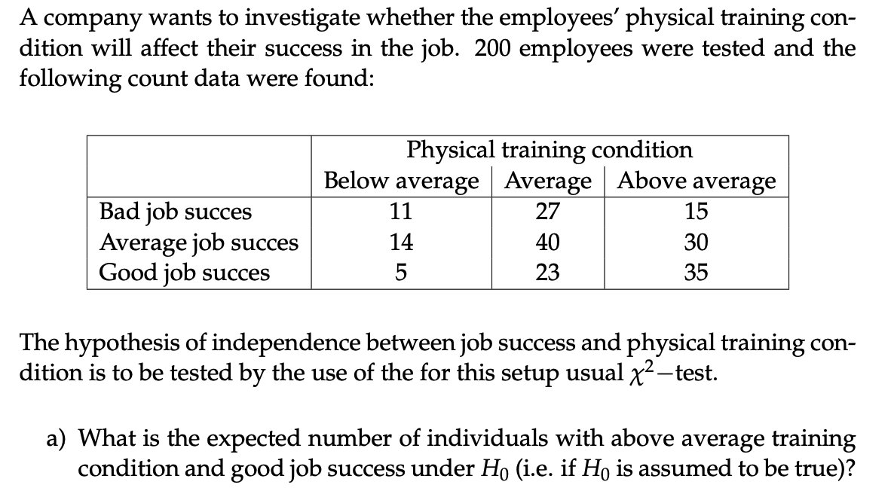

Expected count = row total × column total / grand total.

Good job success (row total) = 5 + 23 + 35 = 63.
Above-average training condition (column total) = 15 + 30 + 35 = 80.

Expected count = 63 × 80 / 200 = 25.2.

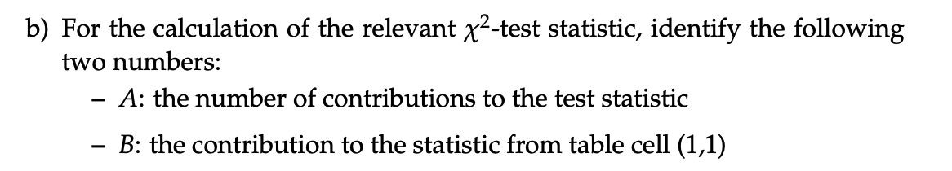

$A = 3·3 = 9$. Each cell contributes one term to the test statistic in Equation (7-55).

Cell (1,1) represents bad job success and below-average training condition. The observed count is 11. Using Equation (7-53), the expected count is

$$E = \left(11 + 27 + 15\right)·\frac{\left(11 + 14 + 5\right)}{200}= 53·\frac{30}{200}= 7.95$$

Using Equation (7-55), the contribution from cell (1,1) is

$$B =\frac{{\left(11 - 7.95\right)}^{2}}{7.95} ≈ 1.170$$

Using Method 7.22, the degrees of freedom are $\left(3 - 1\right)·\left(3 - 1\right)= 4$

The observed chi-square statistic is 10.985, so the upper-tail probability is:

$$p_value = 1 - chi2.cdf(10.985, df=4)$$

$$p_{value}= P(χ²₄ ≥ 10.985) ≈ 0.0267.$$

At the 5% significance level, we reject $H₀$ because 0.0267 < 0.05.

