Part 1

My site will nit pe formal , it will be fun. I drew a little me that will show up in the home page , an probably sometimes in the footer .

Figure 1 logo

I choose to have in the menu quick access to four of the pages called: Home, Accessibility, Contact and Degree. The other two pages , I will have access to them from the degree page because I consider that Quiz and Data are more related to Degree and would be much better to go on the pages after you read the content from degree page .

Figure 2 the map

The pages will show the figures aligned in the center because it will be easier to display them on both devices, mobiles and computers.

Figure 3 display

The menu will be formed from a long bar , with 4 buttons floated at left called HOME, DEGREE, ACCESIBILITY and CONTACT. In the right , I will show my website’s name that would be very short „Tina’s Website”. I will do that with the help of the w3school website .

<https://www.w3schools.com/html/html_examples.asp>

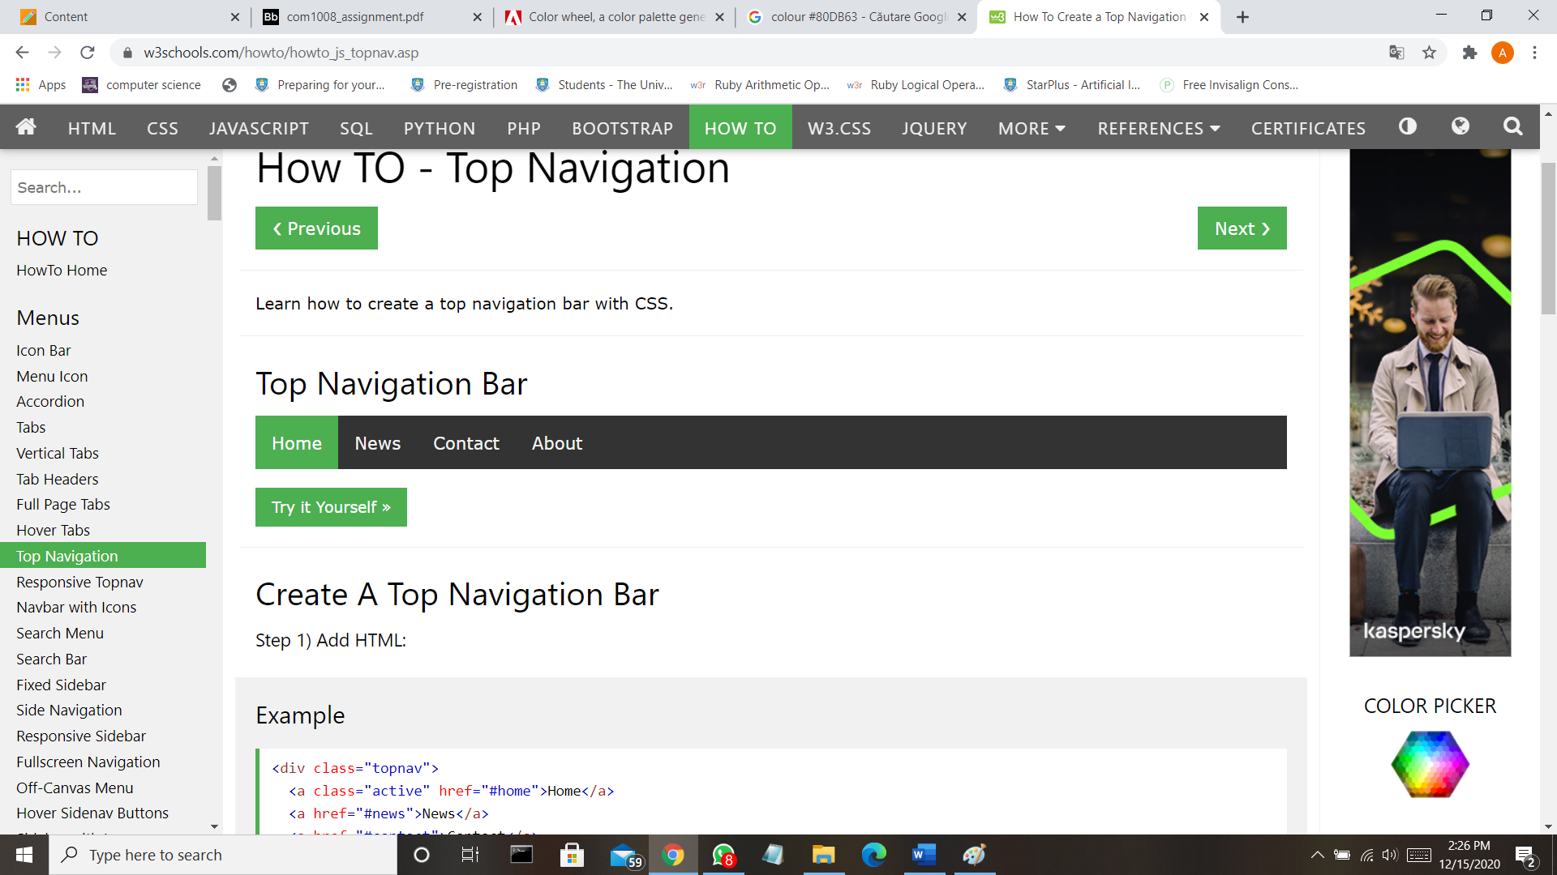

Figure 4 navigation bar example

I will use the color.adobe.com in order to choose the perfect colors from the same palette . It is easy to find your perfect match of tonalities and also , they give the codes for them .

Figure 5 the palette tool

Source: <https://color.adobe.com/create/color-wheel>

The colors that I choose are this :

Figure 6 color #F5DD8E

Figure 7 color #372240



Figure 8 color #E07B63

Figure 9 color #80DB63

And the basic colors for writing are white and black .

In order to avoid copyright , I will try my best to do my own images and look for pictures that its quality is very good . The images that will be extracted from different sources, I will put the source under them in order to avoid copyright .

Regarding security , we know that is better to give information that do not put in danger your own safety so I will put only my university email and the address of the Computer Science department . Defending against cross-site scripting making myself sure every part of string is interpreted as a string primitive, not a controlled character. For that I will need to write a function to encode special characters.

I will try my best to not have a lot of breakpoints making the site very easily to be done . In the cases where the font needs resizing , I will do that through @media .

I will do some sketches and attach the picture here . They will show how I intend to design my website .

There will approximately no difference between the computer and mobile , but I will focus on displaying perfectly on a mobile and when it comes about changing the font-size for computer , I will do it in css. (the drawings are just some sketches, their design is made very quick by hand).

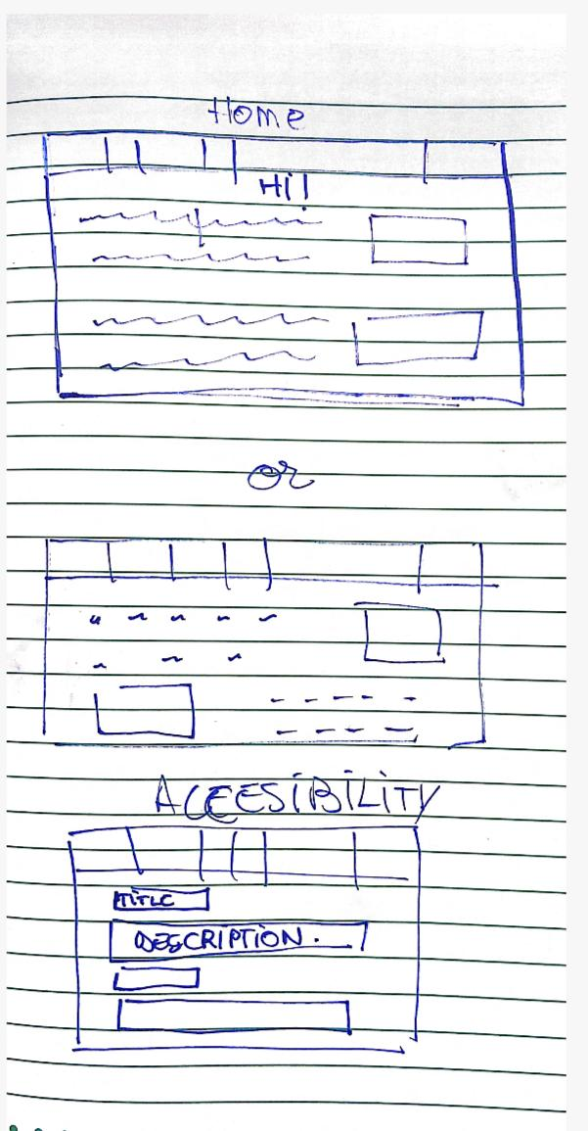

Figure 10 computer pages

Figure 11 mobile pages

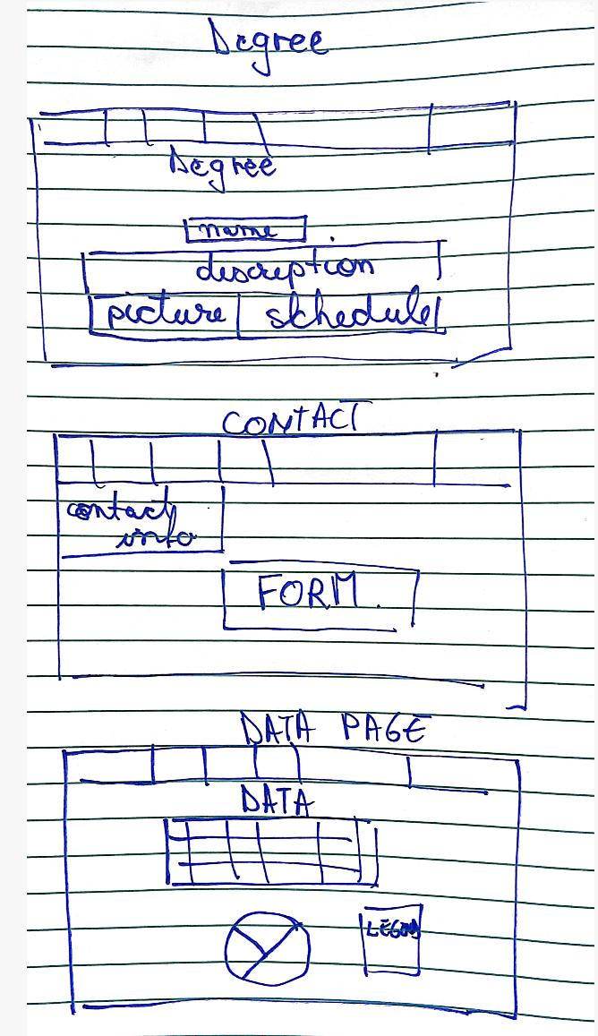

Figure 12 computer pages

Figure 13 computer page

My main purpose is to make my own templates , very easy ones and simple . With the same writing almost everywhere.