**1. Introduction**

The following subsections of the Software Requirements Specifications (SRS) document provides an overview of the entire SRS.

**1.1 Purpose**

This document outlines the usage and implementation of the GYM app.

**1.2 Document Conventions**

This Document was created based on the IEEE template for System Requirement Specification Documents.

**1.3 Scope**

The app is mainly for those who plan to lose or gain weight and require a planned medium for the same. The intended audience of this document is anyone who needs a platform where they find a sustainable and clear plan with videos to lose/maintain/gain weight

**1.3 Overview**

The app will initially take some inputs from the user whether he/she is interested in losing/maintaining/gaining muscle and some extra information regarding the same. Based on the inputs, the software will map the videos, diet and schedule them for the particular user. Further, the app keeps track of the workouts and diet maintained by the user and gives him a score to assess his discipline.

**1.4 Need for the System**

1. There are many apps for tracking the running and daily activities of every individual.

2. However, each individual has a different need of either losing/maintaining/gaining the weight.

3. There are no apps which address all these issues. Further, there are different apps for diet control and schedule maker.

4. One has to install many apps to meet one unique goal.

5. In addition to suggesting the workouts, this GYM app also plans a schedule where every day's diet and videos related to the same are conveyed.

**1.5 Similar Apps**

Adidas Mi-Coach-

This app has a GPS based tracker for running. It also gives a score for individual's daily performance. It is a more robust and a well-designed app, but doesn't have features of conveying related videos of exercises and the diet plan.

Seven-7 Minute Workout Challenge-

This app has universal and scientifically approved exercises for maintaining the muscle. But the app has only 15 activities for 7 minutes, and the scoring is just based on them. As mentioned earlier, this too doesn't have the suggestion of videos and diet planner. Further, this app doesn't have the tracking feature too.

**2. Functional Analysis**

**(1) The application will be able to record exercises, repetitions and the diet followed.**

**Description:** The app will have a calendar layout that the user will be able to click on a specific day where they can find all the events and diet scheduled for the day. Further, the activities will be monitored and recorded for the same date.

**Implementation:** A UI is created for the User to enter the repetitions of the exercises performed, diet followed for the day. Based on the given schedule and the followed schedule, application gives a score to the user for that day. The score will be a function of the repetitions mentioned by the application and the repetitions performed by the user. Similarly for the diet, calories intake and the calories mentioned by the applications will effect the score.

**Criticality:** The feature is important because without this user will have no directions to proceed. This forms the heart of the app.

**Risks:** The user might enter the wrong data to top the chart and measures are to be taken to address the issue. Further, this may lead the app to suggest wrong and intense exercises which may affect the performance of the user and subsequently the app.

**Dependency:** This depends on the calendar app of the device. Without proper interface with the calendar app, this makes GYM app malfunction. Further, effectiveness of the accounting by the user also has impact on the performance.

**(2) The application will be able to suggest the videos, diet and schedule them on the calendar.**

**Description:** The app will take the inputs from the user and suggest videos, diet and schedule for the user.

**Implementation:** A data base of the videos (can be from youtube), is created. Based on the user inputs like what part of the body the user is focussed, the videos will be mapped. For a low data device case instead of the videos, thumbnails from the video at regular intervals can be mapped. Further, diet is also planned similarly.

**Criticality:** This is also an important feature because this is the main feature which is been absent in many of the available apps.

**Risks:** The scheduling of videos and diet based on the inputs of the users needs an effective algorithm. A very effective algorithm after a literature survey will be taken to address the issue.

**Dependency:** This relies on the information from youtube. Instead a database collected from youtube and stored in an external server would address the issue. However since you tube is available free in near future it wouldn’t be a problem.

**(3) The application will be able to track the running activity of the user and convert them into the calories burnt.**

**Description:** Running speed, calories burnt, the track ran, etc will be monitored and recorded for the day in the calendar.

Implementation: The app will take the GPS location of the device and tracks the user's running activity. This will work only with users internet and location ON. This helps in calculating the calories burnt by the user. For calculation, time taken by the user and the distance travelled by the user will be considered.

**Criticality:** This is a less important feature, just to compete with the other apps. This acts like an add-on. Even without this feature the app would achieve its goal.

**Risks:** The tracking eats up the battery of the device a lot. This will be addressed by giving an option to user whether to track the route or not.

**Dependency:** The GPS interface and the gyrometer of the device have to be properly accessed for the proper functioning of the app.

**(4) The application will be able to score the user globally to motivate the user.**

**Description:** User will be ranked based on the score he/she has obtained and will be ranked globally in categories of daily and overall performance.

**Implementation:** The app will record the user's score and upload it to a global server where ranking is done based on all the users' performance which can be displayed to every user in the app itself under a unique category named Ranking. This will be done with only prior permissions from the user so that the privacy of the user is not affected. However even if the user is not interested in disclosing his identity, ranking can be displayed with some random comic names.

**Criticality:** This is also an add-on kind of feature. It is a motivation for the user to be more discipline towards the workouts and diet.

**Risks:** The fake accounting might effect the chart. Inorder to avoid the fake accounting by the users only the data with feasible results is accounted while ranking the user.

**Dependency:** Seggragation of correct and incorrect data depends on the algorithm. The algorithm hence decides the function of the app.

**(5) The application will be able work offline/low data mode.**

**Description:** Since network availability is not available in many scenaros, app will be working during offline and low data mode.

**Implementation:** For a low data mode, instead of videos, pictures from the videos at regular intervals will be provided. Thus the information is conveyed with a very less data consumption. Further, the app will be storing the data during offline mode and upload the same to the server whenever the device goes online.

**Criticality:** This is an important feature. Most of the devices wont have access to the internet all the time. Hence this is an important feature for proper functioning of the app.

**Risks:** The stored data might eat up a lots of space. Hence only bare minimum required data and optimized data will be stored to manage the storage space.

**Dependency:** This depends on the available storage in the device and the RAM of the devics.

**3. Operational Scenario**

**First Time Enrollment:**

1. User opens the application.

2. User enrolls the name and personal details.

3. User chooses if he/she wants to lose/maintain/gain muscle.

4. User will be given a choice whether he/she is interested in shaping up specific body parts/or whole body activty.

5. User will be asked for whether he/she is beginner/intermediate/Pro so that the application decide the videos based on the inputs.

6. Based on the user information, the application maps the videos, diet and sorts them according to schedule.

7. Application finally suggests a plan.

**Daily Activities:**

1. User can look at the videos scheduled for the day and follow the mentioned workout.

2. User has to follow the diet plan.

3. At the end of the day, user will be accounting for all his daily activities.

4. Some of them (say exercises) will be automated while doing the activity itself.

5. The others like diet are accounted at the end of the day. User is trusted to during this process for a successful schedule.

6. The application gives a score for the day and suggests/re-schedules the plan based on the daily activity.

7. Further, a global score is provided for the user to motivate him.

**DataBase Mapping:**

1. Server will have a collection of videos and each video will be labelled with many categories.

2. When a user requests for videos with specified categories, videos which map to the categories mentioned by user will be sorted out.

3. Similarly diet related to the categories is also data based and based on the users input they are also sorted out respectively.

4. Now based on user’s requirement schedule for a week/month will be planned and displayed on calendar.

5. Further while mapping user input data during usage of app, will be seggragated based on their age and sex. This ensures proper functioning of a mapping algorithm.

6. Reviews and feedback from the users also segregated based on age and sex.

**Improving the Database:**

1. With evolution of the app and usage of the app by users data base will be re-mapped.

2. Users will give rating to the exercises and based on the ratings the remapping will be done. This helps in improving the performance of the app with the usage.

3. Further, the rating can be displayed to the user which allows him to choose among many of the available videos. This ensures the quality of the videos available in the app.

4. The mentioned feature can be added as a commercial element where only premium users can have access to the ratings. Thus the review and the feedback of the users will be used efficiently in this way.

**4. Other Features**

**Alarming:**

1. The user will be reminded using the in built alarm app about his work out or schedule.

2. Further, if user permits, the diet can also be reminded at regular intervals.

3. This adds as an extra feature for the app. The turn on and off feature will be given to let the users customize the app based on their requirements.

**Privacy:**

1. The application will not disclose any personal information of the customers.

2. Even in the global rankings the other user names will not be displayed unless the user wishes to do so.

3. Further, the application will give access based on secured authorization.

4. The authorization can be linked with the device which the user will be operating while doing the workouts.

5. Encryption of data will be implemented which will ensure that without the encrypted key unauthorized access of data impossible.

**Version:**

1. The application will receive feedbacks in a separate category where a user can comment on the crash of the app, malfunctioning of the app.

2. This will be collected and will be updated in the next versions.

3. Further, every version the changes will be logged. However each version should support roll back of the app.

**Playlist:**

1. The application will have a playlist which is linked to you tube.

2. This helps the user to push him during the work outs.

3. User will be given choice of the playlist linked to youtube.

4. Since you tube is an open source kind of platform, no extra cost will be involved. Further users will have access to a wide range of music.

**Web Access:**

1. Devices like mobile happen to be in smaller size and viewing the videos will be difficult things some times.

2. A web access to every account helps the user to organize the things in a well-planned manner and track the things.

3. User can have very clear and precise analysis through videos in a web based platform.

4. Later during his workouts he will have the device where he can chose the already viewed videos.

**Compatibility:**

1. The application should take a maximum of 75 MB of RAM while running.

2. The application should not exceed a window size of 10 inches

3. Application shall be compatible with any android version above 2.3.3.

**Demo:**

1. Demo of using the app should be available during the first time access of the app. This will be in form of short video and a document.

2. Further this feature will be made as an option in the menu of the app.

**5.Interfaces With the Device**

**Hardware:**

1. Touch Screen-The app will access the touch screen of the device for taking inputs.

2. Audio Jack-During the time of playlist while having the workout and video lectures where user will be trained, the audi jack will be used.

3. System Clock: For alarm and the time calculations during the workout, the app will use the system clock.

4. GPS and Gyrometer-As mentioned earlier will be used for tracking.

**Software:**

Internet: App will use the internet data and may cost the user for the same. However, user can opt out this.

**6 .Testing the Application**

**Testing Process:**

1. The application will be tested with in a university . A university with proffesors and students, with sufficient male and female users will form a diverse test case.

2. Users will be allowed to use the app for a month, where they input their daily activities and rate the videos.

3. The app will update suggesting based on the feedback of the users in that span of testing period.

4. An app review will be taken at the end of the testing duration.

5. Any malfunctions and the crashes of the app will be noted and sorted out.

6. During the process server functioning and algorithm will also be evaluated.

7. Algorithm of mapping, if not efficient will be tweaked based on the user suggestions.

8. Further, during the testing stage, users will be allowed to suggest on what else would make the app better.

**7. Sample Use Case**

Figure 1 presents a sample use case of a user and the choices/menu options he/she will have. Figure 2 presents the activities to be performed by the application.

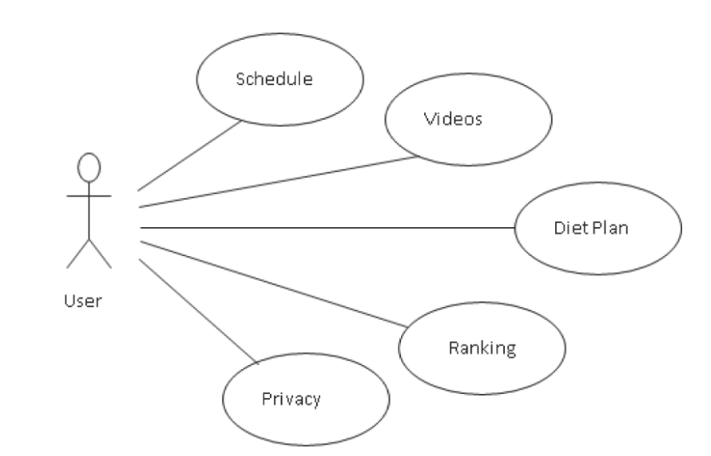

Figure 1. User Case

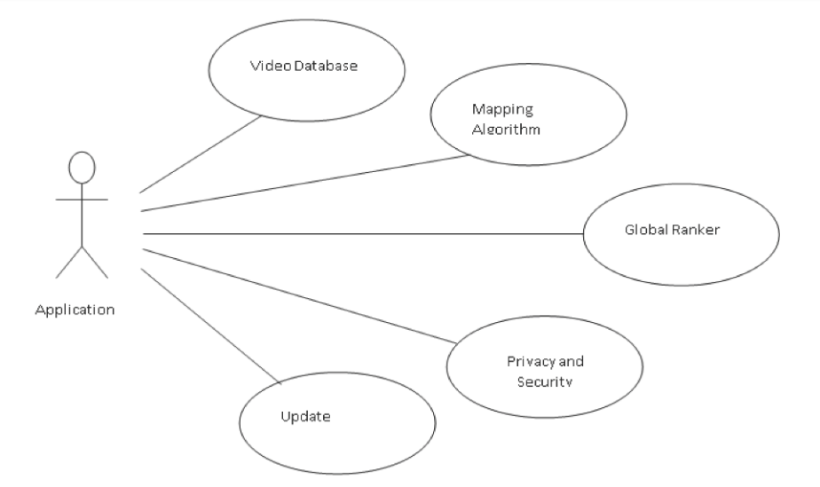

Figure 2. Application Case

**8. Glossary**

**Acronym Expansion**

RAM Random Access Memory

MB Mega Bytes

UI User Interface

GPS Global Positioning System

**9. Space for Updating Versions and Comments**

**Change Log:**

Version Number Removed Features Added Features

0.0.1 - -

**Usefule Links-**

Link to the play store app-Link to the web based app-