DOCUMENTACIÓN TÉCNICA
WhatsPoke - Aplicación Android MVVM


Alberto Pinteño Plaza 2º DAM

Índice:
1. Arquitectura General
2. Diagrama de Clases
2.1 Paquete data.local
2.2 Paquete data.local.datastore
2.3 Paquete data.remote
2.4 Paquete data.repository
2.5 Paquete ui.viewmodel
2.6 Paquete model
3. Diagrama de Casos de Uso
4. Diagrama de Secuencia: Guardar Favorito
5. Patrones y Decisiones Técnicas
6. Estructura de Paquetes
7. Capturas de Pantalla

1. Arquitectura General
La aplicación sigue estrictamente la arquitectura MVVM (Model-View-ViewModel) con separación de responsabilidades en capas:
Capa | Responsabilidad
UI Layer | Screens (Compose) + ViewModels (StateFlow/SharedFlow)
Domain Layer | Modelos de dominio (Pokemon, mappers DTO/Entity)
Data Layer | Repositories + Data Sources (Remote API, Local Database, DataStore)
DI Layer | Inyección de dependencias con Hilt

2. Diagrama de Clases

2.1 Paquete data.local
Base de datos local Room con DAOs para persistencia de favoritos y comentarios.
AppDatabase (abstract class, RoomDatabase)
─ Métodos ─
+ pokemonDao(): PokemonDao
+ commentDao(): CommentDao

PokemonDao (interface, @Dao)
─ Métodos ─
+ getAllFavorites(): Flow<List<PokemonEntity>>
+ getFavoriteById(id: Int): PokemonEntity?
+ insertFavorite(pokemon: PokemonEntity): Long
+ deleteFavoriteById(id: Int)
+ isFavoriteFlow(id: Int): Flow<Boolean>
+ getPokemonWithComments(id: Int): Flow<PokemonWithComments?>

CommentDao (interface, @Dao)
─ Métodos ─
+ getCommentsForPokemon(pokemonId: Int): Flow<List<CommentEntity>>
+ insertComment(comment: CommentEntity)
+ deleteCommentById(commentId: Long)

PokemonEntity (@Entity tableName="pokemon_favorites")
─ Atributos ─
- id: Int (@PrimaryKey)
- name: String
- description: String
- imageUrl: String
- type: String
- height: Int
- weight: Int
- abilities: String
- stats: String

CommentEntity (@Entity tableName="comments")
─ Atributos ─
- commentId: Long (@PrimaryKey autoGenerate)
- pokemonId: Int (ForeignKey -> PokemonEntity.id, CASCADE)
- authorName: String
- content: String
- timestamp: Long
PokemonWithComments
─ Atributos ─
- pokemon: PokemonEntity (@Embedded)
- comments: List<CommentEntity> (@Relation)

2.2 Paquete data.local.datastore
SettingsDataStore (@Singleton)
─ Atributos ─
- context: Context
─ Métodos ─
+ userNameFlow: Flow<String>
+ themeModeFlow: Flow<String>
+ saveUserName(name: String): suspend
+ saveThemeMode(mode: String): suspend

2.3 Paquete data.remote
PokeApiService (interface, Retrofit)
─ Métodos ─
+ getPokemonList(limit, offset): PokemonListResponseDto
+ getPokemonDetail(id): PokemonDetailResponseDto

PokemonListResponseDto
─ Atributos
- count: Int
- next: String?
- previous: String?
- results: List<PokemonResultDto>

PokemonResultDto
─ Atributos
- name: String
- url: String

PokemonDetailResponseDto
─ Atributos
- id: Int
- name: String
- height: Int
- weight: Int
- sprites: SpritesDto
- types: List<TypeSlotDto>
- abilities: List<AbilitySlotDto>
- stats: List<StatSlotDto>

2.4 Paquete data.repository
PokemonApiRepository @Singleton
─ Atributos ─
- pokeApiService: PokeApiService
─ Métodos ─
+ getPokemonList(...): PokemonListResponseDto
+ getPokemonDetail(...): PokemonDetailResponseDto

FavoriteRepository @Singleton
─ Atributos ─
- pokemonDao: PokemonDao
─ Métodos ─
+ getAllFavorites(): Flow<List<PokemonEntity>>
+ addFavorite(pokemon): Boolean
+ removeFavorite(id)
+ isFavoriteFlow(id): Flow<Boolean>
+ getPokemonWithComments(id): Flow<PokemonWithComments?>

CommentRepository @Singleton
─ Atributos ─
- commentDao: CommentDao
─ Métodos ─
+ getCommentsForPokemon(id): Flow<List<CommentEntity>>
+ addComment(comment)
+ deleteComment(id)

SettingsRepository @Singleton
─ Atributos ─
- settingsDataStore: SettingsDataStore
─ Métodos ─
+ userNameFlow: Flow<String>
+ themeModeFlow: Flow<String>
+ saveUserName(name)
+ saveThemeMode(mode)

2.5 Paquete ui.viewmodel
UiState<out T> (sealed class)
─ Estados ─
- Loading
- Success<T>(data: T)
- Error(message: String)

ElemListViewModel (@HiltViewModel)
─ Atributos ─
- pokemonApiRepository, favoriteRepository
─ Métodos ─
+ pokemonListState: StateFlow<UiState<List<Pokemon>>>
+ favoriteIds: StateFlow<Set<Int>>
+ eventFlow: SharedFlow<String>
+ loadPokemonList()
+ addToFavorites(pokemon)

DetailItemViewModel (@HiltViewModel)
─ Atributos ─
- pokemonApiRepository, favoriteRepository
─ Métodos ─
+ pokemonDetailState: StateFlow<UiState<Pokemon>>
+ isFavorite: StateFlow<Boolean>
+ eventFlow: SharedFlow<String>
+ loadPokemonDetail(id)
+ toggleFavorite()

FavListViewModel (@HiltViewModel)
─ Atributos ─
- favoriteRepository
─ Métodos ─
+ favoritesState: StateFlow<UiState<List<Pokemon>>>
+ loadFavorites()
+ deleteFavorite(id)

DetailFavViewModel (@HiltViewModel)
─ Atributos ─
- favoriteRepository, commentRepository
─ Métodos ─
+ pokemonWithComments: StateFlow<PokemonWithComments?>
+ comments: StateFlow<List<CommentEntity>>
+ loadPokemonWithComments(id)
+ addComment(pokemonId, authorName, content)
+ deleteComment(commentId)

ProfileViewModel (@HiltViewModel)
─ Atributos ─
- settingsRepository
─ Métodos ─
+ userName: StateFlow<String>
+ themeMode: StateFlow<String>
+ saveUserName(name)
+ saveThemeMode(mode)

2.6 Paquete model
Pokemon (data class)
─ Atributos ─
- id, name, description, imageUrl, type, height, weight, abilities, stats, isFavorite
─ Extension Functions ─
+ PokemonResultDto.toPokemon(): Pokemon
+ PokemonDetailResponseDto.toPokemon(): Pokemon
+ PokemonEntity.toPokemon(): Pokemon
+ Pokemon.toEntity(): PokemonEntity

3. Diagrama de Casos de Uso
Actor principal: Usuario
ID | Caso de Uso | Flujo
CU-01 | Ver Lista de Pokemon | Home -> Carga API -> Muestra lista con Coil
CU-02 | Ver Detalle de Pokemon (API) | Pulsar tarjeta -> Retrofit GET /pokemon/{id} -> Detalle completo
CU-03 | Guardar Favorito | Pulsar corazón -> ViewModel -> Repository -> DAO insert -> Icono amarillo
CU-04 | Detectar Duplicado de Favorito | Pulsar guardar -> Repository verifica -> SharedFlow -> Toast
CU-05 | Ver Favoritos | Tab Favorites -> Repository -> DAO Flow -> UI actualiza en vivo
CU-06 | Eliminar Favorito | Pulsar corazón -> AlertDialog -> Confirmar -> DAO delete -> Flow
CU-07 | Añadir Comentario | FAB -> Escribir -> Send -> DataStore userName -> Insert -> Lista actualizada
CU-08 | Configurar Perfil | Profile -> Editar nombre -> Save -> DataStore -> StateFlow actualiza UI

4. Diagrama de Secuencia: Guardar Favorito
Escenario: Usuario pulsa "Guardar en Favoritos" en DetailItemScreen
Participantes:
- Usuario
- DetailItemScreen (UI)
- DetailItemViewModel
- FavoriteRepository
- PokemonDao
- Room Database

Flujo de Secuencia:
Paso | Interacción | Nota
1 | Usuario -> DetailItemScreen | Pulsa botón "Save to Favorites"
2 | DetailItemScreen -> DetailItemViewModel | Invoca toggleFavorite()
3 | DetailItemViewModel -> FavoriteRepository | Llama a getFavoriteById(id)
4 | FavoriteRepository -> PokemonDao | Invoca getFavoriteById(id)
5 | PokemonDao -> Room Database | SELECT * FROM pokemon_favorites WHERE id = ?
6 | Room Database -> PokemonDao | Retorna PokemonEntity? (null si no existe)
7 | PokemonDao -> FavoriteRepository | Retorna null
8 | FavoriteRepository -> DetailItemViewModel | Retorna null (no existe)
9 | DetailItemViewModel -> FavoriteRepository | Llama a addFavorite(pokemon.toEntity())
10 | FavoriteRepository -> PokemonDao | Invoca insertFavorite(pokemonEntity)
11 | PokemonDao -> Room Database | INSERT INTO pokemon_favorites (...)
12 | Room Database -> PokemonDao | Retorna rowId (éxito)
13 | PokemonDao -> FavoriteRepository | Retorna rowId
14 | FavoriteRepository -> DetailItemViewModel | Retorna true (éxito)
15 | DetailItemViewModel (interno) | Actualiza _isFavorite.value = true
16 | DetailItemViewModel -> DetailItemScreen | StateFlow<Boolean> emite true
17 | DetailItemViewModel (interno) | _eventFlow.emit("Pokemon guardado")
18 | DetailItemViewModel -> DetailItemScreen | SharedFlow<String> emite mensaje
19 | DetailItemScreen | Muestra Toast con el mensaje
20 | DetailItemScreen -> ElemListScreen | favoriteIds StateFlow se actualiza
21 |  | Icono del corazón cambia a amarillo automáticamente

Notas del flujo:
- Unidireccionalidad: La UI solo observa StateFlow/SharedFlow. Nunca modifica datos directamente.
- Reactivo: Room emite Flows que actualizan múltiples observadores sin intervención manual.
- Manejo de errores: OnConflictStrategy.IGNORE devuelve -1 en conflictos; el ViewModel lo interpreta.

5. Patrones y Decisiones Técnicas
Aspecto | Decisión | Justificación
Inyección de Dependencias | Hilt | Estándar oficial de Google, reduce boilerplate
Comunicación UI-VM | StateFlow + SharedFlow | StateFlow para estados, SharedFlow para eventos
Imágenes | Coil | Carga eficiente con caché, integración Compose
Serialización JSON | Gson + Retrofit | Compatible con estructura PokeAPI
Relación Room | 1:N Pokemon-Comments | ForeignKey CASCADE borra comentarios al eliminar padre
Conflictos Room | OnConflictStrategy.IGNORE | Evita excepciones en duplicados
Tema Dinámico | DataStore + WhatsPokeTheme | Tema leído de DataStore, propaga a toda la app

6. Estructura de Paquetes
com.example.whatspoke
├── WhatsPokeApplication.kt # @HiltAndroidApp
├── MainActivity.kt # Entry point
├── model/
│ └── Pokemon.kt # Modelo dominio + Mappers
├── data/
│ ├── local/
│ │ ├── AppDatabase.kt # Room Database
│ │ ├── dao/
│ │ │ ├── PokemonDao.kt
│ │ │ ── CommentDao.kt
│ │ ├── entity/
│ │ │ ├── PokemonEntity.kt
│ │ │ ├── CommentEntity.kt
│ │ │ └── PokemonWithComments.kt
│ │ └── datastore/
│ │ └── SettingsDataStore.kt
│ ├── remote/
│ │ ├── PokeApiService.kt
│ │ └── dto/
│ │ ├── PokemonListResponseDto.kt
│ │ └── PokemonDetailResponseDto.kt
│ └── repository/
│ ├── PokemonApiRepository.kt
│ ├── FavoriteRepository.kt
│ ├── CommentRepository.kt
│ └── SettingsRepository.kt
├── di/
│ ├── AppModule.kt
│ ├── DatabaseModule.kt
│ └── NetworkModule.kt
├── ui/
│ ├── components/
│ │ └── PokemonCard.kt
│ ├── navigation/
│ │ └── NavGraph.kt
│ ├── screens/
│ │ ├── ElemListScreen.kt
│ │ ├── DetailItemScreen.kt
│ │ ├── FavListScreen.kt
│ │ ├── DetailFavScreen.kt
│ │ ├── ProfileScreen.kt
│ │ └── AboutScreen.kt
│ ├── theme/
│ │ ├── Color.kt
│ │ ├── Theme.kt
│ │ └── Type.kt
│ └── viewmodel/
│ ├── UiState.kt
│ ├── ElemListViewModel.kt
│ ├── DetailItemViewModel.kt
│ ├── FavListViewModel.kt
│ ├── DetailFavViewModel.kt
│ └── ProfileViewModel.kt

8. Capturas de Pantalla

8.1 Pantalla Principal (ElemListScreen)
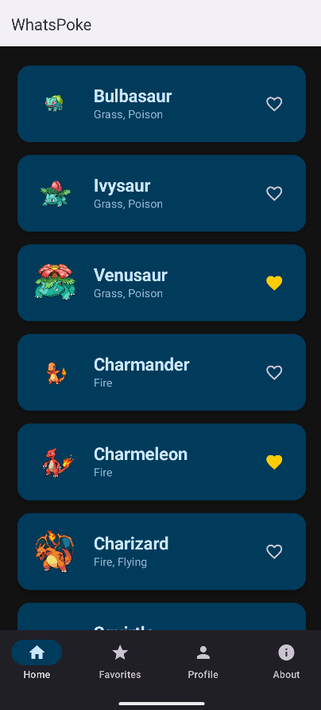

8.2 Pantalla de Detalle desde API (DetailItemScreen)
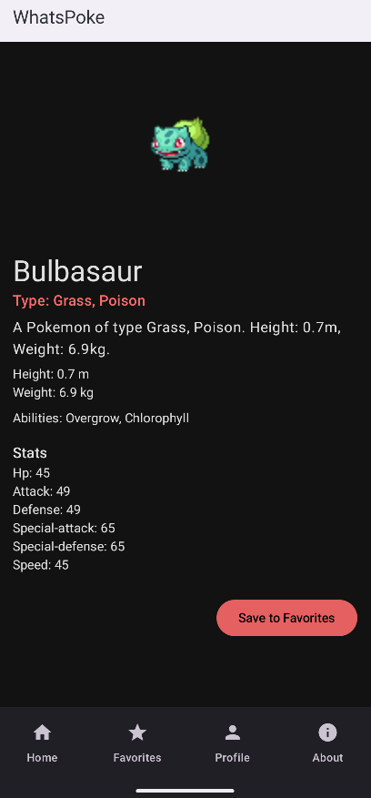

8.3 Pantalla de Perfil (ProfileScreen)
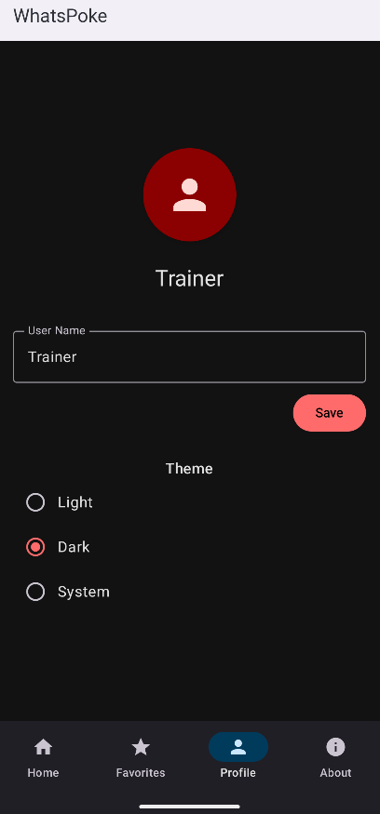

8.4 Pantalla de Favoritos (FavListScreen)
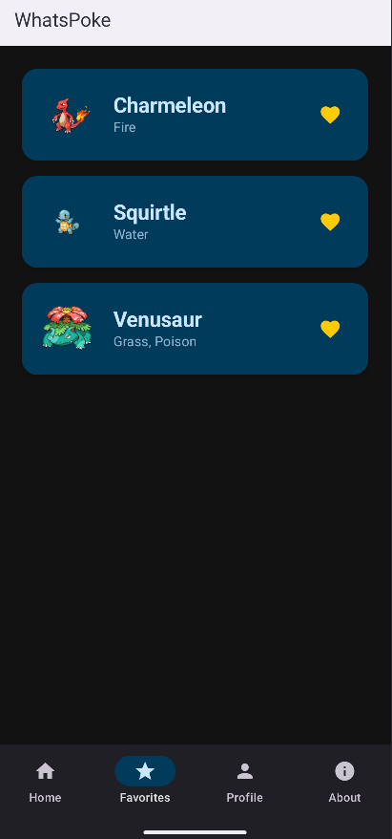
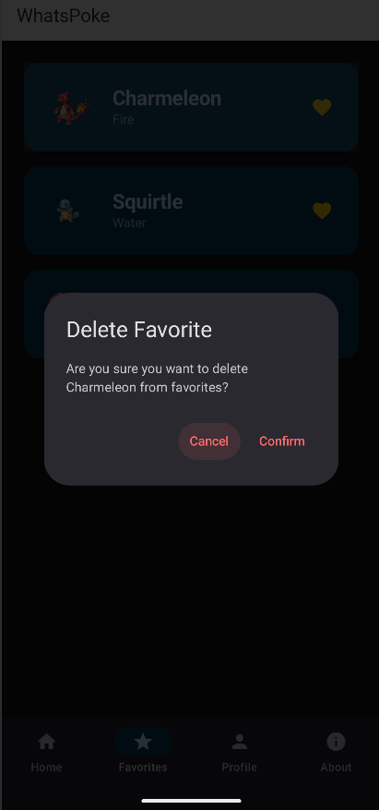

8.5 Pantalla de Detalle de Favorito (DetailFavScreen)
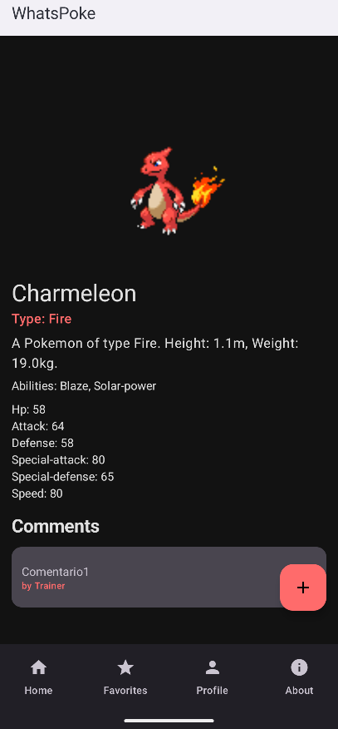

8.6 Pantalla About (AboutScreen)
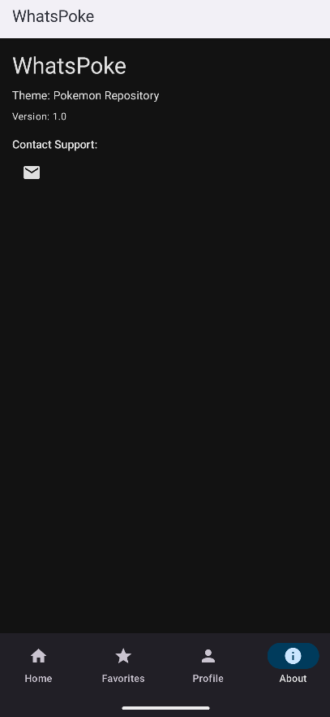

8.7 App Inspection - Base de Datos Room
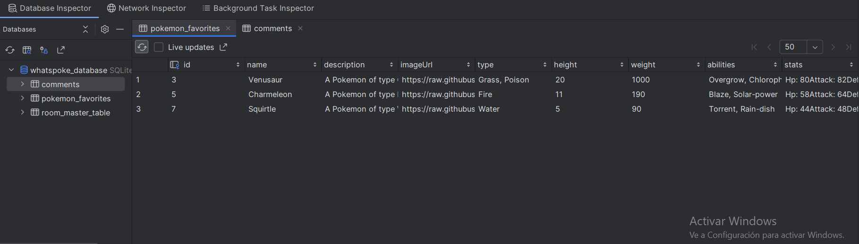

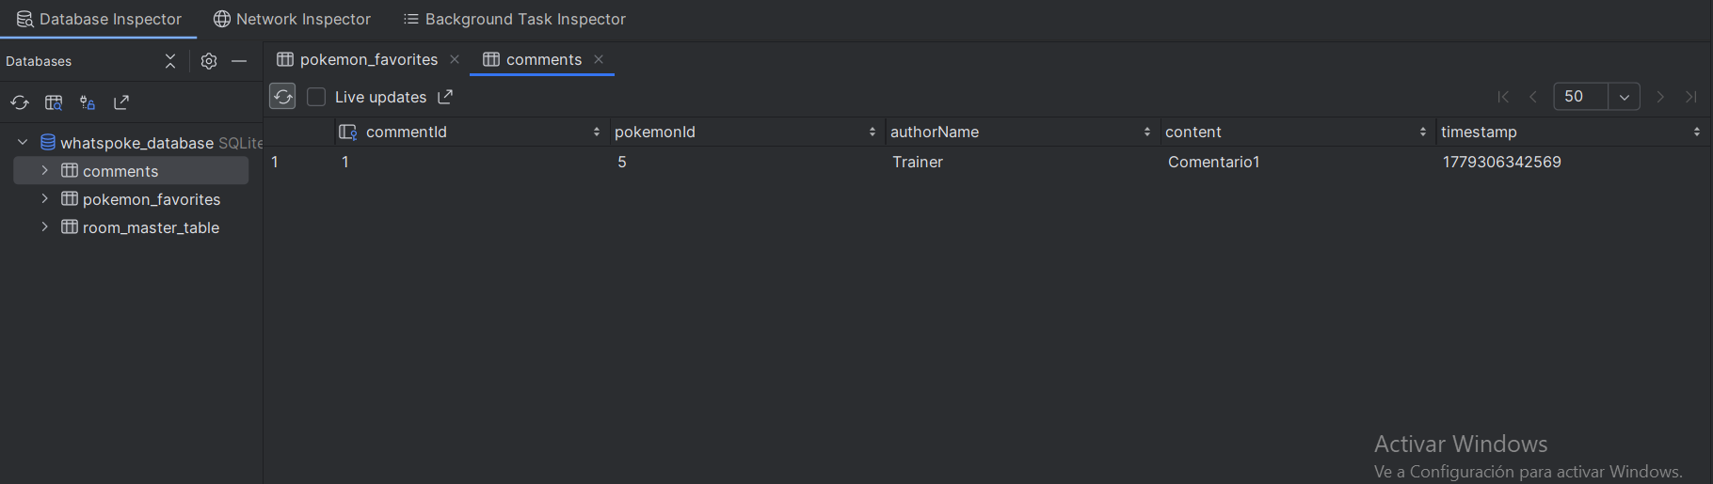

8.8 DataStore - Fichero de Configuración Local
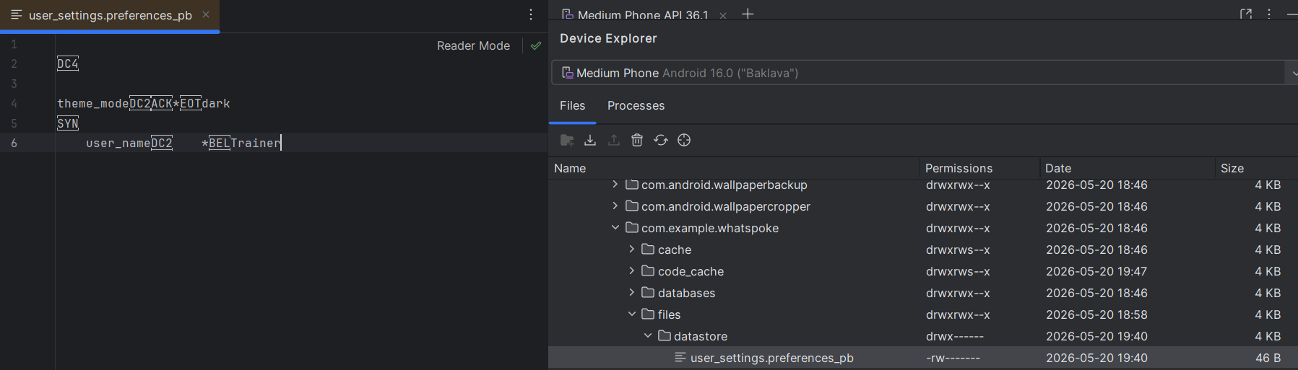

8.9 Network Inspector - Tráfico de Red
