

Readme

Windows Azure Toolkit for Social Games

|  |  |  |  |  |  |
| --- | --- | --- | --- | --- | --- |
| |  |  | | --- | --- | | Version: | 1.0.0 | | Last updated: | 9/29/2011 | |  |

## Contents

Overview 2

Get Started 3

Overview

Building a social game is a tough challenge. From the first iteration developers must plan for and deal with issues like high concurrency, real time interaction, and rapid growth. The Windows Azure Toolkit for Social Games provides you with the tools you need to ramp up your game development quickly on an architecture that will help you face future challenges. The toolkit leverages the power of Windows Azure and game development best practices to handle even the most demanding social games.

This version of the toolkit consists of a generic game play service API, and two sample games that consumes the operations exposed by the game service: “Tic-Tac-Toe” a “Four in a Row”. The game play service is responsible for handling the generic game operations like user authentication, joining multiple players to a game, and persisting the game live state.

This guide will walk you through the steps for running the sample game locally using the Windows Azure emulator.

## Prerequisites

* 1. The following software is required to run this toolkit:
  + [Microsoft Visual Web Developer 2010 Express or Microsoft Visual Studio 2010](http://www.microsoft.com/express/Web/)
  + [Microsoft .NET Framework 4.0](http://www.microsoft.com/downloads/details.aspx?FamilyID=ab99342f-5d1a-413d-8319-81da479ab0d7)
  + Internet Information Services 7 , with ASP.NET Feature enabled
  + [Windows Azure SDK and Tools for Visual Studio (September 2011) version 1.5](http://go.microsoft.com/fwlink/?LinkID=128752)
  + [Microsoft SQL Server 2008 (Express edition or greater)](http://www.microsoft.com/express/Database/InstallOptions.aspx)
  + [Windows Identity Foundation Runtime](http://support.microsoft.com/kb/974405)
  + An HTML 5 capable browser – for example Internet Explorer 9

## Learning more about the Windows Azure Platform

To learn more about the Windows Azure Platform and AppFabric check these resources:

* + Complete the Hands-On Labs in the Windows Azure Platform Training Course online on [MSDN](http://go.microsoft.com/fwlink/?LinkID=207018).
  + Learn how to build applications with the Windows Azure Platform Training Kit you can [Download Here](http://go.microsoft.com/fwlink/?LinkID=130354).

Get Started

To get started with the Windows Azure Toolkit for Social Games you can run it locally using the Windows Azure compute emulator and your local SQL Server.

**Running the Setup**

* 1. Run the **Setup.exe** file located in the root folder where you extracted the toolkit package. Notice that this script requires administrator privileges.
  2. The setup will launch the Content Installer. The Content Installer is designed to check your system to ensure that it is properly configured with all of the dependencies to build and use the sample.
  3. The next step involves checking your machine for the required software and configuration. If you don’t have the required configuration or dependencies, then in some of the cases you will be provided with a link to download them, in other cases the Web Platform Installer will install them. After installing a missing prerequisite, click **Refresh** to initiate the detection process again. Once the detection process is complete and you have verified every prerequisite, click **Next** to continue.
     1. 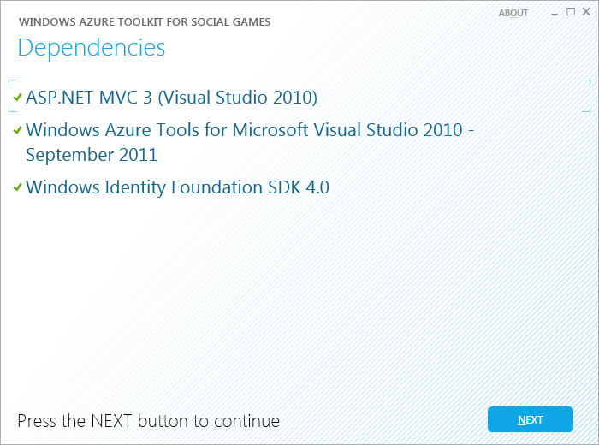
     2. Figure 1
     3. Checking Dependencies
  4. Next, a setup process will be executed to create a database in your local SQL Server.
     1. 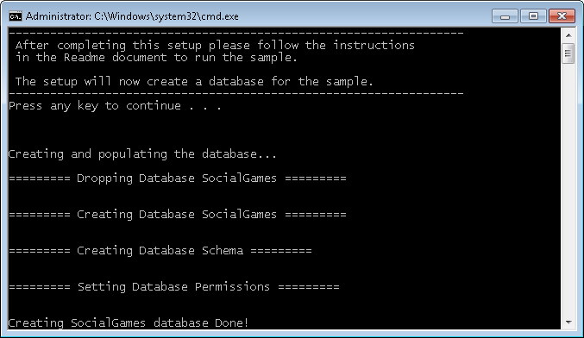
     2. Figure 2
     3. Setup scripts

The setup scripts will create a SocialGames database using your local SQL Express server instance (.\SQLExpress), and Windows Authentication to connect. If you want to use other SQL Server instance for the sample, you can edit the **Configuration.xml** file, located under the root folder of this package, with Visual Studio.

Additionally, the setup scripts will configure the sample to use the local Windows Azure Storage emulator. If you want to use a storage account, you can configure the account name and account key of the **WindowsAzureStorage** setting, in the Configuration.xml file, located under the root folder of this package, with Visual Studio.

1. After changing the settings, please run the setup again.
   * 1. XML
     2. <Configuration>
     3. <Database>
     4. <!-- e.g. '.\SQLEXPRESS' or 'yourserver.database.windows.net' -->
     5. <ServerName>.\SQLEXPRESS</ServerName>
     6. <DatabaseName>SocialGames</DatabaseName>
     7. <Username></Username>
     8. <Password></Password>
     9. </Database>
     10. <WindowsAzureStorage>
     11. <!-- use empty values for local storage emulator -->
     12. <AccountName></AccountName>
     13. <AccountKey></AccountKey>
     14. </WindowsAzureStorage>
     15. </Configuration>

**Running the Samples**

* 1. Open Visual Studio as administrator from **Start** | **All Programs** | **Microsoft Visual Studio 2010** by right clicking the Microsoft Visual Studio 2010 shortcut and choosing **Run as administrator**.
  2. Using Visual Studio, open the **SocialGames.sln** solution located under the **code** folder of this sample.
  3. Make sure that the **SocialGames.Cloud.Local** project is selected as the StartUp project (shown in **bold**).
     1. 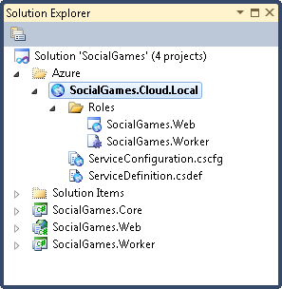
     2. Figure 3
     3. The SocialGames solution
  4. Press **CTRL+F5** to build and deploy the application to the compute emulator. Your default Web browser should open pointing to <http://127.0.0.1:81/> and showing the Social Gaming Examples home page.
     1. **Note:** By default, the application is configured to use port 81, so you should make sure this port is free before running the application.
     2. 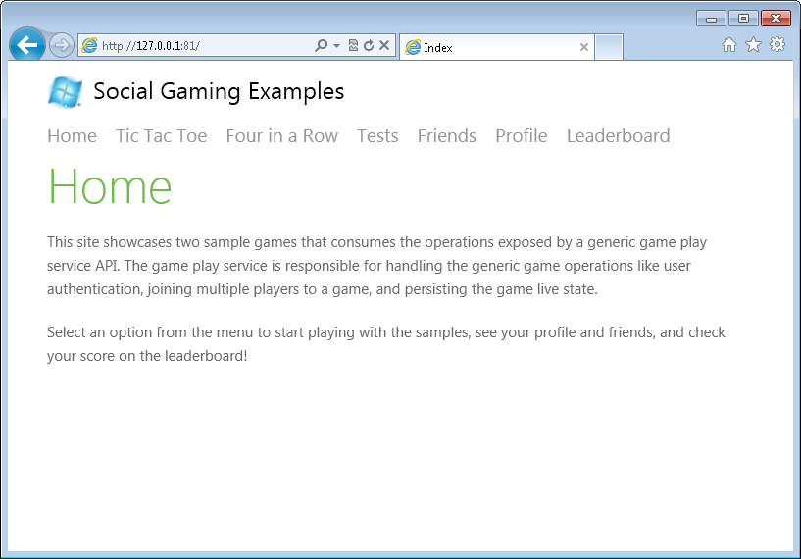
     3. Figure 4
     4. Social Gaming Examples home page
  5. Click the **Tic Tac Toe** menu option. You will be redirected to the login page.
  6. Login with Windows Live Id or Facebook:
     1. 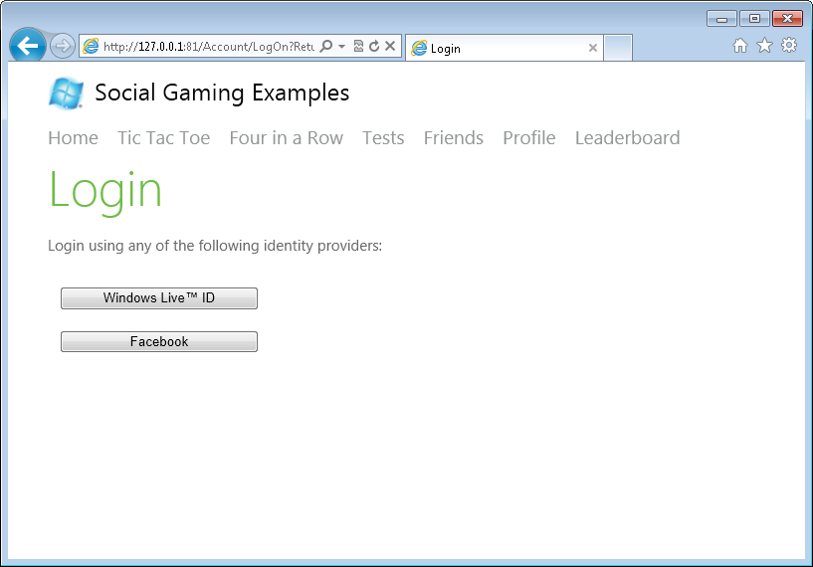
     2. Figure 5
     3. Login page
     4. **Note:** This sample uses a pre-configured AppFabric Access Control Service for managing user identity and access control. If you have a Windows Azure account and you want to use your own service you can do so, by updating the settings in the Web.config file of the SocialGames.Web project and the ServiceConfiguration.cscfg file in SocialGames.Cloud.Local.
  7. The browser is redirected back to the Tic Tac Toe invite page. Copy the invite URL provided in the screen.
     1. 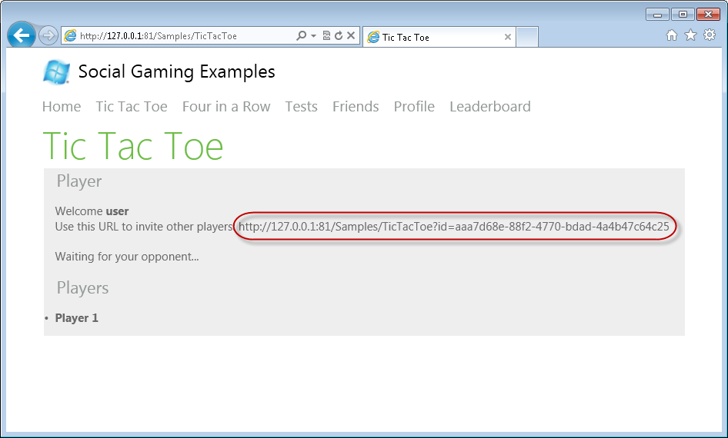
     2. Figure 6
     3. Invite page
  8. Open another browser window using InPrivate mode (Ctrl+Shift+P in Internet Explorer) and browse to the invite url. Login using a different account. Wait until the board is displayed and start playing in turns with the two different windows.
     1. 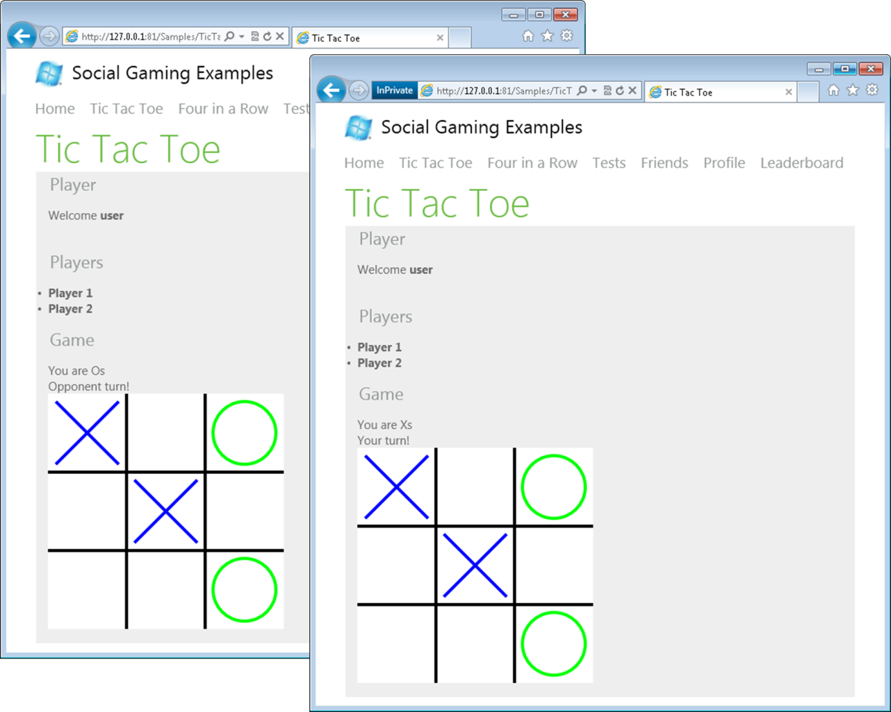
     2. Figure 7
     3. Online multiplayer Tic Tac Toe game
  9. Once the game finishes, click on the **Leaderboard** menu option. A board is shown, listing the players and their current scores.
     1. 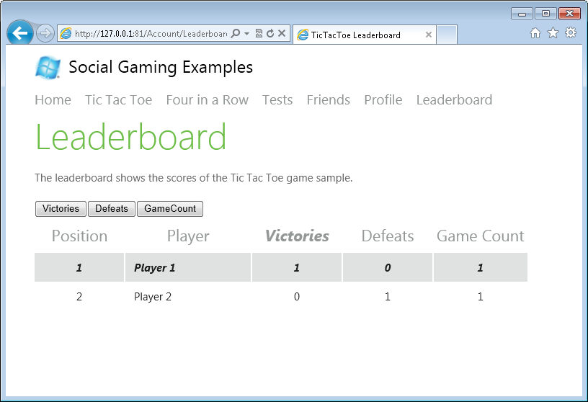
     2. Figure 8
     3. Leaderboard page
  10. Now, click on the **Four in a Row** menu option to play a different game. Make sure to select the player to invite from the combo box, and click on **Invite Friend**.
      1. 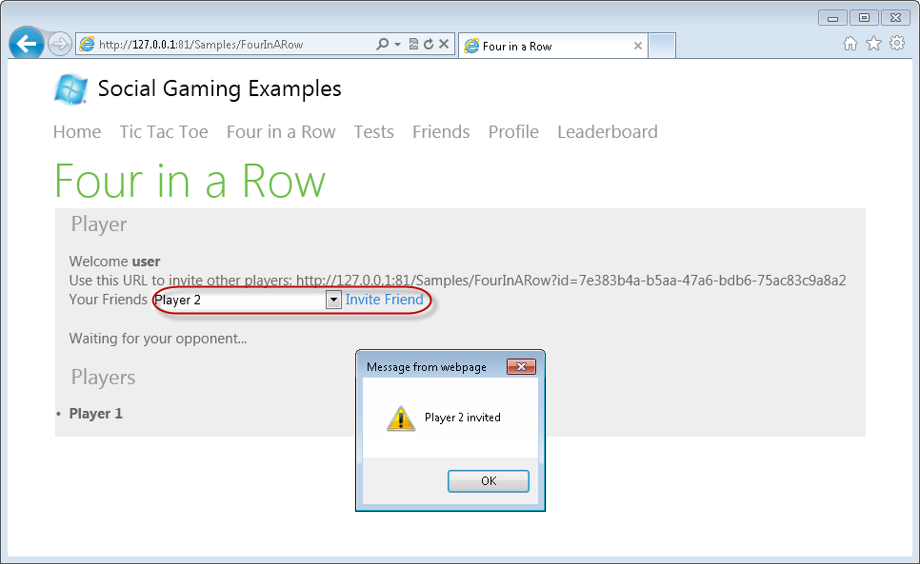
      2. Figure 9
      3. Inviting a friend
      4. **Note:** After accepting an invitation, the game sets a friend relation between the players of an invited game.
  11. Switch to the browser of the invited player, and click on the **Friends** menu option. The invitation to the game should be displayed in the Invitations section. Click on **Go** to start the game.
      1. 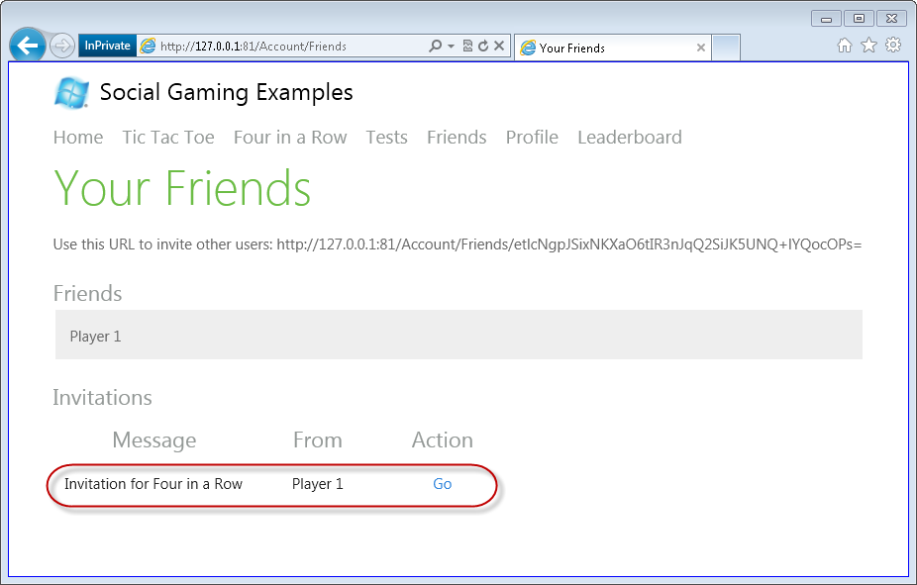
      2. Figure 10
      3. Invite notifications
  12. Wait until the board is displayed and start playing in turns with the two different windows.
      1. 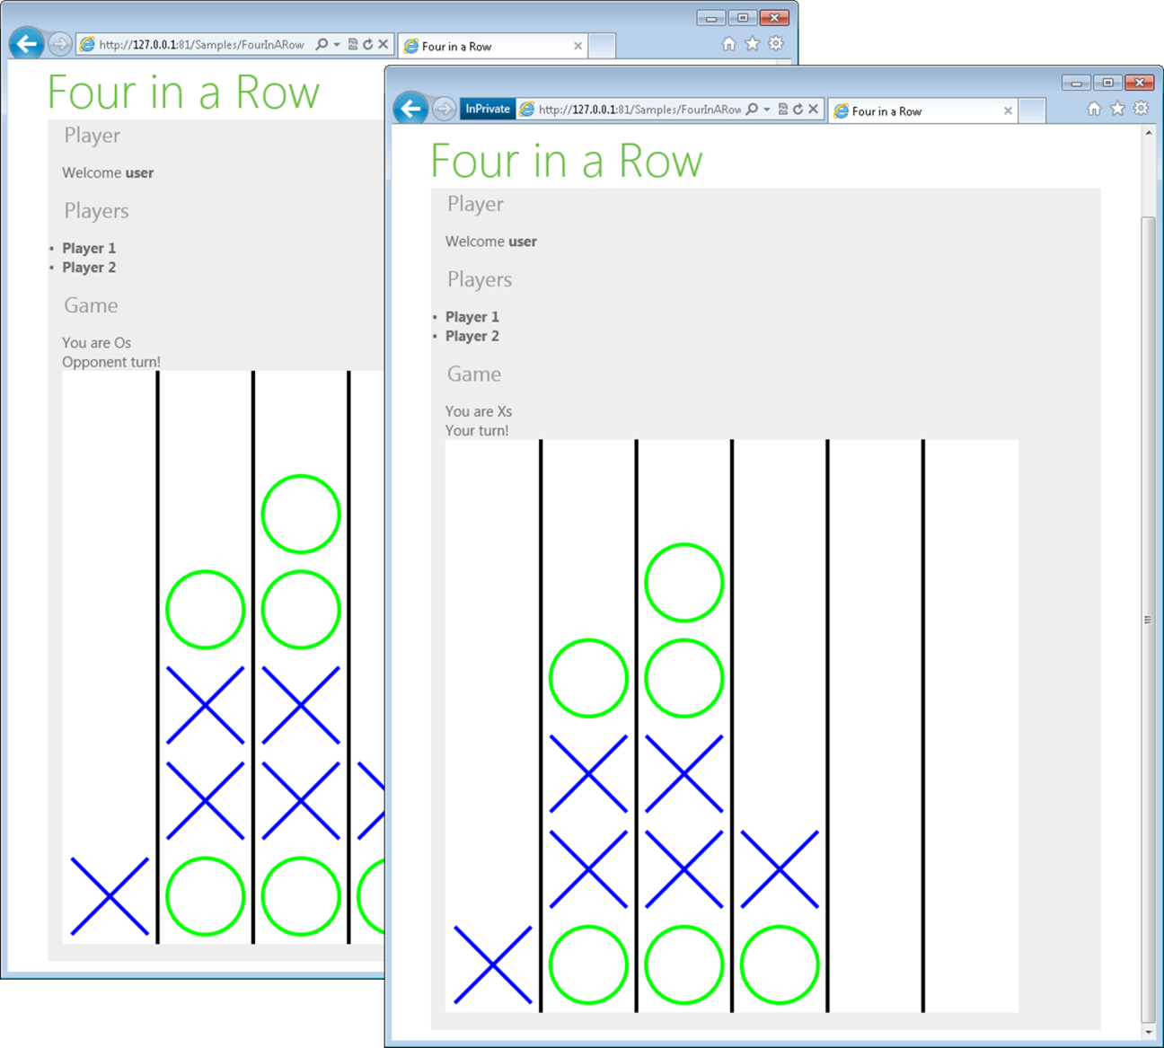
      2. Figure 11
      3. Online multiplayer Four in a Row game
  13. TBC

Exploring the Toolkit

TBC