**Theoretical Exercise - Problem #1**

**Distribution of work**

*Pseudocode: Team 1: Alejandro, Alejandro*

*Testing: Team 2: Alberto, Andrés*

**0 - Problem Description**

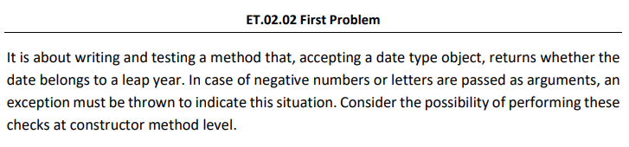

**1- Write, at least the pseudocode of the identified method.**

| public class Date {  int day;  int month;  int year;  public Date(int day, int month, int year) throws NumberException {  this.day = day;  if (this.day<1 || this.day>31) {  throw new NumberException();  }  this.month = month;  if (this.day<1 || this.day>12) {  throw new NumberException();  }  this.year = year;  if (this.year<0) {  throw new NumberException();  }  }    public void setDay(int day) {  this.day = day;  }    public void setMonth(int month) {  this.month = month;  }    public void setYear(int year) {  this.year = year;  }    public int getDay() {  return day;  }    public int getMonth() {  return month;  }    public int getYear() {  return year;  }  boolean isLeap() {  boolean leap = false;  int year = getYear();  if ((year % 4 == 0) && (year % 100 != 0) || (year % 400 == 0)){  leap = true;  }  return leap;  }  } |
| --- |

**2 - Identify the variables that must be considered to test the method.**

For this problem we will be focusing on the method “isLeap()”, which is the one that tells the information that we want. For this we will be focusing on the following variable:

* year: we should take into account the years as it will be introduced in the method in order to know if the year is Leap or not.

It is also important to make sure all of the values are valid, if not we could have a non expected result.

**3 - Identify the test values for each one of the variables previously identified, specifying the technique used to obtain each of those values).**

To perform the test cases, we will be using the **equivalence class**, **values** and **boundary values** for the years.

As we are talking about years, we will only take values as valid from 1582, as this is the date where Gregorian Calendar was implemented.

So our table would be like this:

| **Parameter** | **Equivalence class** | **Values from equivalence class** | **Boundary values (heavy variant)** | **Error guessing values** |
| --- | --- | --- | --- | --- |
| isLeap() | [-∞, 0)  [1, 1581]  [1582, ∞] | -1  1000  2000 | 0  1, 1581  1582 | -20,0  1, 1500 |
| day | [-∞, 0)  [1, 15), [15, 31), [31, ∞) | -2147483648, 0, 1, 15, 31, 2147483648 | -2147483649, -2147483648, -2147483649, -1, 0, 1, 2, 14, 15, 16, 30, 31, 32, 2147483647, 2147483648, 2147483649 | 0, 32, 33 |
| month | [-∞, 0]  [1, 12]  [12, ∞] | -2147483648, 0, 1, 12, 2147483648 | -2147483649, -2147483648, -2147483649, -1, 0, 1, 2, 11, , 12, 13,2147483647, 2147483648, 2147483649 | 0, 13 |
| year | [-∞, ∞] | -2147483648, 0, 1, 1581, 1582, 2147483648 | -2147483649, -2147483648, -2147483649, -1, 0, 1, 2, 1580,1581,1582,1583,2147483647, 2147483648, 2147483649 |  |

**4 - Calculate the maximum possible number of test cases that could be generated from the test values.**

The possible combinations of test cases could be:

* For the years: (-20, -1, 0, 1, 1000, 1500, 1581, 1582, 1755, 1967, 2000, 2020, 2050, 2100).

So the total number of test values is: 15.

* NOTE * : take into account that in the code, the condition to accept the year value is that it should be bigger than 0, so it is also tested. However, the results would be the expected ones as of 1582 where the Gregorian Calendar was implemented (and there is a proof that is true).

**5 - Define some test suites using each use**

We could be taking the following cases:

Model is this way: Date (day, month, year).

We use only the year to know if the year is a leap or not.

* Value divisible by 4, 400 but not by 100.
* Value non-divisible by 4, 400 but by 100.

Whenever one of the two conditions is met, then we can say that the year is a leap year.

**6 - Define test suits to achieve pairwise coverage by using the proposed algorithm in lectures. You can check the results by means of the software PICT1**

To this part we have done a class that will generate the results, that classe is called ‘DateTestPairWaise”

**7 - For code snippets that include decisions, propose a set of test cases to achieve coverage of decisions.**

To this part we have done a class that will generate the results, that classe is called ‘DateTestDecision”

**8 - For code snippets that include decisions, propose test case sets to achieve MC/DC coverage.**

| IsLeap() | | | | |
| --- | --- | --- | --- | --- |
| Conditions | | | Decision |  |
| year % 4 = 0 | year % 100 != 0 | year % 400 = 0 | (A AND !B) OR C | Dominant Condition |
| "TRUE" | "TRUE" | "TRUE" | YES | A,B,C |
| "TRUE" | "TRUE" | "FALSE" | YES | A,B |
| "TRUE" | "FALSE" | "TRUE" | YES | C |
| "TRUE" | "FALSE" | "FALSE" | NO | B,C |
| "FALSE" | "TRUE" | "TRUE" | YES | C |
| "FALSE" | "TRUE" | "FALSE" | NO | A,C |
| "FALSE" | "FALSE" | "TRUE" | YES | C |
| "FALSE" | "FALSE" | "FALSE" | NO | A,B,C |

**9 - Comment on the results of the number of test cases obtained in section 4, 5, and 6, as well as the execution of the oracles: what could be said about the coverage achieved?**

**9.1. Pair Waise Coverage**

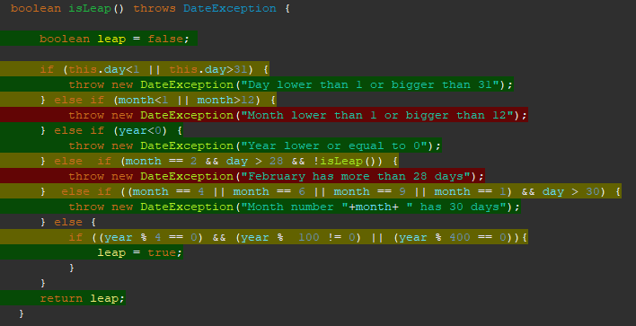

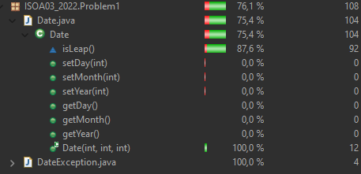

**9.2. Decision Coverage**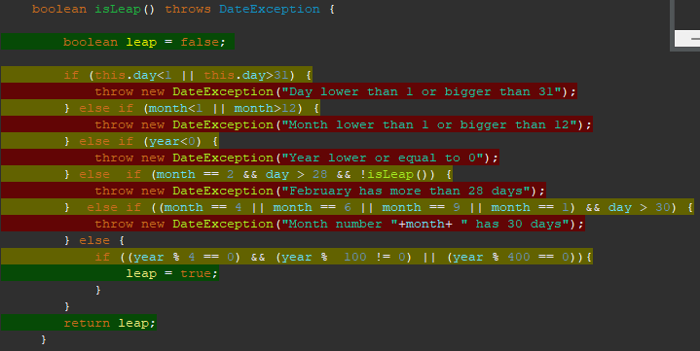

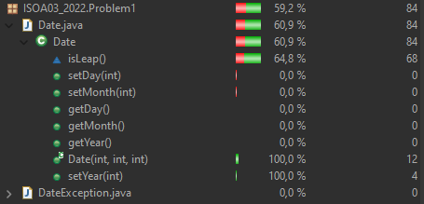

**9.3. Each Use**

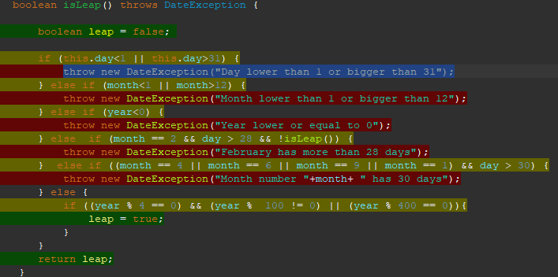

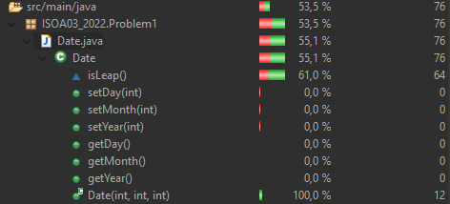

**9.4. MC/DC**

