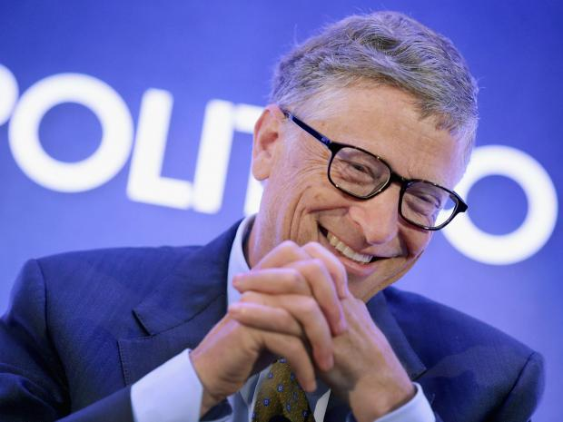**Artificial intelligence will become strong and threaten us, says Bill Gates, as he details new AI-driven personal assistant**

Gates joins Elon Musk and Stephen Hawking in publicly worrying about intelligent robots.

Artificial intelligence will start out as a help but will become “strong enough to be a concern”, Bill Gates has said in its latest question and answer session on Reddit.

In response to [a question about whether machine super intelligence will become an existential threat](https://www.reddit.com/r/IAmA/comments/2tzjp7/hi_reddit_im_bill_gates_and_im_back_for_my_third/co3q2xf), Gates said that he was “in the camp that is concerned about super intelligence”.

“First the machines will do a lot of jobs for us and not be super intelligent,” he wrote. That should be positive if we manage it well.

“A few decades after that though the intelligence is strong enough to be a concern. I agree with Elon Musk and some others on this and don't understand why some people are not concerned.”

The warning came as part of Gates’ Ask Me Anything (AMA) session on Reddit. It is the third time that he has taken part in one of the question and answer sessions on the site.

Microsoft’s technologies such as Cortana, the digital personal assistant, make use of artificial intelligence to anticipate what users will want and respond to their requests. During the AMA, Gates said that he was working on such technology.

“One project I am working on with Microsoft is the Personal Agent which will remember everything and help you go back and find things and help you pick what things to pay attention to,” he wrote. “The idea that you have to find applications and pick them and they each are trying to tell you what is new is just not the efficient model - the agent will help solve this. It will work across all your devices.”

Microsoft executives were among the signatories [to an open letter that received support from hundreds of computer scientists and technologists](http://www.independent.co.uk/life-style/gadgets-and-tech/news/stephen-hawking-elon-musk-and-others-call-for-research-to-avoid-dangers-of-artificial-intelligence-9972660.html). Elon Musk and Stephen Hawking signed the letter, which called for research into the problems of artificial intelligence.

Both Musk and Hawking have spoken out about the dangers of such technology. Musk has described it as “[summoning the demon” and the “biggest existential threat there is](http://www.independent.co.uk/life-style/gadgets-and-tech/news/tesla-boss-elon-musk-warns-artificial-intelligence-development-is-summoning-the-demon-9819760.html)”, and [Hawking said that AI could be the end of humanity](http://www.independent.co.uk/news/science/stephen-hawking-ai-could-be-the-end-of-humanity-9898320.html).

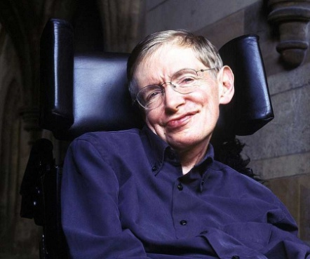**Stephen Hawking warns artificial intelligence could end mankind**

Rory Cellan-JonesTechnology correspondent, 2 Dec. 2014

**Prof Stephen Hawking, one of Britain's pre-eminent scientists, has said that efforts to create thinking machines pose a threat to our very existence.**

He told the BBC:"The development of full artificial intelligence could spell the end of the human race." His warning came in response to a question about a revamp of the technology he uses to communicate, which involves a basic form of AI. But others are less gloomy about AI's prospects.

The theoretical physicist, who has the motor neurone disease amyotrophic lateral sclerosis (ALS), is using a new system developed by Intel to speak. Machine learning experts from the British company Swiftkey were also involved in its creation. Their technology, already employed as a smartphone keyboard app, learns how the professor thinks and suggests the words he might want to use next.

Prof Hawking says the primitive forms of artificial intelligence developed so far have already proved very useful, but he fears the consequences of creating something that can match or surpass humans. "It would take off on its own, and re-design itself at an ever increasing rate," he said. "Humans, who are limited by slow biological evolution, couldn't compete, and would be superseded." But others are less pessimistic.

"I believe we will remain in charge of the technology for a decently long time and the potential of it to solve many of the world problems will be realised," said Rollo Carpenter, creator of Cleverbot. Cleverbot's software learns from its past conversations, and has gained high scores in the Turing test, fooling a high proportion of people into believing they are talking to a human.

## Rise of the robots

Mr Carpenter says we are a long way from having the computing power or developing the algorithms needed to achieve full artificial intelligence, but believes it will come in the next few decades. "We cannot quite know what will happen if a machine exceeds our own intelligence, so we can't know if we'll be infinitely helped by it, or ignored by it and sidelined, or conceivably destroyed by it," he says. But he is betting that AI is going to be a positive force. Prof Hawking is not alone in fearing for the future. In the short term, there are concerns that clever machines capable of undertaking tasks done by humans until now will swiftly destroy millions of jobs.

In the longer term, the technology entrepreneur Elon Musk has warned that AI is "our biggest existential threat".

## Robotic voice

In his BBC interview, Prof Hawking also talks of the benefits and dangers of the internet.

He quotes the director of GCHQ's warning about the net becoming the command centre for terrorists: "More must be done by the internet companies to counter the threat, but the difficulty is to do this without sacrificing freedom and privacy."

He has, however, been an enthusiastic early adopter of all kinds of communication technologies and is looking forward to being able to write much faster with his new system.

But one aspect of his own tech - his computer generated voice - has not changed in the latest update. Prof Hawking concedes that it's slightly robotic, but insists he didn't want a more natural voice. "It has become my trademark, and I wouldn't change it for a more natural voice with a British accent," he said. "I'm told that children who need a computer voice, want one like mine."

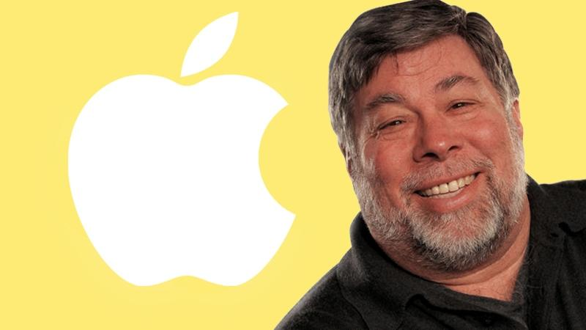

If we build these devices to take care of everything for us, eventually they'llthink faster than us.  
**Steve Wozniak,** Apple co-founder"Computers are going to take over from humans, no question," Mr Wozniak said.

He said he had long dismissed the ideas of writers like Raymond Kurzweil, whohave warned that rapid increases in technology will mean machine intelligencewill outstrip human understanding or capability within the next 30 years.However Mr Wozniak said he had come to recognise that the predictions werecoming true, and that computing that perfectly mimicked or attained humanconsciousness would become a dangerous reality.

"Like people including Stephen Hawking and Elon Musk have predicted, I agreethat the future is scary and very bad for people. If we build these devices to takecare of everything for us, eventually they'll think faster than us and they'll getrid of the slow humans to run companies more efﬁciently," Mr Wozniak said.

"Will we be the gods? Will we be the family pets? Or will we be ants that getstepped on? I don't know about that … But when I got that thinking in my headabout if I'm going to be treated in the future as a pet to these smart machines …well I'm going to treat my own pet dog really nice."  
Mr Wozniak said the negative outcome could be stopped from occurring by thelikely end of Moore's Law, the pattern whereby computer processing speedsdouble every two years.  
The ever increasing speeds have happened due to the shrinking size oftransistors, which mean more can be included in a circuit. But it has beensuggested that Moore's Law cannot continue past 2020 because, by then, the sizeof a silicon transistor will have shrunk to a single atom.  
So unless scientists can start controlling things at sub-atomic level, bydeveloping so-called quantum computers, humanity will be protected fromperpetual increases in computing power.  
"For all the time they've been working on quantum computing they really havenothing to show that's really usable for the things we need … researchers can make predictions, but they haven’t been able to get past three qubits yet,” Mr Wozniak said. Whereas a modern computer processes data in binary ones and zeros, Quantumcomputers run on qubits, which can be a one and a zero at the same tie and can process hugely complex calculations in vastly reduced times compared with existing computers. “I hope it does come, and we should pursue it because it si about scientific exploring,” Mr Wozniac said. “But in the end we just may have created the species that is above us.”