During the cold war, the propaganda was an essential tool to influence the public opinion and the goals of this tool are to present a good image of its own country and denigrate the enemy.

One of the biggest propaganda’s instrument is the cinema and the two superpowers invested a lot in the cinema industry, trying to influence the national opinion and also the foreign. The american films were much better than the soviet films so the America was in advantage in this field.

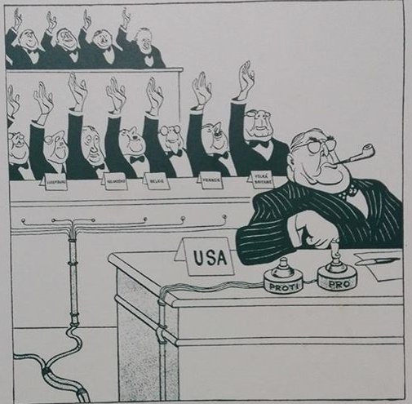

In this photo we can see the soviet propaganda used to criticize the american democracy, accused of not recognize the politics. In this cartoon there’s a votation made with hands rising, in which the final decision is in the hands of the leader. The USSR used a lot this type of cartoons to laugh of America.