WHAT ARE SOCIAL MEDIA?
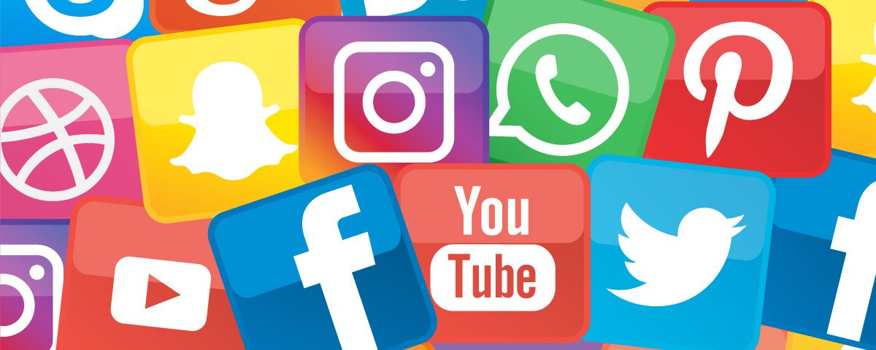
Social media are computer-mediated technologies that allow individuals, companies, governments, and other organizations to view, create and share information, ideas, career interests, and other forms of expression via virtual communities and networks. They use web-based and mobile technologies on smartphones and tablet computers to create highly interactive platforms through which individuals, communities and organizations can share, co-create, discuss, and modify user-generated content or pre-made content posted online.The variety of social media services currently available introduces challenges of definition; however, there are some common features:
- social media are interactive Web 2.0 Internet-based applications,
- user-generated content such as text posts or comments, digital photos or videos, as well as data generated through all online interactions, are the lifeblood of the social media organism,
- users create service-specific profiles for the website or app, that are designed and maintained by the social media organization,
- social media facilitate the development of online social networks by connecting a user's profile with those of other individuals and/or groups.
Social media introduce substantial and pervasive changes to communication between businesses, organizations, communities, and individuals. Social media change the way individuals and large organizations communicate. Social media differ from paper-based or traditional electronic media such as TV braodcasting in many ways, including quality, reach, frequency, usability, immediacy, and permanence. Social media operate in a dialogic transmission system (many sources to many receivers). This is in contrast to traditional media that operates under a monologic transmission model (one source to many receivers), such as a paper newspaper which is delivered to many subscribers. Some of the most popular social media websites, with over 100 million registered users, include Facebook (and its associated Facebook Messenger), YouTube, TikTok, WeChat, Instagram, QQ, Qzone, Weibo, Twitter, Tumblr, Telegram, Baidu Tieba, LinkedIn, WhatsApp, LINE, Snapchat, Pinterest, Viber, VK, Reddit, Discord and more.
Observers have noted a range of positive and negative impacts from social media use. Social media can help to improve individuals' sense of connectedness with real and/or online communities and social media can be an effective communications (or marketing) tool for corporations, entrepreneurs, nonprofit organizations, including advocacy groups and political parties and governments. At the same time, concerns have been raised about possible links between heavy social media use and depression and even the issues of cyberbullying, online harassment and "trolling". According to Nielsen, Internet users continue to spend more time with social media sites than any other type of site. For content contributors, the benefits of participating in social media have gone beyond simply social sharing to building reputation and bringing in career opportunities and monetary income.
Some of the most popular Social Media
- Facebook is a popular free social networking website that allows registered users to create a profile revealing information about themselves, post text, photos and multimedia which is shared with any other users that have agreed to be their “friend” or, with a different privacy setting, with any reader. Users can also use various embedded apps, join common-interest groups, buy and sell items or services on Marketplace, and receive notifications of their Facebook friends' activities and activities of Facebook pages they follow. Facebook claimed that it had more than 2.3 billion monthly active users as of December 2018

- Instagram is an American photo and video-sharing social networking service owned by Facebook. It allows users to upload photos and videos, which can be edited with filters and organized with tags and location information. Posts can be shared publicly or with pre-approved followers. Users can browse other users' content by tags and locations, and view trending content. Users can 'like' photos and follow other users to add their content to a feed.

- Twitter is a free microblogging service that allows registered members to broadcast short posts called tweets. Twitter members can broadcast tweets and follow other users' tweets by using multiple platforms and devices.

- Wikipedia is a free, open content online encyclopedia created through the collaborative effort of a community of users known as Wikipedians. Anyone registered on the site can create an article for publication; registration is not required to edit articles. Wikipedia was founded in January of 2001.

- LinkedIn is a social networking site designed specifically for the business community. The goal of the site is to allow registered members to establish and document networks of people they know and trust professionally.

Viral content
Some social media sites have potential for content posted there to spread virally over social networks. The term is an analogy to the concept of viral infections, which can spread rapidly from person to person. In a social media context, content or websites that are "viral" (or which "go viral") are those with a greater likelihood that users will reshare content posted (by another user) to their social network, leading to further sharing. In some cases, posts containing popular content or fast-breaking news have been rapidly shared and reshared by a huge number of users. Many social media sites provide specific functionality to help users reshare content.
Businesses have a particular interest in viral marketing tactics because a viral campaign can achieve widespread advertising coverage (particularly if the viral reposting itself makes the news) for a fraction of the cost of a traditional marketing campaign, which typically uses printed materials, like newspapers, magazines, mailings, and billboards, and television and radio commercials.

Bots
Social media can enable companies to get in the form of greater market share and increased audiences. Internet bots have been developed which facilitate social media marketing. Bots are automated programs that run over the Internet. Chatbots and social bots are programmed to mimic natural human interactions such as liking, commenting, following, and unfollowing on social media platforms. A new industry of bot providers has been created. Social bots and chatbots have created an analytical crisis in the marketing industry as they make it difficult to differentiate between human interactions and automated bot interactions. Some bots are negatively affecting their marketing data causing a "digital cannibalism" in social media marketing. Additionally, some bots violate the terms of use on many social mediums such as Instagram, which can result in profiles being taken down and banned.

The state or quality of lasting or remaining unchanged indefinitely
Nielsen Holdings Plc (formerly known as Nielsen N.V.) is an American information, data and measuremente firm.

