1. Introduction

The snakelocks anemone (Anemonia viridis) is a species of Cnidarian widely distributed in the Northeast Atlantic Ocean and Mediterranean Sea. It inhabits rocky bottoms ranging from the lower intertidal zone to the subtidal, down to around 15-20 m deep (Calvín Calvo, 2020). The snakelocks anemone has been traditionally exploited for human consumption in Spain, particularly in Andalusia (Daza Cordero et al., 2002; Utrilla et al., 2019). However, the poor ecological state of stocks in the Andalusian coast led to an indefinite ban on its capture in the region, in effect since October 2023. As current demand of this species is not being met, and populations still are subjected to illegal gathering (BOJA, 2023), there is great interest in the development of alternative production methodologies. Aquaculture of the snakelocks anemone is not fully established, but can function as a major engine in the production of this species.

Like most sea anemones, A. viridis is capable of both sexual and asexual reproduction (Bocharova, 2016; Utrilla et al., 2019). Concerning sexual reproduction, A. viridis is a dioic species, and females and males develop their gonads in their mesenteric filaments. Fertilization is external, and spawning usually takes place in spring, around the months of April and May in the Andalusian coast (Utrilla et al., 2019). Asexual reproduction is ubiquitous in sea anemones and can happen through different mechanisms. In the case of A. viridis, asexual reproduction primarily takes place through longitudinal fission of the animal, in a plane that is perpendicular to their pharynx plane (Bocharova, 2016; Macias-Muñoz, 2025). Other variants, such as budding, have been recorded but seem to be sporadic (Utrilla et al., 2019). Asexual reproduction can also occur as a way of regeneration after an injury, as sea anemones are able to regenerate a complete organism from severed body parts (Bocharova, 2016). While sexual reproduction is vital for the long-term success of an aquaculture stock, asexual cloning of anemones represents a reliable way of quickly increasing stock size. However, in order to achieve that, asexual reproduction must 1) be artificially inducible and 2) not affect the wellbeing of the animals severely or irreversibly.

Even though artificially sectioning the animals to induce epimorphic regeneration and obtain two clonal anemones is possible, it is also an invasive procedure that involves handling of the animals, wound healing and regeneration of the missing body parts. Mass recruitment and proliferation of amoebocytes, the immune effector cells in anthozoans, has been described both in A. viridis and other hexacoral anthozoans during wound healing (La Corte et al., 2023a; Mydlarz et al., 2008; Parisi et al., 2020), and generation of reactive oxygen species (ROS) occurs both after injuries and during regeneration in sea anemones and other anthozoans (La Corte et al., 2023a; Mydlarz and Jacobs, 2006; Parisi et al., 2020; Vullein, 2024). While ROS signalling and production perform important roles during wound-healing and regeneration, imbalances between ROS generation and scavenging can result in damage to cellular components such as poly-unsaturated fatty acids (PUFAs), proteins, or DNA binding, potentially impacting the organism’s health even after the regeneration process is over (Lesser, 2006; Lushchak, 2011).

However, the induction of asexual reproduction in A. viridis might not lead to severe impacts on its health after regeneration, as they possess a combination of traits that make them a good candidate-species to reproduce asexually in captivity. First, as an intertidal-dwelling organism, A. viridis polyps are often exposed to large variations in temperature, salinity, humidity and UV exposure, and to other environmental stressors such as wave action. Their wide tolerance limits and ability to recover from challenging environmental situations could mitigate stress due to handling and manipulation of the animal (Casado-Amezúa et al., 2016; Richier et al., 2005). Secondly, as most cnidarians do, they possess a great tissular regeneration capacity, as they are able to heal wounds in less than 24 h and regenerate missing body parts with ease (La Corte et al., 2023b; Parisi et al., 2021). Finally, A. viridis is a symbiotic anthozoan that hosts photosynthetic microalgae (zooxanthellae) of the genre Philozoon (LaJeunesse et al., 2022) in their endoderm. As a result of this symbiotic mutualism, they are adapted to deal with the variation in oxygen partial pressure that take place between daytime and nighttime due to zooxanthellae photosynthesis (Casado-Amezúa et al., 2016; Richier et al., 2005). These adaptations to symbiosis involve a more robust antioxidant system than found in non-symbiotic sea anemones (Cotinat et al., 2022; Merle et al., 2007; Pey et al., 2017; Richier et al., 2006, 2005, 2003), that could prove beneficial in dealing with the surge in ROS production expected during regeneration.

The duality of antioxidant defences and oxidative damage makes oxidative stress a unique and valuable physiological marker to assess both the responses that organisms develop in other to face stressors and the adverse effects that they experience when doing so (Beaulieu and Costantini, 2014).
Furthermore, biomarkers of oxidative stress are not confined to a certain taxonomic range: they can be assessed in any organism that has aerobic metabolism or is exposed to oxygen. The universality of these markers makes them highly valuable when studying cnidarians, where other stress markers such as glucocorticoids would be unapplicable (Beaulieu and Costantini, 2014; Coll et al., 2025; Valavanidis et al., 2006).

Cnidarian immunity is fundamentally innate, comprised of processes of pattern recognition and intracellular signalling followed by effector responses and lastly, tissue repair. (Parisi et al., 2020). Alkaline phosphatases are one of the first enzymes to act in inflammatory processes, and high expression levels of this enzyme have also been reported during regenerative processes in A. viridis (Abe et al., 2001; Mauro et al., 2021; Parisi et al., 2021). Lysosome hydrolases (such as acid phosphatase) are considered regeneration markers in invertebrates, and both acid and alkaline phosphatases have been linked to epithelial cell and nematocyst differentiation in Hydra (Konada et al., 2020; Lentz and Barrnett, 1962; Orlando et al., 1991; Trapani et al., 2016). Regarding cellular responses and the role of ROS production in immune responses, the amoebocytes of some cnidarian species, such as Actinia equina, Aiptasia pulchella or Pseudopterogorgia americana, have been reported to exhibit respiratory burst as an immune mechanism (Gordeeva et al., 2006; Hutton and Smith, 1996; Mydlarz and Jacobs, 2006, 2004).

In the present study, we artificially sectioning individuals of snakelocks anemones (Anemonia viridis) within an Integrated Multitrophic Aquaculture setting, where other organisms were co-cultured in the same tank. We recorded mortality during the process and then assessed the impact of this process on their oxidative status and activity levels of immune enzymes, at two different time scales after the manipulation.

2. Materials and methods

2.1. Experimental design and sampling

300 wild anemones were obtained from natural environments off the coast of Granada (Andalusia, Spain) in November 2020 with the pertinent permits from local authorities. Animals were transferred to facilities of Andalmar Biotech S.L., where they were distributed in floating baskets in a concrete 16 m³ outdoor tank, set under a 0.5 mm white nylon mesh cover. The tank was equipped with a recirculation system consisting of a mechanic sand filter, biological filter with 300 m²/m³ bio-balls and protein skimmer. Natural seawater was pumped from a well in the facilities and then filtered to be used in the circuit. Salinity and pH were monitored during the experimental period, centred around 34.8 ‰ and pH 8. Water temperature varied with ambient temperature, with an overall mean of 17.5 º C through the study.

Anemones were distributed in 11.8 L floating baskets at a density of 16-17 individuals per basket, making a total of 18 baskets. An IMTA set up was established by introducing selected organisms in the tank: beadlet anemones (Actinia equina), sea urchins (Paracentrotus lividus, Arbacia lixula), sea snails (Monodonta turbinata), limpets (Patella caerulela), sea cucumbers (Holothuria tubulosa), mussels (Mytillus edulis), and macroalgae (Ulva rigida, Cystoseira mediterranea).

After acclimation to the aquaculture conditions for one month, n anemones from nine of the baskets were selected as experimental group, and they were sectioned in two through their pharyngeal biradial axis. Each of the resulting halves was separated and left to heal, so as to generate two different clonal individuals. Mortality during the healing phase was recorded.

The first sampling (T1) took place 4 weeks after the sectioning procedure, once the anemones had had time to heal completely. 9 sectioned anemones (1 per basket) were selected, as well as 9 control anemones which had not undergone the procedure. Sectioned anemones were identified at all times to ensure that sampled individuals would not include both clones obtained from the same parent anemone. The second sampling (T2) took place 3 months later, when again 9 control anemones and 9 sectioned anemones were collected with the same regards over clonal anemones.

At both sampling events, each anemone was snap-frozen in liquid nitrogen and stored at -80 ºC. The column and tentacles of each individual was homogenized separately (Heidolph Instruments) in 100 mM Tris, 0.1 EDTA and 0.1% Triton buffer (pH 7.8) at a 1:4 ratio (w/v). Extracts were then centrifuged at 16 000 rpm for 30 minutes at 4ºC (Sigma 3 K30), and the supernatant was collected and stored at -80 ºC for posterior analysis.

2.2. Oxidative status assays

Superoxide dismutase (SOD) (EC 1.15.1.1) activity was determined according to McCord & Fridovich (1969) method, consisting on an indirect measurement as the degree of inhibition of cytochrome c reduction. Determination of catalase (CAT) (EC 1.11.1.6) activity was performed using Aebi (1984) method, based on the decrease in absorbance produced by H₂O₂ consumption by this enzyme.

Glutathione peroxidase (GPx) (EC 1.11.1.9) activity of the samples was determined following Flohé & Günzler (1984), based on an indirect measurement of NADPH oxidation, generated by its coupling with a standard glutathione reductase (GR) (EC 1.8.1.7) reaction. GR activity was measured according to Carlberg & Mannervik (1975) method, consisting on a measure of the absorbance decrement caused by NADPH oxidation. Glucose 6-phosphate dehydrogenase (G6PDH) (EC 1.1.1.49) activity of the samples was obtained using a modified method of Löhr & Waller (1965), based on recording the change in absorbance due to NADPH production by the enzyme.

Determination of glutathione S-transferase (GST) (EC 2.5.1.18) activity was performed following the method of Frasco & Guilhermino (2002), based on the formation of a conjugate between glutathione and 2,4-dinitrochlorobenzene that increases absorbance. NQO1 (EC 1.6.99.2) activity was determined using a modified method of Lemaire et al. (1996), based on measurement of the decrease in absorbance caused by reduction of 2,6-dichlorophenol indophenol.

Soluble protein content was quantified following Bradford (1976) method in order to express enzymatic specific activity. One unit of activity was defined as the amount of enzyme required to transform one μmol of substrate per minute under the measurement conditions (Coll et al., 2025). For SOD, units of activity had a different definition, as the amount of enzyme required to generate a 50% inhibition in the reduction of cytochrome c.

Total antioxidant activity was measured according to Erel (2004) method, based on the change of absorbance due to reduction of 2,2′-azino-bis-(3-ethylbenzothiazoline-6-sulfonic acid), to determine Trolox-equivalent antioxidant capacity (TEAC) of the extracts.

Lastly, oxidative damage to lipids was assayed as thiobarbituric acid reactive substances (TBARS) content, following a modified method from Buege & Aust (1978) and using malondialdehyde (MDA) as a standard.

2.3. Immune status parameters

Acid (EC 3.1.3.2) and alkaline (EC 3.1.3.1) phosphatases (AP and ALP) activity were measured following the method of Huang et al. (2011), based on the change of absorbance produced by the activity of the enzyme on p-nitrophenyl at different pH. Determination of myeloperoxidase (MPx) activity (EC 1.11.1.7) was carried out following a modified method of Mohanty & Sahoo (2010), based on the increase of absorbance due to oxidation of 3,3',5,5'-tetramethylbenzidine (TMB) by the products of MPx activity.

Both oxidative status and immune parameters measurements were carried out with a PowerWave microplate spectrophotometer (Bio-Tek Instrument, Inc.) at a stable temperature of 25 °C for enzymatic determinations.

2.4. Statistical analysis

All statistical analysis and data processing was carried out using R. 4.4.3 and Rstudio 2024.12.1. Results were expressed as mean ± standard error of the mean (SEM). A confidence level of 95% (α = 0.05) was established for all statistical tests. For each variable, a two-way ANOVA was conducted to examine the effect of the reproduction procedure at short and long term on the oxidative status of A. viridis. When interaction between both variables was found to be significant, a t-test was performed at each level of the variable time (T1 and T2) to test for differences between sectioned and control animals. Obtained p-values were adjusted using Benjamini-Hochberg correction for multiple testing. Normality of residuals was assessed via Shapiro-Wilk’s normality test, while homoscedasticity was tested using Levene’s test. All residuals were normally distributed (p > 0.05) and all variables had homogeneity of variances (p > 0.05).

Additionally, principal component analysis (PCA) was performed separately on columnar and tentacular variables to identify correlational structure of the data. Significance of the PCA, loadings and principal components was assessed via permutation tests proposed by Vieira (2012), using the R package PCAtest (Camargo, 2022).

3. Results

Overall, the sectioning procedure registered an 8% mortality during healing of the anemones. The rest of the anemones were able to heal and kept growing during the experimental period.

3.1. Oxidative status parameters

The ANOVA test for SOD activity in handled and control individuals of A. viridis, at different sampling times (Figure 1.A), did not reveal a significant interaction effect between the two variables on columnar or tentacular samples. There was also no significant main effect of the reproduction procedure or the time variable on either tissue. CAT activity (Figure 1.B) showed different responses in tentacular and columnar samples. Columnar activity was increased by regeneration, while there was no effect of time or interaction between both variables. Tentacular CAT activity, however, featured a significant interaction effect. At T1, sectioned anemones featured a significantly higher CAT activity than control anemones (p < 0.001). However, a T2, this relationship became inverted and sectioned individuals exhibited a lower activity (p < 0.01).

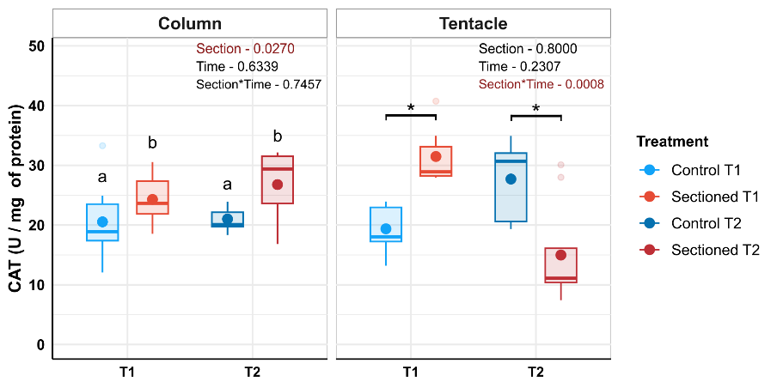
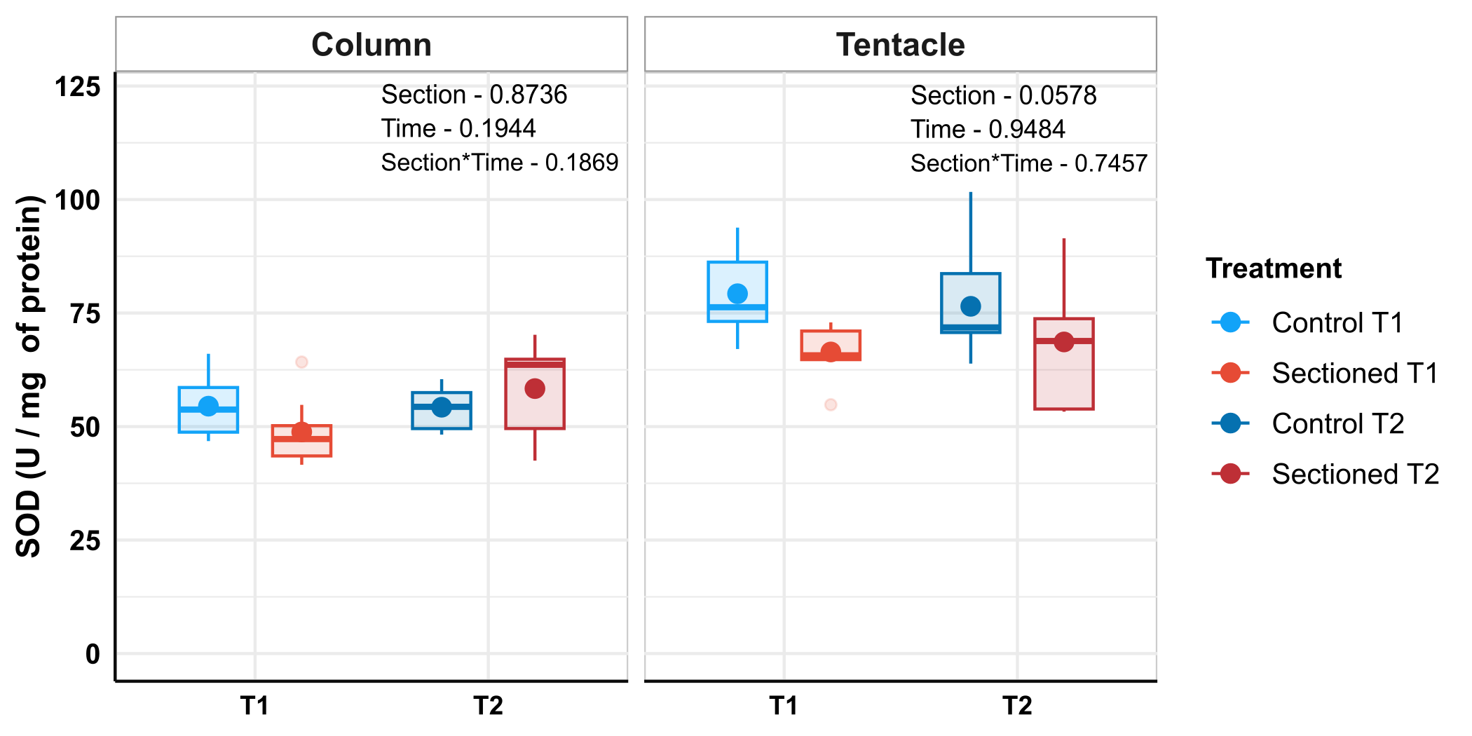
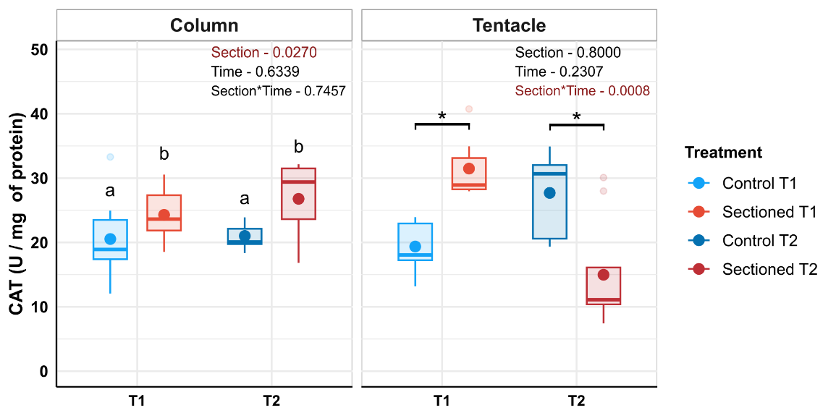
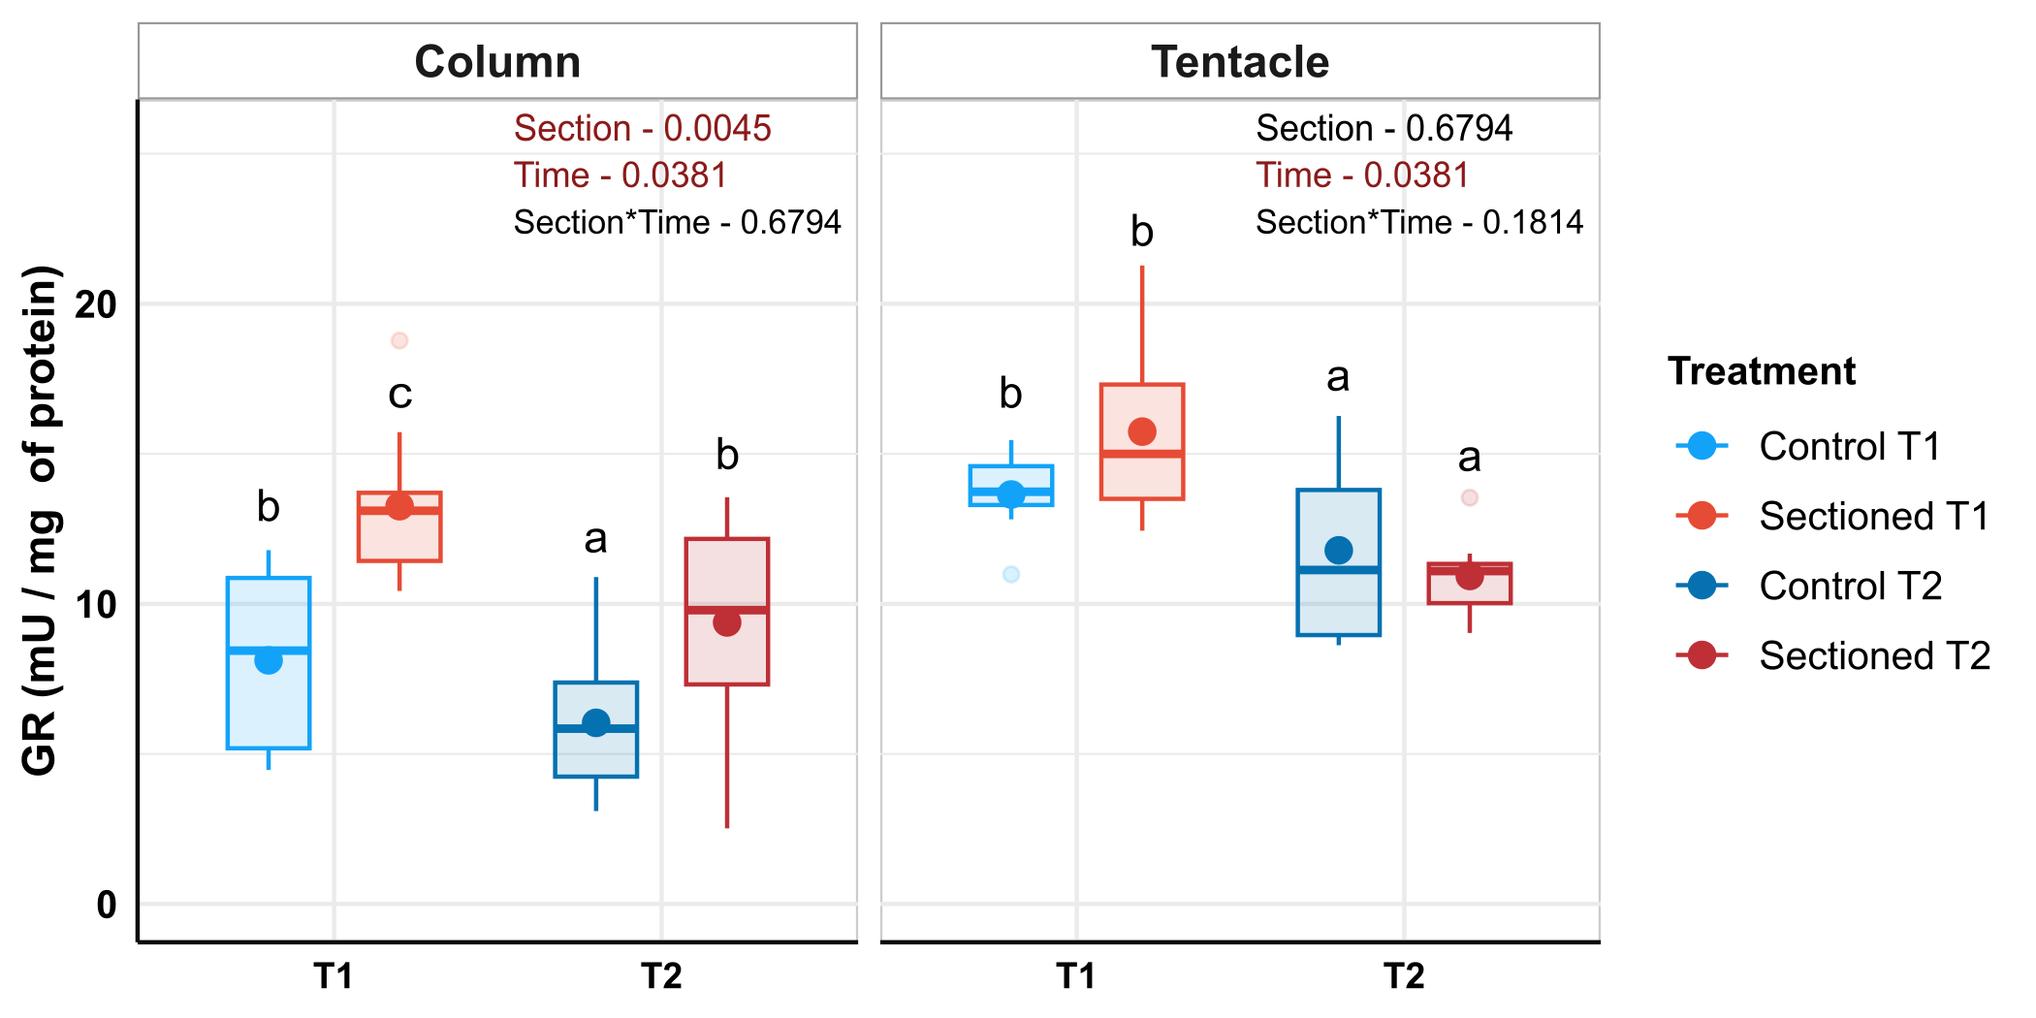
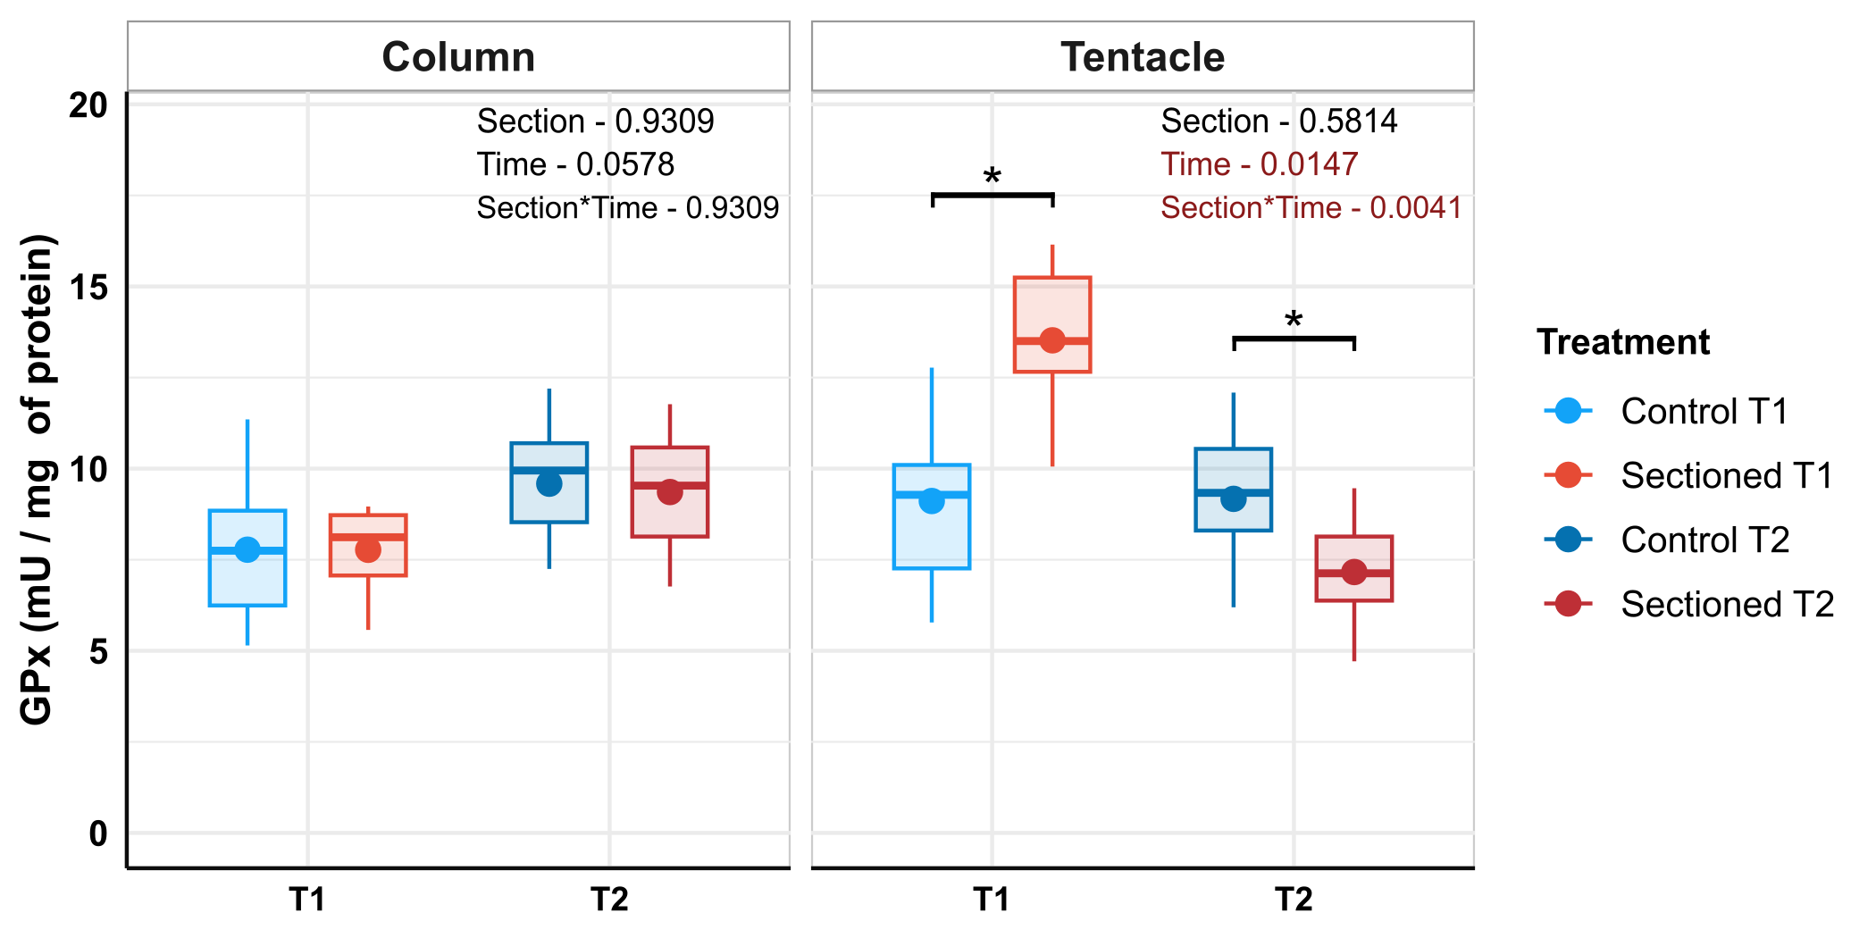
Columnar GPx activity (Figure 1.C) was not affected by either variable, although a nearly significant effect of time increasing the activity of this enzyme can be observed. Tentacular GPx activity (Figure 1.C) featured interaction between both variables in a similar fashion to CAT activity. At T1, GPx activity was higher for sectioned animals (p < 0.05), while at T2, these anemones displayed lower GPx activity than control (p < 0.05). Time had a significant effect on both columnar and tentacular GR, as samples from T2 exhibited lower activity than T1 measurements. Furthermore, columnar GR activity was significantly increased for all sectioned individuals.
Figure 1. (A) Superoxide dismutase, (B) catalase, (C) glutathione-peroxidase and (D) glutathione reductase activity on column and tentacles of control and sectioned anemones, at T1 and T2. Coloured dot represents the mean activity. a, b, c: Significative differences due to sectioning and/or time. *: Significative effects of sectioning at T1 or T2 when interaction is present
There were no significant effects on columnar GST activity (Figure 2.A), but tentacular samples featured significant interaction between the two variables. At T1, sectioned individuals had their GST activity significantly increased (p < 0.001). These differences were not reflected T2, where control and sectioned individuals were found to be similar (p = 0.345). Columnar NQO1 activity (Figure 2.B) increased significantly on sectioned anemones, while tentacular NQO1 activity featured a significant interaction effect. Anemones at T1 exhibited this same pattern of higher activity for sectioned individuals (p < 0.001) detected in columnar activity. At T2, however, no differences were found between control and sectioned samples (p = 0.393).

Total Antioxidant Capacity, measured as TEAC (Figure 2.C) showed no significant effects associated with regeneration or time, on neither columnar nor tentacular tissue. Lipid peroxidation, measured as MDA concentration (Figure 2.D), did not vary significantly in columnar samples, but tentacular MDA was found to be lower on sectioned individuals compared to control ones.
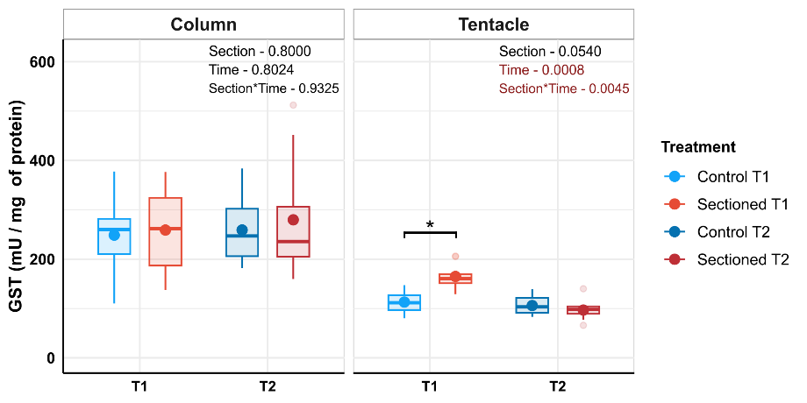
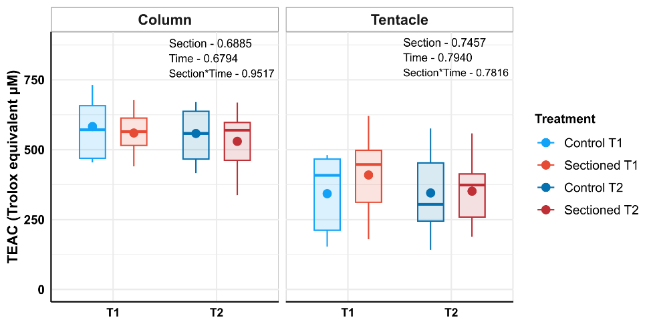
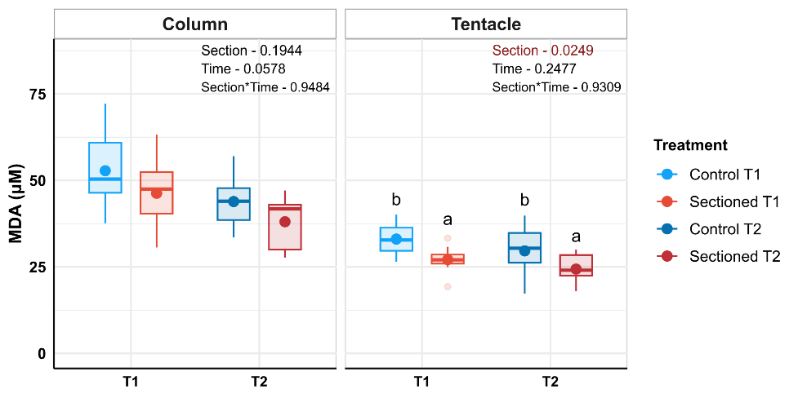
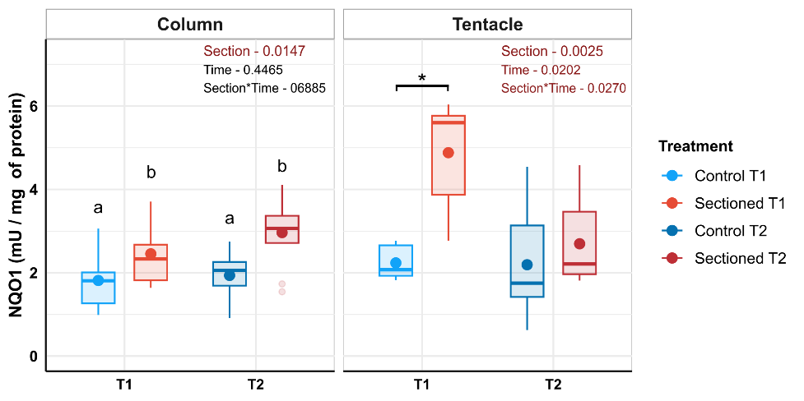
Figure 2. (A) Glutathione-S-transferase activity, (B) NAD(P)H quinone oxidoreductase 1 activity, (C) TEAC and (D) MDA on column and tentacles of control and handled anemones, at T1 and T2. Coloured dot represents the mean activity. a, b: Significative differences due to sectioning and/or time. *: Significative effects of sectioning at T1 or T2 when interaction is present.
3.2. Immune parameters

Neither AP (Figure 3.A) nor ALP (Figure 3.B) showed any significant effect or interaction between the variables. However, columnar ALP activity seemed to increase slightly in response to regeneration of the injury (p = 0.088). MPx activity showed significant interaction in columnar samples. At T1, columnar MPx activity (Figure 3.C) was higher in control individuals (p < 0.001), while there were no significant differences at T2 (p = 0.674). The effect of sectioning and time on tentacular activity also resulted non-significant.

3.3. Principal Component Analysis

Permutation tests for ψ and φ statistics were significant in both columnar variables and tentacular variables, indicating the presence of non-random correlation within the data and adequacy of PCA. In Figure 4, observations are grouped according to time point and section status, and 95 % confidence ellipses were constructed, highlighting separation between experimental groups. Variables were overlayed as vectors.
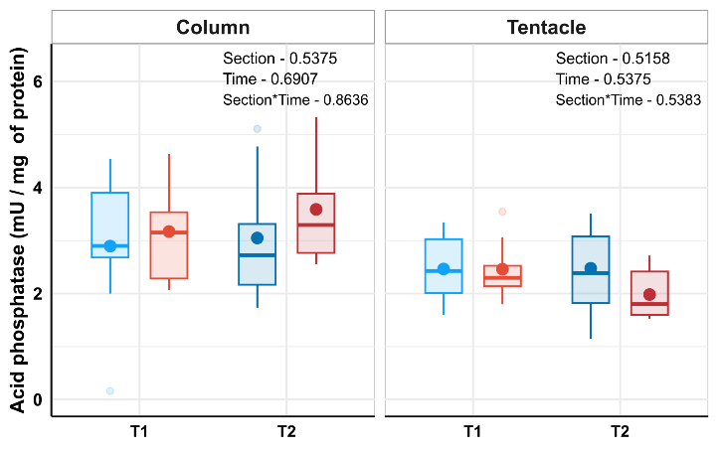
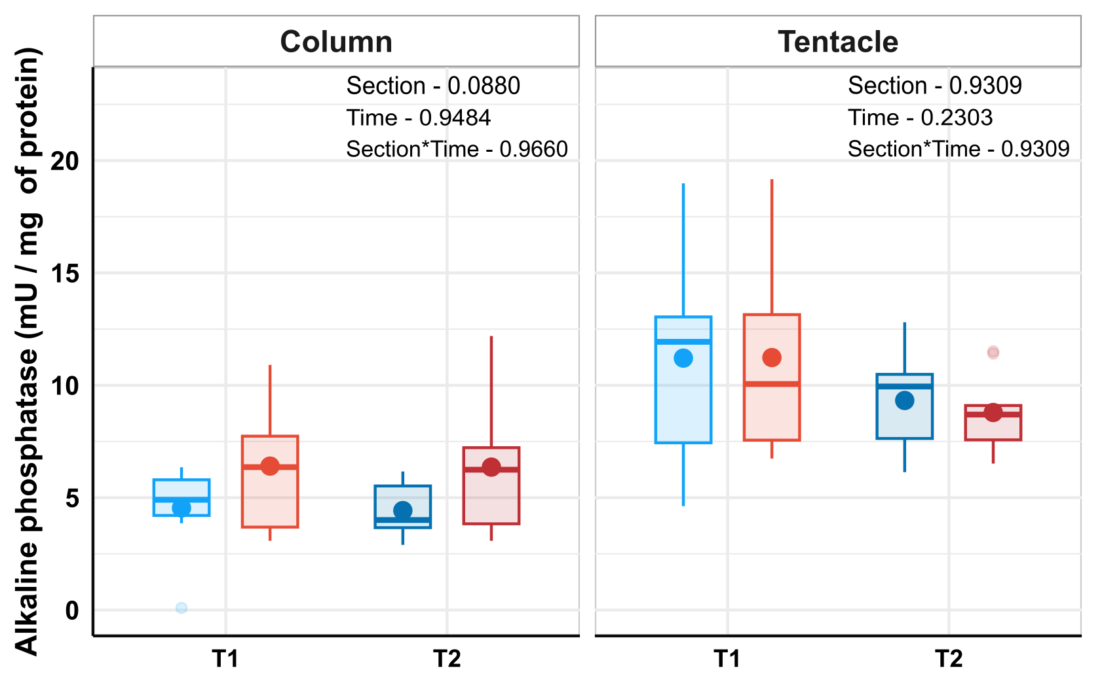
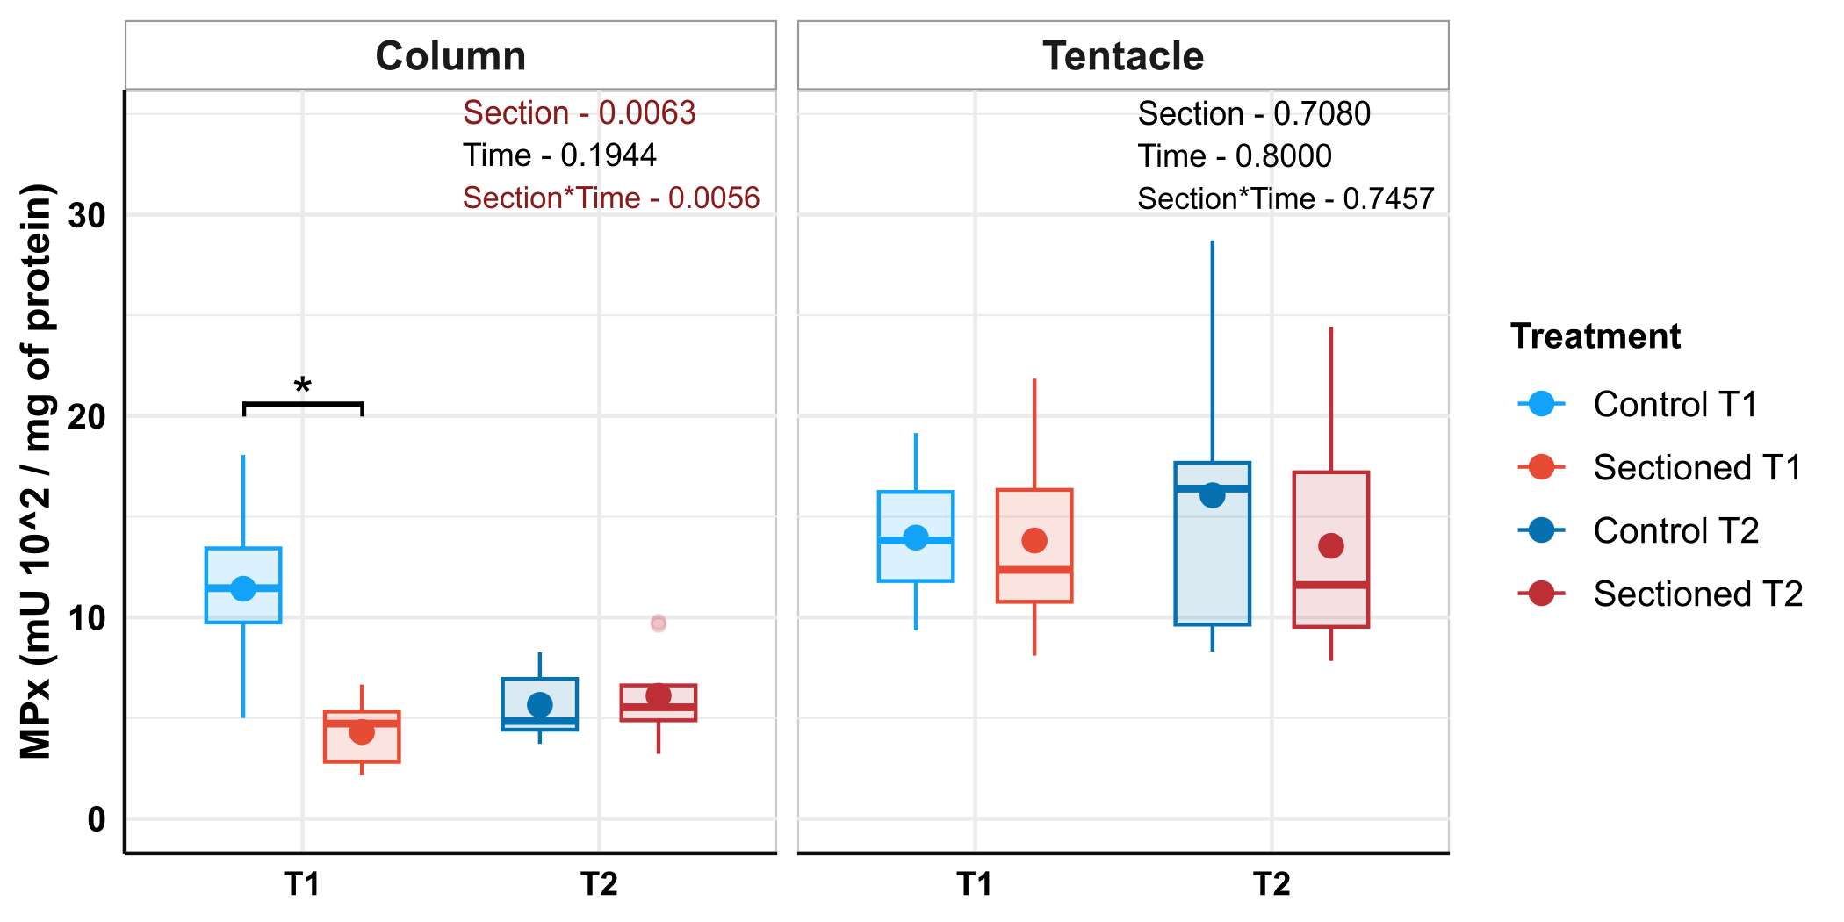
For columnar variables, two principal components (PCs) were significative, and together they accounted for 51.4% of the original data variance. PC1 represented 33.1 % (Confidence Interval-95%: 26.3-45.2) of this variation, and variables SOD, CAT, GPx, GST and MDA contributed significantly to it. PC2 explained 18.8% (C.I.-95%: 16.1-24.8), and only MPx contributed more than expected by chance to this component. A slight separation can be observed between control observations, that tended to score positively for PC2, and sectioned observations (that mostly scored negatively for PC2).
Figure 3. (A) Acid phosphatase, (B) alkaline phosphatase and (C) myeloperoxidase activity on column and tentacles of control and sectioned anemones, at T1 and T2. Coloured dot represents the mean activity. *: Significative effects of sectioning at T1 or T2 when interaction is present.

Regarding tentacular variables, only PC1 resulted significant according to permutation tests, and it accounted for 35% (C.I.-95%: 28.4-47.5) of original data variance. CAT, GR, GST, acid phosphatase, alkaline phosphatase and MPx contributed more than expected by chance to this component. PC2 was not significant according to permutation tests, meaning that it could reflect random correlations derived from sampling error. In this case, Sectioned-T1 samples were separated from other groups, including sectioned samples at T2 which overlapped with control observations.

4. Discussion

Líneas de discusión:
- Induction of asexual reproduction was successfully performed with low mortality. (Do we have general mortality for the experiment? We could test if there was higher mortality in the control group or the section group9
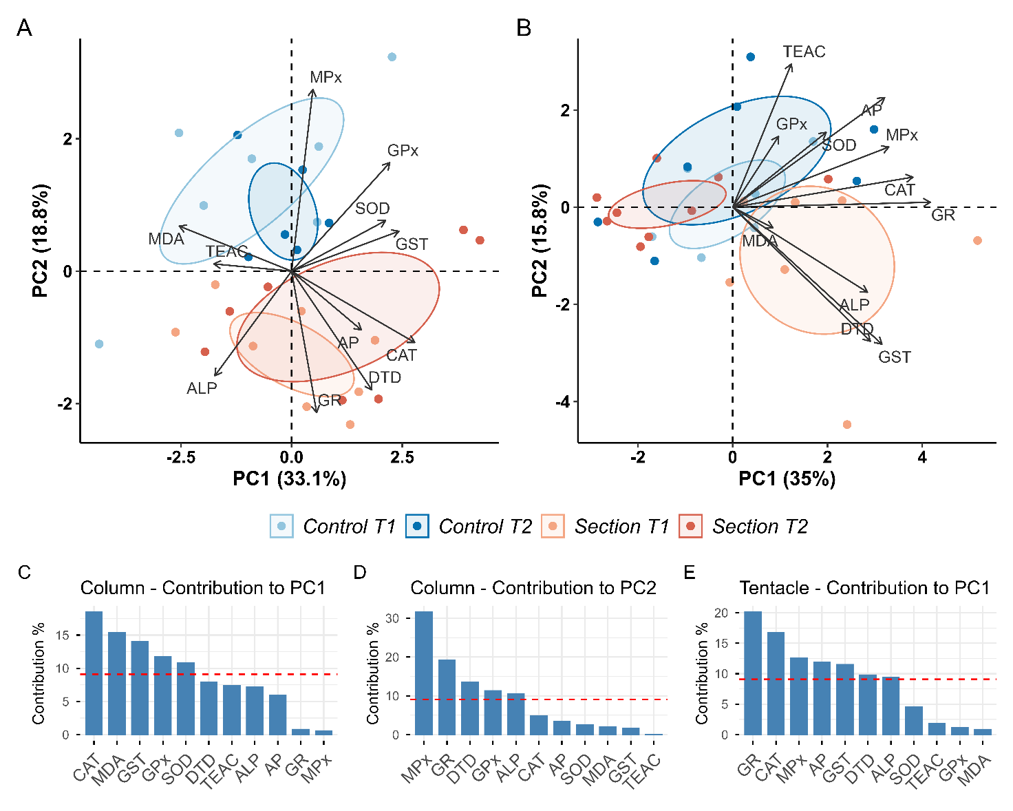
- Impact of the oxidative state was not severe and apparently reversible in several parameters examined. We found increases in catalase, GPx and GR activity levels, but they did not translate into an increase in lipid peroxidation. In fact, lipid peroxidation was found to be lower in handled individuals tentacles. This suggests that mobilization of antioxidant defences was greater than its utilization to prevent oxidative damage to lipids. Lack of alterations to SOD activity is consistent with previous findings and could imply that constitutive SOD activity is greater than what it requires to be to face ROS influx, possibly from the hyperoxia these animals experience during daytime due to symbiont photosynthesis (Try to relate with different SOD isoforms and cellular distribution of them, see below)
Figure 4. Principal Component Analysis (PCA) for examining correlation structure of the data. (A) Biplot of PC1 and PC2 for columnar variables. Samples are grouped according to treatment, with 95% confidence ellipses. (B) Biplot of PC1 and PC2 for tentacular variables. Samples are grouped according to treatment, with 95% confidence ellipses. (C) Percentage contribution of the twelve columnar variables to PC1. (D) Percentage contribution of the twelve columnar variables to PC2. (E) Percentage contribution of the twelve tentacular variables to PC1. Red dashed lines indicate threshold of expected average contribution.

- Less MDA in handled individuals might be related to regeneration processes since they feature younger tissue, especially in tentacles.

- There was a nearly significant higher alkaline phosphatase activity for handled anemones, possibly related to an inflammatory response and posterior regeneration. The general lack of alterations in phosphatases might be related to the fact that sampling 1 (T1) was performed a full month after the injury and anemones had already healed the wound by then. It cannot be discarded that this immune response could have led to the observed antioxidant activation. Column is the most affected body region since it is where the wound was located.

- Columnar PCA showed how PC1 seemed to correlate positively with SOD, CAT, GPx, GR and GST, and negatively to MDA, highlighting protective adaptative function of these enzymes against ROS derived from physical stress and injuries. All four groups appeared in a spectrum with substantial overlap between them alongside this principal component. PC2 was mostly represented by myeloperoxidase activity, which was much higher in control samples than sectioned and separated both groups at the multivariate level, alongside other variables such as GR, DTD and alkaline phosphatase, that tended to be higher in sectioned groups.

- Tentacular PCA offered less information since only one PC was significant. CAT, GR, GST and MPx were the main contributors to this PC1, and they all contributed in the same sense, meaning they were positively correlated in tentacle. Despite PC2 not being significant, DTD, GST and TEAC showed sizable contribution to this PC. Sectioned-T1 observations grouped separately from other experimental groups, which was consistent with univariate analysis that showed how CAT, GPx, GST and DTD returned to levels comparable to control at T2 in sectioned anemones, indicating the reversibility of oxidative status alterations in these organs.

- Oxidative burst activity was found to be lower in handled individuals, but only at T1. This points to a temporary depletion of myeloperoxidase activity due to a higher demand for oxidative burst than upregulation of this enzyme, and highlights the potential role of respiratory burst-producing amoebocytes in cnidarian wound-healing and regeneration. The rapid release of ROS due to these immune effector cells would have also added on to the demand for antioxidant mobilization.

- Post transcriptional regulation of some enzymes can affect their in vitro activity or modify their location, such as with CuZnSOD (reference in Mendeley). Look more into different cellular compartimentalization of SOD isoforms in A. viridis and Philozoon, look studies from Nice.

-Interesting to study short-term tissue regeneration, like other authors have. Describe response and compare with histology results.

5. Conclusions

6. References

Abe, T., Abe, Y., Aida, Y., Hara, Y., Maeda, K., 2001. Extracellular matrix regulates induction of alkaline phosphatase expression by ascorbic acid in human fibroblasts. J Cell Physiol 189, 144–151. https://doi.org/10.1002/JCP.10011
Aebi, H., 1984. [13] Catalase in vitro. Methods Enzymol 105, 121–126. https://doi.org/10.1016/S0076-6879(84)05016-3
Beaulieu, M., Costantini, D., 2014. Biomarkers of oxidative status: missing tools in conservation physiology. Conserv Physiol 2. https://doi.org/10.1093/CONPHYS/COU014
Bocharova, E., 2016. Reproduction of sea anemones and other hexacorals, in: The Cnidaria, Past, Present and Future: The World of Medusa and Her Sisters. https://doi.org/10.1007/978-3-319-31305-4_15
Bradford, M., 1976. A Rapid and Sensitive Method for the Quantitation of Microgram Quantities of Protein Utilizing the Principle of Protein-Dye Binding. Anal Biochem 72. https://doi.org/10.1006/abio.1976.9999
Buege, J.A., Aust, S.D., 1978. Microsomal Lipid Peroxidation. Methods Enzymol 52. https://doi.org/10.1016/S0076-6879(78)52032-6
Calvín Calvo, J.C., 2020. El ecosistema marino mediterráneo: Guía de su flora, fauna y hábitats, 3º Edición. ed. Murcia.
Camargo, A., 2022. PCAtest: testing the statistical significance of Principal Component Analysis in R. PeerJ 10, e12967. https://doi.org/10.7717/PEERJ.12967/SUPP-7
Carlberg, I., Mannervik, B., 1975. Purification and characterization of the flavoenzyme glutathione reductase from rat liver. Journal of Biological Chemistry 250, 5475–5480. https://doi.org/10.1016/S0021-9258(19)41206-4
Casado-Amezúa, P., Terrón-Sigler, A., Pinzón, J.H., Furla, P., Forcioli, D., Allemand, D., Ribes, M., Coma, R., 2016. General ecological aspects of anthozoan- symbiodinium interactions in the mediterranean sea, in: The Cnidaria, Past, Present and Future: The World of Medusa and Her Sisters. https://doi.org/10.1007/978-3-319-31305-4_24
Coll, A., Rufino-Palomares, E.E., Ramos-Barbero, M., Ortiz-Maldonado, A.E., Pantoja-Echevarría, L.M., González-Ordóñez, I., Pérez-Jiménez, A., Trenzado, C.E., 2025. Effects of environmental factors on the oxidative status of Anemonia viridis in aquaculture systems. Comp Biochem Physiol B Biochem Mol Biol 275, 111042. https://doi.org/10.1016/J.CBPB.2024.111042
Cotinat, P., Fricano, C., Toullec, G., Röttinger, E., Barnay-Verdier, S., Furla, P., 2022. Intrinsically High Capacity of Animal Cells From a Symbiotic Cnidarian to Deal With Pro-Oxidative Conditions. Front Physiol 13, 819111. https://doi.org/10.3389/FPHYS.2022.819111/BIBTEX
Daza Cordero, J.L., del Castillo y Rey, F., Márquez Pascual, I., 2002. La Pesquería del Erizo y Anémona de Mar en el Litoral de Cádiz y Málaga. Huelva.
Erel, O., 2004. A novel automated direct measurement method for total antioxidant capacity using a new generation, more stable ABTS radical cation. Clin Biochem 37, 277–285. https://doi.org/10.1016/J.CLINBIOCHEM.2003.11.015
Flohé, L., Günzler, W.A., 1984. [12] Assays of glutathione peroxidase. Methods Enzymol 105, 114–120. https://doi.org/10.1016/S0076-6879(84)05015-1
Frasco, M.F., Guilhermino, L., 2002. Effects of dimethoate and beta-naphthoflavone on selected biomarkers of Poecilia reticulata. Fish Physiology and Biochemistry 2002 26:2 26, 149–156. https://doi.org/10.1023/A:1025457831923
Gordeeva, A. V., Nagler, L.G., Labas, Y.A., 2006. Production of reactive oxygen forms by marine invertebrates: Mechanisms and probable biological role. J Evol Biochem Physiol 42, 253–260. https://doi.org/10.1134/S0022093006030021/METRICS
Huang, Z.H., Ma, A.J., Wang, X.A., 2011. The immune response of turbot, Scophthalmus maximus (L.), skin to high water temperature. J Fish Dis 34. https://doi.org/10.1111/j.1365-2761.2011.01275.x
Hutton, D.M.C., Smith, V.J., 1996. Antibacterial properties of isolated amoebocytes from the sea anemone Actinia equina. Biological Bulletin 191, 441–451. https://doi.org/10.2307/1543017
Konada, R.S.R., Krishnapati, L.S., Ashapogu, V., Lin, C.H., Nadimpalli, S.K., 2020. Comparative analysis of β-hexosaminidase and acid phosphatase from Hydra vulgaris Ind-Pune, H. vulgaris Naukuchiatal and H. magnipapillata sf-1: Localization studies of acid phosphatase and β-hexosaminidase from H. vulgaris Ind-Pune. Comp Biochem Physiol B Biochem Mol Biol 239, 110365. https://doi.org/10.1016/J.CBPB.2019.110365
La Corte, C., Baranzini, N., Dara, M., Bon, C., Grimaldi, A., Parisi, M.G., Zizzo, M.G., Cammarata, M., 2023a. Step-by-Step Regeneration of Tentacles after Injury in Anemonia viridis—Morphological and Structural Cell Analyses. Int J Mol Sci 24, 8860. https://doi.org/10.3390/IJMS24108860/S1
La Corte, C., Baranzini, N., Dara, M., Bon, C., Grimaldi, A., Parisi, M.G., Zizzo, M.G., Cammarata, M., 2023b. Step-by-Step Regeneration of Tentacles after Injury in Anemonia viridis—Morphological and Structural Cell Analyses. Int J Mol Sci 24, 8860. https://doi.org/10.3390/IJMS24108860/S1
LaJeunesse, T.C., Wiedenmann, J., Casado-Amezúa, P., D’Ambra, I., Turnham, K.E., Nitschke, M.R., Oakley, C.A., Goffredo, S., Spano, C.A., Cubillos, V.M., Davy, S.K., Suggett, D.J., 2022. Revival of Philozoon Geddes for host-specialized dinoflagellates, ‘zooxanthellae’, in animals from coastal temperate zones of northern and southern hemispheres. Eur J Phycol 57. https://doi.org/10.1080/09670262.2021.1914863
Lemaire, P., Sturve, J., Förlin, L., Livingstone, D.R., 1996. Studies on aromatic hydrocarbon quinone metabolism and DT-Diaphorase function in liver of fish species. Mar Environ Res 42, 317–321. https://doi.org/10.1016/0141-1136(95)00042-9
Lentz, T.L., Barrnett, R.J., 1962. Changes in the distribution of enzyme activity in the regenerating hydra. Journal of Experimental Zoology 150, 103–117. https://doi.org/10.1002/JEZ.1401500204
Lesser, M.P., 2006. Oxidative stress in marine environments: Biochemistry and physiological ecology. Annu Rev Physiol. https://doi.org/10.1146/annurev.physiol.68.040104.110001
Löhr, G.W., Waller, H.D., 1965. Glucose-6-phosphate Dehydrogenase: (Zwischenferment). Methods of enzymatic analysis 744–751. https://doi.org/10.1016/B978-0-12-395630-9.50135-3
Lushchak, V.I., 2011. Environmentally induced oxidative stress in aquatic animals. Aquatic Toxicology 101, 13–30. https://doi.org/10.1016/J.AQUATOX.2010.10.006
Macias-Muñoz, A., 2025. Investigating the evolution and features of regeneration using cnidarians. Integr Comp Biol 1–14. https://doi.org/10.1093/ICB/ICAF006
Mauro, M., Queiroz, V., Arizza, V., Campobello, D., Custódio, M.R., Chiaramonte, M., Vazzana, M., 2021. Humoral responses during wound healing in Holothuria tubulosa (Gmelin, 1788). Comp Biochem Physiol B Biochem Mol Biol 253, 110550. https://doi.org/10.1016/J.CBPB.2020.110550
McCord, J.M., Fridovich, I., 1969. Superoxide Dismutase: AN ENZYMIC FUNCTION FOR ERYTHROCUPREIN (HEMOCUPREIN). Journal of Biological Chemistry 244, 6049–6055. https://doi.org/10.1016/S0021-9258(18)63504-5
Merle, P.L., Sabourault, C., Richier, S., Allemand, D., Furla, P., 2007. Catalase characterization and implication in bleaching of a symbiotic sea anemone. Free Radic Biol Med 42. https://doi.org/10.1016/j.freeradbiomed.2006.10.038
Mohanty, B.R., Sahoo, P.K., 2010. Immune responses and expression profiles of some immune-related genes in Indian major carp, Labeo rohita to Edwardsiella tarda infection. Fish Shellfish Immunol 28. https://doi.org/10.1016/j.fsi.2009.12.025
Mydlarz, L.D., Holthouse, S.F., Peters, E.C., Harvell, C.D., 2008. Cellular Responses in Sea Fan Corals: Granular Amoebocytes React to Pathogen and Climate Stressors. PLoS One 3, e1811. https://doi.org/10.1371/JOURNAL.PONE.0001811
Mydlarz, L.D., Jacobs, R.S., 2006. An inducible release of reactive oxygen radicals in four species of gorgonian corals. Mar Freshw Behav Physiol 39, 143–152. https://doi.org/10.1080/10236240600708512
Mydlarz, L.D., Jacobs, R.S., 2004. Comparison of an inducible oxidative burst in free-living and symbiotic dinoflagellates reveals properties of the pseudopterosins. Phytochemistry 65, 3231–3241. https://doi.org/10.1016/J.PHYTOCHEM.2004.09.014
Orden de 17 de octubre de 2023, por la que se cierra la pesquería de erizos y anémonas en el litoral de Andalucía, debido a la situación crítica de sus poblaciones y el impacto generado por la invasión del alga Rugulopterix okamurae., 2023. . Boletín Oficial de la Junta de Andalucía.
Orlando, P., Carretta, F., Grippo, P., Cimino, G., De Stefano, S., Strazzullo, G., 1991. Kelletinin I and kelletinin A from the marine mollusc Buccinulum corneum are inhibitors of eukaryotic DNA polymerase α. Experientia 47, 64–66. https://doi.org/10.1007/BF02041254
Parisi, M.G., Grimaldi, A., Baranzini, N., La Corte, C., Dara, M., Parrinello, D., Cammarata, M., 2021. Mesoglea Extracellular Matrix Reorganization during Regenerative Process in Anemonia viridis (Forskål, 1775). International Journal of Molecular Sciences 2021, Vol. 22, Page 5971 22, 5971. https://doi.org/10.3390/IJMS22115971
Parisi, M.G., Parrinello, D., Stabili, L., Cammarata, M., 2020. Cnidarian immunity and the repertoire of defense mechanisms in anthozoans. Biology (Basel) 9. https://doi.org/10.3390/biology9090283
Pey, A., Zamoum, T., Christen, R., Merle, P.L., Furla, P., 2017. Characterization of glutathione peroxidase diversity in the symbiotic sea anemone Anemonia viridis. Biochimie 132. https://doi.org/10.1016/j.biochi.2016.10.016
Richier, S., Furla, P., Plantivaux, A., Merle, P.L., Allemand, D., 2005. Symbiosis-induced adaptation to oxidative stress. Journal of Experimental Biology 208. https://doi.org/10.1242/jeb.01368
Richier, S., Merle, P.L., Furla, P., Pigozzi, D., Sola, F., Allemand, D., 2003. Characterization of superoxide dismutases in anoxia- and hyperoxia-tolerant symbiotic cnidarians. Biochim Biophys Acta Gen Subj 1621. https://doi.org/10.1016/S0304-4165(03)00049-7
Richier, S., Sabourault, C., Courtiade, J., Zucchini, N., Allemand, D., Furla, P., 2006. Oxidative stress and apoptotic events during thermal stress in the symbiotic sea anemone, Anemonia viridis. FEBS J 273, 4186–4198. https://doi.org/10.1111/J.1742-4658.2006.05414.X
Trapani, M.R., Parisi, M.G., Parrinello, D., Sanfratello, M.A., Benenati, G., Palla, F., Cammarata, M., 2016. Specific inflammatory response of Anemonia sulcata (Cnidaria) after bacterial injection causes tissue reaction and enzymatic activity alteration. J Invertebr Pathol 135. https://doi.org/10.1016/j.jip.2016.01.010
Utrilla, O., Castro-Claros, J.D., Urra, J., Navas, F.D., Salas, C., 2019. Reproduction of the anthozoan Anemonia sulcata (Pennant, 1777) in southern Spain: from asexual reproduction to putative maternal care. Mar Biol 166. https://doi.org/10.1007/s00227-019-3558-5
Valavanidis, A., Vlahogianni, T., Dassenakis, M., Scoullos, M., 2006. Molecular biomarkers of oxidative stress in aquatic organisms in relation to toxic environmental pollutants. Ecotoxicol Environ Saf 64, 178–189. https://doi.org/10.1016/J.ECOENV.2005.03.013
Vieira, V.M.N.C.S., 2012. Permutation tests to estimate significances on Principal Components Analysis. Computational Ecology and Software 103–123.
Vullein, A., 2024. Evolutionary conservation and roles of ROS signalling in the initiation of regeneration. Insight from the cnidarian Nematostella vectensis and the annelid Platynereis dumerilii. IRCAN - Institut de Recherche sur le Cancer et le Vieillissement. https://doi.org/10.34894/VQ1DJA

