Notas y esquema general Introduccion:

-Anemonia viridis as food item and restrictions in Andalusia and Spain.

-Reproduction modes in A. viridis, birradial symmetry and anatomy.

- Integrated multitrophic aquaculture. Sustainability

- Oxidative stress as a marker of wellbeing in aquaculture

-Justificar y/o relacionar los cambios metabólicos asociados 1) al estrés por manipulación (inducción asexual) y 2) a la maduración sexual y como ambos pueden afectar al estado estado oxidativo (para justificar la metodología del trabajo)

In vertebrates, one of the first events triggered during wound healing, inflammation and regeneration, is the alkaline phosphatase (ALP) activity, especially by fibroblasts localized in the connective tissue [[35](https://www.mdpi.com/1422-0067/22/11/5971#B35-ijms-22-05971)]. This enzyme is usually highly expressed also during tissue regeneration in cnidarian and in Hydra, and it has been described as one of the main enzymatic markers related to nematocyte and epithelial cell differentiation during tentacle regeneration [[36](https://www.mdpi.com/1422-0067/22/11/5971#B36-ijms-22-05971)]. Here, we showed that ALP in A. viridis increases significantly in tentacle extracts after amputation in all three time points considered, while the enzyme amount remains at a constant level in the body extract.

Phosphatases have been described as markers of regeneration in *Hydra*, in which the increase of epithelial cells and nematocytes differentiation have been related to changes in the levels of acid and [alkaline phosphatase](https://www.sciencedirect.com/topics/agricultural-and-biological-sciences/alkaline-phosphatase) ([De Petrocellis et al., 1999](https://www.sciencedirect.com/science/article/pii/S0022201116300106" \l "b0050)).

Research questions:

* Can asexual reproduction be induced artificially in the snakelocks anemone?
* Does this induction affect the wellbeing of the animals negatively and irreversibly?

1. Introduction

The snakelocks anemone (*Anemonia viridis*) is a species of Cnidarian widely distributed in the Northeast Atlantic Ocean and Mediterranean Sea. It inhabits rocky bottoms ranging from the lower intertidal zone to the subtidal, down to around 15-20 m deep (Calvín Calvo, 2020). The snakelocks anemone has been traditionally exploited for human consumption in Spain, particularly in Andalusia (Daza Cordero et al., 2002; Utrilla et al., 2019). However, the poor ecological state of stocks in the Andalusian coast led to an indefinite ban on its capture in the region, in effect since October 2023. As current demand of this species is not being met, and populations still are subjected to illegal gathering (BOJA, 2023), there is great interest in the development of alternative production methodologies. Aquaculture of the snakelocks anemone is not fully established, but can function as a major engine in the production of this species.

Like most sea anemones, *A. viridis* is capable of both sexual and asexual reproduction (Bocharova, 2016; Utrilla et al., 2019). Concerning sexual reproduction, *A. viridis* is a dioic species, and females and males develop their gonads in their mesenteries. Fertilization is external, and spawning usually takes place in spring, around the months of April and May in the Andalusian coast (Utrilla et al., 2019). Asexual reproduction is ubiquitous in sea anemones and can happen through different mechanisms. In the case of *A. viridis*, asexual reproduction primarily takes place through longitudinal fission of the animal, in a plane that is perpendicular to their pharynx plan (Bocharova, 2016; Macias-Muñoz, 2025) e. Other variants, such as budding, have been recorded but seem to be sporadic (Utrilla et al., 2019). Asexual reproduction can also occur as a way of epimorphic regeneration after an injury, as sea anemones are able to regenerate a complete organism from severed body parts (Bocharova, 2016). While sexual reproduction is vital for the long-term success of an aquaculture stock, asexual cloning of anemones represents a reliable way of quickly increasing stock size. However, in order to achieve that, asexual reproduction must 1) be artificially inducible and 2) not affect the wellbeing of the animals severely or irreversibly.

Even though artificially sectioning the animals to induce epimorphic regeneration and obtain two clonal anemones is possible, it is also an invasive procedure that involves handling of the animals, wound healing and regeneration of the missing body parts. Mass recruitment and proliferation of amoebocytes, the immune effector cells in anthozoans, has been described both in *A. viridis* and other hexacoral anthozoans during wound healing (La Corte et al., 2023; Parisi et al., 2020), and generation of reactive oxygen species (ROS) represents a key process during regeneration in sea anemones and other anthozoans (La Corte et al., 2023; Mydlarz & Jacobs, 2006; Parisi et al., 2020; Vullein, 2024). While ROS signalling and production perform important roles during wound-healing and regeneration, imbalances between ROS generation and scavenging can result in damage to cellular components such as poly-insaturated fatty acids (PUFAs), proteins, or DNA binding, potentially impacting the organism’s health even after the regeneration process is over (referencias).

However, the induction of asexual reproduction in *A. viridis* might not lead to severe impacts on its health after regeneration, as they possess a combination of traits that make them a good candidate-species to reproduce asexually in captivity. First, as an intertidal-dwelling organism, *A. viridis* polyps are often exposed to large variations in temperature, salinity, humidity and UV exposure, and to other environmental stressors such as wave action (referencia). Their wide tolerance limits and ability to recover from challenging environmental situations could mitigate stress due to handling and manipulation of the animal (referencia). Secondly, as most Cnidarians do, they possess a great tissular regeneration capacity, as they are able to heal wounds in less than 24 h and regenerate missing body parts with ease (referencia parisi y otras). Finally, *A. viridis* is a symbiotic anthozoan that hosts photosynthetic microalgae (zooxanthellae) in their endoderm. As a result of this symbiotic mutualism, they are adapted to deal with the variation in oxygen partial pressure that take place between daytime and nighttime due to zooxanthellae photosynthesis (referencias Niza y Casado amenzua). These adaptations to symbiosis involve a more robust antioxidant system than found in non-symbiotic sea anemones (referencia Niza).

Oxidative status analysis is a reliable way to assess the overall wellbeing state of marine invertebrates, as stress responses often converge into oxidative stress pathways, where a few key antioxidant enzymes may have their activity levels enhanced to face an increased influx of ROS (referencias). Coupled with determinations of oxidative damage to cellular components, this type of assessment can quickly provide an overall picture of the condition of the animals at a cellular level (referencia).

Last paragraph before goals:

- In vertebrates, alkaline phosphatase is one of the first enzymes to act in wound healing and inflammatory processes.

- In cnidarians, specifically, high expression levels of this enzyme have been reported during tissue regeneration.

- In Hydra, changes in acid and alkaline phosphatases have been linked to epithelial cell and nematocyst differentiation.

There is no record of myeloperoxidase activity in cnidarians, yet amoebocytes are cells with neutrophil character that phagocyte and possess Toll-like receptors (TLRs) in their cell surface. This article (referencia aiptasia) couldn’t find myeloperoxidase activity in Aiptasia pullcheri.

In the present study, we assessed the impact of artificially sectioning of snakelocks anemones (Anemonia viridis) on their oxidative state at two different timescales, within an Integrated Multitrophic Aquaculture setting, where other organisms were co-cultured in the same tank.

2. Materials and methods

2.1. Experimental design and sampling

300 wild anemones were obtained from natural environments off the coast of Granada (Andalusia, Spain) in November 2020 with the pertinent permits from local authorities. Animals were transferred to facilities of Andalmar Biotech S.L., where they were distributed in floating baskets in a concrete 16 m3 outdoor tank. The tank was equipped with a recirculation system consisting of a mechanic sand filter, biological filter with 300 m2/m3 bio-balls and protein skimmer. Natural seawater was pumped from a well in the facilities and then filtered to be used in the circuit. Salinity and pH were monitored during the experimental period, centred around 34.8 ‰ and pH 8. Water temperature varied with ambient temperature, with an overall mean of 17.5 º C through the study.

Anemones were distributed in 11.8 L floating baskets at a density of 16-17 individuals per basket, making a total of 18 baskets. An IMTA set up was established by introducing selected organisms in the tank: beadlet anemones (*Actinia equina*), sea urchins (*Paracentrotus lividus*, *Arbacia lixula*), sea snails (Monodonta turbinata), limpets (*Patella caerulela*), sea cucumbers (*Holothuria tubulosa*), mussels (*Mytillus edulis*), and macroalgae (*Ulva rigida*, *Cystoseira mediterranea*) (Coll et al., 2025).

After acclimation to the aquaculture conditions for one month, anemones from nine of the baskets were selected as experimental group, and they were sectioned in two through their pharyngeal biradial axis. Each of the resulting halves was separated and left to heal, so as to generate two different clonal individuals. Mortality during the healing phase was recorded.

The first sampling (T1) took place 4 weeks after the sectioning procedure, once the anemones had had time to heal completely. 9 handled anemones (1 per basket) were selected, as well as 9 control anemones which had not undergone the procedure. Handled anemones were identified at all times to ensure that sampled individuals would not include both clones obtained from the same parent anemone. The second sampling (T2) took place 3 months later, when again 9 control anemones and 9 handled anemones were collected with the same regards over clonal anemones.

At both sampling events, each anemone was snap-frozen in liquid nitrogen and stored at -80 ºC. The column and tentacles of each individual was homogenized separately (Heidolph Instruments) in 100 mM Tris, 0.1 EDTA and 0.1% Triton buffer (pH 7.8) at a 1:4 ratio (w/v). Extracts were then centrifuged at 16 000 rpm for 30 minutes at 4ºC (Sigma 3 K30), and the supernatant was collected and stored at -80 ºC for posterior analysis.

2.2. Oxidative status assays

Superoxide dismutase (SOD) (EC 1.15.1.1) activity was determined according to McCord & Fridovich (1969) method, consisting on an indirect measurement as the degree of inhibition of cytochrome c reduction. Determination of catalase (CAT) (EC 1.11.1.6) activity was performed using Aebi (1984) method, based on the decrease in absorbance produced by H2O2 consumption by this enzyme.

Glutathione peroxidase (GPx) (EC 1.11.1.9) activity of the samples was determined following Flohé & Günzler (1984), based on an indirect measurement of NADPH oxidation, generated by its coupling with a standard glutathione reductase (GR) (EC 1.8.1.7) reaction. GR activity was measured according to Carlberg & Mannervik (1975) method, consisting on a measure of the absorbance decrement caused by NADPH oxidation. Glucose 6-phosphate dehydrogenase (G6PDH) (EC 1.1.1.49) activity of the samples was obtained using a modified method of Löhr & Waller (1965), based on recording the change in absorbance due to NADPH production by the enzyme.

Determination of glutathione S-transferase (GST) (EC 2.5.1.18) activity was performed following the method of Frasco & Guilhermino (2002), based on the formation of a conjugate between glutathione and 2,4-dinitrochlorobenzene that increases absorbance. c (EC 1.6.99.2) activity was determined using a modified method of Lemaire et al. (1996), based on measurement of the decrease in absorbance caused by reduction of 2,6-dichlorophenol indophenol.

Soluble protein content was quantified following Bradford (1976) method in order to express enzymatic specific activity. One unit of activity was defined as the amount of enzyme required to transform one μmol of substrate per minute under the measurement conditions (Coll et al., 2025). For SOD, units of activity had a different definition, as the amount of enzyme required to generate a 50% inhibition in the reduction of cytochrome c.

Total antioxidant activity was measured according to Erel (2004) method, based on the change of absorbance due to reduction of 2,2′-azino-bis-(3-ethylbenzothiazoline-6-sulfonic acid), to determine Trolox-equivalent antioxidant capacity (TEAC) of the extracts.

Lastly, oxidative damage to lipids was assayed as thiobarbituric acid reactive substances (TBARS) content, following a modified method from Buege & Aust (1978) and using malondialdehyde (MDA) as a standard.

2.3. Immune status parameters

Acid (EC 3.1.3.2) and alkaline (EC 3.1.3.1) phosphatases (AP and AlP) activity were measured following the method of Huang et al. (2011), based on the change of absorbance produced by the activity of the enzyme on p-nitrophenyl at different pH. Determination of myeloperoxidase (MPx) activity (EC 1.11.1.7) was carried out following a modified method of Mohanty & Sahoo (2010), based on the increase of absorbance due to oxidation of 3,3',5,5'-tetramethylbenzidine (TMB) by the products of MPx activity.

Both oxidative status and immune parameters measurements were carried out with a PowerWave microplate spectrophotometer (Bio-Tek Instrument, Inc.) at a stable temperature of 25 °C for enzymatic determinations.

2.4. Statistical analysis

All statistical analysis and data processing was carried out using R. 4.4.3 and Rstudio 2024.12.1. Results were expressed as mean ± standard error of the mean (SEM). A confidence level of 95% (α = 0.05) was established for all statistical tests. For each variable, a two-way ANOVA was conducted to examine the effect of the handling procedure at short and long term on the oxidative status of *A. viridis*. When interaction between both variables was found to be significant, a t-test was performed at each level of the variable time (T1 and T2) to test for differences between handled and control animals. Obtained p-values were adjusted using Benjamini-Hochberg correction for multiple testing. Normality of residuals was assessed via Shapiro-Wilk’s normality test, while homoscedasticity was tested using Levene’s test. All residuals were normally distributed (p > 0.05) and all variables had homogeneity of variances (p > 0.05).

3. Results

Overall, the handling procedure registered an 8% mortality during healing of the anemones. The rest of the anemones were able to heal and keep growing in the next months.

3.1. Oxidative status parameters

The ANOVA test for SOD activity in handled and control individuals of *A. viridis*, at different sampling times (Figure 1), did not reveal a significant interaction effect between the two variables on columnar or tentacular samples. There was also no significant main effect of the handling procedure or the time variable on either tissue. A light tendency was found on tentacular SOD activity, where handled individuals yielded a slightly smaller activity, but this pattern was not found to be statistically significant. CAT activity (Figure 1) showed different responses in tentacular and columnar samples. Columnar activity was increased by handling, while there was no effect of time or interaction between both variables. Tentacular CAT activity, however, featured a significant interaction effect. At T1, handled anemones featured a significantly higher CAT activity than control anemones (p = 0.000274/ p < 0.001). However, a T2, this relationship became inverted and handled individuals exhibited a lower activity (p = 0.00599/ p < 0.01).

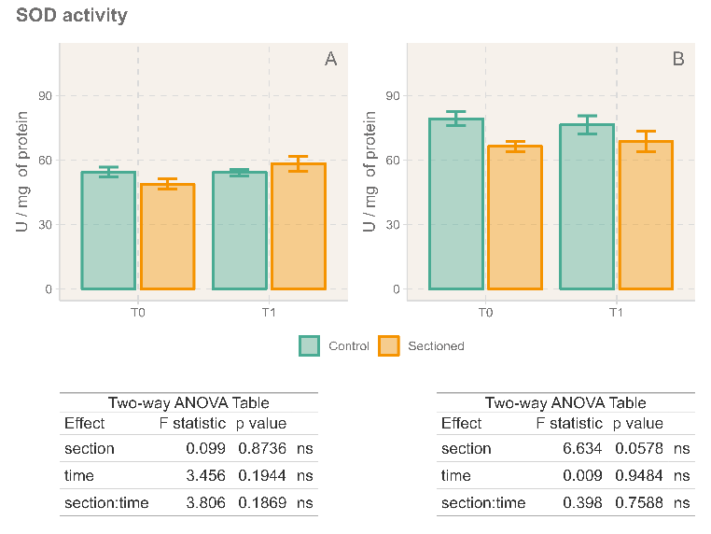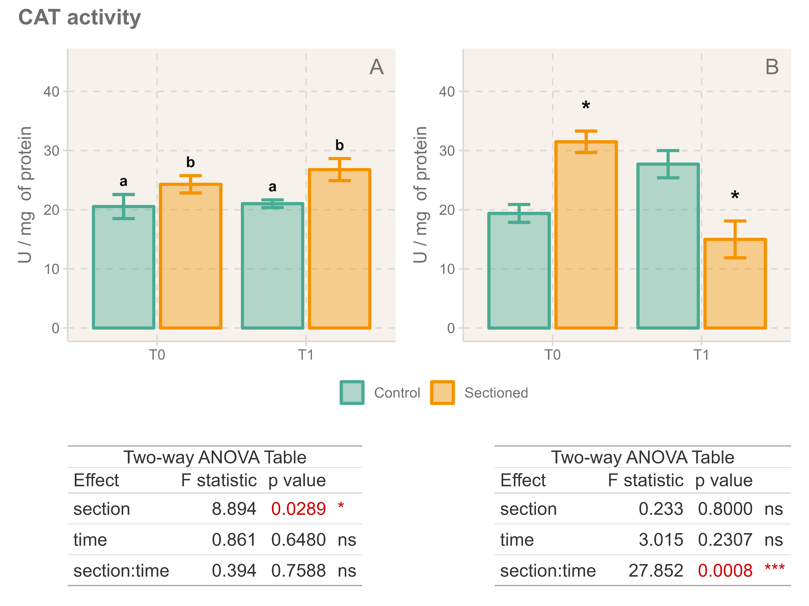

Columnar GPx activity (Figure 3.A) was not affected by either variable, although a nearly significant effect of time increasing the activity of this enzyme can be observed. Tentacular GPx activity (Figure 3.B) featured interaction between both variables. At T1, there was no significant differences between control and handled animals (p = 0.0535); while, at T2, handled anemones displayed lower GPx activity (p = 0.0286 / p < 0.05). GR activity is displayed in Figure 3.B and 3.D. Time had a significant effect on both columnar and tentacular GR, as samples from T2 exhibited lower activity than T1 measurements. Furthermore, columnar GR activity was significantly increased for all handled individuals.

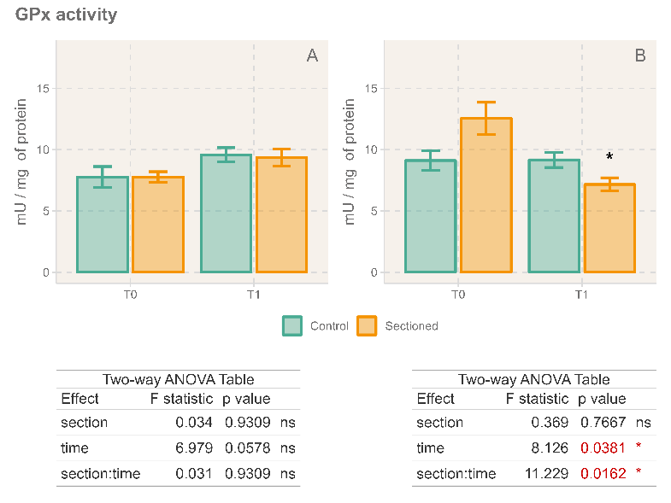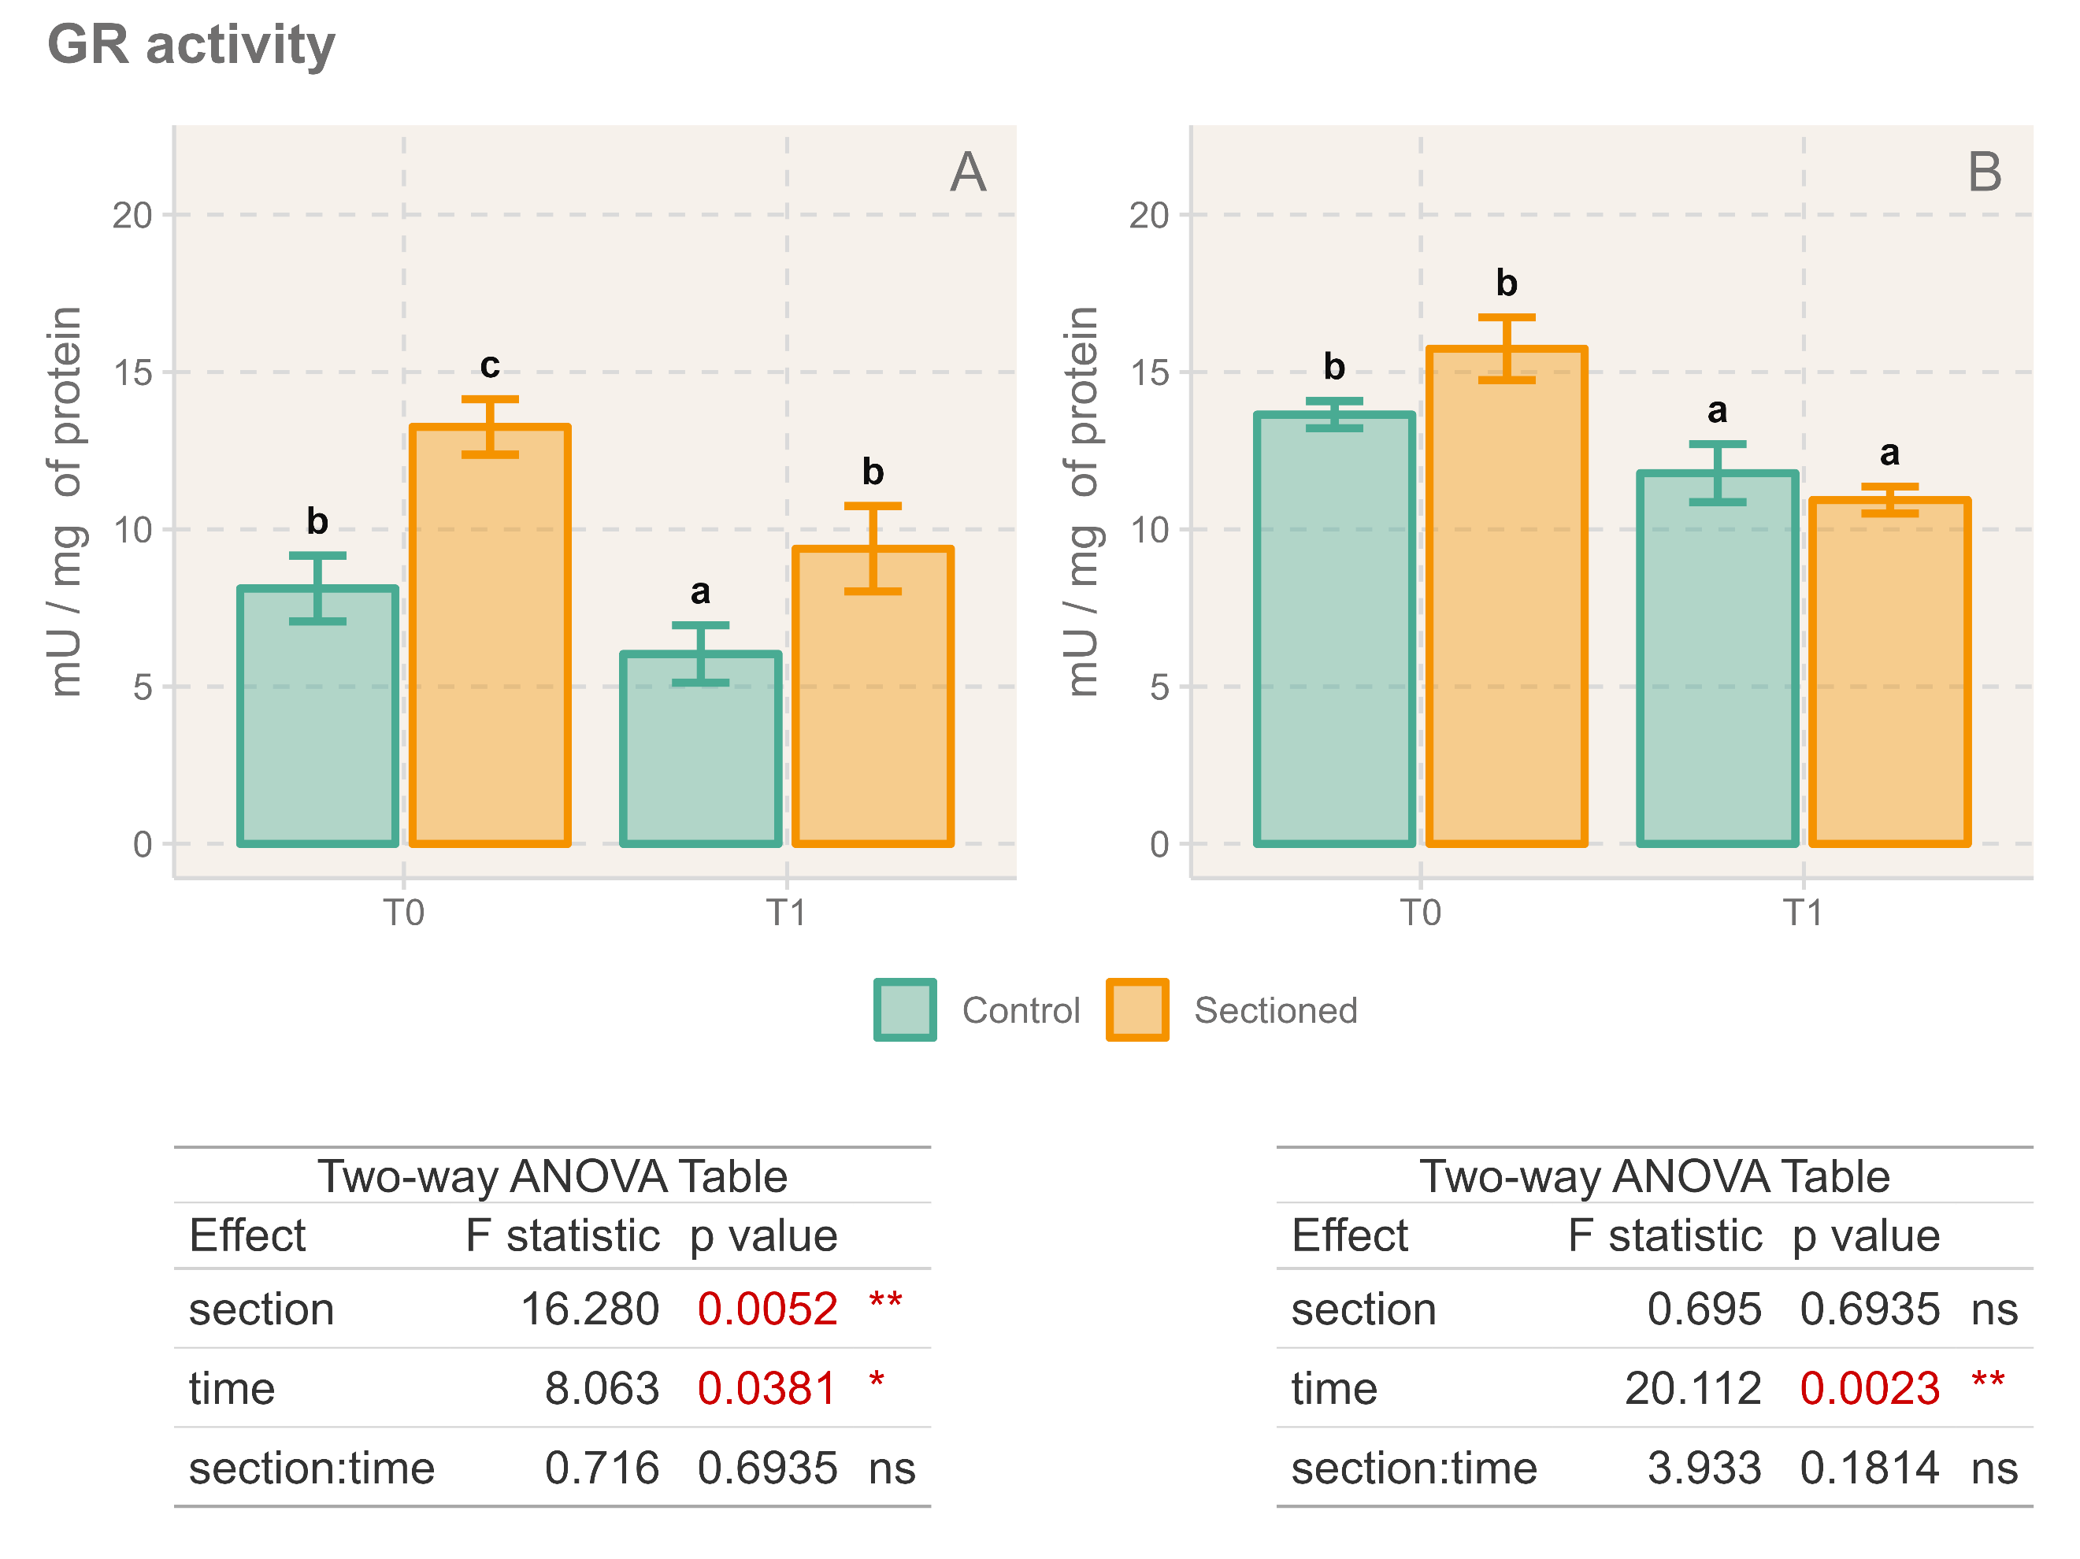

There were no significant effects on columnar GST activity (Figure 4), but tentacular samples featured significant interaction between the two variables. At T1, handled individuals had their GST activity significantly increased (p = 0.000656 / p < 0.001). These differences were not reflected T2, where control and handled individuals were found to be similar (p = 0.345). Columnar NQO1 activity (Figure 4. C) increased significantly on handled anemones, while tentacular NQO1 activity featured a significant interaction effect (Figure 5.B). Anemones at T1 exhibited this same pattern of higher activity for handeld individuals (p = 0.000103 / p < 0.001) detected in columnar activity. At T2, however, no differences were found between control and handled samples (p = 0.393).

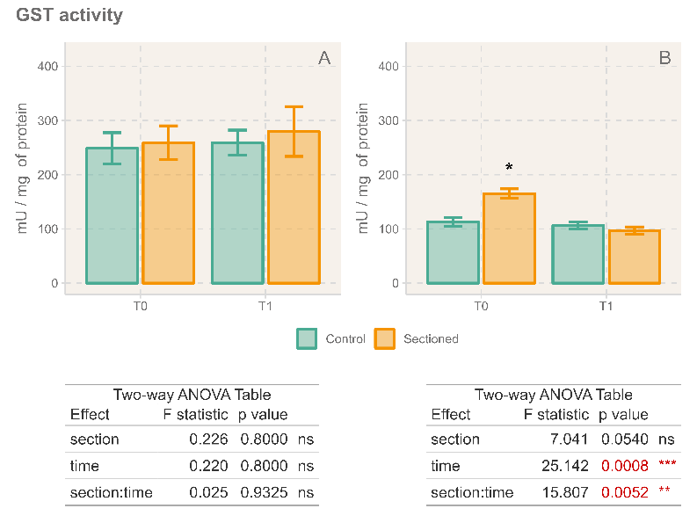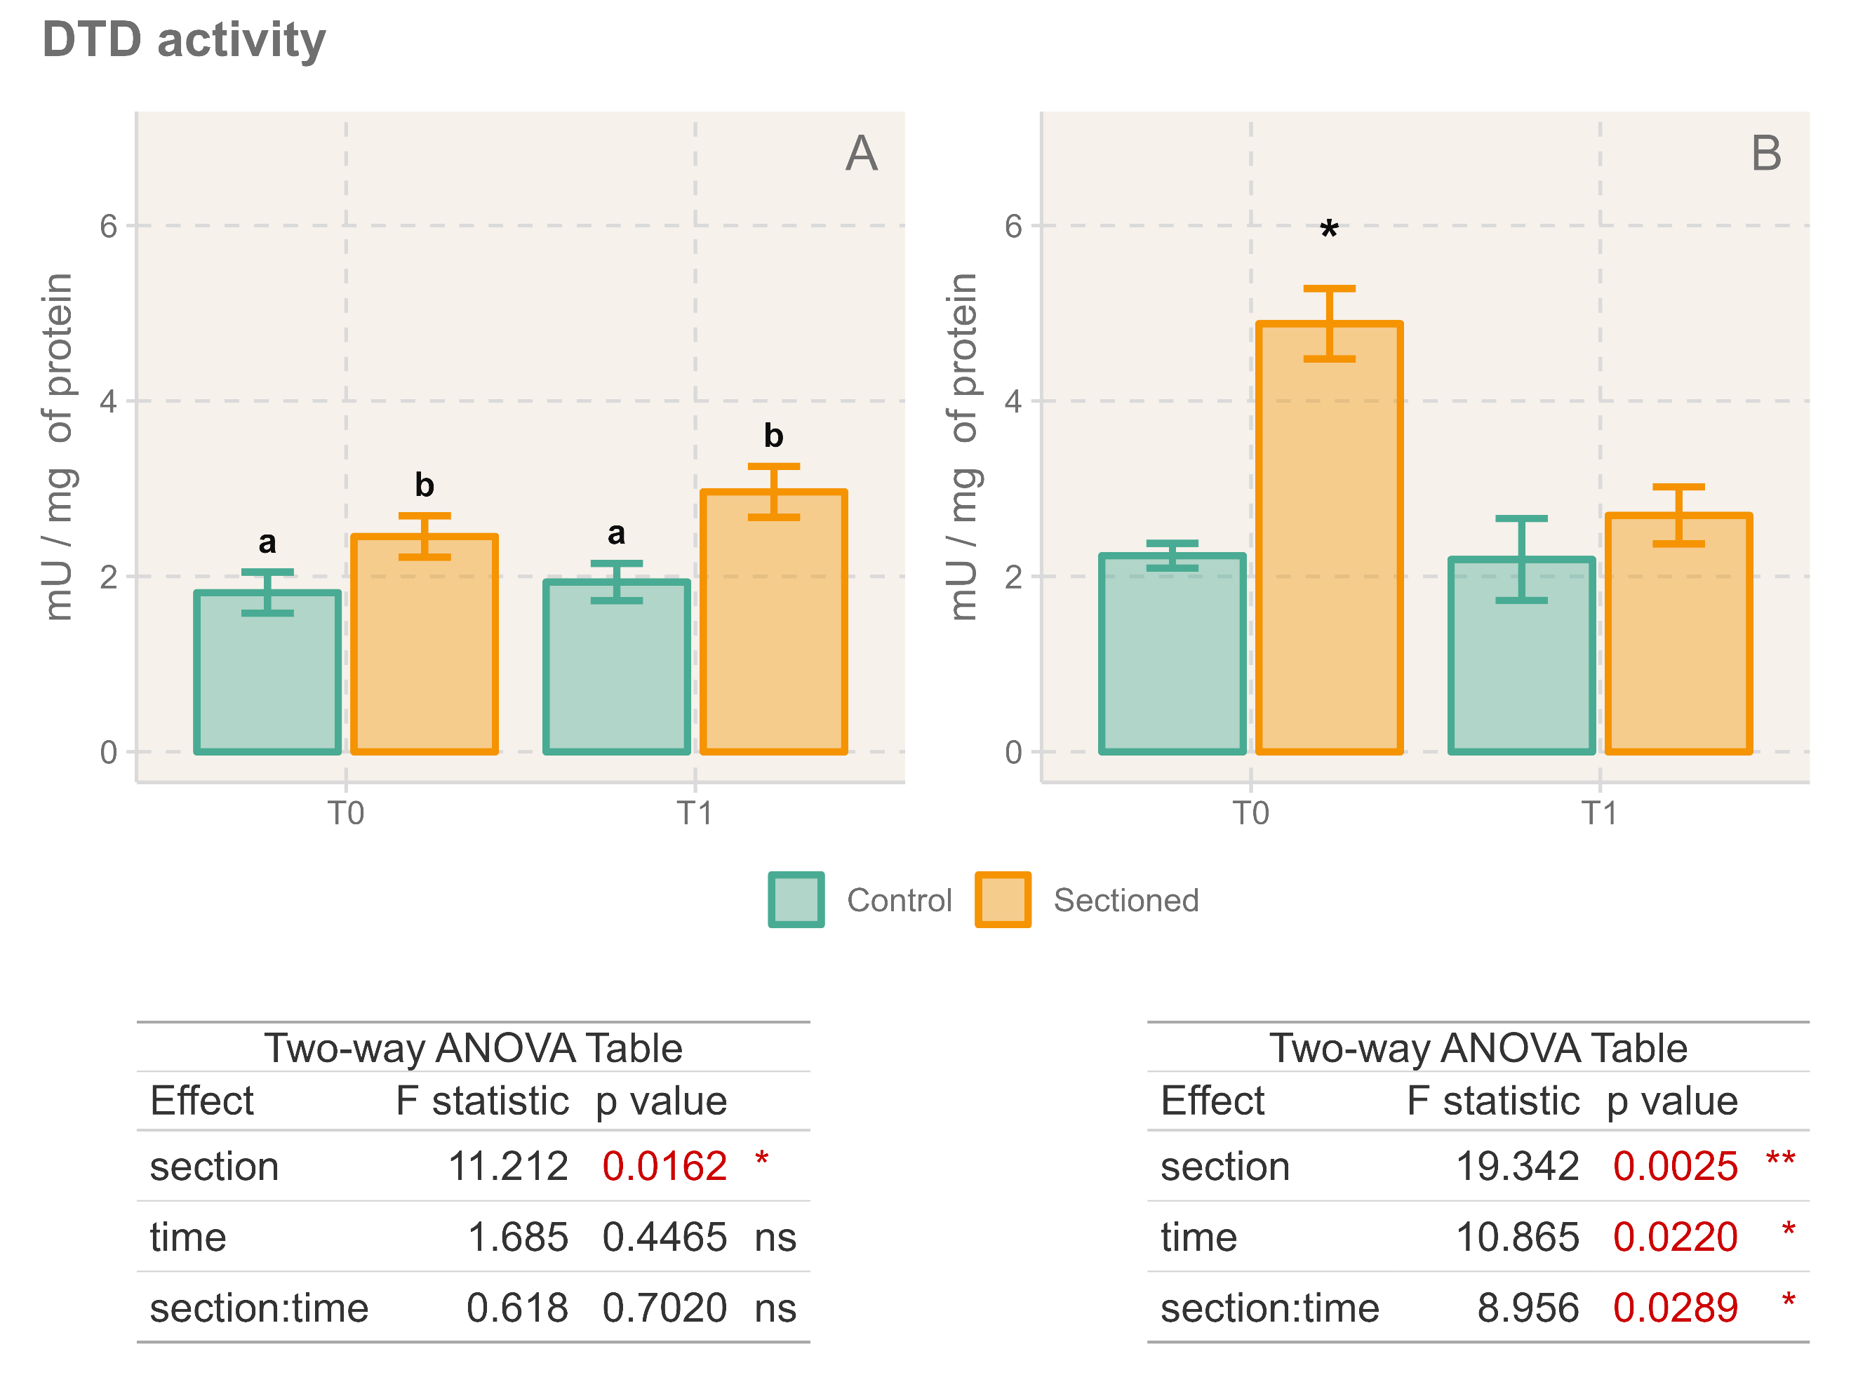

Total Antioxidant Capacity, measured as TEAC (Figure 5) showed no significant effects associated with handling or time, on neither columnar nor tentacular tissue. Lipid peroxidation, measured as MDA concentration (Figure 5), did not vary significantly in columnar samples, but tentacular MDA was found to be lower on handled individuals compared to control ones.

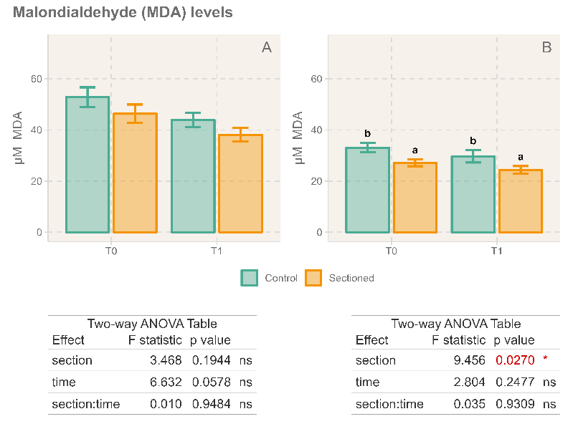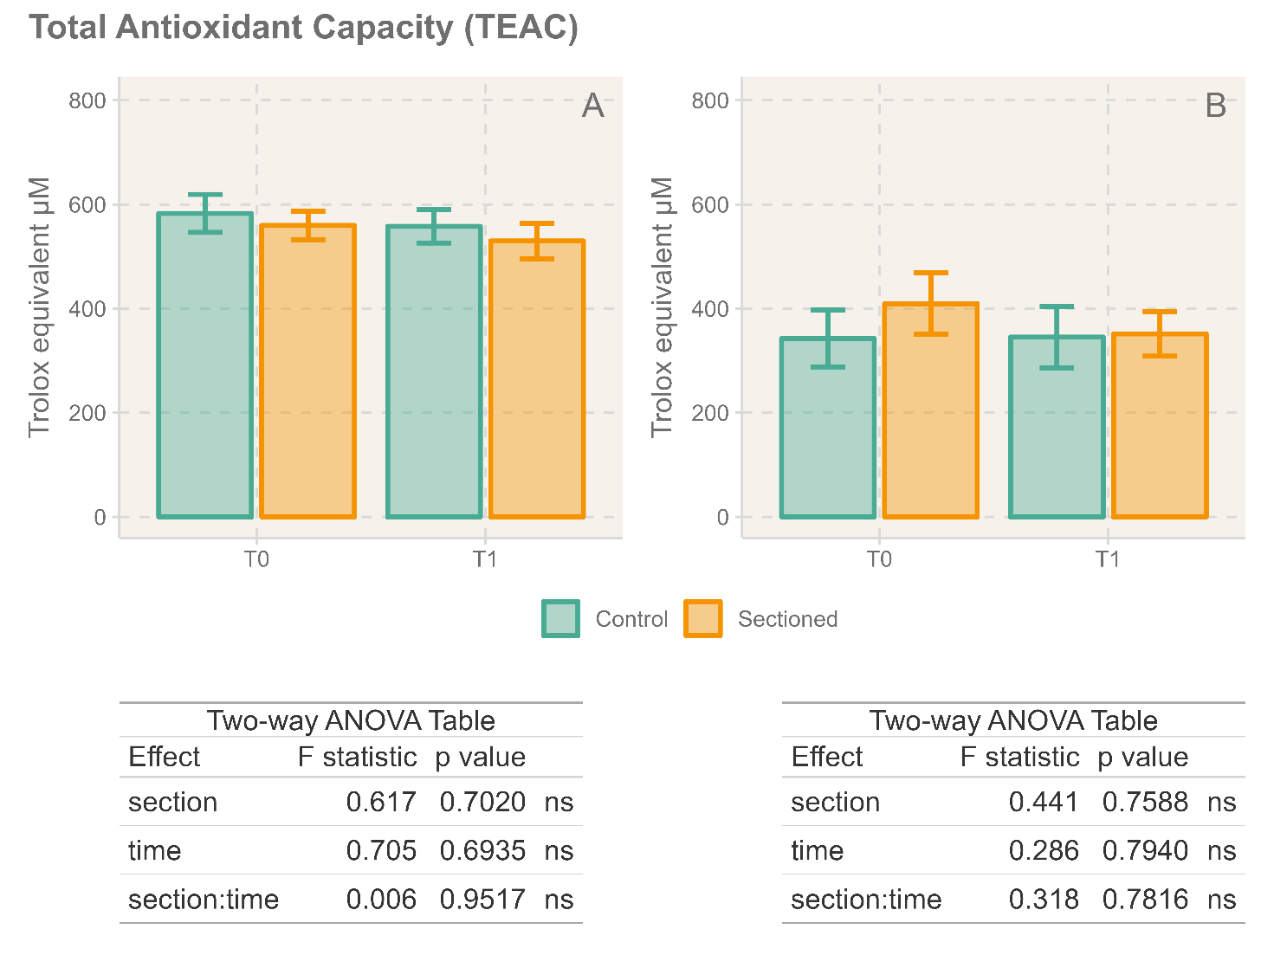

3.2. Immune parameters

Neither acid phosphatase (Figure 6. A-B) nor alkaline phosphatase (Figure 6. C-D) showed any significant effect or interaction between the variables. However, columnar alkaline phosphatase activity seemed to increase slightly in response to handling of the animals (p = 0.088). MPx activity showed significant interaction in columnar samples. At T1, columnar MPx activity (Figure 6 E-F) was lower for handled individuals (p = 0.000895 / p < 0.001), while there were no significant differences at T2 (p = 0.674). The effect of handling and time on tentacular activity also resulted non-significant.

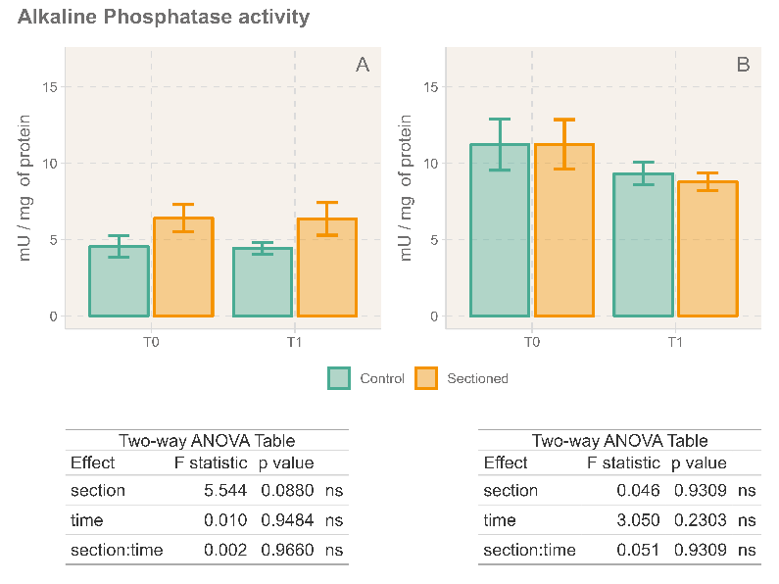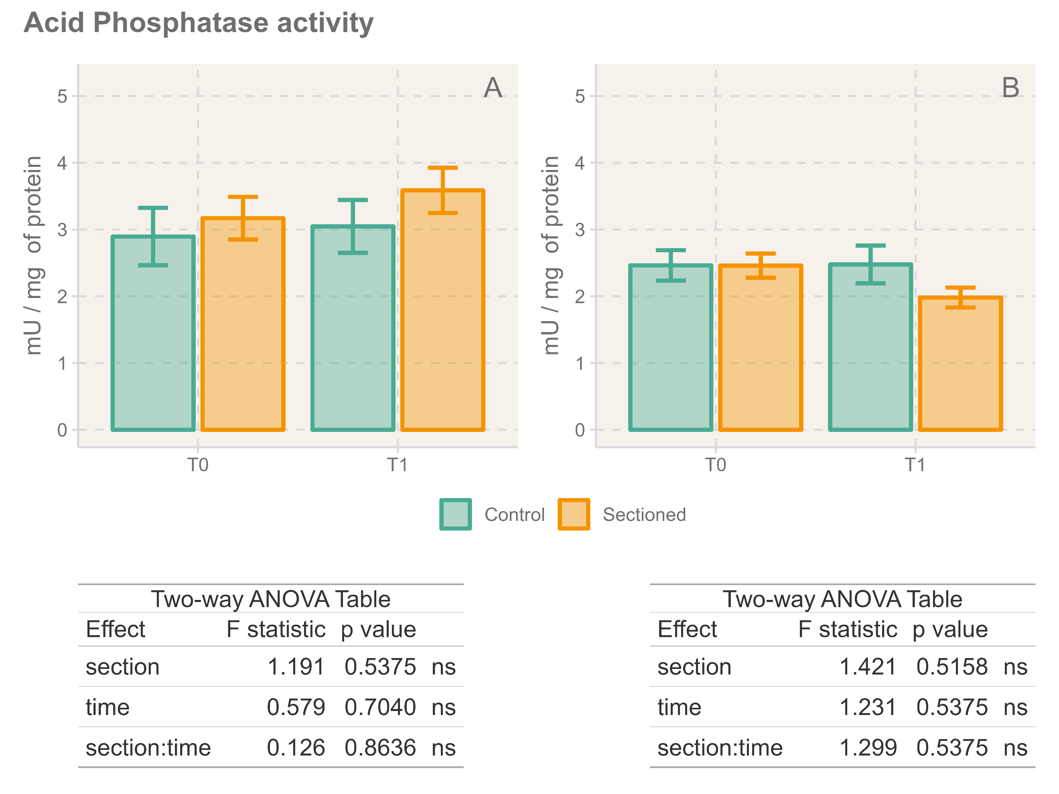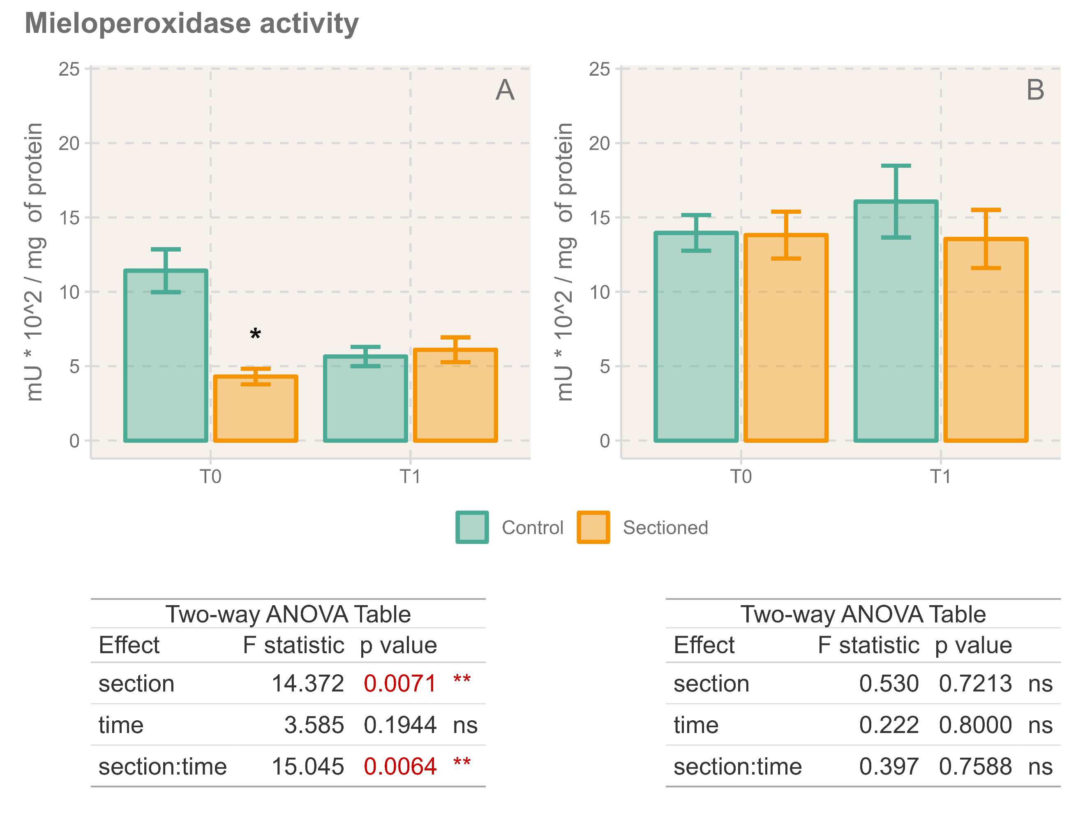

4. Discussion

- Induction of asexual reproduction was successfully performed with low mortality.

- Impact on the oxidative state. Severe? Reversible? Use guidelines from that article about oxidative status analysis. Catalase and GR were affected; SOD has p = 0.055 on tentacles for the effect of section. GPx has p = 0.057 for the effect of time.

- **Less MDA in handled individuals** might be related to regeneration processes since they feature younger tissue? Investigate regeneration

- Inflammatory or immune activation in response to handling and regeneration process. Stabilize with time. Leads to antioxidant activation. Column is the most affected body region since it is where the wound was located.

- We detected myeloperoxidase activity in cnidarians

5. Conclusions

6. References

Aebi, H. (1984). [13] Camansatalase in vitro. *Methods in Enzymology*, *105*(C), 121–126. https://doi.org/10.1016/S0076-6879(84)05016-3

Bradford, M. (1976). A Rapid and Sensitive Method for the Quantitation of Microgram Quantities of Protein Utilizing the Principle of Protein-Dye Binding. *Analytical Biochemistry*, *72*(1–2). https://doi.org/10.1006/abio.1976.9999

Buege, J. A., & Aust, S. D. (1978). Microsomal Lipid Peroxidation. *Methods in Enzymology*, *52*(C). https://doi.org/10.1016/S0076-6879(78)52032-6

Carlberg, I., & Mannervik, B. (1975). Purification and characterization of the flavoenzyme glutathione reductase from rat liver. *Journal of Biological Chemistry*, *250*(14), 5475–5480. https://doi.org/10.1016/S0021-9258(19)41206-4

Coll, A., Rufino-Palomares, E. E., Ramos-Barbero, M., Ortiz-Maldonado, A. E., Pantoja-Echevarría, L. M., González-Ordóñez, I., Pérez-Jiménez, A., & Trenzado, C. E. (2025). Effects of environmental factors on the oxidative status of Anemonia viridis in aquaculture systems. *Comparative Biochemistry and Physiology Part B: Biochemistry and Molecular Biology*, *275*, 111042. https://doi.org/10.1016/J.CBPB.2024.111042

Easy, R. H., & Ross, N. W. (2010). Changes in Atlantic salmon Salmo salar mucus components following short- and long-term handling stress. *Journal of Fish Biology*, *77*(7). https://doi.org/10.1111/j.1095-8649.2010.02796.x

Erel, O. (2004). A novel automated direct measurement method for total antioxidant capacity using a new generation, more stable ABTS radical cation. *Clinical Biochemistry*, *37*(4), 277–285. https://doi.org/10.1016/J.CLINBIOCHEM.2003.11.015

Flohé, L., & Günzler, W. A. (1984). [12] Assays of glutathione peroxidase. *Methods in Enzymology*, *105*(C), 114–120. https://doi.org/10.1016/S0076-6879(84)05015-1

Frasco, M. F., & Guilhermino, L. (2002). Effects of dimethoate and beta-naphthoflavone on selected biomarkers of Poecilia reticulata. *Fish Physiology and Biochemistry 2002 26:2*, *26*(2), 149–156. https://doi.org/10.1023/A:1025457831923

Huang, Z. H., Ma, A. J., & Wang, X. A. (2011). The immune response of turbot, Scophthalmus maximus (L.), skin to high water temperature. *Journal of Fish Diseases*, *34*(8). https://doi.org/10.1111/j.1365-2761.2011.01275.x

Lemaire, P., Sturve, J., Förlin, L., & Livingstone, D. R. (1996). Studies on aromatic hydrocarbon quinone metabolism and DT-Diaphorase function in liver of fish species. *Marine Environmental Research*, *42*(1–4), 317–321. https://doi.org/10.1016/0141-1136(95)00042-9

Löhr, G. W., & Waller, H. D. (1965). Glucose-6-phosphate Dehydrogenase: (Zwischenferment). *Methods of Enzymatic Analysis*, 744–751. https://doi.org/10.1016/B978-0-12-395630-9.50135-3

McCord, J. M., & Fridovich, I. (1969). Superoxide Dismutase: AN ENZYMIC FUNCTION FOR ERYTHROCUPREIN (HEMOCUPREIN). *Journal of Biological Chemistry*, *244*(22), 6049–6055. https://doi.org/10.1016/S0021-9258(18)63504-5

Mohanty, B. R., & Sahoo, P. K. (2010). Immune responses and expression profiles of some immune-related genes in Indian major carp, Labeo rohita to Edwardsiella tarda infection. *Fish and Shellfish Immunology*, *28*(4). https://doi.org/10.1016/j.fsi.2009.12.025

Swain, P., Dash, S., Sahoo, P. K., Routray, P., Sahoo, S. K., Gupta, S. D., Meher, P. K., & Sarangi, N. (2007). Non-specific immune parameters of brood Indian major carp Labeo rohita and their seasonal variations. *Fish and Shellfish Immunology*, *22*(1). https://doi.org/10.1016/j.fsi.2006.03.010