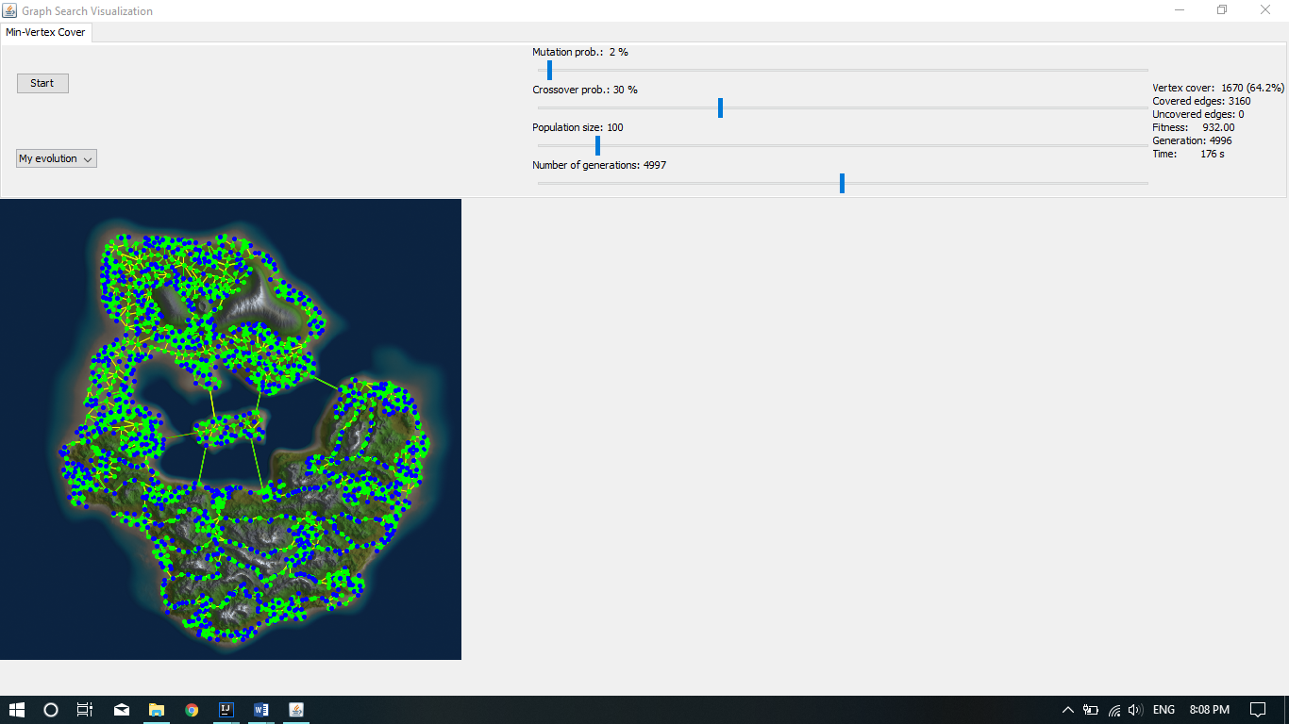

The genome is created with an array of Booleans to determine when a node is connected or not to another node, if is connected is true, if not is false. When every node is determined if is or not connected we count the nodes that are true in the array and the total nodes to calculate the vertex cover percentage