Don Matrelli’s Legacy

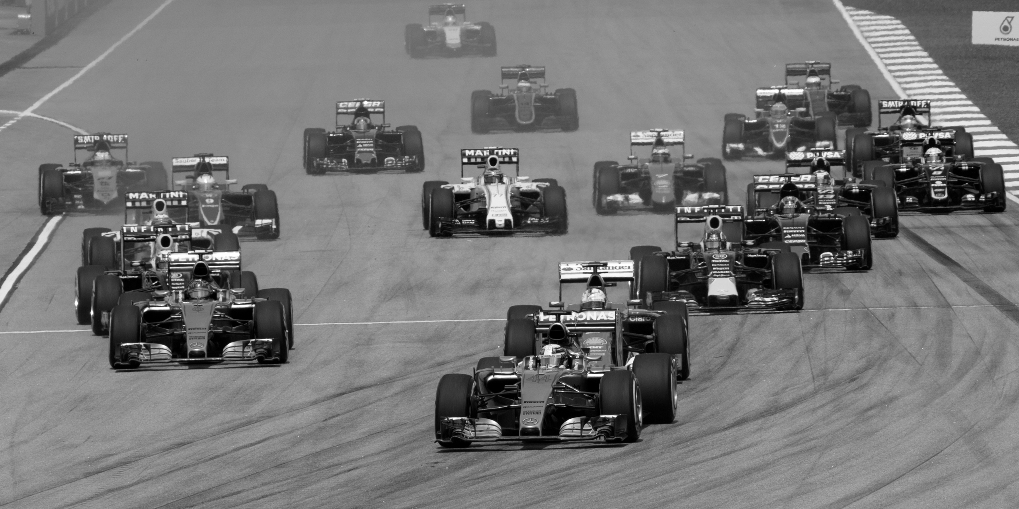

a mod for Grand Prix Circuit

by Alberto Marnetto



The Story So Far

Many years have passed since the golden times of the Circuit, when Don Matrelli and Bruno Gourdo battled for victories and glory while the backmarkers tried to stay clear from the dangers posed by Tse Sakamoto. New generations of drivers have appeared, trying to emulate the glory and the glamour of their predecessors.

The next racing season is about to start, and after your impressive achievements in the lower series you have been given the possibility to join the top car racing division and write your name in the history books of motorsport. Do you have what it takes to claim Don Matrelli’s legacy?

Introduction

Welcome to Don Matrelli’s Legacy! This expansion takes place in the same universe of Grand Prix Circuit, but in a later year: the track calendar has seen changes, new teams have entered the fray and a batch of fresh competitors has replaced the old guard. The world has also evolved, but in this timeline, for some reason, the cars still have a manual transmission.

Don Matrelli’s Legacy keeps the gameplay of the original game, but it features new content to offer you a novel challenge.

First of all, this expansion contains three new tracks, featuring the best from the past, the present and the future of motor racing.

Then come the new racecars. Some of them are better than others, allowing you to adjust the level of challenge. The three cars also require noticeably different driving styles to express their full potential. As always, any resemblance to really existing teams is purely incidental...

Finally, you will face brand new opponents. This mod is aimed to experienced Grand Prix Circuit players, so the difficulty level is higher. Especially at the higher difficulty levels, top drivers will sometimes be impossible to reach. Accept that as a fact of life: the Circuit is unfair, and so is this game.

System Requirements

Don Matrelli’s Legacy can run on most systems able to start Grand Prix Circuit. Due to the improved graphics, only EGA video cards are supported.

Installation and Usage

To play Don Matrelli’s Legacy you need a copy of the base game Grand Prix Circuit. Copy all the files of the mod into the directory containing the original GPEGA.EXE. None of the original files will be overwritten.

To start playing the mod, run

GPEGA2

Optionally, instead of playing the full expansion you can selectively activate the new content by appending the following parameters:

/C enables the new cars
/T enables the new tracks
/O enables the new opponents

For example, run GPEGA2 /T /O to play with the new tracks and opponents, but using the original cars. An interesting challenge in this variant is to drive a McLaren on the Möbius circuit and try to send it over 216 mph.

Known Bugs

During testing, some bugs were found that could not be eliminated:

1. Track corruption: after playing many races in a row, glitches may appear, leading to the car’s position suddently jerking, or to a program crash.
2. Soft lock: if the car’s health is depleted after a minor collision, you might be left stranded on the track: the car will be unable to run but you won’t be towed to the pit. Pressing Esc will return to the main screen, but this will destroy all your season progress.

To mitigate these issues, we recommend to save the game after each race when playing in the Championship. Moreover, we suggest to reboot the program at mid-season (between Baku and Silverstone).

The Cars

Unfortunately, the three historical teams of the Circuit will not offer you a seat since they have decided to confirm their current drivers for the incoming season. But fear not, for other constructors have noticed your talent and would be glad to see you joining their ranks!

Rivella

“They used to call us a beginner's team. They stopped doing that when our ‘beginners’ started to beat their top drivers”.
Guido Sterzer, team principal of Rivella Racing
The Rivella Racing Team is one of the youngest entries in the Circus, but it has quickly risen to the status of title contender. The team, carrying the brand of Switzerland’s favourite alcohol-free beverage, joined the division three years ago among general skepticism (“a producer of soft drinks from a small Alpine nation is now fielding racecars? Such things can only happen in a video game!”) but soon astonished the competition with its performance.

The strongest point of their blue-and-red car, whose designer’s identity is kept secret, is its aerodynamics. Indeed the Rivella can generate an impressive amount of downforce, giving it the best cornering capabilities in the field without creating too much drag on the straights.

The engine has been a liability in the past seasons, but this time Rivella seems to have finally found a good powertrain. The V8 Cosworth is not particularly impressive in terms of raw peak power, but it is a very smooth engine, able to generate high torque at any rotational rate and compensate with traction and acceleration what it lacks in top speed.

If you join Rivella, be careful. The car, with its great handling and quick speed recovery, might be forgiving, but the management is not. The leadership knows that they have championship-worthy material this year and expects you to bring home the trophy. Any mistake you commit will remind them of the other dozen of candidates who would do anything to be in your seat. Give your best and exploit the car’s strong points to the fullest!

Anglo-German

“Focused, precise, always one step ahead, with an eye for detail – and an obsession for power!”
Sir Hugo Wulf, owner of Anglo-German, speaking about his dream driver
The Anglo-German Motorsport Alliance is a consortium of some of the oldest carmakers from the two founding nations. The team entered the Circuit six years ago, bringing top talent and capital, aiming to harvest victories. The task was accomplished with ruthless efficiency: their cars (“Green and gray, but more gray than green and, most importantly, dark”) have won the last four Championships, and most of the individual races.

This year, however, rumors say that the development did not go as planned. The new engine, dedicated to Charlemagne, aimed to beat all records in terms of torque and power. It hit the performance target, but at high cost: the resulting powertrain is big and heavy, requiring to compromise the car’s aerodynamics just to accommodate it and adding extra stress on the tyres. Worse, optimal power generation is only reached at very high rotational speeds, with a noticeable lack of torque everywhere below 10,000 rpm. The car might be great at Monza and almost unbeatable on the Möbius strip, but the tests on more technical circuits have shown all the design shortcomings.

To be successful with this year’s Anglo-German you will need to be a master of all things driving. Heavy foot on the accelerator will be required, as well as aggressive downshifting to always keep the engine in the “lively” zone. All this will have to be combined with very sensitive hands on the wheel: smooth steering is needed to keep the car on track despite its low grip.

An unexpected benefit of joining Anglo-German is its human side. Its leaders like to play the role of big villains, but they are actually quite supportive and protective towards their pilots. Also, they are technically minded people who try to cut the corporate nonsense to a minimum. All of them are aware that this year’s car is not as good as the past ones and will be grateful if someone manages nonetheless to bring it to victory. Will you be their man?

Gastón Martini

“We wrote a parody piece about them. L’Equipe wrote a serious piece about them. They turned out to be the same article”.
Thierry Santoro, journalist at the satyrical newspaper Le Canard enchainé
The Gastón Martini Formula, toy team of the eponymous Franco-Italian businessman, is the demonstration that low entry barriers are not always a good thing. It is unclear whence Mr. Martini got the capital to create the team. Also unclear is the way he managed to procure all the components needed to build what, at least superficially, resembles a racecar. The biggest mistery, of course, is how vehicle and team got a licence to compete in the self-appointed “pinnacle of motorsport”.

Be it as it may, the first disastrous season did not deter the patron to sign up for a new year of racing. Their only pilot has hastily left – same as his three predecessors – so the team is looking for you as a replacement. Due to the low number of candidates, the Gastón Martini management is even open to lower their demands about sponsor money, even if this will further affect the vehicle maintenance and the regularity of the paychecks for the staff.

Just as last year, the Gastón Martini is an awful car, with no saving grace except maybe its cute green-and-white livery. The chassis is the same of the past season; the powertrain is even worse since the old engine failed beyond repair and its replacement seems taken from a lower Formula and tuned above its operational limits.

Approach the Gastón Martini with Zen spirit. You cannot win – you will find it hard even to avoid finishing last – and most likely the engine will blow just when you are about to bring home your first point. On the other hand, if you manage to beat just a couple of adversaries, or maybe even end the season with a handful of points, you will be rightfully regarded as a master and get tons of offers from the top teams. Be patient, overcome the pain, and never stop fighting.

Warning: the starting tyres on your Gastón Martini are the only set of slicks the team managed to buy. If you pit for a replacement, the mechanics will be forced to swap them with rain tyres. You might not like the consequences...

The Tracks

The calendar of the Circuit changes very slowly, but it does change. Since Don Matrelli’s era three circuits have disappeared: the Hockenheimring’s absence is only temporary, as the track is undergoing a multi-year restructuring project, but the Monaco G.P. has been dropped forever after the famous scandal involving the second cousin of the Prince and the aunt of the then-president of the Automobile Federation. As for Detroit, we all agree it should never have been included in a top racing championship.

Here are the venues making a new appearance.

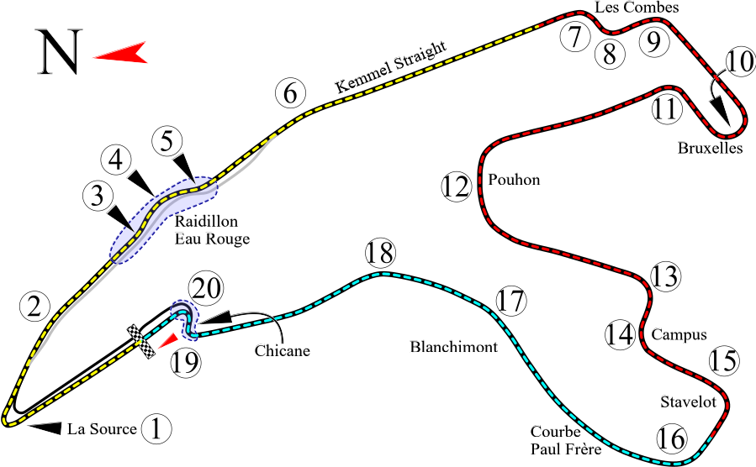
Circuit de Spa-Francorchamps

This legendary track needs no introduction. It has been readded by popular demand for the joy of drivers and fans alike. Driving on it is a honour, but also a demanding task: it’s the longest of the calendar, and its mix of high-speed curves, long straights and technical sections makes it very difficult to master. This year the race takes place at the beginning of the autumn, with increased risk of bad weather.

With this season’s regulations, it seems some sections of Spa demand lower speeds than usual: the test drivers of Anglo-German were disappointed by the inability of their car to negotiate the Eau Rouge at full throttle, and the new version of the final chicane required them to shift down to the first gear. Whatever car you drive, it’s up to you to find a way to optimize the cornering and unleash the engine on the straight sections.

Baku City Circuit (Bakı Şəhər Halqası)

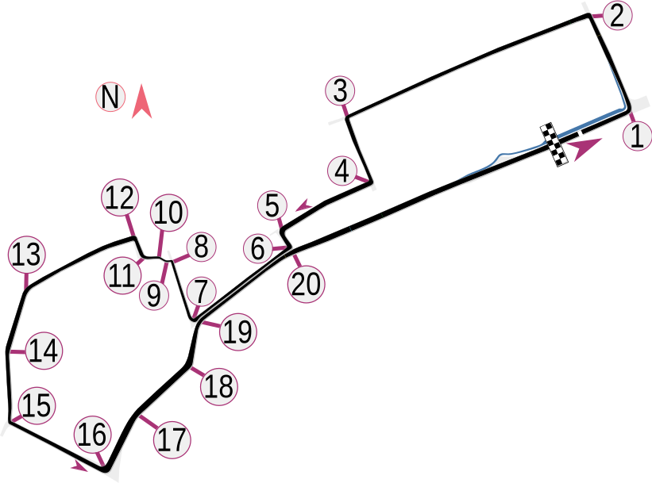

The roads of Baku will set the scene for the newly-minted Azerbaijan Grand Prix. The transcaucasian nation has enjoyed strong economic and technological growth in the past years, and hosting a premier motor racing event is one of the many initiatives of its leadership to increase its global prestige.

The circuit offers fantastic views of the sea and of the city. From the beautiful Baku Fortress built in year 1138 to futuristic glass skyscrapers like the Flame Towers, a lap around the track is like a miniature trip in the city history. But don’t let that distract you: same as in every street circuit, 90-degree corners are everywhere, and before getting to the long straight leading to the finish line you will have to negotiate the labyrinth of sharp curves surrounding the Old Town. Memorize every critical point and hope that the tarmac does not eat up your tyres, as it happened to Mr. Hermann some years ago.

Möbius Space Dragstrip (Möbius Raumdragsterrennstrecke)

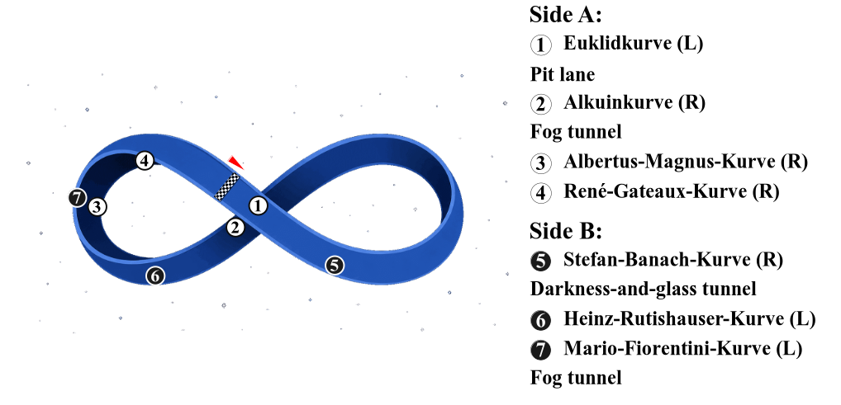
A circuit that is literally out of this world. Möbius is a track built in space, near one of the Earth’s Lagrangian points. It consists in a strip of asphalt that, due to physical effects, appears straight but is actually knotted on itself: about 20 seconds after leaving the finish line, the driver returns to the starting point, except he finds itself on the opposite side of the asphalt! It takes other 20 seconds to run through the strip a second time and finally complete the lap. The curves on the circuit are named in honor of European mathematicians of all historical eras.

The Möbius track was built in a brief era of optimism and international collaboration that preceded the return to the usual global chaos: the project enjoyed the scientific and financial contributions of 33 nations under the leadership of Germany, and was even competed on time! The original design foresaw a pure dragster track, and indeed the road was built perfectly straight. A few days after the inauguration, however, a gravitational collapse warped the structure, bending the circuit in multiple points. This accident was seen as bad omen for the things to come, but at least it made Möbius a more interesting racing place and not only a test track to measure the cars’ top speed.

Banners and yardage signs around the circuit have a purely decorative purpose. To be taken seriously are instead the tunnels. The so-called “fog tunnels” make it difficult to see track borders and opponents, and the car will crash if it strays too far from the centreline. The “darkness-and-glass” gallery is less treacherous but still to be navigated with attention.

The Opponents

You have certainly heard about these gentlemen already, so we will be brief.

Franz Hermann (#1, Netherlands): the best driver of his generation. If you manage to challenge him, let alone beat him, pat yourself on the back!

Kim Leonardo (#12, Italy): a rising star. He has still some rough edges, but he is developing at impressive speed. Try to keep pace with him.

Carl Saint-Mleux (#16, Monaco): beau et maudit. His immense talent has somehow always been hampered by some stroke of bad luck.

Aussie Priast (#81, Australia): fast and cold-blooded. He can easily switch between daring overtakes and tactical management of the situation.

Lord Blimey (#63, UK): very skilled, but tends to complain a lot. He was a very promising talent, but somehow he never managed to fully bloom.

Niño Matador (#55, Spain): son of a famous rally champion. Not as amazing as the top drivers, but very competent and with great tactical skills.

Sir Arbalestier (#44, UK): he dominated the Circuit for many years, setting an amazing number of records. Nowadays he is slightly less hungry.

Asnee Smylin (#23, Thailand): great team player and solid driver. He never managed to make it to the top, but he always brings home some points.

Goro Inamoto (#22, Japan): not a top driver, but he attracts many sponsors. Also, the Circuit needs at least one Japanese pilot to keep its traditions.

Hints

First and foremost, we repeat the recommendation to save after every race while competing in the Championship Circuit. But, before you select that option, it’s better to begin with the practice mode and single races.

Start by familiarizing with the new tracks and machinery. Get a feel for how the cars behave, learn their strong and weak points. Even just trying to determine the top speed of each car will reveal important information. You will also need to figure out a good launch procedure, allowing you to start fast without blowing your engine.

You might want to increase the number of laps in a race. We suggest at least 5: this will force you to manage vehicle damage more carefully, but also give you more time to overtake the opponents. In many tracks you will start from the middle of the grid, so you will need enough time to gain positions.

Note that Don Matrelli’s Legacy is harder than the base game. Even if you are used to sweep the floor against Travis Daye and Vito Giuffrè, do not expect to just select the “pro” difficulty level and win every race: the new opponents are much faster, and some of them drive better cars than yours. To conquer the championship, you will need patience, skill and luck. If the experience is too frustrating, remember this is a game: set the difficulty level that makes the game most enjoyable for you. You can also race against the classic (weaker) opponents if you prefer.

Given the stronger competition, you are likely to get overtaken often. Be aware that the opponents often hit your car while passing, damaging your health. If you feel you are about to be overtaken, try to stay near the road side: this reduces the risk of collisions.

Be ready to accept the risk of DNFs: the scoring system favours the brave. For example, a 50-50 chance of ending in second place or crashing is better than a 100% chance of ending in fifth place. Hence, make pit stops only if it’s really worth it. Note, also, that for one of the cars a pit stop basically means race over.

At the highest difficulty level it is impossible to win all the races: some opponents will set times your vehicle cannot reach. Focus on winning the tracks that best suit your car and minimize the losses on the others. You will also need a pinch of luck: hope for a hard-fought season where the opponents steal points from each other.

Acknowledgments

Don Matrelli’s Legacy was made possible by the availability of various open-source tools. In particular, we wish to thank the following people:

- Daniel Stien (“dstien”), “llm” and the other contributors to the Stressed resource editor
https://github.com/dstien/stressed/

- “albertus82” and the other contributors to the cyclesmod tool
https://programitalia.wordpress.com/2015/02/09/cyclesmod/

- Mark Tyler and the other developers of mtPaint
https://mtpaint.sourceforge.net/

- Fabrice Bellard and the other developers of FFmpeg
https://ffmpeg.org

- The developers of radare2
https://www.radare.org

- The developers of opencode
https://opencode.ai/

Image credits

The graphics are partially original creations by Alberto Marnetto, partially adaptations of the sprites of the original game, partially copies or derived works of the images created by the authors listed below. We wish to express our gratitude to all who have published pictures under a free license. This mod would have been impossible without their work.

Track backgrounds and maps are released under the CC BY-SA 4.0 license. You can extract them from the mod by using the tool Stressed by Daniel Stien. Since the images contain copyrighted work of other authors, if you wish to reuse them, please additionally follow the license terms shown in the “Copyright information” section. In case of doubt, feel free to write at alberto.m.dev@gmail.com .

The other in-game graphics are copyright of Accolade or its successors.

Copyright information

Source code

Author: Alberto Marnetto
License: MIT
URL:
https://github.com/AlbertoMarnetto/don-matrelli-s-legacy

Pictures

Manual cover image
Author: Wikicommons user “Morio”
License: CC BY-SA 4.0
Original URL:
https://commons.wikimedia.org/wiki/File:2015_Malaysian_GP_opening_lap.jpg

Baku track map
Author: Wikicommons user “HumanBodyPiloter5”
License: CC0 1.0
Original URL:
https://commons.wikimedia.org/wiki/File:Baku_Formula_One_circuit_map.svg

Baku background (1)
Author: Liilia Moroz
License: CC BY-SA 4.0
Original URL:
https://commons.wikimedia.org/wiki/File:Panorama_of_Baku_from_the_sea.jpg

Baku background (2)
Author: Press Service of the President of the Republic of Azerbaijan
License: CC BY 4.0
Original URL:
https://commons.wikimedia.org/wiki/File:Ilham_Aliyev_watched_the_opening_ceremony_of_the_2018_Formula-1_Azerbaijan_Grand_Prix_and_final_race_35.jpg

Baku background (3)
Author: Diego Delso (delso.photo)
License: CC BY-SA 4.0
Original URL:
https://commons.wikimedia.org/wiki/File:Baku,_Azerbaiy%C3%A1n,_2016-09-28,_DD_29.jpg

Baku background (4)
Author: Diego Delso (delso.photo)
License: CC BY-SA 4.0
Original URL:
https://commons.wikimedia.org/wiki/File:Vista_de_Baku,_Azerbaiy%C3%A1n,_2016-09-26,_DD_138.jpg

Baku background (5)
Author: www.dreamlight.az – Derivative work: Wikicommons user “Jjtkk”
License: CC BY-SA 3.0
Original URL:
https://commons.wikimedia.org/wiki/File:Baku_banner.jpg

Baku background (6)
Author: Wikicommons user “MrArifnajafov”
License: CC BY-SA 3.0
Original URL:
https://commons.wikimedia.org/wiki/File:Panoramabild_Baku_Filarmonia_Park.JPG

Baku background (7)
Author: Alberto Marnetto
License: CC BY-SA 4.0

Spa-Francorchamps track map
Author: Will Pittenger
License: CC BY-SA 3.0
Original URL:
https://en.wikipedia.org/wiki/File:Spa-Francorchamps_of_Belgium.svg

Spa-Francorchamps background (1)
Author: United Autosports
License: CC BY-SA 2.0
Original URLs:
https://commons.wikimedia.org/wiki/File:2022_4_Hours_of_Spa-Francorchamps_-_Circuit.jpg
https://www.flickr.com/photos/unitedautosports/52387982694/

Spa-Francorchamps background (2)
Author: Jean-Pol Grandmont
License: CC BY 3.0
Original URL:
https://commons.wikimedia.org/wiki/File:Baileux_050608_(2).jpg

Spa-Francorchamps background (3)
Author: Wikicommons user “FrDr”
License: CC BY-SA 4.0
Original URL:
https://commons.wikimedia.org/wiki/File:Circuit_de_Spa-Francorchamps_03.jpg

Spa-Francorchamps background (4)
Author: Wikicommons user “FrDr”
License: CC BY-SA 4.0
Original URL:
https://commons.wikimedia.org/wiki/File:Circuit_de_Spa-Francorchamps_14.jpg

Spa-Francorchamps background (5)
Author: Alberto Marnetto
License: CC BY-SA 4.0

Möbius background
Author: Alberto Marnetto
License: CC BY-SA 4.0

Licence texts

CC0 1.0: https://creativecommons.org/publicdomain/zero/1.0/deed.en
CC BY 3.0 : https://creativecommons.org/licenses/by/3.0/deed.en
CC BY-SA 3.0 : https://creativecommons.org/licenses/by-sa/2.0/deed.en
CC BY-SA 3.0 : https://creativecommons.org/licenses/by-sa/3.0/deed.en
CC BY-SA 4.0 : https://creativecommons.org/licenses/by-sa/4.0/deed.en
MIT: https://mit-license.org/

