-- Insert queries
USE `musical_system`;

INSERT INTO `compact_disks` VALUES('X01','BOY',1980);
INSERT INTO `compact_disks` VALUES('X02','TARZAN',2006);

INSERT INTO `pieces_of_music` VALUES(01,'I will follow');
INSERT INTO `pieces_of_music` VALUES(02,'Twilight');
INSERT INTO `pieces_of_music` VALUES(03,'An cat Bubh');
INSERT INTO `pieces_of_music` VALUES(04,'into the heart');
INSERT INTO `pieces_of_music` VALUES(05,'Out of control');
INSERT INTO `pieces_of_music` VALUES(06,'Youll be in my heart');
INSERT INTO `pieces_of_music` VALUES(07,'Who better than me');

INSERT INTO `persons` VALUES('PER_01','LAWRENCE MULLEN','BRITISH');
INSERT INTO `persons` VALUES('PER_02','DAVID HOWELL','BRITISH');
INSERT INTO `persons` VALUES('PER_03','ADAM CLAYTON','BRITISH');
INSERT INTO `persons` VALUES('PER_04','PAUL DAVIDSON','BRITISH');
INSERT INTO `persons` VALUES('PER_05','PHIL COLLINS','AMERICAN');

INSERT INTO `authorships` VALUES('AUT_01', 'COMPOSER');
INSERT INTO `authorships` VALUES('AUT_02', 'WRITER');
INSERT INTO `authorships` VALUES('AUT_03', 'ARRENGER');

INSERT INTO `instruments` VALUES('INST_01','GUITAR');
INSERT INTO `instruments` VALUES('INST_02','BASS');
INSERT INTO `instruments` VALUES('INST_03','KEYBOARD');

INSERT INTO `recorded_disks` VALUES('X01',01,01);
INSERT INTO `recorded_disks` VALUES('X01',02,02);
INSERT INTO `recorded_disks` VALUES('X01',03,03);
INSERT INTO `recorded_disks` VALUES('X01',04,04);
INSERT INTO `recorded_disks` VALUES('X01',05,05);
INSERT INTO `recorded_disks` VALUES('X02',01,06);
INSERT INTO `recorded_disks` VALUES('X02',02,07);

INSERT INTO `plays` VALUES('PER_02',01,'INST_01');
INSERT INTO `plays` VALUES('PER_02',02,'INST_02');
INSERT INTO `plays` VALUES('PER_03',03,'INST_03');
INSERT INTO `plays` VALUES('PER_04',04,'INST_01');
INSERT INTO `plays` VALUES('PER_05',05,'INST_01');

INSERT INTO `author_of` VALUES (01,'PER_01','AUT_01');
INSERT INTO `author_of` VALUES (02,'PER_01','AUT_01');
INSERT INTO `author_of` VALUES (03,'PER_01','AUT_02');
INSERT INTO `author_of` VALUES (04,'PER_03','AUT_03');
INSERT INTO `author_of` VALUES (05,'PER_02','AUT_02');

-- Query 1
SELECT cd.title, rd.disk_id, cd.year, pm.title, rd.no_track
FROM recorded_disks as rd
LEFT JOIN compact_disks AS cd
ON cd.disk_id = rd.disk_id
LEFT JOIN pieces_of_music AS pm
on rd.track_id = pm.track_id
WHERE rd.disk_id = 'X01';

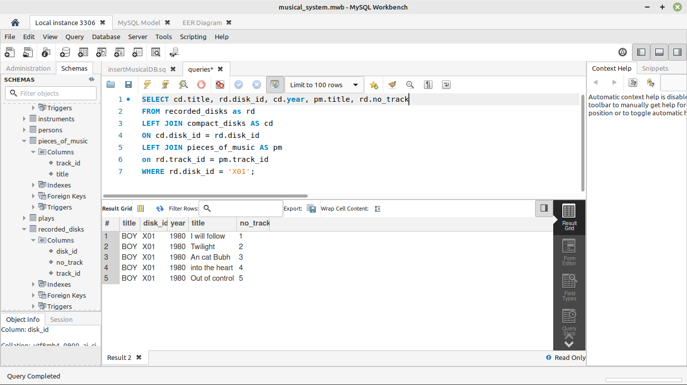

--Query 2
SELECT pm.title AS 'Song title', ps.name AS 'Name', ins.name AS 'Instrument/authorship'
FROM plays as p
LEFT JOIN pieces_of_music as pm
ON p.track_id = pm.track_id
LEFT JOIN persons as ps
ON p.person_id = ps.person_id
LEFT JOIN instruments AS ins
ON p.instrument_id = ins.instrument_id
WHERE pm.title = 'I will follow'
UNION
SELECT pm.title AS 'Song title', ps.name AS 'Name', auts.type AS 'Instrument/authorship'
FROM author_of as ao
LEFT JOIN pieces_of_music as pm
ON ao.track_id = pm.track_id
LEFT JOIN persons as ps
ON ao.person_id = ps.person_id
LEFT JOIN authorships AS auts
ON ao.authorship_id = auts.authorship_id
WHERE pm.title = 'I will follow';

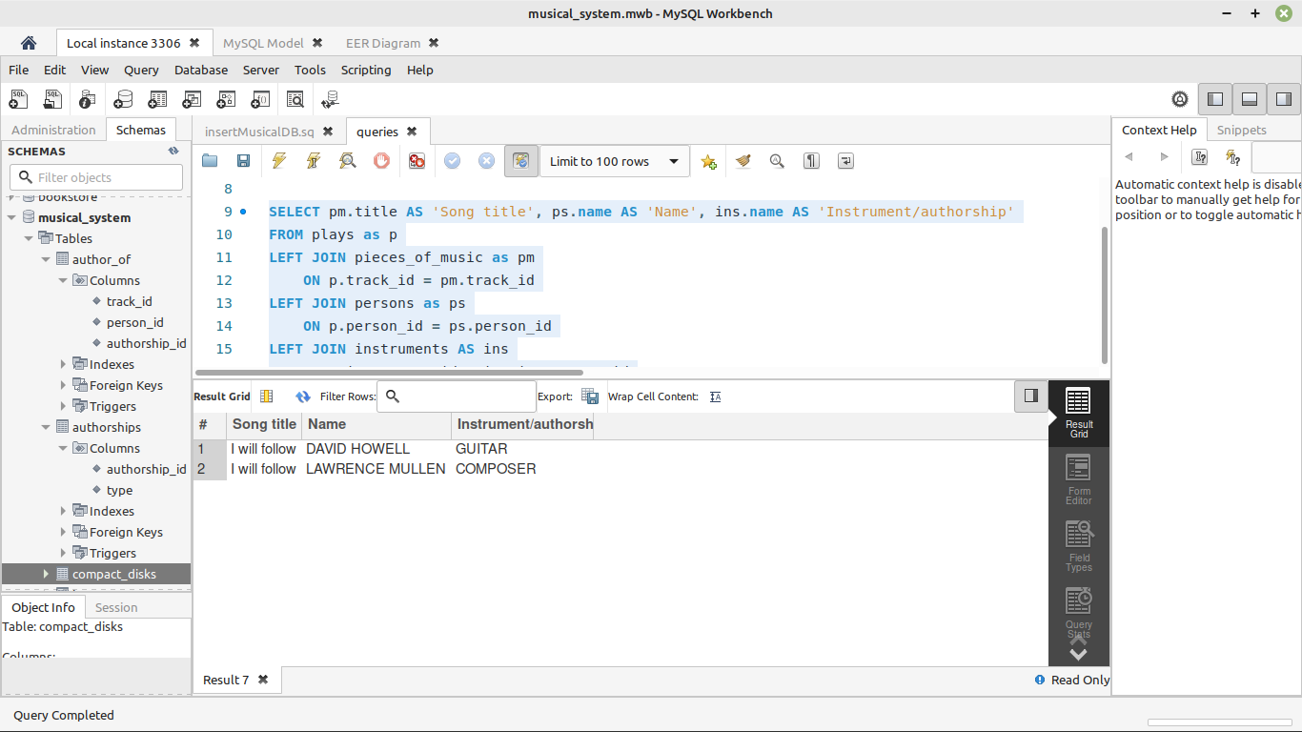

-- Query 3
SELECT ps.name, ins.name
FROM instruments as ins
LEFT JOIN plays AS p
ON ins.instrument_id = p.instrument_id
LEFT JOIN persons AS ps
ON p.person_id = ps.person_id
WHERE ins.name = 'GUITAR';

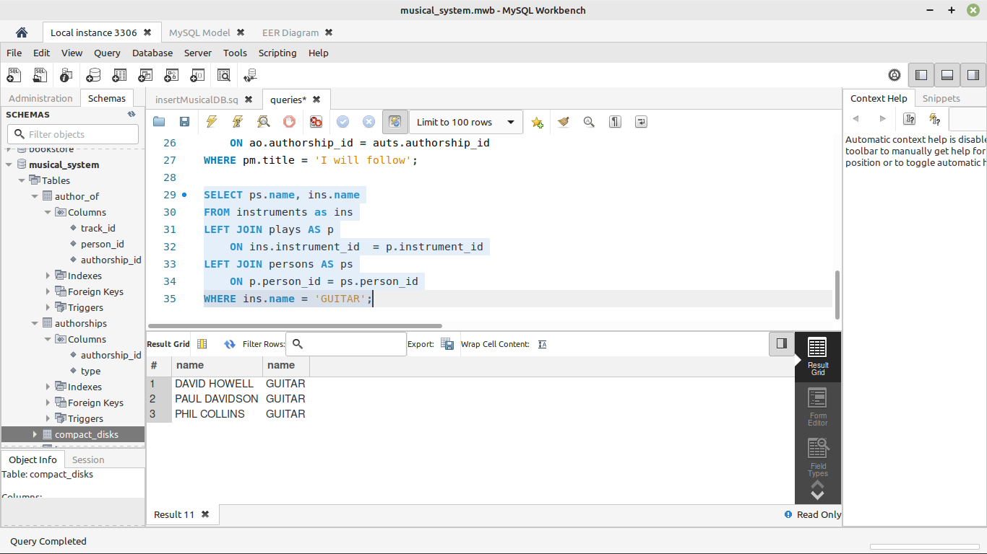

--Query 4
SELECT pm.title AS 'Song title',
cd.year,
rd.no_track,
ps.name AS 'Name',
ps.nationality,
ins.name AS 'Instrument/authorship'
FROM pieces_of_music as pm
LEFT JOIN recorded_disks as rd
ON pm.track_id = rd.track_id
LEFT JOIN compact_disks as cd
ON rd.disk_id = cd.disk_id
LEFT JOIN plays as p
ON p.track_id = pm.track_id
LEFT JOIN persons as ps
ON p.person_id = ps.person_id
LEFT JOIN instruments AS ins
ON p.instrument_id = ins.instrument_id
UNION
SELECT pm.title AS 'Song title',
cd.year,
rd.no_track,
ps.name AS 'Name',
ps.nationality,
auts.type AS 'Instrument/authorship'
FROM pieces_of_music as pm
LEFT JOIN recorded_disks as rd
ON pm.track_id = rd.track_id
LEFT JOIN compact_disks as cd
ON rd.disk_id = cd.disk_id
LEFT JOIN author_of as ao
ON ao.track_id = pm.track_id
LEFT JOIN persons as ps
ON ao.person_id = ps.person_id
LEFT JOIN authorships AS auts
ON ao.authorship_id = auts.authorship_id;

