Navigating the parse tree
https://spacy.io/usage/linguistic-features
https://spacy.io/api/annotation#pos-tagging

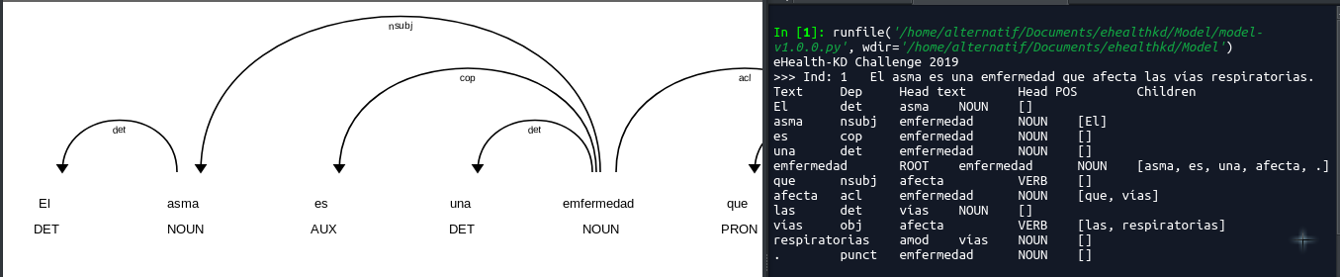

Se encontro que spacy puede trabajar con diferentes etiquetas de a cuerdo a Universal Dependency Relations
http://universaldependencies.org/u/dep/#universal-dependency-relations
https://universaldependencies.org/u/dep/all.html

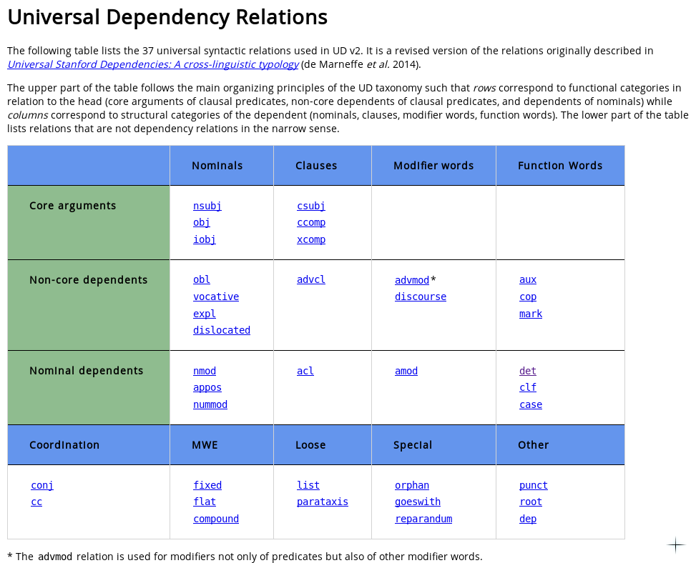

referencia: https://glossary.sil.org/term

Core Argument
Definition:
A core argument of a verb is a subject, direct object, or indirect object.
Examples:
(English)
- In John gave a donation to the Salvation Army, the core arguments are John, a donation, and Salvation Army.

Como propuesta es
Ignorar las palabras con las etiquetas tipo
#Part-of-speech tagging
"DET":"determiner",
"ADP":"adposition",
"PUNCT":"punctuation",
"SYM":"symbol",
"X":"other",
#Syntactic Dependency Parsing
"case":"case marking",
"det":"determiner",

Concept: a general category that indicates the key phrase is a relevant term, concept, idea, in the knowledge domain of the sentence.
Para los conceptos se necesita el TAG NOUN y Core arguments
Nota:Utilizar la info entre la palabra padre-hijo

Action: a concept that indicates a process or modification of other concepts. It can be indicated by a verb or verbal construction, such as “afecta* (affects), but also by nouns, such as “exposición” (exposition), where it denotes the act of being exposed to the Sun, and “daños” (damages), where it denotes the act of damaging the skin. It can also be used to indicate non-verbal functional relations, such as “padre” (parent), etc.
Para las acciones se ocupa el TAG VERB, NOUN y Nominal dependents
*advmod como indica la sugerencia de la tabla

Predicate: used to represent a function or filter of another set of elements, which has a semantic label in the text, such as “mayores” (older), and is applied to a concept, such as “personas” (people) with some additional arguments such as “60 años” (60 years).
Para predicado el TAG ADJ y Nominal dependents
Nota: menciona que se aplica a un concepto, revisar que la palabra parent es concept y un argumento al que hace referencia (hijos) este argumento es Nominal dependence

Reference: A textual element that refers to a concept –of the same sentence or of different one–, which can be indicated by textual clues such as “esta”, “aquel”, etc.
Para las referencias se ocupa el TAG AUX y Non-core dependents

Se sigue analizando la estructura de la tabla pues las columnas varian para conceptos y acciones
Falta revisar bien los AUX por que en el ejemplo “esta”, “aquel” son más especificos, podria ser revisar tipo/clasificacion de AUX (ver si esto se puede hacer en spacy)

