Alberto Franco
11/20/2025
DOORDASH Project Analysis Of Operation Deliveries
https://github.com/Albertofranco123/doordash-project-delivery-operations--analysis/blob/main/README.md


DoorDash Delivery Analysis – SOAR Report

1. S — Specify (Problem Definition)
The objective of this analysis is to evaluate delivery performance across multiple restaurants in a DoorDash-style delivery environment. The central questions addressed in this project are:
- Why do delivery orders arrive late?
- What factors in the dataset contribute to delivery delays?
- Which types of orders are more likely to experience delays?
- How can the average delivery delay be reduced?
- How many orders can be expected in the next 2 years based on forecasting?
These questions are aligned with three analytical perspectives:
- Descriptive: What is the overall delivery performance?
- Diagnostic: Why do delays occur, and what factors explain these failures?
- Predictive: How will order volume behave over the next two years?

2. O — Obtain (Data Collection & Preparation)
The dataset was imported from Kaggle:
https://www.kaggle.com/datasets/akshaygaikwad448/pizza-delivery-data-with-enhanced-features/data
Data preparation was conducted in Power BI Desktop using Power Query. Preparation steps included:
- Correcting data entry errors, such as fixing the typo between “Marco’s Pizza” and “Marcos Pizza” using Replace Values.
- Formatting columns with the correct data types (dates, decimals, whole numbers).
- Creating a binary column that converted the Is_Delayed TRUE/FALSE values into 1/0 to simplify DAX calculations using COUNT.
These data cleaning steps ensured reliable measures and visualizations for the analysis.

3. A — Analyze
The analysis is divided into Descriptive, Diagnostic, and Predictive components.

Descriptive Analysis
Key KPIs from the dashboard:
- Average Delivery Time: 29.49 minutes
- Total Deliveries: 1004
- Successful Deliveries: 794
- Delivery Success Rate: 79.1%
- Unsuccessful Deliveries: 20.9%
Descriptive findings:
- Delivery delays increase during certain high-traffic hours, especially between 6:00 PM and 8:00 PM.
- Cities with the highest number of late deliveries include Boston, Los Angeles, Miami, Phoenix, and Seattle.
- Restaurants show different levels of delay frequency; Papa John’s and Domino’s have the highest counts of late orders.
These findings establish baseline performance levels and highlight early areas of concern.

Diagnostic Analysis
Traffic Impact on Delays:
Higher traffic levels show a clear correlation with increased delivery delay minutes. Restaurants operating in areas with Traffic Level 2–3 consistently experience longer delays.
Pizza Complexity:
Higher ingredient complexity leads to an increased failure rate (late or unsuccessful orders). Success rates decline significantly when pizza complexity exceeds 12–15 ingredients. Simple pizzas tend to perform well, while highly complex pizzas show the highest delay risk.
Restaurant Performance Variability:
Some restaurants are more negatively affected by traffic and complexity, indicating operational inefficiencies. Papa John’s and Domino’s exhibit higher delay counts, potentially due to longer preparation times, higher order volume, or inadequate scheduling during peak hours.

Predictive Analysis
Forecasting was performed using a time-series visualization of Total Orders Over Time for the next two years.
Historical order volume begins low and stable, then gradually increases. The forecast shows continued growth, suggesting rising demand in the future.

4. R — Report (Insights & Recommendations)
Insights:
- Traffic and the number of pizza ingredients (complexity) are strong predictors of delivery delays.
- On average, restaurants have similar delay percentages. Therefore, improving the success rate requires preparing ingredients in advance, especially during peak hours, to reduce cooking and assembly time.
- Operational improvements in delivery logistics are necessary, as traffic also contributes significantly to delays.

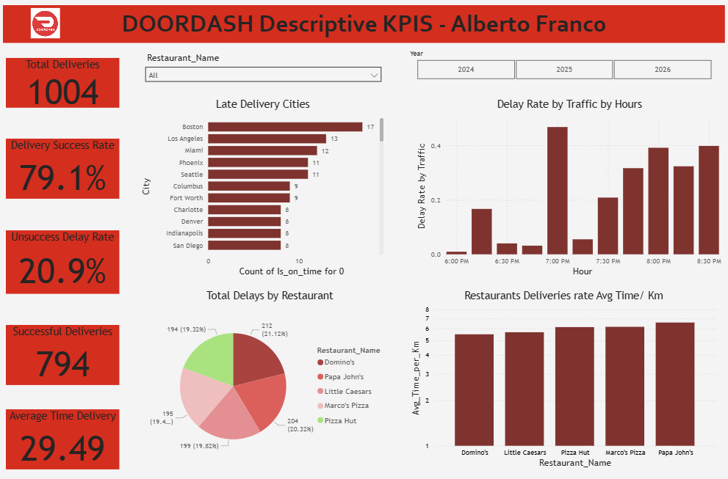
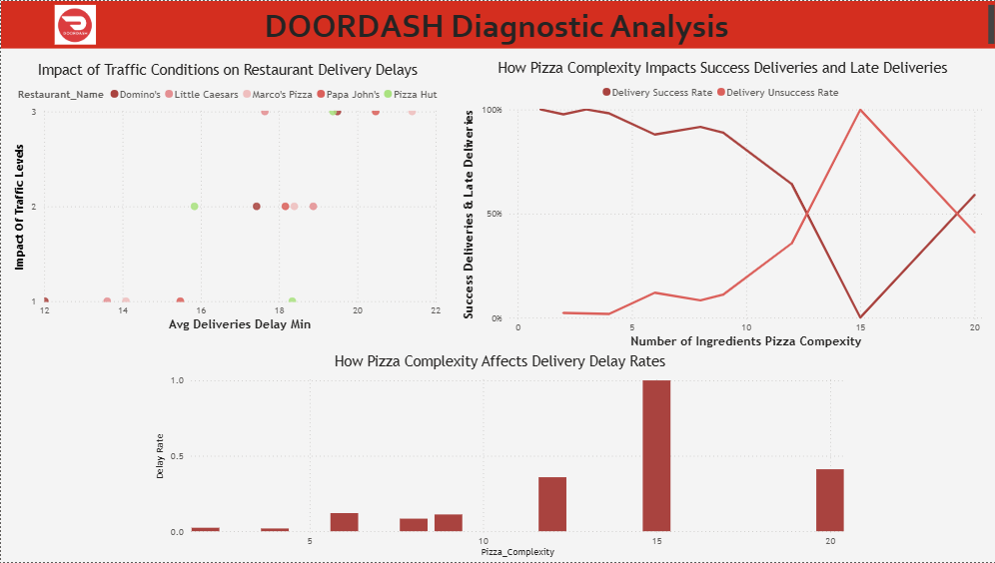

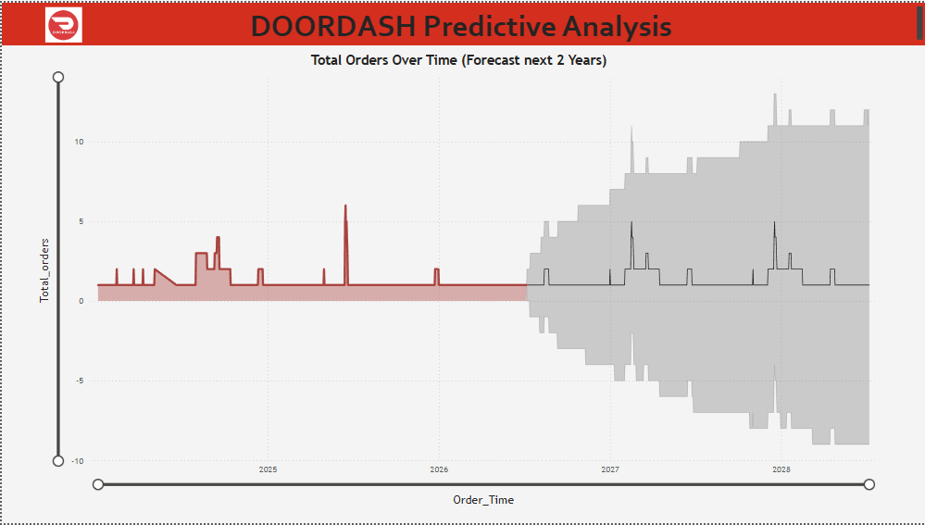

- Key Calculations:
- Avg time / KM: Important metric calculating the SUM of all deliveries in minutes / the SUM of all Distance KM. This is better metric than avg metric because we are using distance as a variable. TIME/ DISTANCE = KM PER HOUR
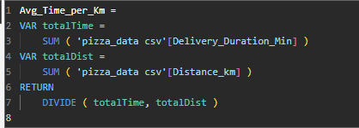
- Delay rate: Important to know which deliveries where late, if column: IS_DELAYED = TRUE
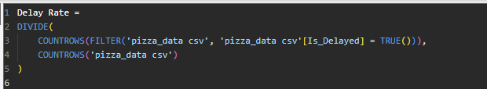
- Delivery Success Rate and Unsuccessful Rate: Count column if Is_on_time = 0 count it and divide it by total orders. (LATE DELIVERIES / TOTAL ORDERS)
- (DELIVERIES ON TIME / TOTAL ORDERS)

