Dear *Journal of the Association of Environmental and Resource Economists* Editorial Board,

With this disclosure statement, I declare that:

1. Neither I, nor my close relatives, have received financial support from any interested parties that have a financial, ideological, or political stake related to the article;
2. Neither I, nor my close relatives, have held any paid or unpaid positions in organizations whose policy positions, goals or financial interests relate to this article;
3. No party had the right to review the paper prior to its circulation

This research was financially supported by the University of California, Santa Barbara’s Academic Senate, and the National Aeronautics and Space Administration Land Cover and Land Use Change Program.

Best regards,

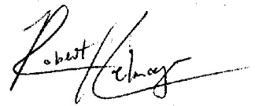

Robert Heilmayr  
Assistant Professor of Environmental Economics  
Environmental Studies Program  
Bren School of Environmental Science & Management  
University of California, Santa Barbara  
Email: rheilmayr@es.ucsb.edu  
Phone: 817-228-0609