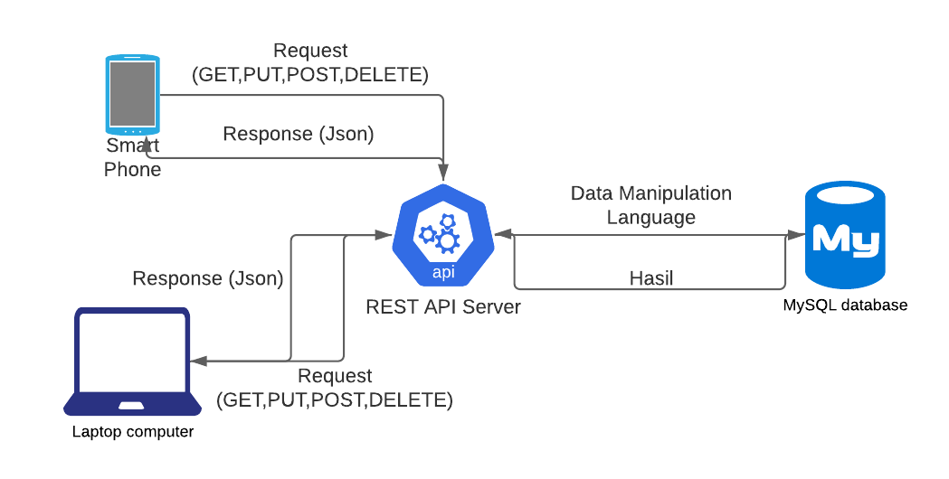

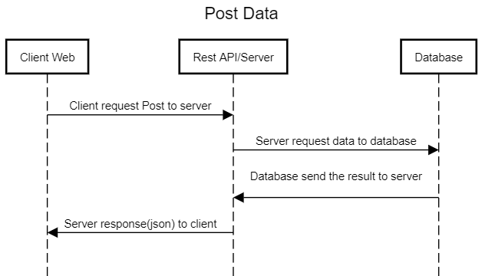

**Gambar 1 Diagram kontak Web API**

**Gambar 2 Post Data**

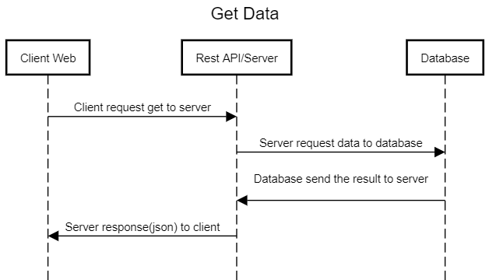

**Gambar 3 Get Data**

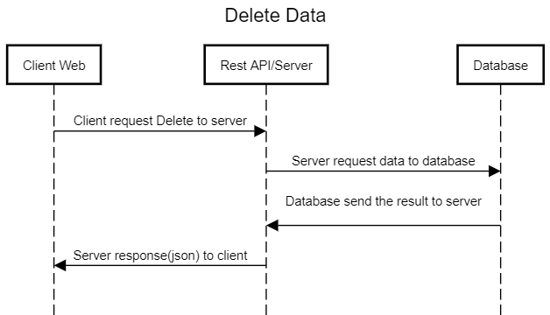

**Gambar 4 Delete Data**

**Gambar 4 Delete Data**

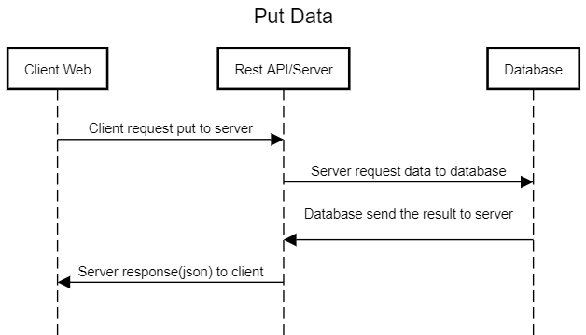

**Gambar 5 Put Data**