**DATABASE DESIGN DOCUMENT**

DOMAIN: Employee hierarchy management system based on skill set and experience.

BACKGROUND STUDY & REQUIREMENT ANALYSIS

In a software company, the hierarchy is typically structured based on skills, experience, and responsibilities. The following is a common hierarchy structure seen in most of the software companies.

1. **Entry-Level Positions:**

Interns or Trainees: Individuals who are still in school or recent graduates gaining practical experience in the field.

Junior Developers/Programmers/Engineers: Entry-level professionals who have basic skills and are in the early stages of their career.

*Reports to: Team Lead or Senior Developer*

2. **Mid-Level Positions:**

Software Developers/Programmers/Engineers: Those with a few years of experience, responsible for designing, coding, testing, and maintaining software applications.

Quality Assurance (QA) Engineers: Individuals responsible for testing software to ensure it meets quality standards.

UI/UX Designers: Professionals focused on creating user-friendly interfaces and experiences.

*Reports to: Technical Lead or Project Manager*

3. **Senior-Level Positions:**

Senior Software Developers/Engineers: Highly experienced professionals who take on more complex projects, provide mentorship, and often have specialized expertise.

Technical Leads: Individuals responsible for leading a team of developers, making technical decisions, and ensuring project success.

QA Leads: Experienced QA professionals who oversee testing processes and ensure quality standards are met.

*Reports to: Development Manager or Project Manager*

4**. Management Positions:**

Development Managers: Responsible for managing a team of developers, setting project goals, and ensuring efficient software development processes.

QA Managers: Oversee the QA team, set quality standards, and ensure testing processes are effective.

Project Managers: Individuals responsible for planning, executing, and closing projects, ensuring they are delivered on time and within budget.

*Reports to: Director of Engineering or Head of Development*

5. **Executive Positions:**

CTO (Chief Technology Officer): Responsible for the overall technology strategy of the company.

CEO (Chief Executive Officer): The top executive responsible for the overall leadership and management of the company.

Overall, this hierarchy reflects a progression from entry-level roles to more senior and leadership positions based on skills, experience, and the ability to take on increasing responsibilities.

*Reports to: Board of Directors or CEO (for CTO and CIO)*

*Inorder to design the database for employee hierarchy management based on skills and experience we should be able to asses the skills,experience and other performance indicators of an employee. We should be able to analyse the performance of the employee in each and every scenario. So we should create employee table, skills table, employeeskills mapping table, experience table, department table, position table, performance review table etc. The employee table will contain all the basic details related to an employee. It should contain the person to which the employee reports to. The skills table contains the skills that the employees possess. The employeeskill mapping table maps employees with the skills in the skills table. The department table contains the departments where employees work. The position table consists of the different roles of the employees like senior software developer, team lead etc. The experience table consists of the experience history of an employee. Goal table consist of the history of different goals assigned to the employees and how they managed to do it. The performance review table consist of the performance evaluation done on an employee from time to time. By using the data from the tables employee hierarchy management based on skills and experience can be done.*

*ER DIAGRAM*

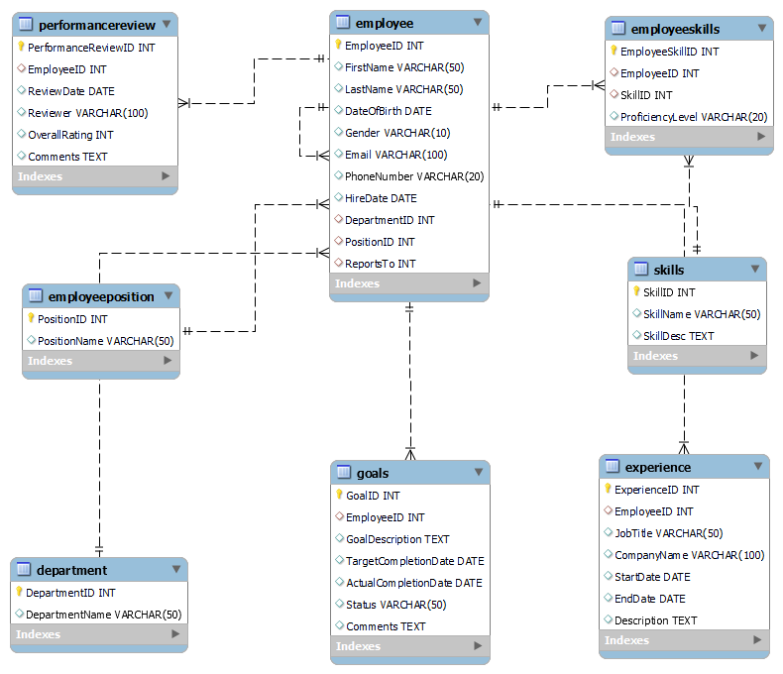

TABLES

*Employee Table:*

*Employee table consist of all the common details related with an employee.*

EmployeeID: int (Primary Key)

FirstName: varchar(50)

LastName: varchar(50)

DateOfBirth: date

Gender: varchar(10)

Email: varchar(100)

PhoneNumber: varchar(20)

HireDate: date

DepartmentID: int (Foreign Key referencing Department table)

PositionID: int (Foreign Key referencing Position table)

ManagerID: int (Foreign Key referencing Employee table)

NORMALIZATION

1NF

* All columns contain atomic values.
* The primary key EmployeeID uniquely identifies each row.

2NF

* It is in 1NF.
* All non-prime attributes are fully functionally dependent on the entire primary key ‘EmployeeID’.

3NF

* It is in 2NF.
* No transitive dependencies are present. So,it is in 3NF.

*Department Table:*

*Department table consist of the department details. Each department will have a departmentId and and a departmentName. Each employee will have atleast one department.*

DepartmentID: int (Primary Key)

DepartmentName: varchar(50)

NORMALIZATION

1NF

* All columns contain atomic values.
* The primary key DepartmentID uniquely identifies each row.

2NF

* It is in 1NF.
* All non-prime attributes are fully functionally dependent on the entire primary key ‘DepartmentID’.

3NF

* It is in 2NF.
* No transitive dependencies are present. So,it is in 3NF.

*Position Table:*

*Postion table contains the different positions in a company. Each employee will have a position like assosiate software developer, senior software developer, team lead etc.*

PositionID: int (Primary Key)

PositionName: varchar(50)

NORMALIZATION

1NF

* All columns contain atomic values.
* The primary key PositionID uniquely identifies each row.

2NF

* It is in 1NF.
* All non-prime attributes are fully functionally dependent on the entire primary key ‘PositionID’.

3NF

* It is in 2NF.
* No transitive dependencies are present. So,it is in 3NF.

*Skills Table:*

*Skills table include the different types of skills that the possess. Each employee will have multiple skills.*

SkillID: int (Primary Key)

SkillName: varchar(50)

SkillDescription: text

NORMALIZATION

1NF

* All columns contain atomic values.
* The primary key SkillID uniquely identifies each row.

2NF

* It is in 1NF.
* All non-prime attributes are fully functionally dependent on the entire primary key ‘SkillID’.

3NF

* It is in 2NF.
* No transitive dependencies are present. So,it is in 3NF.

*EmployeeSkills Table:*

*EmployeeSkills table is a mapping table which maps employess with different skill sets. Employees proficiency in that skill is also an attribute of the table.*

EmployeeSkillID: int (Primary Key)

EmployeeID: int (Foreign Key referencing Employee table)

SkillID: int (Foreign Key referencing Skills table)

ProficiencyLevel: varchar(20)

NORMALIZATION

1NF

* All columns contain atomic values.
* The primary key EmployeeSkillID uniquely identifies each row.

2NF

* It is in 1NF.
* All non-prime attributes are fully functionally dependent on the entire primary key ‘EmployeeSkillID’.

3NF

* It is in 2NF.
* No transitive dependencies are present. So,it is in 3NF.

*Experience Table:*

*Experience table contains the information about each employees experience. It includes the companies in which he worked , the duration, the description of it and the jobtitle in which he worked.*

ExperienceID: int (Primary Key)

EmployeeID: int (Foreign Key referencing Employee table)

JobTitle: varchar(50)

CompanyName: varchar(100)

StartDate: date

EndDate: date

Description: text

NORMALIZATION

1NF

* All columns contain atomic values.
* The primary key ExperienceID uniquely identifies each row.

2NF

* It is in 1NF.
* All non-prime attributes are fully functionally dependent on the entire primary key ‘ExperienceID’.

3NF

* It is in 2NF.
* No transitive dependencies are present. So,it is in 3NF.

*PerformanceReview Table:*

*This table will contain the performance review of the employee till now in the company. The employee will have an overall rating points and comments from reviewers from time to time. This is also used for assessing the employee.*

PerformanceReviewID: int (Primary Key)

EmployeeID: int (Foreign Key referencing Employee table)

ReviewDate: date

Reviewer: varchar(100)

OverallRating: int

Comments: text

NORMALIZATION

1NF

* All columns contain atomic values.
* The primary key PerformanceReviewID uniquely identifies each row.

2NF

* It is in 1NF.
* All non-prime attributes are fully functionally dependent on the entire primary key ‘PerformanceReviewID’.

3NF

* It is in 2NF.
* No transitive dependencies are present. So,it is in 3NF.

*Goals Table:*

*This table contains the goals assigned to an employee from time to time and his performance in completing them. It includes goal description, targetcompletiondate, actualcompletiondate and it’s status.*

GoalID: int (Primary Key)

EmployeeID: int (Foreign Key referencing Employee table)

GoalDescription: text

TargetCompletionDate: date

ActualCompletionDate: date

Status: varchar(50)

Comments: text

NORMALIZATION

1NF

* All columns contain atomic values.
* The primary key GoalID uniquely identifies each row.

2NF

* It is in 1NF.
* All non-prime attributes are fully functionally dependent on the entire primary key ‘GoalID’.

3NF

* It is in 2NF.
* No transitive dependencies are present. So,it is in 3NF.