Climate Change Concern: Empowering Today, Preserving Tomorrow

Storyline/Problem Statement

As we approach the imminent South African general elections in 2024, the Climate Change Concern (CCC) party emerges as a dynamic force committed to reshaping the political discourse. In our pursuit of a transformative political agenda, the CCC places climate change at the forefront of our manifesto, underscoring our dedication to environmental sustainability and the welfare of our nation.

Understanding the dynamics of the electorate is pivotal to our electoral strategy. We recognise that the sentiments of the general public are not only indicative of their concerns but also represent an unparalleled opportunity to promote increased voter support.

By prioritizing climate change actions, the CCC endeavours to align with voters who recognise the urgency of environmental stewardship. This is not a mere electoral ploy; it is a commitment to a sustainable future for our country and the greater globe.

The CCC invites all South Africans to join us in this bold venture, where the fight against climate change becomes a unifying force. By contributing to our collective understanding of public sentiments, you are not merely participating in an election; you are shaping the destiny of a nation ready to confront the challenges of the 21st century. Together, let us usher in an era where environmental consciousness converges with political will, laying the foundation for a resilient and sustainable South Africa.

Purpose

Understanding the general public's concerns about climate change is crucial for a political party for several reasons:

1. **Voter Alignment and Electoral Appeal:** By knowing the public's concerns about climate change, a political party can align its policies with the issues that matter most to voters. This alignment can attract voters who prioritize climate change and environmental issues, potentially increasing the party's support base.
2. **Policy Development:** Awareness of public concerns allows a political party to develop comprehensive and targeted policies to address climate change. Crafting effective policies requires an understanding of the specific issues that resonate with the electorate, ensuring that the proposed solutions are relevant and practical.
3. **Long-term Viability:** Given the long-term nature of climate change, addressing this issue is not just about short-term electoral gains but also about the long-term viability and credibility of the political party. Parties that show a commitment to addressing environmental concerns may gain trust and support over the years.
4. **Global Image:** Climate change is a global challenge, and political parties are not only accountable to their domestic constituencies but also to the international community. Parties that demonstrate a commitment to addressing climate change can enhance their global image, potentially influencing diplomatic relations and international cooperation.
5. **Youth Engagement:** Climate change is often a top concern among younger voters. By addressing these concerns, a political party can engage with the youth demographic and build support among a generation that is likely to be directly affected by the long-term consequences of climate change.
6. **Corporate and Investor Relations:** Public concerns about climate change also influence corporate and investor behaviour. Companies and investors increasingly consider environmental sustainability in their decision-making. Political parties that align with public sentiment on climate.

Data

The collection of this data was funded by a Canada Foundation for Innovation JELF Grant to Chris Bauch, University of Waterloo. The dataset aggregates tweets pertaining to climate change collected between Apr 27, 2015 and Feb 21, 2018. In total, 43,943 tweets were collected. Each tweet is labelled as one of 4 classes, which are described below.

Class Description

* 2 News: the tweet links to factual news about climate change
* 1 Pro: the tweet supports the belief of man-made climate change
* 0 Neutral: the tweet neither supports nor refutes the belief of man-made climate change
* -1 Anti: the tweet does not believe in man-made climate change Variable definitions

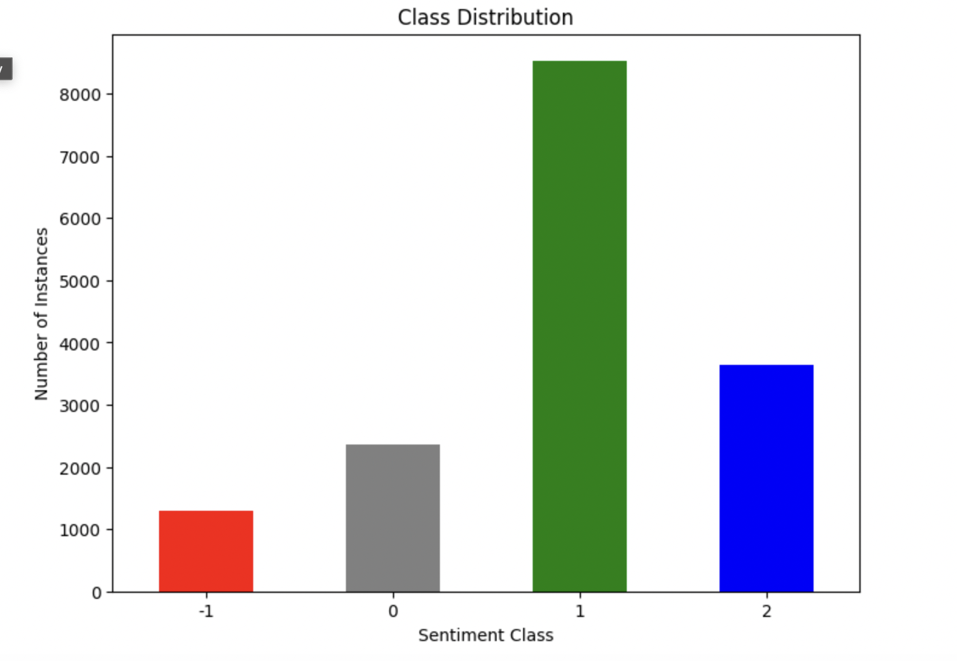

* 1 Pro: the tweet supports the belief of man-made climate change
* **Credibility and Trust/Strategic Alliance:** When a political party acknowledges and reflects the widely held belief in man-made climate change, it builds credibility and trust among the electorate. Voters are more likely to support a party that shares their values and concerns, particularly on critical issues such as the environment.
* -1 Anti: the tweet does not believe in man-made climate change variable definitions

**Bridge Building:** Recognizing the existence of climate change scepticism provides an opportunity for the political party to engage with and understand the concerns of this segment of the population. This can facilitate bridge-building efforts, fostering dialogue and potentially changing opinions through informed communication and education.

**Educational Initiatives/Strategic Communication:** Knowing that a proportion of the public does not believe in man-made climate change highlights the need for educational initiatives. The political party can undertake efforts to provide accurate information, raise awareness, and foster a better understanding of the scientific consensus on climate change, potentially influencing public opinion over time.

