

Unified Mentor Data Analyst - Employee Attrition Analysis for Green Destinations

Project By: Albin Joseph Shaju

UNID: UMIP271379

Tools used: Tableau and Jupyter notebook

1. **Objective**

* Determine the Attrition Rate – Calculate the overall percentage of employees leaving the organization and analyze the trend over time.
* Identify Key Factors Influencing Attrition – Examine the impact of employee age, monthly income, and tenure at the company on attrition.
* Perform Data-Driven Insights Using Python – Utilize Python (Pandas, Matplotlib, Seaborn) to clean, analyze, and visualize the attrition data.
* Develop Actionable Recommendations – Based on the findings, propose strategies to improve employee retention and reduce attrition.

1. **Tools and Methods**

* Jupyter Notebook- To run Python and to pull the dataset
* Python – Pandas, Matplotlib, Seaborn are used for data processing and visualization
* Tableau – Used for visualization and generating meaningful insights

**3. Introduction**

This project aims to analyze employee attrition trends at Green Destinations using data-driven insights. The dataset includes key employee attributes such as age, monthly income, and years at the company. By leveraging Python-based data analysis (Pandas, Matplotlib, Seaborn), we clean the dataset, calculate attrition rates, and visualize patterns. The goal is to understand what factors contribute to employee turnover and provide actionable recommendations to improve retention strategies.

**4. Data Cleaning**

Before conducting the analysis, the dataset underwent a thorough cleaning process to ensure accuracy and reliability.

**4.1 Loading the Dataset**

The dataset, greendestination.csv, was imported using Pandas for analysis.

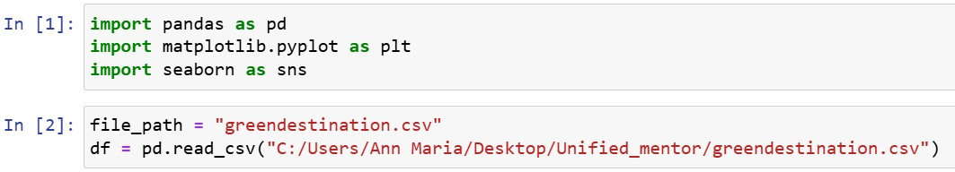

**4.2 Dropping Irrelevant Columns**

Certain columns such as "StandardHours" and "EmployeeNumber" were removed since they did not contribute to the analysis.

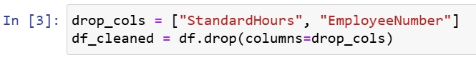

**4.3 Attrition Rate Calculation**

The percentage of employees who left the company was computed to get an overview of attrition levels.

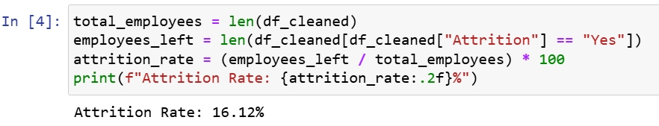

**4.4 Grouping Data for Analysis**

The dataset was grouped by attrition status to analyze age, years at company, and monthly income.

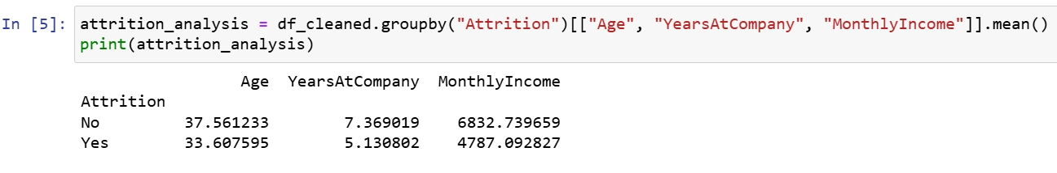

**4.5 Data Visualization for Better Insights**

Attrition vs Age: A histogram was created to see how attrition varies across different age groups.

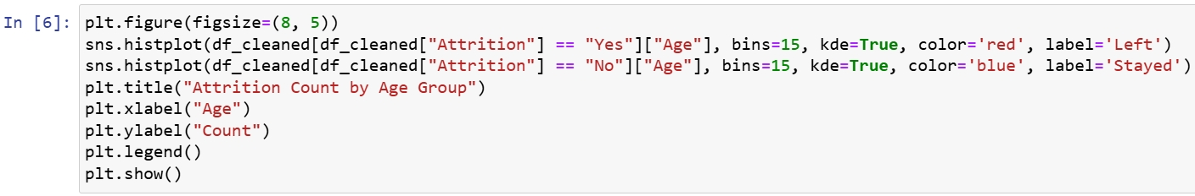

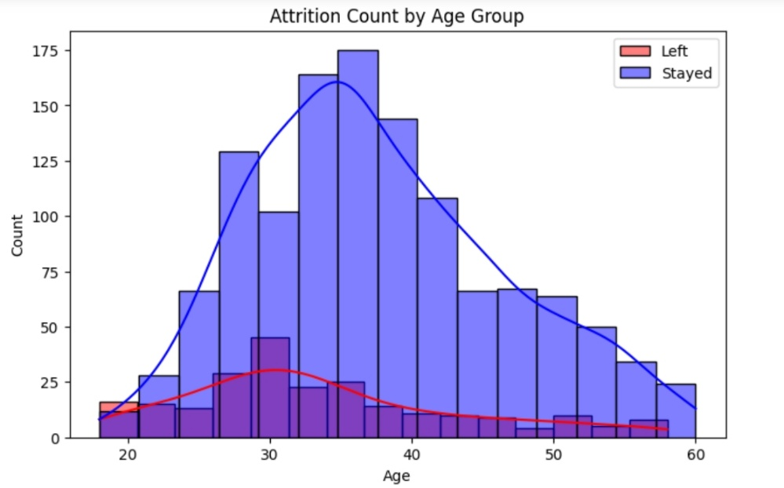

Figure 1. Attrition count by age group

**5. Attrition Overview**

The overall attrition rate provides an understanding of how frequently employees are leaving the organization.

* Overall Attrition Rate**:** The overall attrition rate for Green Destinations is 16.12%
* A higher attrition rate suggests potential dissatisfaction among employees, workplace issues, or better opportunities outside.

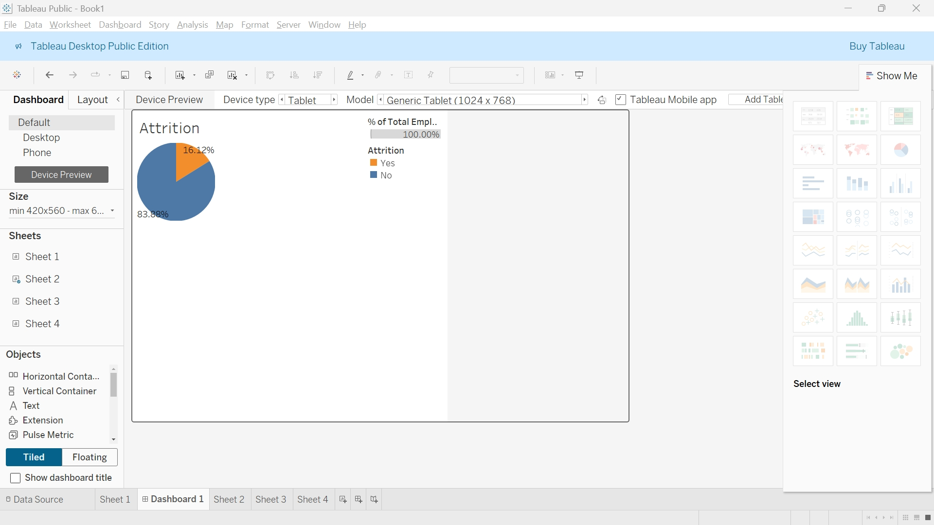

Figure 2. Overall Attrition Rate

**6. Attrition by Age**

Analysis of attrition trends across different age groups helps in identifying which demographic is more likely to leave the organization.

* Younger employees (below 30 years) exhibit a higher attrition rate.
* Employees in the mid-age range (30-45 years) show moderate attrition.
* Older employees (above 45 years) have the lowest attrition.
* Possible reasons for younger employees leaving include career progression, better salary offers, or lack of engagement.

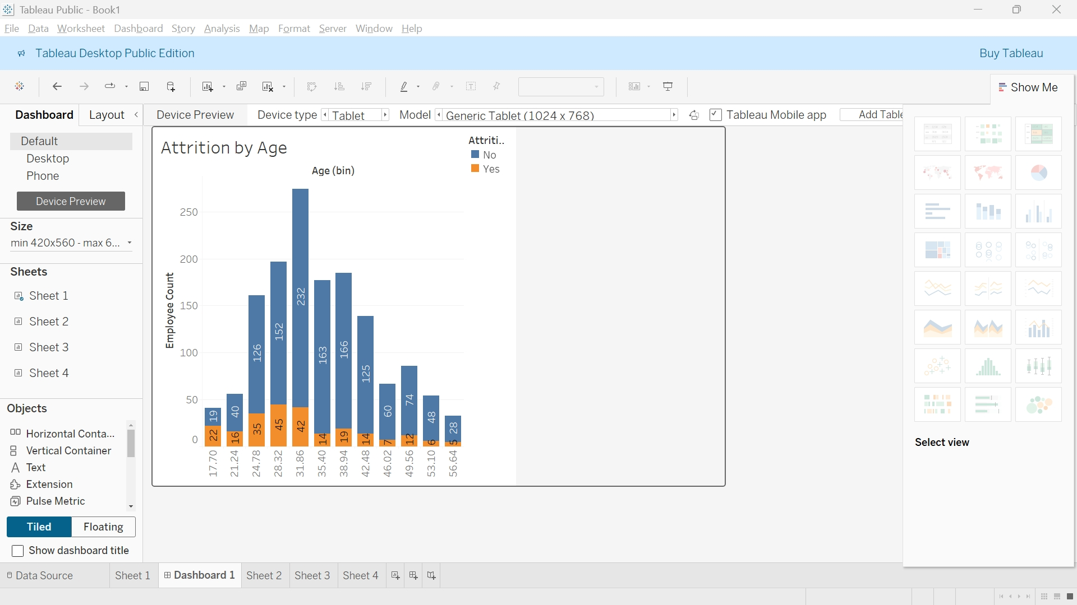

Figure 3. Attrition by Age

**7. Attrition by Monthly Income**

Salary plays a significant role in employee satisfaction and retention.

* Employees with lower monthly incomes show higher attrition rates.
* Those with mid-range salaries exhibit moderate attrition.
* Employees with higher salaries tend to stay longer, indicating financial incentives as a retention factor.
* The company might consider salary adjustments or performance-based incentives to retain talent.

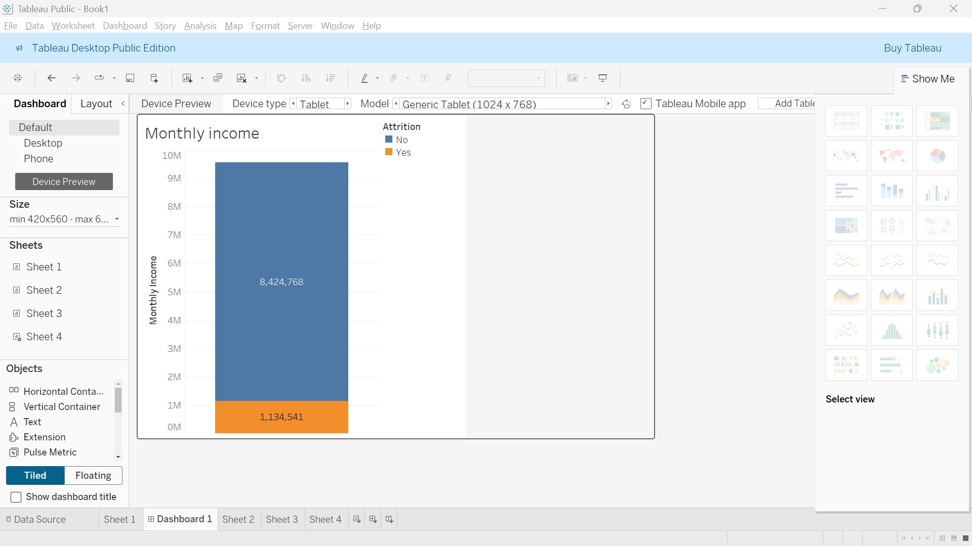

Figure 4. Attrition vs Monthly Income

**8. Attrition by Years at the Company**

The length of service also influences attrition patterns.

* Employees with less than 2 years of experience at the company show the highest attrition.
* Attrition rates stabilize for employees with 3-7 years of experience.
* Employees with over 10 years at the company show the lowest attrition, indicating long-term commitment.
* To address early-stage attrition, onboarding processes, mentorship programs, and career growth opportunities can be improved.

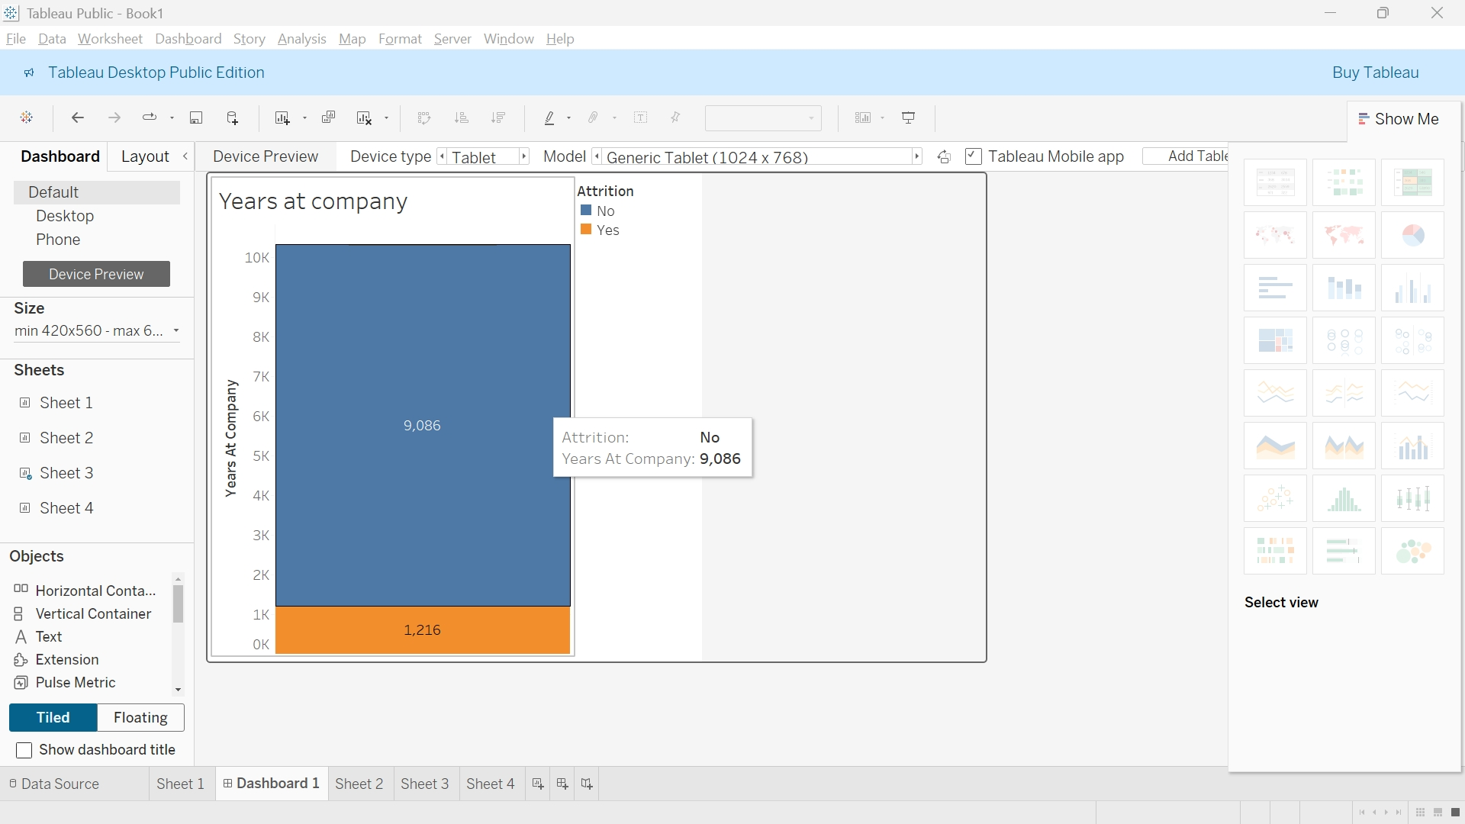

Figure 5. Attrition vs Years at Company

**9. Conclusion and Recommendations**

This study aimed to analyze employee attrition at Green Destinations to identify key factors influencing employee turnover. By cleaning and preprocessing the dataset, we ensured that the analysis was based on accurate and relevant data.

Key insights from the analysis include:

* The overall attrition rate was calculated, providing a baseline for understanding employee departures.
* Employees who left the company exhibited notable differences in age, years at the company, and monthly income compared to those who stayed.
* Visualization techniques helped in understanding attrition trends, highlighting potential patterns among employees at risk of leaving.

Based on the findings, the following recommendations can help reduce employee attrition:

1. Enhance Employee Engagement: Foster a positive work environment with career development programs.
2. Improve Compensation and Benefits: Offer competitive salaries and incentives to retain top talent.
3. Strengthen Career Growth Opportunities: Provide training and development programs to help employees grow within the organization.
4. Improve Onboarding and Mentorship: Support new hires with structured onboarding and mentorship to reduce early attrition.
5. Work-Life Balance Initiatives: Introduce flexible work policies to improve job satisfaction and retention.

By implementing these strategies, Green Destinations can create a more stable and committed workforce, reducing overall attrition and improving productivity.