CHAPTER 2: LITERATURE REVIEW

2.1 Introduction
In this chapter, the existing body of literature related to the development of an app for detecting and recognizing obstacles surrounding blind and visually impaired (BVI) individuals indoors is reviewed. Unlike in other literature reviews that present the studies in sequence, the current one is divided into sections based on a domain framework formulated specifically in accordance with the objectives of the project. This approach allows one to assess the existing state of the art with respect to the research gaps the project seeks to bridge. The methodology used in the identification and selection of relevant literature is presented in Section 2.2. The chronology of the developments in the field under discussion is reviewed in Section 2.3. The types of publications found are characterized in Section 2.4. Section 2.5 provides the main part of the review divided into four domains: object detection, distance and depth perception, multimodal interface design, and evaluation methodology. The output of the review—gap mapping table—is synthesized in Section 2.6. Section 2.7 concludes the chapter. The need to point out that the general literature refers to the technologies discussed as 'navigation' tools should be emphasized. However, the scope of this project, as set forth in Chapter 1, is narrower and relates to indoor obstacles detection only.
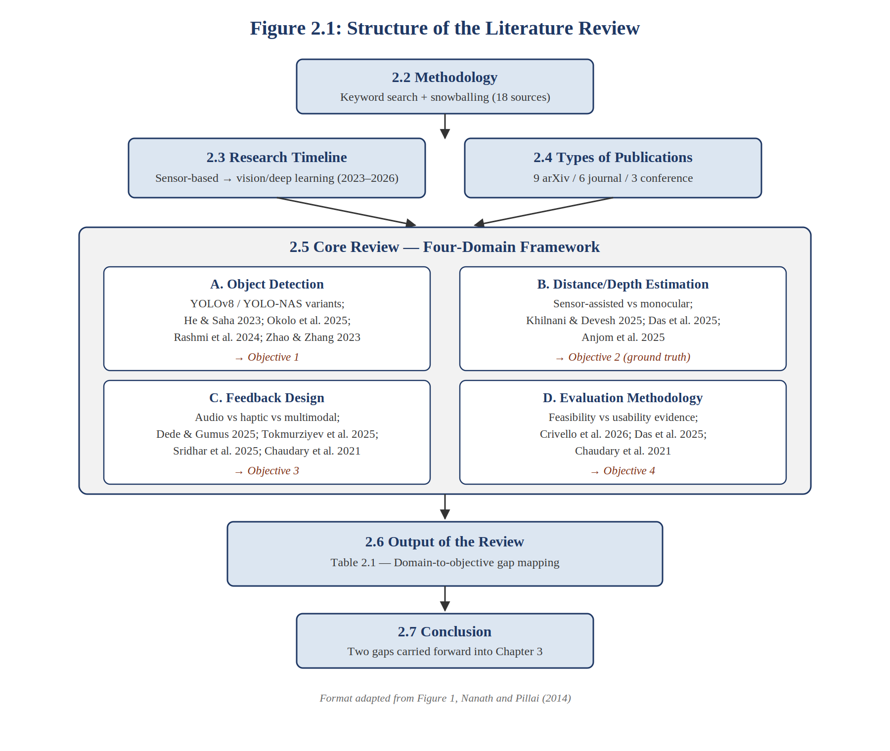
Figure 2.1: Structure of the literature review, adapted from the format of Figure 1 in Nanath and Pillai (2014).

2.2 Methodology for Literature Review
The literature sources for the research were found using a combination of academic search engines (mainly Google Scholar) and pre-print/publishing databases (arXiv, IEEE Xplore, ACM Digital Library, Springer Link, Science Direct). This reflects the rapidly developing, applied character of the discipline, when the peer-reviewed article is published later than the current advances.

The first keyword list was created directly based on the project proposal and its objectives and then combined (e.g., “YOLO” was combined with “visually impaired,” “haptic feedback” was combined with “navigation”) in order to ensure that the findings would lie at the point where computer vision and assistive technology overlap, not in any of these domains alone. The keywords used included:
- assistive navigation
- visually impaired object detection
- YOLO obstacle detection
- monocular depth estimation mobile
- haptic feedback navigation
- smart cane
- usability blind visually impaired
The literature searches, whenever possible, were confined to articles written after 2019 to be consistent with the time frame of practical deployment of YOLO family of detectors as well as mobile deep learning algorithms on smartphone devices. Previous studies using only sensors were mentioned exclusively if they provided the baseline against which the field progressed. A snowball sampling technique was then used: the references of articles directly related to the topic (e.g., Khilnani & Devesh, 2025; Okolo et al., 2025; and state-of-the-art survey by Crivello et al., 2026) were screened for other articles fulfilling the same relevance criteria.
Only those papers that covered one or more technical aspects of the project (detection, distance estimation, and feedback), and used smartphone or wearables form factors, rather than autonomous vehicle or industrial robotics, for instance, were included because they have different cost and latency requirements. As a result, the review provided a literature corpus consisting of fourteen papers – ranging from arXiv papers to peer-reviewed journal papers and conferences. The fifteenth paper (Nanath and Pillai (2014)) is mentioned in Section 2.1 for its structure, but not as part of the literature corpus. Table 2.1 presents the papers in the context of their relevance to the field (Section 2.5).Table 2.1. Papers reviewed, by primary domain and publication type
Paper | Primary Domain | Publication Type
Anjom et al. (2025) | B – Distance/Depth Estimation | arXiv preprint
Chaudary et al. (2021) | C – Feedback Design | Journal (Virtual Reality)
Crivello et al. (2026) | D – Evaluation Methodology | Journal (Int. J. Human–Computer Interaction)
Das et al. (2025) | B – Distance/Depth Estimation | arXiv preprint
Dede and Gumus (2025) | C – Feedback Design | Journal (J. Multimodal User Interfaces)
He and Saha (2023) | A – Object Detection | arXiv preprint
Khilnani and Devesh (2025) | B – Distance/Depth Estimation | arXiv preprint
Kuriakose, Shrestha and Sandnes (2023) | B – Distance/Depth Estimation | Journal (Expert Systems with Applications)
Lokhande (2024) | A – Object Detection | Journal (Int. J. Intelligent Systems and Applications in Engineering)
Okolo et al. (2025) | A – Object Detection | Journal (Journal of Disability Research)
Rashmi, Guru and Anusuya (2024) | A – Object Detection | arXiv preprint
Sridhar et al. (2025) | C – Feedback Design | Conference (ACM SIGACCESS ASSETS)
Tokmurziyev et al. (2025) | A – Object Detection | arXiv preprint
Zhao and Zhang (2023) | A – Object Detection | Conference (ISIA ’23)

2.3 Research Timeline
The study of navigation systems aimed at aiding BVI people has been around before the deep learning era mentioned above in this literature review. First electronic navigation aids from the 1990s and early 2000s used either cane or wearable devices that had ultrasonic and infrared sensors. The sensors detected the presence of obstacles well but could not recognize what kind of objects these obstacles were. This was the leading approach in the industry for around two decades and still influences some modern designs when it is used as an inexpensive alternative to vision-based systems.
The adoption of approaches based on vision and deep learning is relatively new, and it coincides with the emergence of real-time object detectors. The example of DeepNAVI shows how vision and deep learning allow a smartphone to perform deep learning on itself and determine the distance to, location of, and movement of the obstacle without internet access (Kuriakose, Shrestha, and Sandnes, 2023). Since 2023, there has been a rapid rise in studies employing YOLO object detectors to aid navigation systems. This phenomenon coincided with the release of YOLO object detectors' more effective versions, including YOLOv8 and YOLO-NAS (He and Saha, 2023; Rashmi, Guru, and Anusuya, 2024).

The year 2025 marks yet another inflection point in the above trajectory, marked by a cluster of papers (Khilnani and Devesh 2025; Okolo et al., 2025; Sridhar et al., 2025; Dede and Gumus 2025; Tokmurziyev et al., 2025; Das et al., 2025; and Anjom et al., 2025) that revolve around two parallel issues: the use of pairing detection along with distance/depth estimation and moving beyond audio-only feedback towards more advanced haptic or multimodal systems. Both issues have a common rationale and both are rooted in two missing elements of previous systems that were focused either on only pairing detection or on only audio-only feedback. These two issues, which mark the shift, form the basis for the domain framework discussed in Section 2.5. Finally, an up-to-date state-of-the-art review (Crivello et al., 2026), which analyzes 75 carefully selected papers, confirms this development as being the current direction of the research area but also highlights the fact that less than half of all published systems include a usability testing stage (44%).

2.4 Types of Publications

The main body of literature consists of fourteen documents (Table 2.1): six are arXiv preprints, six are peer-reviewed journals (Journal of Disability Research, Journal on Multimodal User Interfaces, Expert Systems with Applications, Virtual Reality among others), and two are peer-reviewed conference proceedings (ACM SIGACCESS ASSETS, IEEE/ISIA). The significant preponderance of arXiv preprints, as compared to other less-developed disciplines, provides an interesting point to note: the development of the field is fast enough for peer review to be still carried out for the latest works, especially for those published within the past twelve months. Several works (e.g., Das et al., 2025; Anjom et al., 2025; Tokmurziyev et al., 2025) had not gone through the process of peer review at the time of this literature review. It is consistent with general tendencies in the areas of computer vision and deep learning research, which means that in the current review, the preprint status will be considered acceptable for claims related to timeliness (e.g., performance characteristics), while the peer-reviewed status will be considered evidence-based for evaluation of usability methodology, as procedures are often exposed as flawed in the process of peer review.

2.5 Core Review

Unlike the per-author literature review method, this literature is organized into four categories based on how they relate to the objectives of this project: (A) Object Detection for Real-Time Assistive Navigation, (B) Distance and Depth Estimation for Obstacle Awareness, (C) Designing Multi-modal Feedback, and (D) Evaluation Techniques for Assistive Navigation Systems. If an individual study touches upon two or more of the above categories, it will be covered in the category it relates to most directly and referenced in other appropriate categories.

2.5.1 Domain A: Object Detection for Real-Time Assistive Navigation
The YOLO family remains dominant in this area because of the real-time inference capability of the network on hardware constraints without suffering from latency, which is typical for two-stage detectors. As noted in a study of seven YOLO architectures for outdoor object detection, He and Saha (2023) discovered that among the seven studied architectures, YOLOv8 demonstrates the best trade-off between precision and recall for obstacle detection in their dataset, which is the goal of Objective 1 of this project. Furthering this research, Rashmi, Guru, and Anusuya (2024) investigate indoor small object detection, applying YOLO-NAS Small combined with Super Gradients for training in order to resolve a deficiency of mostly outdoor benchmark, which needs to be addressed in this indoor-focused project. The navigation algorithm, built upon the PP-YOLO architecture by Zhao & Zhang (2023), reached 96.3% recognition accuracy at 8 fps in a distance of 8 meters; however, the recognition accuracy dropped to 85% at busy intersections, illustrating that the reported results depend heavily on the scene used for testing.

One of the main limitations in this area has been the approach to comparative assessments which tends to prioritize either speed or accuracy while disregarding their combination alongside the cost of deployment. In this context, Lokhande (2024) makes an effort to alleviate the problem partially by approaching the topic from the perspective of edge computing in general, showing that the use of int8 quantisation leads to a 45% reduction in inference latency at a relatively modest cost in terms of detection accuracy, which is directly applicable to the process of selecting a model in this project. Okolo et al. (2025) are the closest to this project in scope and are thus considered to be the primary point of divergence in terms of both methodology and cost when discussing it in this literature review. The system created by them involves combining YOLOv8 with ultrasonic sensor technology to detect distance and transmitting data in a form of audio and tactile feedback, resulting in 91.70% average detection accuracy on nine obstacles. Finally, Tokmurziyev et al. (2025) demonstrate another approach to detection, combining YOLO-World with GPT-4o-based scene reasoning in their LLM-Glasses system, which shows an interesting trend in the area of integrating detection with large multimodal language models.

2.5.2 Domain B: Distance and Depth Estimation for Obstacle Awareness
Obstacle detection alone has been recognized as being relatively useless without a consideration of the distances involved – it matters not whether an object is detected if there is no means of knowing if the object is one meter or ten meters from the user. Khilnani and Devesh (2025) use this premise to make a case for developing a smart cane, which combines obstacle detection with distance estimation to allow prioritization of obstacles based on urgency as opposed to simply detecting them. The mean average precision (mAP) score achieved by Khilnani and Devesh (2025) in the obstacle detection part of the work using RT-DETR framework was 71.7% at an IoU threshold of 0.5. This outcome forms the basis of Objective 2 in the current project.
In this field, two general approaches are often used: sensory techniques (either ultrasonic or infrared, such as Okolo et al., 2025) and depth estimation using only the input from the camera. The second approach is more commonly used in practice due to its simplicity and lower costs related to not needing extra equipment, however, it also has drawbacks: Anjom et al. (2025) develop a system for alerting visually impaired pedestrians with embedded object detection and depth-estimation model using quantization for both models in order to make them sufficiently light-weight, similar to the key ideas of this project's approach to the problem. Similarly, Das et al. (2025) develop PathFinder - an offline mapless smartphone system for estimating monocular depth images in order to find an obstacle-free path and state that their approach decreases mean absolute error and increases decision-making speed compared to other AI-based solutions and provide validation through usability test conducted with 15 blind or visually impaired users. The latter point is directly taken into consideration when developing evaluation protocol for this project's Objective 4.

The gap that is present throughout this field is validation on physically measured distances versus a labeled data set or self-reported number; the papers are usually measuring against their own benchmark instead of actual distances that have been measured independently, which is exactly what Objective 2 in this project will address through physically placing obstacles at certain distances and then measuring error.

2.5.3 Domain C: Multimodal Feedback Design
Most systems that people use still mostly give information through sound, which's easy to set up but does not work well when it is noisy outside and takes up a sense that blind and visually impaired users already use to know what is around them. Some people are working on using touch to give information of just sound. Dede and Gumus made a device called Vis-Assist that people can wear. It helps them tell what things are by how it vibrates. This device can help people know what 19 different things are by how it vibrates after they use it for a little while. This shows that touch can give us information than just a simple warning that something is near. Tokmurziyev and other people made something called LLM-Glasses that vibrates on the side of the head and people can tell what the different vibrations mean 81.3 percent of the time. This means that using touch to give information can be very helpful for knowing what is around us even if it is not as good, as sound.
Okolo and others (2025) did a study that combined sound and touch feedback in one system. However they did not find out how much the touch part helped compared to sound. This projects test (Objective 4) aims to fill that gap. It can compare how well people do tasks with types of feedback even in a small study.
Chaudary and others (2021) did a study on guiding people who're blind. They found that people who are blind liked types of touch guidance based on how familiar they were with it and if they used a cane before. This shows that designing touch feedback is not a problem even, with basic hardware.

There is a problem with some systems that can do lots of things. These systems, like NaviSense by Sridhar and others from 2025 need hardware. This hardware includes things like LiDAR units or special headsets for augmented reality. Most people do not have these things in their phones. This is why we are doing this project with a limit. We want to use the hardware that is already, in smartphones. This way we can use NaviSense and other systems like it on our phones without needing things. We think this is an idea because it is simple and lots of people can use it. The project is only using smartphone hardware on purpose. This is because we want to make something that lots of people can use with the phones they already have.

2.5.4 Domain D: Evaluation Methodology for Assistive Navigation Systems
The way people check how well something works in the studies I looked at is not very consistent. A detailed report from 2026 by Crivello et al. Looked at 75 papers that were chosen very carefully. They found out that 44 percent of these papers actually tested how easy it was for people to use the system or they tested it with people who did not know what was going on. The other papers just looked at how the system worked from a technical point of view like how accurate it was or how long it took, without actually checking if people would use it. This is a problem because just looking at how well a system works from a technical point of view does not tell us if people who are blind or have low vision, blind or visually impaired users would actually use it. Blind or visually impaired users are the ones who need to use these systems. We have to make sure they work for them.
When we look at systems that actually check how easy they are to use we see that they all do it in ways. For example Das and his team tested PathFinder with 15 people who're blind or have trouble seeing and they found out that 73 percent of these people could figure out how to use the system in less than a minute. Also 80 percent of them liked how accurate and responsive PathFinder was.
On the hand Chaudary and his team used a special questionnaire called meCUE 2.0 and they also had interviews and group discussions with 11 blind or visually impaired people and one sighted caretaker. This shows us how we can combine numbers with conversations to get a better understanding of how usable a system is.
Then there is the case of Dede and Gumus who checked out Vis-Assist with four participants. They measured how long it took for people to complete tasks, which's a good way to see if a system is easy to use. However since they only had a few people test it we have to be careful about what we can say about how usable Vis-Assist is. This is a problem, in this field because many studies do not have a lot of participants, which makes it hard to say for sure if a system is easy to use or not.
This project is connected to Objective 4. When we do not have a lot of time or when we need to follow rules it is common to test things with sighted people who are blindfolded instead of people who are blind or have low vision. This is what some people do when they are working on projects like this. The survey by Crivello et al. In 2026 says that there are two ways to test things: one is to test with people who are blind or have low vision and the other is to test with sighted people who are blindfolded. However they do not say which way is better.
There is a difference between showing that something can work and really knowing that people who are blind or have low vision can use it. Some studies do not make this clear. They show that something can work with blindfolded people. They do not say if it would really work for people who are blind or have low vision.
This project is different. We know that there is a difference between showing that something can work and really knowing that people can use it. So we did a test to see if our system could work. We did this test in a controlled space. We asked people to do some tasks. We also talked to them after they did the tasks to see what they thought. We are not saying that our system is ready for people who're blind or have low vision to use. We know that people who are blind or have vision have different experiences and needs, than sighted people who are wearing a blindfold. We will talk about this again in Chapter 6.

2.6 Output of the Review
The main contribution of this review is a mapping between the four domains identified above and the specific gaps this project’s objectives are designed to close (Table 2.2).
Table 2.2. Domain-to-objective gap mapping
Domain | Dominant approach in literature | Identified gap | Addressed by
A. Object Detection | YOLO variants (YOLOv8, YOLO-NAS) optimised mainly for outdoor scenes; accuracy and speed reported separately from deployment cost | Few studies jointly benchmark accuracy, latency, and cost for indoor, mobile-only deployment | Objective 1
B. Distance/Depth Estimation | Either sensor-assisted (ultrasonic) or monocular depth, validated mainly against annotated datasets or internal benchmarks | Few studies validate distance-estimation accuracy against an independently measured, physical ground truth | Objective 2
C. Feedback Design | Predominantly audio-only; haptic treated as either a full substitute or an untested addition | Contribution of haptic channel rarely isolated from audio in controlled comparisons | Objective 3
D. Evaluation Methodology | Only 44% of surveyed systems (Crivello et al., 2026) include any usability testing; blindfolded-participant results often reported without distinguishing feasibility from usability evidence | Systematic, ethics-approved proof-of-concept testing – with that distinction stated explicitly – is the exception rather than the norm | Objective 4

This project is looking at something to what Okolo et al did in 2025. They found that using a YOLO detector and a sensor to figure out how away something is, then using sound and touch to tell the user works really well. They got it right 91.70 percent of the time. However they used an ultrasonic unit to do this, which is not something that is already built into a phone. They also did not compare ways of detecting things and measuring distance to see which one is the best. They did not check to see if their way of measuring distance was actually accurate either.

The goal of this project is not to come up with an idea because Okolo et al already showed that using detection and distance and feedback together can work. The goal is to use the parts of a smartphone to make this work without adding anything extra. We also want to compare the ways of detecting things and measuring distance to see which one is the best.. We want to check to make sure that our way of measuring distance is actually accurate, by using obstacles that are a certain distance away which we measure by hand. We are using Okolo et al as a reference point. We want to make sure that our project like Okolo et al can achieve high detection accuracy.

2.7 Conclusion

This chapter reviewed current research in four key areas related to smartphone-based indoor obstacle awareness for blind and visually impaired users: object detection, distance and depth estimation, multimodal feedback design, and evaluation methods. The review highlights a field that has developed quickly since 2023. It shows a trend toward using YOLO-based detection along with some form of distance estimation and, more often, haptic feedback together with audio. However, distance-estimation accuracy is rarely tested against a physical ground truth. Additionally, the distinction between a proof-of-concept test and real usability evidence is not always clear. These two gaps, ground-truth-validated distance estimation and a clear separation between feasibility and usability define the specific contribution this project aims to make and guide the methodology outlined in Chapter 3.
REFERENCES
Anjom, J., Chowdhury, R.I., Hasan, T. and Hossain, M.I.A. (2025) An Embedded Real-time Object Alert System for Visually Impaired: A Monocular Depth Estimation based Approach through Computer Vision. arXiv:2507.08165. Available at: https://arxiv.org/abs/2507.08165 (Accessed: 5 July 2026).
Chaudary, B., Pohjolainen, S., Aziz, S., Arhippainen, L. and Pulli, P. (2021) 'Teleguidance-based remote navigation assistance for visually impaired and blind people—usability and user experience', Virtual Reality, 27, pp. 141-158. https://doi.org/10.1007/s10055-021-00536-z
Crivello, A. et al. (2026) 'Navigation Solutions for Blind and Visually Impaired Persons: A State-of-the-Art Survey', International Journal of Human–Computer Interaction. https://doi.org/10.1080/10447318.2026.2643358
Das, D., Das, A.D., Sadaf, F., Uddin, A. and Mondal, T. (2025) Real-Time Assistive Navigation for the Visually Impaired: A Scalable Approach for Indoor and Outdoor Mobility. arXiv:2504.20976. Available at: https://arxiv.org/abs/2504.20976 (Accessed: 5 July 2026).
Dede, I. and Gumus, A. (2025) 'Vis-Assist: computer vision and haptic feedback-based wearable assistive device for visually impaired', Journal on Multimodal User Interfaces, 19(2), pp. 217-234. https://doi.org/10.1007/s12193-025-00452-5
He, C. and Saha, P. (2023) Investigating YOLO Models Towards Outdoor Obstacle Detection For Visually Impaired People. arXiv:2312.07571. Available at: https://arxiv.org/abs/2312.07571 (Accessed: 5 July 2026).
Khilnani, C.S. and Devesh, S.U. (2025) A Computer Vision and Depth Sensor-Powered Smart Cane for Real-Time Obstacle Detection and Navigation Assistance for the Visually Impaired. arXiv:2508.16698. Available at: https://arxiv.org/abs/2508.16698 (Accessed: 5 July 2026).
Kuriakose, B., Shrestha, R. and Sandnes, F.E. (2023) 'DeepNAVI: A deep learning based smartphone navigation assistant for people with visual impairments', Expert Systems with Applications, 212, 118720. https://doi.org/10.1016/j.eswa.2022.118720
Lokhande, H. (2024) 'Optimizing Real-Time Object Detection on Edge Devices: A Transfer Learning Approach', International Journal of Intelligent Systems and Applications in Engineering, 12(21s), pp. 3896-3902.
Nanath, K. and Pillai, R.R. (2014) 'Green Information Technology: Literature Review and Research Domains', Journal of Management Systems, 24(1), pp. 57-79.
Okolo, G.I. et al. (2025) 'Smart Assistive Navigation System for Visually Impaired People', Journal of Disability Research. https://doi.org/10.57197/JDR-2024-0086
Rashmi, B.N., Guru, R. and Anusuya, M.A. (2024) Small Object Detection for Indoor Assistance to the Blind using YOLO NAS Small and Super Gradients. arXiv:2409.07469. Available at: https://arxiv.org/abs/2409.07469 (Accessed: 5 July 2026).
Sridhar, A.N. et al. (2025) 'NaviSense: A Multimodal Assistive Mobile Application for Object Retrieval by Persons with Visual Impairment', Proceedings of the 27th International ACM SIGACCESS Conference on Computers and Accessibility (ASSETS '25). https://doi.org/10.1145/3663547.3759726
Tokmurziyev, I., Altamirano Cabrera, M., Khan, M.H., Mahmoud, Y., Moreno, L. and Tsetserukou, D. (2025) LLM-Glasses: GenAI-driven Glasses with Haptic Feedback for Navigation of Visually Impaired People. arXiv:2503.16475. Available at: https://arxiv.org/abs/2503.16475 (Accessed: 5 July 2026).
Zhao, L. and Zhang, L. (2023) 'A Blind Navigation Algorithm Based on The PPYOLO Model', Proceedings of the 2023 International Conference on Intelligent Sensing and Industrial Automation (ISIA '23), pp. 1-5. https://doi.org/10.1145/3632314.3632359

