TBMI26 – Computer Assignment Reports
Boosting
Deadline – February 26 2018

Author/-s:
Albin Bergström allbe673
Lovisa Hassler lovha997

In order to pass the assignment you will need to answer the following questions and upload the document to LISAM. You will also need to upload all code in .m-file format. If you meet the deadline we correct the report within one week after the deadline. Otherwise we give no guarantees when we have time.

- Plot how the classification accuracy on training data and test data depend on the number of weak classifier (in the same plot). Be sure to include the number of training data (non-faces + faces) and the number of Haar-Features.

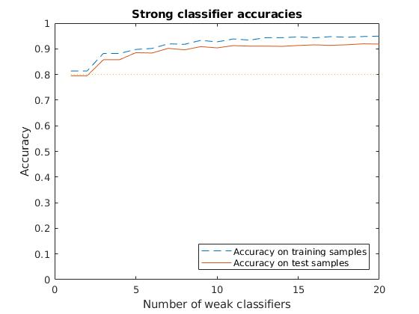

Matlab output for the training:

Training weak classifier 20 of 20.
100% Done.
Time elapsed: 8m 11.5751s.
Estimated training time: 8m 11.8585 s.

Best test-data accuracy (0.9195) is given with 19 weak classifiers.
Number of training samples used: 1000
Number of test samples used: 3000
Number of Haar-filters generated: 300

- How many weak classifiers did you chose before testing the data?
We made a loop to create several strong classifiers with varying number of weak classifiers and then comparing them. 1 to 20 weak classifiers was used.

- How many weak classifiers did you use for final strong classifier? Why?
The best strong classifier in this example uses 19 weak classifiers, since it gives the best accuracy on the training data.

Altough it can be seen in the plot that the accuracy of the strong classifier quickly converges, which means that maybe we might as well use 10 weak classifiers instead of 19 and get a similar result.

- What is the accuracy on the test data after applying the optimized strong classifier?
The most accurate strong classifier has an accuracy of 0.9195 on the test data, using the Haar features shown below.
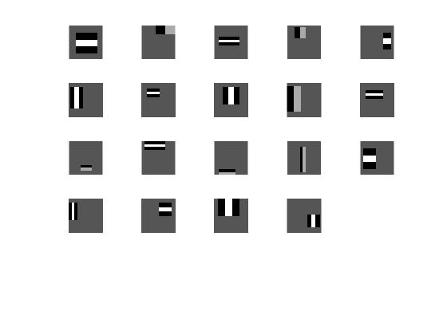

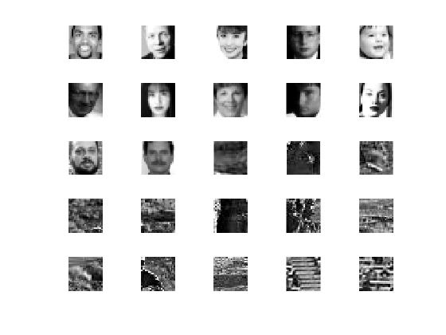
- Plot some of the misclassified faces and non-faces that seem hard to classify correctly.

- Defend your results. Are they reasonable?
A lot of the non-faces that were incorrectly classified as faces has a lot of noise and strong edges that match the Haar filters and are therefore missclassified as faces.

The faces that are missed are in lot of the cases images with either very low contrast or very high, maybe there is hair covering parts of the face, shadows in the face or glasses or other obstacles.

7. Can we expect perfect results?
The result will most probably never be perfect, but it could get better. A higher number of randomly generated Haar-features could be used as well as more high-resolution images. Although this will of course require more from the computer performing the classification in terms of memory and computational power. Maybe a perfect classification machine is only possible in theory?

Cameras and other devices with face-recognition functionality today have a close to perfect accuracy but are still dependent on light conditions and that the face is not occluded or angled away from the camera.

Maybe with some other method than AdaBoosting using Haar features we could get a better result. Our human brains does after all success in classifying most faces/non-faces :)

