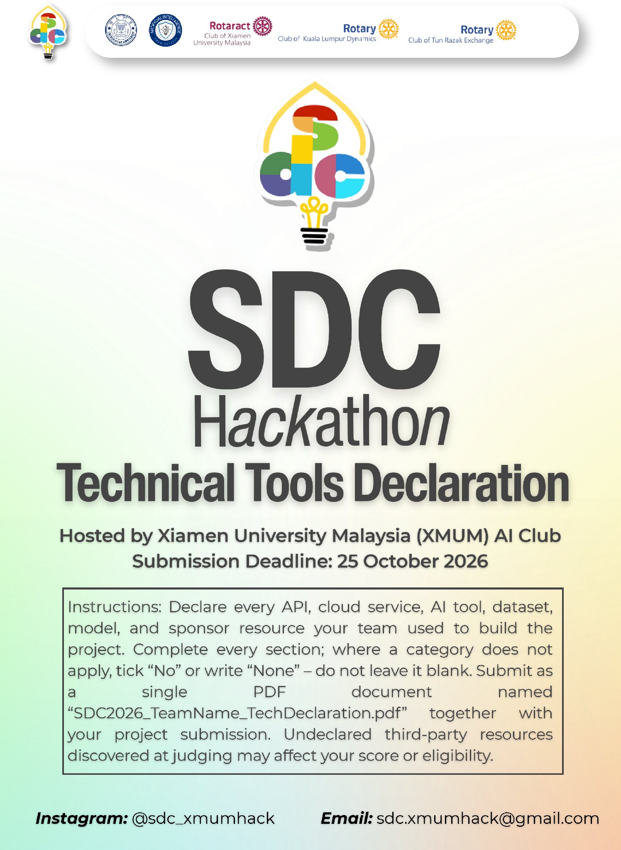
SDC HACKATHON 2026
Technical & Tools Declaration
Hosted by Xiamen University Malaysia (XMUM) AI Club
Submission Deadline: [Insert date]
Instructions: Declare every API, cloud service, AI tool, dataset, model, and sponsor resource your team used to build the project. Complete every section; where a category does not apply, tick “No” or write “None” – do not leave it blank. Submit as a single PDF document named “SDC2026_TeamName_TechDeclaration.pdf” together with your project submission. Undeclared third-party resources discovered at judging may affect your score or eligibility.

1. Team & Project Overview
Team Name | Kita Akan Lawan
Project / Solution Name | StockNow
Name (Leader) | Alfred Jason Gustono
Email & Phone (Leader) | alfredgustono0926@gmail.com / [leader phone number]
University Affiliation(s) | Xiamen University Malaysia
Live Prototype URL | To be provided before judging
Code Repository URL (public / access granted to judges) | To be provided before judging

2. Architecture & Technology Stack

2.1 System Architecture Overview
Describe how the components declared in this document connect end-to-end (e.g., user interface → backend → AI model/API → database → cloud hosting). Attach a system block diagram as an appendix if available.
[Maximum 200 words]
Users (Owner, Manager, Staff) open StockNow in a web browser on a phone or desktop. The Next.js app, deployed on Replit, serves the React interface and server routes. Stock in/out, suppliers, budgets and approvals are read from and written to Supabase PostgreSQL through supabase-js.
When a restock plan is requested, the server-side engine loads six months of sales, current stock, open orders and the remaining monthly budget from Supabase, then calculates forecasts, safety stock, buy/skip decisions, profit and confidence deterministically. Only these computed results (product names, quantities and amounts, no personal data) are sent to the Google Gemini API, which returns the plan summary and supplier message wording; a fixed template is used if Gemini is unavailable.
Approved plans are saved as purchase orders. Each supplier message opens in WhatsApp through a click-to-chat link and a person sends it. Every action is written to the activity_logs table. Orbyte modules (Directory, eLeave, notifications, Payment) are shown as simulated integration points in the demo. See Appendix A for the block diagram.

2.2 Languages, Frameworks & Libraries
List the main programming languages, frameworks, and third-party libraries that your team did not create. Open-source use is permitted provided it is declared and properly licensed/attributed.
Name & Version | Purpose in Project | License
JavaScript on Node.js 20+ (Replit: Node.js 22) | Programming language and runtime for the UI, server routes and restock engine | MIT (Node.js)
Next.js 15.5.28 | Web framework: pages, server routes and production build | MIT
React 19.2.0 | User-interface components | MIT
lucide-react 0.555.0 | Interface icons | ISC
@supabase/supabase-js 2.117.0 | Client for reading and writing the Supabase PostgreSQL database | MIT
Inter typeface (Google Fonts) | Interface font | SIL Open Font License 1.1

3. APIs & Cloud Services

3.1 External APIs
List every external API your solution calls (GenAI, maps, payments, messaging, data feeds, etc.). Do not include API keys or secrets in this document.
API & Provider | Purpose in Project | Access Tier (free / paid / sponsor-provided)
Google Gemini API (Google) | Writes the restock plan summary and supplier order/reminder messages from figures already computed by the engine | Free tier (team's own account)
Supabase API (Supabase Inc.) | Database reads and writes for products, stock movements, plans, orders, settings and activity log | Free tier
WhatsApp click-to-chat link, wa.me (Meta) | Opens a pre-filled supplier message; a person sends it. No API key or automatic sending | Free
Google Fonts (Google) | Serves the Inter font | Free

3.2 Cloud Platforms & Deployment
List every cloud service used for hosting, storage, databases, authentication, or compute, and indicate how the prototype is deployed.
Service & Provider | Purpose in Project | Plan / Region
Replit (Replit, Inc.) | Hosting and deployment of the Next.js app; stores API keys as server-side secrets | Sponsor-provided (SDC) / region
Supabase (Supabase Inc.) | Managed PostgreSQL database for all app data (no authentication used in the demo) | Free plan / region

4. AI Tools, Models & Datasets

4.1 AI Models Used in the Solution
List every AI model embedded in or called by your application, including pre-trained, fine-tuned, and self-trained models.
Model & Version | Source / Provider | Usage (pre-trained / fine-tuned / self-trained) | License / Terms
Google Gemini 3.8 Flash (gemini-3.8-flash; configurable with GEMINI_MODEL) | Google, via Gemini API | Pre-trained, used as-is (no fine-tuning) | Gemini API Additional Terms of Service
StockNow restock engine (weighted moving average + linear trend, rule-based budget allocation) | Built by the team | Self-built statistical rules; no model training | Team-owned

4.2 Datasets
List all datasets used for training, fine-tuning, evaluation, or in the running application. State clearly if a dataset contains personal or sensitive data.
Dataset Name | Source / URL | Type (public / private / self-collected / synthetic) | License | Personal Data? (Y/N)
StockNow demo data (8 products, 6 months of sales, 6 demand scenarios, fictional staff and suppliers) | Created by the team; built into the app and Supabase seed | Synthetic | Team-owned | N
DOSM MSMEs Performance 2024 | dosm.gov.my (cited in proposal only, not loaded into the app) | Public | DOSM terms of use | N

4.3 AI-Assisted Development Tools
Tools used to help write code, design, content, or documentation (e.g., chat assistants, code completion tools, image generators). Declaring these tools does not reduce your score; undeclared use may.
Did your team use any generative-AI tool to help create code, design, text, or other project material?
☒ Yes ☐ No
If yes, list them below:
Tool & Version | Used For | Extent of Use (minor / moderate / major)
Claude Code (Anthropic), used Oct 2026 | Generating and revising prototype code, UI design and test scripts; drafting documentation text | Major

Briefly describe how your team reviewed, tested, and took responsibility for AI-generated output:
[Maximum 100 words]
Claude produced drafts; the team made every product decision. Each revision was reviewed by the team in the clickable prototype over seven feedback rounds, and features we judged unreliable or unnecessary, such as an AI chatbot, were removed at our request. Forecast and budget figures were checked by hand against the app's “Show calculation” breakdown, and automated browser tests were run for every flow on desktop and mobile. All documentation was read, corrected and approved by the team, which takes full responsibility for the submitted code and content.

5. Sponsor-Provided Resources
Declare any official SDC sponsor-provided GenAI API, cloud credits, tools, mentoring, or data that your team used.
Did your project use any official SDC sponsor-provided resource?
☒ Yes ☐ No
If yes, list them below:
Sponsor | Resource (API / credits / platform / data) | How It Was Used in the Project
Replit | Cloud platform (hosting & deployment) | Hosts and deploys the StockNow web app used for the demo and judging

Was the sponsor resource essential to the core functionality of the prototype, or could it be replaced? Explain briefly:
[Maximum 100 words]
Not essential to the core functionality. Replit gives us convenient hosting and deployment for the demo, but StockNow is a standard Next.js application with its data in Supabase, so it could be redeployed to another Node.js host (for example Vercel or a virtual server) by changing only environment settings. The AI restock engine is our own code and does not depend on Replit.

6. Security, Privacy & Responsible Use

6.1 Data Handling & Privacy
What user or personal data does your application collect, store, or send to third-party services (including AI APIs)? How is it protected, and how long is it kept? State “No user data is collected” if applicable.
[Maximum 150 words]
The demo uses synthetic data only; no real customer or personal data is collected. In real use StockNow stores business records: products, prices, stock movements, purchase plans and orders, supplier business contacts, and staff names and roles for the activity log. No customer data is stored.
Data is kept in Supabase PostgreSQL (encrypted at rest, HTTPS in transit). Only product names, quantities, amounts and supplier business names are sent to the Gemini API; phone numbers and staff details are not. API keys are kept as Replit server secrets, never in the browser or repository.
The demo has no login, so before real use we will add authentication (Supabase Auth or Orbyte sign-in) with row-level security. Records are kept while the business uses StockNow and can be exported or deleted on request, following Malaysia's PDPA 2010.

6.2 Known Limitations & Risks
Identify the main technical limitations of your AI components (e.g., hallucination, bias, rate limits, dependency on a single provider) and any mitigation you have implemented.
[Maximum 150 words]
Forecast: the engine needs at least three months of sales per product and models trend, not seasonality, so it underestimates festive spikes (26.8% average error in our festive test scenario vs 11.0% overall). Mitigation: a confidence score, a “Show calculation” breakdown, a backtest view and human approval of every item.
GenAI: Gemini can produce wrong text, so it never calculates numbers; it only words results already computed. A fixed template is used if it fails, is rate-limited or unavailable, which also avoids dependence on one provider.
Data and security: results so far are on synthetic data, so Phase 2 will validate with real retailer sales. The demo has no login and must not hold real data until authentication is added. Supplier messages are never sent automatically.

7. Compliance & Readiness Checklist
Tick all boxes that apply before submitting.
☒ | All APIs, cloud services, AI tools, models, and datasets used in the project are declared in this document.
☒ | All third-party code, datasets, and models are used in accordance with their licenses, and attribution is provided where required.
☒ | No API keys, passwords, or other credentials are exposed in the code repository, prototype, or this document.
☒ | Any use of generative-AI tools for development has been disclosed and reviewed by the team.
☒ | Any use of official SDC sponsor resources has been declared in Section 5.
☐ | The prototype described here is accessible to judges through the links provided in Section 1.
☐ | All fields in this template have been completed within the word limits stated.

8. Declaration
By submitting this document, the team leader confirms that the information provided is complete and accurate to the best of the team’s knowledge, and that every API, cloud service, AI tool, dataset, model, and sponsor resource used in the project has been declared.
[Signature]
[Date]

APPENDIX A – SYSTEM BLOCK DIAGRAM
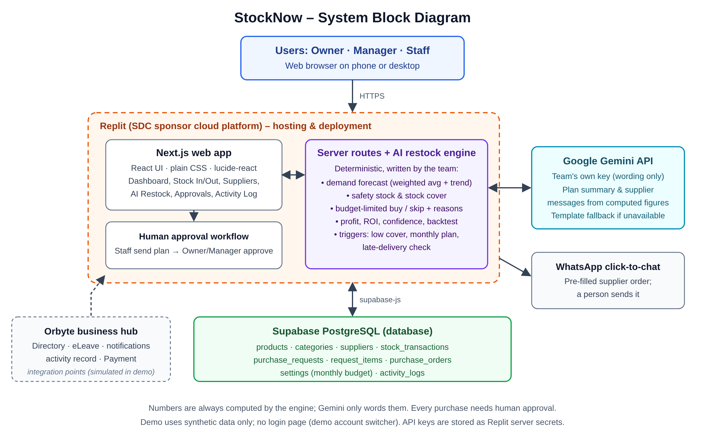
Figure A1. StockNow architecture: browser, Next.js app and AI restock engine on Replit, Gemini API for wording, Supabase PostgreSQL, WhatsApp and Orbyte integration points.

